**Skill lab projects**

Name: Ramakrishna m n

Roll no:RVCE24BEC119

**Simulation using LT spice software**

**Day1**:- simulation of basic circuits finding voltage across resistors and currents

**Circuit diagram:-**

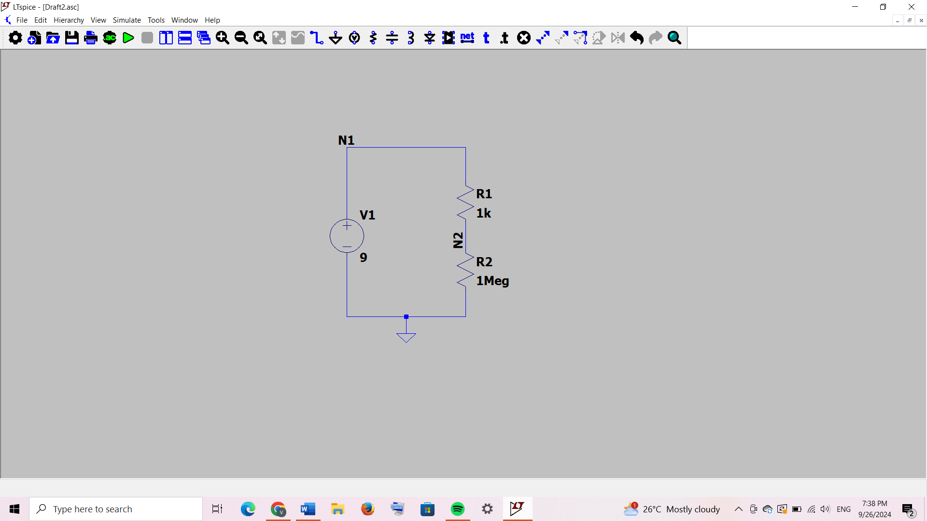

**Components used:-**

Resistors(2),voltage source(1),grounding,wires

**Calculations:-**

Voltage across V(N1)=9V

Current through circuit is given by

I=V(N1)/(R1+R2)

I=9/(1k+1Meg)

I=8.99101e-06 A

Therefore current through R1,R2 and V1 are I,I,-I respectively

Voltage through N2 is

V(N2)=V(N1)-V(R1)

V(N2)=9-[I(R1)*R1]

V(N2)=9-8.99101e-03

V(N2)=8.99101V

**Output:-**

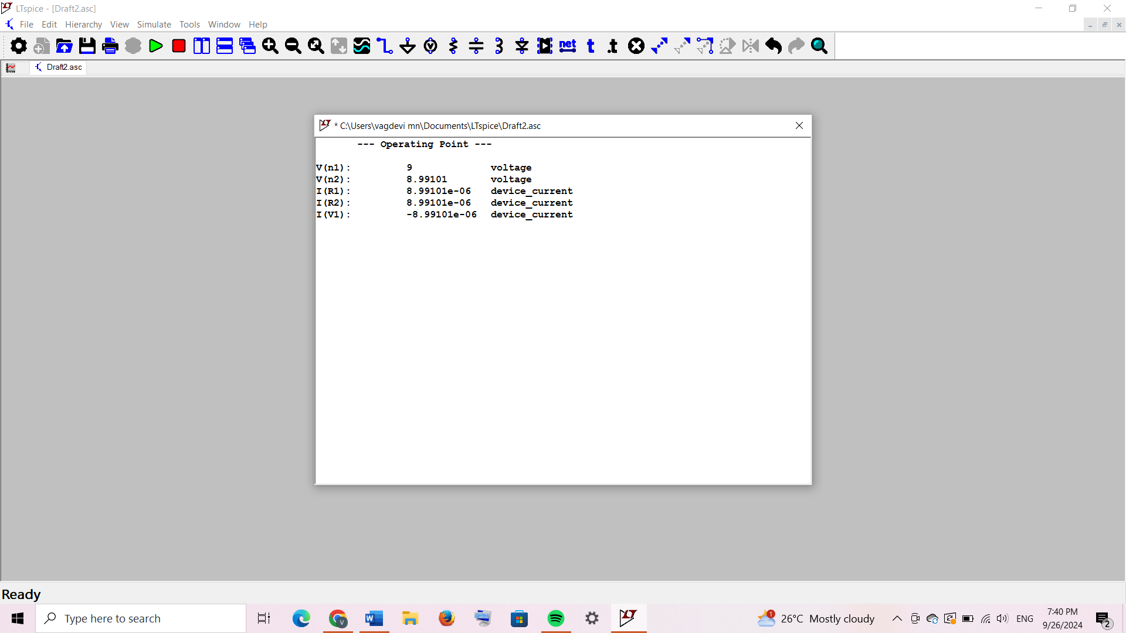

**Conclution:-**

We can see that both theoretical value and output value was same