🛒
My Mart
Full-Stack Online Grocery Store
Step-by-Step Build Guide & Code Explanation
Flask REST API • SQLite + SQLAlchemy • HTML / CSS / JavaScript • 5-set dataset
Author: Ram
Version 2.0 • October 2026
Contents

ℹ️ If the page numbers are missing, right-click the table of contents in Word and choose Update Field → Update entire table.

1. Introduction

1.1 What is My Mart?
My Mart is an online grocery store that runs on your own computer at http://localhost:5000. Customers browse products, add them to a cart, pay by UPI QR code or Cash on Delivery, and track their orders. An admin manages products and orders and sees sales analytics. Anyone can open the Dataset Explorer and see, set by set, the data the store runs on.
This guide rebuilds the whole project from an empty folder, one step at a time. For every step it shows the real code from the project and explains what each part does and why it was written that way.
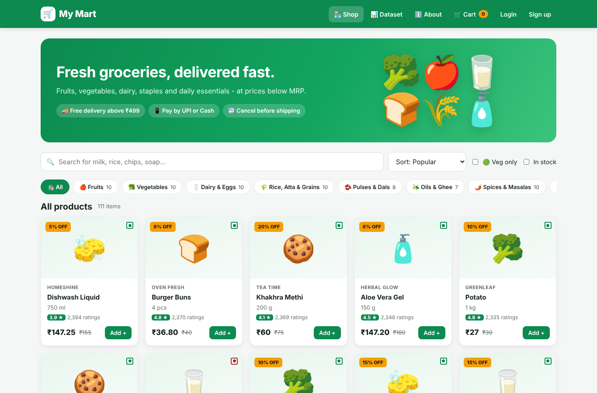
Figure 1 – The finished shop page

1.2 What you will learn
- How a frontend (what runs in the browser) talks to a backend (the server) through a REST API.
- How to design a relational database with primary keys, foreign keys and constraints.
- How to use an ORM (SQLAlchemy) so database tables become Python classes.
- How to build login with hashed passwords and protect admin-only pages.
- How to create a realistic dataset and load it into a database automatically.
- How to write automated tests, document a project and publish it on GitHub.

1.3 Features of the finished project
Customers | Admin | Everyone
Register / log in | Revenue, orders, avg order value, customers | Dataset Explorer page
Search, category, veg, in-stock filters | Revenue-by-month line chart | Each data set explained
7 sort orders + pagination | Sales by category, top 10 products | Column dictionary
Cart saved in the database | Payment, status, weekday, city charts | Live statistics + chart per set
Free-delivery progress bar | Low-stock alert + restock | Search rows, download CSV
UPI QR or Cash on Delivery | Add / edit / delete products | ER diagram of the sets
Order tracking + cancel | Move orders Placed → Delivered | About page (architecture)

1.4 Technology stack
Layer | Technology | Why it was chosen
Language | Python 3.10+ | Easy to read, very popular for web back-ends and data
Web framework | Flask 3 | Small and simple, so you can see exactly what happens
Database | SQLite | No installation: the whole database is a single file
ORM | Flask-SQLAlchemy / SQLAlchemy 2 | Write Python classes instead of raw SQL
Login | Flask-Login + Werkzeug | Secure session cookies and password hashing
QR code | qrcode[pil] | Generates the UPI payment QR image
Settings | python-dotenv | Reads secrets from a .env file, not from the code
Frontend | HTML5, CSS3, vanilla JavaScript | No build tools or Node.js needed
Charts | Hand-written SVG (charts.js) | Works offline, no external library
Tests | unittest (pytest compatible) | Built into Python

2. How the Project Works (Architecture)
Before writing code, it helps to understand the big picture. The project has four layers:
Layer | Folder | Job
1. Frontend | frontend/ | HTML pages the user sees. JavaScript calls the API with fetch() and draws the results.
2. Backend (REST API) | backend/app/api/ | Python functions that receive requests like GET /api/products and return JSON.
3. Database | backend/instance/mymart.db | SQLite file holding 6 tables. Accessed through SQLAlchemy models.
4. Dataset | data/*.csv | 5 CSV files. Loaded into the database automatically on the first run.

Data flow
Browser (frontend/*.html + js)
│ fetch("/api/cart", {method:"POST", body: {...}})
▼
Flask server (run.py → backend/app)
│ blueprint function e.g. cart.add_item()
▼
SQLAlchemy models (backend/app/models)
│ INSERT / SELECT / UPDATE
▼
SQLite database (backend/instance/mymart.db) ◄── first run: data/*.csv

2.1 Example: what happens when you click “Add +”
- In the shop page, the button calls the JavaScript function addToCart(productId) in frontend/js/app.js.
- addToCart sends POST /api/cart with the JSON body {"product_id": 5, "quantity": 1}. The browser attaches the login cookie automatically.
- Flask routes the request to add_item() in backend/app/api/cart.py. The @login_required decorator checks the cookie first.
- add_item() loads the product, checks the stock limit, then inserts or updates a row in the cart_items table.
- It returns the new cart summary as JSON (items, subtotal, delivery fee, total).
- JavaScript updates the cart badge in the navbar and shows a green toast message.
💡 Tip: One Flask server does two jobs: it answers /api/... requests with JSON, and it sends the HTML/CSS/JS files for every other URL. That's why you only start one program.

2.2 Final folder structure
MyMart/
├── run.py start the server
├── manage.py database commands (reset-db, export, stats…)
├── requirements.txt Python libraries
├── .env.example settings template
├── start.bat / start.sh one-click setup + run
├── backend/
│ ├── app/
│ │ ├── __init__.py app factory
│ │ ├── config.py settings
│ │ ├── extensions.py db + login manager
│ │ ├── seed.py loads CSV → database
│ │ ├── utils.py helpers
│ │ ├── models/ category, product, user, cart, order
│ │ └── api/ auth, products, cart, orders, admin, dataset
│ └── tests/test_api.py 19 automated tests
├── frontend/
│ ├── index.html product.html cart.html checkout.html orders.html
│ ├── login.html register.html admin.html dataset.html about.html 404.html
│ ├── css/style.css
│ └── js/app.js js/charts.js
├── data/ 5 CSV files + generate_dataset.py + README.md
└── docs/ API.md, DATABASE.md, UPGRADE_NOTES.md, screenshots/

3. Step 1 – Prepare Your Computer
Install these tools once:
Tool | Where to get it | Check it works
Python 3.10 or newer | python.org/downloads (tick “Add Python to PATH”) | python --version
Code editor | VS Code or PyCharm | Open a folder in it
Git | git-scm.com | git --version
GitHub account | github.com | Log in
Web browser | Chrome / Edge / Firefox | -

⚠️ Note: On Windows, if python is not recognized, try py instead, or reinstall Python with “Add Python to PATH” ticked.

4. Step 2 – Create the Folder Structure
Create an empty folder called MyMart, and inside it create these folders:
Windows Command Prompt
mkdir MyMart
cd MyMart
mkdir backend backend\app backend\app\models backend\app\api backend\tests
mkdir frontend frontend\css frontend\js data docs docs\screenshots

Then create three empty __init__.py files: backend/__init__.py, backend/tests/__init__.py, and (later, with content) backend/app/__init__.py. A folder that contains an __init__.py file is a Python package, which means other files can import from it, e.g. from backend.app import create_app.

4.1 Why split the project this way?
- Separation of concerns: frontend, backend and data each live in their own folder, so each part is easy to find and change.
- models/: one file per database table.
- api/: one file per feature (auth, cart, orders…). Each file is a Flask Blueprint, a group of related URLs.
- data/: the dataset lives as plain CSV, so anyone on GitHub can read it without running the project.

5. Step 3 – Virtual Environment & Libraries
A virtual environment (venv) is a private copy of Python just for this project. Libraries you install go into it, so different projects never conflict.
Terminal
python -m venv venv # create it (once)
venv\Scripts\activate # Windows - activate it every time you open a terminal
source venv/bin/activate # macOS / Linux
pip install -r requirements.txt

You'll know the venv is active when (venv) appears at the start of the terminal line.

5.1 requirements.txt explained
📄 requirements.txt
Flask>=3.0,<4 # web framework (REST API + serves the frontend)
Flask-SQLAlchemy>=3.1,<4 # ORM: Python classes <-> database tables
SQLAlchemy>=2.0,<3 # database toolkit used by Flask-SQLAlchemy
Flask-Login>=0.6.3,<1 # login sessions / "remember me"
Werkzeug>=3.0,<4 # password hashing (installed with Flask)
qrcode[pil]>=7.4 # UPI QR code image at checkout (pulls in Pillow)
python-dotenv>=1.0 # reads settings from the .env file

Library | What it does in My Mart
Flask | Receives HTTP requests, runs our Python functions, sends back JSON or HTML files
Flask-SQLAlchemy / SQLAlchemy | Turns Python classes (Product, Order…) into database tables and queries
Flask-Login | Remembers who is logged in (session cookie); provides current_user and @login_required
Werkzeug | generate_password_hash / check_password_hash, so passwords are never stored as plain text
qrcode[pil] | Draws the UPI payment QR code as a PNG image (Pillow does the image work)
python-dotenv | Loads settings such as SECRET_KEY and MERCHANT_UPI_ID from the .env file

💡 Tip: >=3.0,<4 means “version 3.0 or newer, but not version 4”. That way you get bug fixes without a future major version breaking the code.

6. Step 4 – Build the Dataset
A store needs data. Instead of typing hundreds of rows by hand, we write a Python script, data/generate_dataset.py, that generates realistic data and saves it as 5 CSV files. The script uses only the Python standard library.

6.1 The five data sets
# | Set / file | Rows | One row means | Links to
1 | categories.csv | 12 | An aisle (Fruits, Dairy…) | -
2 | products.csv | 111 | A product you can buy | category_id → categories
3 | customers.csv | 60 | A registered customer | -
4 | orders.csv | 420 | One checkout (receipt header) | user_id → customers
5 | order_items.csv | 1,385 | One product line in an order | order_id → orders, product_id → products

How the sets connect
categories 1 ──< products 1 ──< order_items >── 1 orders >── 1 customers
(“1 ──< many” means one row on the left is linked to many rows on the right)

6.2 Reproducible randomness
📄 data/generate_dataset.py
SEED = 42
DATA_DIR = Path(__file__).resolve().parent

START_DATE = datetime(2026, 4, 1, 8, 0, 0)
END_DATE = datetime(2026, 9, 30, 22, 0, 0)
NUM_CUSTOMERS = 60
NUM_ORDERS = 420
FREE_DELIVERY_ABOVE = 499
DELIVERY_FEE = 40

rng = random.Random(SEED)

random.Random(42) creates a random-number generator with a fixed seed. The same seed always produces the same “random” numbers, so everyone who runs the script gets exactly the same files. That matters for a project on GitHub: your screenshots and numbers will match what other people see.

6.3 Set 1 & 2 – categories and products
Categories are a hand-written list of tuples. Products are listed per category with a name, pack size, MRP and a veg flag. Brands are fictional.
📄 data/generate_dataset.py
def build_products():
rows = []
pid = 1
for cat_id, items in PRODUCTS.items():
for name, unit, mrp, veg in items:
brand = rng.choice(BRANDS[cat_id])
discount = rng.choice([0, 0, 5, 5, 8, 10, 10, 12, 15, 20])
price = round(mrp * (100 - discount) / 100, 2)
# a few products deliberately low / out of stock so the admin
# "low stock" alert has something to show
stock = rng.choice([0, 3, 7]) if rng.random() < 0.08 else rng.randint(15, 200)
rows.append({
"id": pid,
"sku": f"MM-{cat_id:02d}-{pid:04d}",
"name": name,
"brand": brand,
"category_id": cat_id,
"unit": unit,
"mrp": money(mrp),
"price": money(price),
"discount_pct": discount,
"stock": stock,
"rating": f"{rng.uniform(3.4, 4.9):.1f}",
"rating_count": rng.randint(12, 2400),
"is_veg": veg,
"description": DESCRIPTIONS[cat_id].format(name=name, brand=brand),
"created_at": random_datetime(datetime(2026, 1, 1), datetime(2026, 3, 31)).strftime("%Y-%m-%d %H:%M:%S"),
})
pid += 1
return rows

Line by line:
- For each product a random brand and discount are picked. price = mrp × (100 − discount) / 100, so the selling price is never above the MRP.
- About 8 % of products get a stock of 0, 3 or 7. This is deliberate, so the admin's low-stock alert has something to show.
- The SKU (Stock Keeping Unit) code is built as MM-<category>-<id>, e.g. MM-03-0024.

6.4 Set 3 – customers
60 unique names are made by combining a random first name and last name. Each customer gets a city chosen with weights (Hyderabad and Bengaluru appear most often), a fake phone number starting with 9, and an @example.com e-mail. example.com is a domain reserved for examples, so these addresses can never belong to a real person.

6.5 Sets 4 & 5 – orders and order items
This is the most interesting part, because the business rules are built into the data:
📄 data/generate_dataset.py
delivery = 0 if subtotal >= FREE_DELIVERY_ABOVE else DELIVERY_FEE
method = rng.choices(["UPI", "COD"], weights=[65, 35])[0]

days_old = (END_DATE - created).days
if days_old <= 1:
status = rng.choice(["Placed", "Packed"])
elif days_old <= 3:
status = rng.choice(["Packed", "Shipped", "Delivered"])
else:
status = "Cancelled" if rng.random() < 0.06 else "Delivered"

if status == "Cancelled":
pay_status = "Refunded" if method == "UPI" else "Cancelled"
elif method == "UPI":
pay_status = "Paid"
else:
pay_status = "Paid" if status == "Delivered" else "Pending"

- Popularity weights: fresh food (fruit, veg, dairy, bakery) and cheap items are picked more often, just like in a real store.
- Delivery fee: ₹0 when the subtotal is at least ₹499, otherwise ₹40.
- Status: orders from the last 1–3 days are still Placed, Packed or Shipped. Older ones are Delivered, and about 6 % are Cancelled.
- Payment: 65 % UPI and 35 % COD. A COD order is only “Paid” once it's delivered.
Run it with python data/generate_dataset.py. Output:
Generating MyMart dataset (seed=42)
wrote categories.csv 12 rows
wrote products.csv 111 rows
wrote customers.csv 60 rows
wrote orders.csv 420 rows
wrote order_items.csv 1385 rows

💡 Tip: The full column-by-column description of every set is in data/README.md (the data card). Chapter 14 and the Dataset Explorer page show how users can see it.

7. Step 5 – Configuration (config.py and .env)
Settings such as the secret key, database location and UPI ID must not be hard-coded, because the old version broke on other computers for exactly that reason. backend/app/config.py reads them from environment variables, with safe defaults.
📄 backend/app/config.py
ROOT_DIR = Path(__file__).resolve().parents[2]
BACKEND_DIR = ROOT_DIR / "backend"
FRONTEND_DIR = ROOT_DIR / "frontend"
DATA_DIR = ROOT_DIR / "data"
INSTANCE_DIR = BACKEND_DIR / "instance"

if load_dotenv:
load_dotenv(ROOT_DIR / ".env")

Path(__file__).resolve().parents[2] means “the folder two levels above this file”, which is the project root. Every other path is built from it, so the project works wherever you put it, on Windows, Mac or Linux.
📄 backend/app/config.py
class Config:
# Flask
SECRET_KEY = os.getenv("SECRET_KEY", "dev-only-change-me-in-production")
SESSION_COOKIE_HTTPONLY = True
SESSION_COOKIE_SAMESITE = "Lax"

# Database - SQLite file inside backend/instance/ (path works on every OS)
SQLALCHEMY_DATABASE_URI = os.getenv(
"DATABASE_URL", "sqlite:///" + (INSTANCE_DIR / "mymart.db").as_posix()
)
SQLALCHEMY_TRACK_MODIFICATIONS = False

# Shop rules
FREE_DELIVERY_ABOVE = float(os.getenv("FREE_DELIVERY_ABOVE", 499))
DELIVERY_FEE = float(os.getenv("DELIVERY_FEE", 40))
LOW_STOCK_THRESHOLD = int(os.getenv("LOW_STOCK_THRESHOLD", 10))
MAX_QTY_PER_ITEM = int(os.getenv("MAX_QTY_PER_ITEM", 10))

# UPI (demo payment) - put your own UPI ID in .env
MERCHANT_UPI_ID = os.getenv("MERCHANT_UPI_ID", "mymart@upi")
MERCHANT_NAME = os.getenv("MERCHANT_NAME", "My Mart")

# Default admin created by the seeder
ADMIN_EMAIL = os.getenv("ADMIN_EMAIL", "admin@mymart.com")
ADMIN_PASSWORD = os.getenv("ADMIN_PASSWORD", "Admin@123")

# Load the sample dataset automatically when the database is empty
AUTO_SEED = _bool("AUTO_SEED", True)
DEMO_CUSTOMER_PASSWORD = os.getenv("DEMO_CUSTOMER_PASSWORD", "Customer@123")

- os.getenv("NAME", default) reads a setting from .env, or uses the default if it isn't set.
- SECRET_KEY signs the login cookie. If someone knew it, they could fake a login, so change it in .env.
- AUTO_SEED means the dataset is loaded automatically when the database is empty.
📄 backend/app/config.py
class TestConfig(Config):
TESTING = True
SQLALCHEMY_DATABASE_URI = "sqlite:///:memory:"
SECRET_KEY = "test"

TestConfig inherits from Config and only overrides what is different: tests use an in-memory database (sqlite:///:memory:) that disappears after each test.
The .env.example file is a template. Copy it to .env and change values there. .env is listed in .gitignore, so your secrets never reach GitHub.

8. Step 6 – Extensions and the App Factory

8.1 extensions.py
📄 backend/app/extensions.py
from flask_login import LoginManager
from flask_sqlalchemy import SQLAlchemy

db = SQLAlchemy()
login_manager = LoginManager()

The extensions are created here without an app and attached later. This avoids circular imports: models can from ..extensions import db without importing the whole app.

8.2 The app factory: backend/app/__init__.py
create_app() is a function that builds and returns a configured Flask app. Tests call it with TestConfig, and run.py calls it with the normal Config. This pattern is called an application factory.
📄 backend/app/__init__.py
def create_app(config_class=Config):
app = Flask(__name__, static_folder=None)
app.config.from_object(config_class)
app.json.sort_keys = False # keep JSON keys in the order we write them
INSTANCE_DIR.mkdir(parents=True, exist_ok=True)

# ---- extensions --------------------------------------------------------
db.init_app(app)
login_manager.init_app(app)

from .models import User

@login_manager.user_loader
def load_user(user_id):
return db.session.get(User, int(user_id))

@login_manager.unauthorized_handler
def unauthorized():
return jsonify({"error": "Please log in first."}), 401

# ---- API ----------------------------------------------------------------
from .api import BLUEPRINTS

for bp in BLUEPRINTS:
app.register_blueprint(bp)

- static_folder=None turns off Flask's default static folder, because we serve the frontend/ folder ourselves.
- user_loader tells Flask-Login how to turn the user id stored in the cookie back into a User object (current_user).
- unauthorized_handler returns a JSON 401 error instead of redirecting, because our frontend expects JSON.
- Every blueprint from api/ is registered, which makes all the /api/... URLs live.
📄 backend/app/__init__.py
@app.errorhandler(ApiError)
def handle_api_error(err):
db.session.rollback()
return jsonify({"error": err.message}), err.status

@app.errorhandler(HTTPException)
def handle_http(err):
if request.path.startswith("/api/"):
return jsonify({"error": err.description}), err.code
if err.code == 404:
return send_from_directory(FRONTEND_DIR, "404.html"), 404
return err

Error handlers make sure the API always answers with {"error": "message"} and the right status code. db.session.rollback() undoes any half-finished database change when something goes wrong.
📄 backend/app/__init__.py
# ---- frontend -------------------------------------------------------------
@app.get("/")
@app.get("/<page>")
def page(page=""):
filename = PAGES.get(page)
if filename is None:
return send_from_directory(FRONTEND_DIR, "404.html"), 404
return send_from_directory(FRONTEND_DIR, filename)

@app.get("/static/<path:filename>")
def static_files(filename):
return send_from_directory(FRONTEND_DIR, filename)

# ---- database -------------------------------------------------------------
with app.app_context():
db.create_all()
if app.config.get("AUTO_SEED"):
from .seed import ensure_admin, is_empty, seed_database

if is_empty():
quiet = app.config.get("TESTING", False)
if not quiet:
print(" * First run: loading the sample dataset from data/*.csv ...")
seed_database(verbose=not quiet)
ensure_admin()

return app

- PAGES (defined at the top of the file) maps URLs to HTML files, e.g. /cart → cart.html. Unknown pages get 404.html.
- /static/<path> serves CSS and JS, e.g. /static/css/style.css.
- db.create_all() creates any missing tables. If the database is empty, the CSV dataset is loaded and the admin account is created.

9. Step 7 – Database Models (Tables)
A model is a Python class that describes a table. Each class attribute created with db.Column(...) is a column. SQLAlchemy creates the SQL for us.

9.1 Key database ideas
Term | Meaning | Example in My Mart
Primary key (PK) | A column that uniquely identifies each row | products.id
Foreign key (FK) | A column that points to a PK in another table | products.category_id → categories.id
Unique constraint | No two rows may have the same value | users.email, products.sku
Check constraint | A rule every row must satisfy | stock >= 0, quantity > 0
Index | Makes searching a column faster | products.name, orders.created_at
Relationship | Python shortcut to follow a FK | product.category.name

9.2 Category model
📄 backend/app/models/category.py
class Category(db.Model):
"""Set 1 - a group of related products (Fruits, Dairy, ...)."""

__tablename__ = "categories"

id = db.Column(db.Integer, primary_key=True)
name = db.Column(db.String(80), unique=True, nullable=False)
slug = db.Column(db.String(80), unique=True, nullable=False)
emoji = db.Column(db.String(8), default="🛍️")
description = db.Column(db.String(255))

products = db.relationship("Product", back_populates="category", lazy="dynamic")

def to_dict(self, with_count=False):
data = {
"id": self.id,
"name": self.name,
"slug": self.slug,
"emoji": self.emoji,
"description": self.description,
}
if with_count:
data["product_count"] = self.products.filter_by(is_active=True).count()
return data

db.relationship("Product", back_populates="category", lazy="dynamic") lets us write category.products to get the products in a category. to_dict() converts the object into a dictionary that Flask can send as JSON.

9.3 Product model
📄 backend/app/models/product.py
Money = db.Numeric(10, 2, asdecimal=False)

class Product(db.Model):
"""Set 2 - an item that can be bought."""

__tablename__ = "products"

id = db.Column(db.Integer, primary_key=True)
sku = db.Column(db.String(30), unique=True, nullable=False)
name = db.Column(db.String(150), nullable=False, index=True)
brand = db.Column(db.String(80))
category_id = db.Column(db.Integer, db.ForeignKey("categories.id"), nullable=False, index=True)
unit = db.Column(db.String(40)) # "1 kg", "500 ml", "6 pcs"
mrp = db.Column(Money, nullable=False) # maximum retail price
price = db.Column(Money, nullable=False) # selling price
stock = db.Column(db.Integer, nullable=False, default=0)
rating = db.Column(db.Float, default=0)
rating_count = db.Column(db.Integer, default=0)
is_veg = db.Column(db.Boolean, default=True)
description = db.Column(db.Text)
image_url = db.Column(db.String(255))
is_active = db.Column(db.Boolean, default=True, nullable=False) # soft delete
created_at = db.Column(db.DateTime, default=datetime.now)

category = db.relationship("Category", back_populates="products")

__table_args__ = (
db.CheckConstraint("stock >= 0", name="ck_product_stock_positive"),
db.CheckConstraint("price >= 0", name="ck_product_price_positive"),
)

@property
def discount_pct(self):
if not self.mrp or self.mrp <= self.price:
return 0
return round((self.mrp - self.price) * 100 / self.mrp)

- Money = db.Numeric(10, 2, asdecimal=False) stores prices with 2 decimal places and gives them back as normal Python floats.
- is_active is used for soft delete: an admin “deleting” a product only hides it, so old orders still link to it.
- discount_pct is a @property, a value calculated from MRP and price rather than stored, so it can never be out of date.
- The CheckConstraints stop the database from ever saving a negative stock or price.

9.4 User model (customers and admin)
📄 backend/app/models/user.py
class User(UserMixin, db.Model):
"""Set 3 - a customer or an admin account."""

__tablename__ = "users"

id = db.Column(db.Integer, primary_key=True)
name = db.Column(db.String(120), nullable=False)
email = db.Column(db.String(150), unique=True, nullable=False, index=True)
phone = db.Column(db.String(15))
password_hash = db.Column(db.String(255), nullable=False)
role = db.Column(db.String(20), nullable=False, default="customer") # customer | admin
city = db.Column(db.String(80))
state = db.Column(db.String(80))
created_at = db.Column(db.DateTime, default=datetime.now)

orders = db.relationship("Order", back_populates="user", lazy="dynamic")

# ---- password helpers -------------------------------------------------
def set_password(self, password):
self.password_hash = generate_password_hash(password)

def check_password(self, password):
return check_password_hash(self.password_hash, password or "")

@property
def is_admin(self):
return self.role == "admin"

Passwords are never stored. set_password() saves a salted hash, a one-way scrambled version of the password. At login, check_password() hashes what the user typed and compares the two. Even someone who steals the database can't read the passwords. UserMixin adds the properties Flask-Login needs (is_authenticated, get_id()…).

9.5 CartItem model
📄 backend/app/models/cart.py
class CartItem(db.Model):
"""A product sitting in a user's cart (saved in the DB, so it survives logout)."""

__tablename__ = "cart_items"

id = db.Column(db.Integer, primary_key=True)
user_id = db.Column(db.Integer, db.ForeignKey("users.id", ondelete="CASCADE"), nullable=False)
product_id = db.Column(db.Integer, db.ForeignKey("products.id", ondelete="CASCADE"), nullable=False)
quantity = db.Column(db.Integer, nullable=False, default=1)
added_at = db.Column(db.DateTime, default=datetime.now)

product = db.relationship("Product")

__table_args__ = (
db.UniqueConstraint("user_id", "product_id", name="uq_cart_user_product"),
db.CheckConstraint("quantity > 0", name="ck_cart_qty_positive"),

The cart is stored in the database (the old version used the browser session), so it survives logout. The unique constraint on (user_id, product_id) means a product appears only once per cart; adding it again increases the quantity instead.

9.6 Order and OrderItem models
📄 backend/app/models/order.py
ORDER_STATUSES = ["Placed", "Packed", "Shipped", "Delivered", "Cancelled"]
PAYMENT_METHODS = ["UPI", "COD"]

📄 backend/app/models/order.py
class OrderItem(db.Model):
"""Set 5 - one product line inside an order.

product_name and unit_price are copied at purchase time, so the receipt
stays correct even if the product is later renamed, re-priced or removed.
"""

__tablename__ = "order_items"

id = db.Column(db.Integer, primary_key=True)
order_id = db.Column(db.Integer, db.ForeignKey("orders.id", ondelete="CASCADE"), nullable=False, index=True)
product_id = db.Column(db.Integer, db.ForeignKey("products.id"), index=True)
product_name = db.Column(db.String(150), nullable=False)
unit_price = db.Column(Money, nullable=False)
quantity = db.Column(db.Integer, nullable=False)
line_total = db.Column(Money, nullable=False)

Snapshot columns: product_name and unit_price are copied into the order line when the order is placed. If the admin changes the price tomorrow, yesterday's receipt still shows what the customer actually paid.
cascade="all, delete-orphan" on Order.items means that deleting an order also deletes its lines. lazy="selectin" loads all items of many orders in one extra query, which is faster than one query per order.
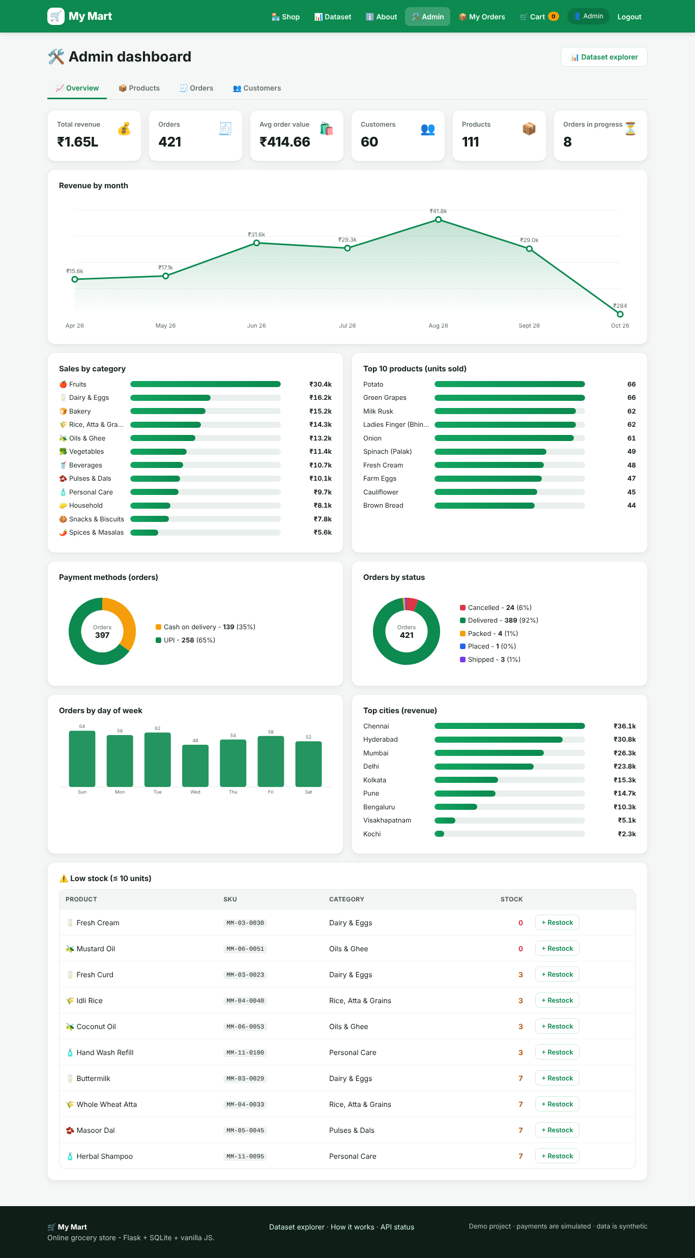
Figure 2 – The models feed the admin dashboard analytics

10. Step 8 – Loading the Dataset (seed.py)
seed.py reads each CSV file and inserts the rows using the models.
📄 backend/app/seed.py
def _read(name):
with (DATA_DIR / name).open(encoding="utf-8") as f:
return list(csv.DictReader(f))

def _dt(value):
return datetime.strptime(value, "%Y-%m-%d %H:%M:%S")

📄 backend/app/seed.py
# Set 3 - customers (all demo customers share one password; hashing once is faster)
shared_hash = generate_password_hash(cfg["DEMO_CUSTOMER_PASSWORD"])
for r in _read("customers.csv"):
db.session.add(User(
id=int(r["id"]), name=r["name"], email=r["email"], phone=r["phone"],
password_hash=shared_hash, role="customer", city=r["city"], state=r["state"],
created_at=_dt(r["joined_at"]),
))
db.session.flush()

- csv.DictReader turns each CSV row into a dictionary such as {"id": "1", "name": "Ananya Gupta", ...}. Values are text, so they're converted with int(), float() and _dt().
- All 60 demo customers share the same password, so it's hashed once and reused. Hashing is slow on purpose, so this keeps seeding fast.
- db.session.add() stages a row and db.session.commit() saves everything in one transaction. If anything fails, nothing is half-saved.
- ensure_admin() creates the admin from ADMIN_EMAIL / ADMIN_PASSWORD if it doesn't exist yet.
- reset_database() drops all tables, recreates them and seeds again. It's used by python manage.py reset-db.

11. Step 9 – Helper Utilities (utils.py)
📄 backend/app/utils.py
class ApiError(Exception):
"""Raise anywhere in a view to return {"error": message} with a status code."""

def __init__(self, message, status=400):
super().__init__(message)
self.message = message
self.status = status

def admin_required(view):
@wraps(view)
def wrapper(*args, **kwargs):
if not current_user.is_authenticated:
raise ApiError("Please log in first.", 401)
if not current_user.is_admin:
raise ApiError("Admin access only.", 403)
return view(*args, **kwargs)

return wrapper

- ApiError: any API function can raise ApiError("Only 3 left", 400). The error handler from Step 6 turns it into a JSON response. This keeps the views short.
- admin_required is a decorator, a function that wraps another function. It runs before the view and blocks anyone who isn't logged in (401) or isn't an admin (403).
📄 backend/app/utils.py
def paginate(query, serializer, default_per_page=20, max_per_page=100):
page = int_arg("page", 1, minimum=1)
per_page = int_arg("per_page", default_per_page, minimum=1, maximum=max_per_page)
result = query.paginate(page=page, per_page=per_page, error_out=False)
return {
"items": [serializer(x) for x in result.items],
"page": result.page,
"per_page": per_page,
"pages": result.pages,
"total": result.total,
}

Pagination returns a list one page at a time (e.g. 20 products) together with the page number and total count, so the browser never downloads hundreds of rows at once.

12. Step 10 – The REST API
A REST API is a set of URLs (endpoints) that the frontend calls. The HTTP method says what to do: GET = read, POST = create, PUT/PATCH = update, DELETE = remove. The status code says how it went: 200 OK, 201 Created, 400 bad input, 401 not logged in, 403 forbidden, 404 not found, 409 conflict.
Each file in backend/app/api/ is a Blueprint with a URL prefix:
📄 backend/app/api/__init__.py
from . import admin, auth, cart, dataset, orders, products

BLUEPRINTS = [auth.bp, products.bp, cart.bp, orders.bp, admin.bp, dataset.bp]

12.1 Authentication – api/auth.py
📄 backend/app/api/auth.py
@bp.post("/register")
def register():
data = body()
name = (data.get("name") or "").strip()
email = (data.get("email") or "").strip().lower()
phone = (data.get("phone") or "").strip()
password = data.get("password") or ""
city = (data.get("city") or "").strip() or None

if len(name) < 2:
raise ApiError("Please enter your full name.")
if not EMAIL_RE.match(email):
raise ApiError("Please enter a valid email address.")
if phone and not PHONE_RE.match(phone):
raise ApiError("Phone must be a 10-digit Indian mobile number.")
if len(password) < 6:
raise ApiError("Password must be at least 6 characters.")
if User.query.filter_by(email=email).first():
raise ApiError("This email is already registered.", 409)

user = User(name=name, email=email, phone=phone or None, city=city, role="customer")
user.set_password(password)
db.session.add(user)
db.session.commit()
login_user(user)
return ok({"user": user.to_dict(), "message": "Account created!"}, 201)

- Input is validated before saving: name length, email format (regular expression), 10-digit Indian mobile, password of at least 6 characters, and email not already used (409).
- login_user(user) creates the session cookie, so the new user is logged in straight away.
📄 backend/app/api/auth.py
@bp.post("/login")
def login():
data = body()
email = (data.get("email") or "").strip().lower()
user = User.query.filter_by(email=email).first()
if user is None or not user.check_password(data.get("password")):
raise ApiError("Invalid email or password.", 401)
login_user(user, remember=bool(data.get("remember")))
return ok({"user": user.to_dict(), "message": f"Welcome back, {user.name.split()[0]}!"})

The same message, “Invalid email or password”, is returned whether the email or the password is wrong. That way an attacker can't find out which emails are registered.

12.2 Products – api/products.py
📄 backend/app/api/products.py
query = Product.query.filter(Product.is_active.is_(True))

q = (request.args.get("q") or "").strip()
if q:
like = f"%{q}%"
query = query.filter(
db.or_(Product.name.ilike(like), Product.brand.ilike(like), Product.description.ilike(like))
)

category = request.args.get("category")
if category:
if category.isdigit():
query = query.filter(Product.category_id == int(category))
else:
query = query.join(Category).filter(Category.slug == category)

if request.args.get("veg") == "1":
query = query.filter(Product.is_veg.is_(True))

The query is built step by step: start with all active products, then add a filter only for each parameter the user sent. ilike is a case-insensitive “contains” search. db.or_ matches if the name or the brand or the description contains the text. Finally the query is sorted and paginated.

12.3 Cart – api/cart.py
📄 backend/app/api/cart.py
def cart_summary(user_id):
"""Build the cart response: lines, totals and delivery fee."""
cfg = current_app.config
lines = (
CartItem.query.filter_by(user_id=user_id)
.join(Product)
.order_by(CartItem.added_at, CartItem.id)
.all()
)
items, subtotal, savings, count = [], 0.0, 0.0, 0
for line in lines:
p = line.product
line_total = round(p.price * line.quantity, 2)
subtotal += line_total
savings += (p.mrp - p.price) * line.quantity
count += line.quantity
items.append({
"product": p.to_dict(),
"quantity": line.quantity,
"line_total": line_total,
"available": p.is_active and p.stock >= line.quantity,
})
subtotal = round(subtotal, 2)
delivery = 0 if subtotal == 0 or subtotal >= cfg["FREE_DELIVERY_ABOVE"] else cfg["DELIVERY_FEE"]
return {
"items": items,
"items_count": count,
"subtotal": subtotal,
"savings": round(savings, 2),
"delivery_fee": delivery,
"total": round(subtotal + delivery, 2),

cart_summary() calculates everything the cart page needs: each line total, subtotal, savings versus MRP, the delivery fee (free above ₹499) and the grand total. Every cart endpoint returns this summary, so the page always shows correct numbers.
📄 backend/app/api/cart.py
def _validate_qty(product, qty):
max_qty = current_app.config["MAX_QTY_PER_ITEM"]
if qty < 1:
raise ApiError("Quantity must be at least 1.")
if qty > max_qty:
raise ApiError(f"You can buy at most {max_qty} of an item per order.")
if qty > product.stock:
if product.stock == 0:
raise ApiError(f"{product.name} is out of stock.")
raise ApiError(f"Only {product.stock} units of {product.name} are available.")

12.4 Checkout & orders – api/orders.py
UPI QR code: a UPI payment link has the form upi://pay?pa=<upi id>&pn=<name>&am=<amount>&cu=INR. Any UPI app (GPay, PhonePe, Paytm) understands it. The qrcode library draws it as a PNG:
📄 backend/app/api/orders.py
def _upi_link(amount):
cfg = current_app.config
return (
"upi://pay?"
f"pa={quote(cfg['MERCHANT_UPI_ID'])}"
f"&pn={quote(cfg['MERCHANT_NAME'])}"
f"&am={amount:.2f}&cu=INR"
f"&tn={quote('MyMart order')}"
)

@bp.get("/checkout/upi")
@login_required
def upi_details():
summary = cart_summary(current_user.id)
if not summary["items"]:
raise ApiError("Your cart is empty.")
return ok({
"upi_id": current_app.config["MERCHANT_UPI_ID"],
"payee": current_app.config["MERCHANT_NAME"],
"amount": summary["total"],
"upi_link": _upi_link(summary["total"]),
})

@bp.get("/checkout/upi-qr.png")
@login_required
def upi_qr():
"""PNG QR code that any UPI app (GPay, PhonePe, Paytm...) can scan."""
import qrcode # imported lazily so the rest of the app works without it

summary = cart_summary(current_user.id)
if not summary["items"]:
raise ApiError("Your cart is empty.")
img = qrcode.make(_upi_link(summary["total"]), box_size=8, border=2)
buf = BytesIO()
img.save(buf, format="PNG")
return Response(buf.getvalue(), mimetype="image/png", headers={"Cache-Control": "no-store"})

Placing an order is the most important function. It must be correct even if two customers buy the last item at the same moment:
📄 backend/app/api/orders.py
# Re-check stock inside the same transaction that reduces it
for line in lines:
p = db.session.get(Product, line.product_id)
if p is None or not p.is_active:
raise ApiError("A product in your cart is no longer available. Please review your cart.", 409)
if line.quantity > p.stock:
raise ApiError(f"Only {p.stock} units of {p.name} left. Please update your cart.", 409)

summary = cart_summary(current_user.id)
order = Order(
order_number="TEMP",
user_id=current_user.id,
status="Placed",
payment_method=method,
# NOTE: demo project - UPI payments are trusted, not verified with a bank/gateway
payment_status="Paid" if method == "UPI" else "Pending",
upi_ref=upi_ref or None,
items_count=summary["items_count"],
subtotal=summary["subtotal"],
delivery_fee=summary["delivery_fee"],
total=summary["total"],
delivery_name=name,
delivery_phone=phone,
delivery_address=address,
delivery_city=city,
)
db.session.add(order)
db.session.flush() # gives order.id
order.order_number = _next_order_number(order.id)

for line in lines:
p = line.product
db.session.add(OrderItem(
order_id=order.id, product_id=p.id, product_name=p.name,
unit_price=p.price, quantity=line.quantity,
line_total=round(p.price * line.quantity, 2),
))
p.stock -= line.quantity
db.session.delete(line)

db.session.commit()

- Validate the payment method, UPI reference and address.
- Re-check stock for every cart line. If anything is missing, stop with a 409 error.
- Create the Order row. flush() sends it to the database so it gets an id, then the order number MM2610-00421 is built from that id.
- For every cart line: create an OrderItem (with the name/price snapshot), reduce the product's stock, and delete the cart line.
- commit() saves everything together. If any step failed, nothing would be saved (that's a transaction).
⚠️ Note: This is a demo: UPI payments are trusted and marked “Paid”. A real shop would confirm the payment with a payment gateway (Razorpay, Cashfree, etc.) before marking it paid.
Cancel: customers may cancel while the status is Placed or Packed. restock(order) adds the quantities back to stock, and UPI payments become “Refunded”.
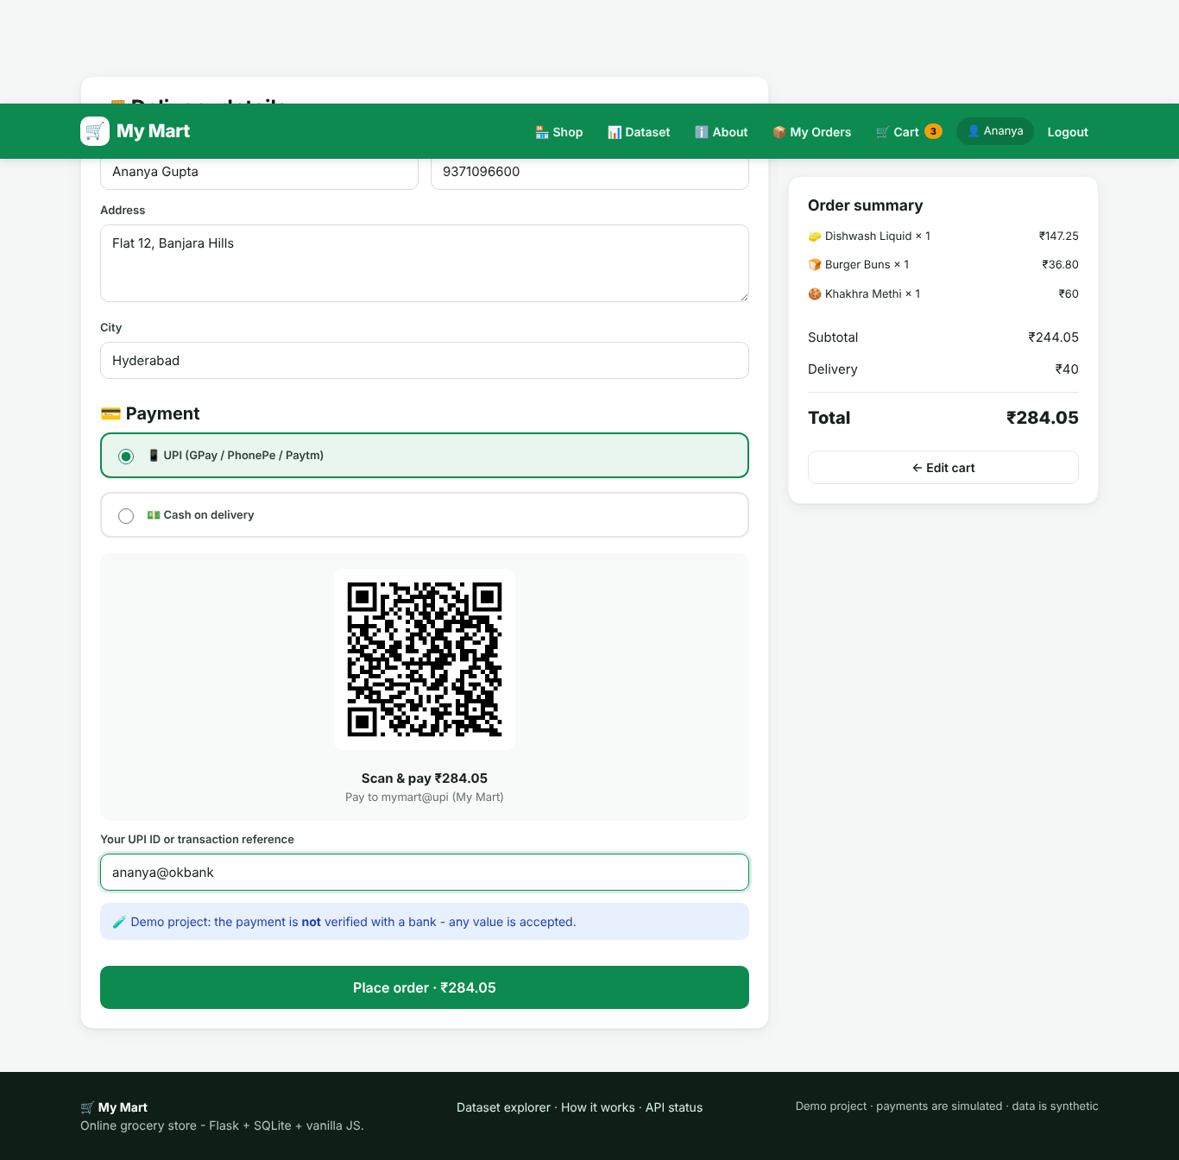
Figure 3 – Checkout with UPI QR code

12.5 Admin – api/admin.py
Every admin route uses @admin_required. The analytics endpoint uses SQL GROUP BY queries written with SQLAlchemy:
📄 backend/app/api/admin.py
month = func.strftime("%Y-%m", Order.created_at)
by_month = (
db.session.query(month.label("month"), func.count(Order.id), func.sum(Order.total))
.filter(NOT_CANCELLED)
.group_by("month")
.order_by("month")
.all()

This means: take every non-cancelled order, group by year-month, and for each month return the number of orders and the sum of totals. That gives the data for the “Revenue by month” chart.
Order status workflow: the admin can only move an order forward, and can cancel only before delivery. This is a simple state machine:
📄 backend/app/api/admin.py
TRANSITIONS = {
"Placed": ["Packed", "Cancelled"],
"Packed": ["Shipped", "Cancelled"],
"Shipped": ["Delivered", "Cancelled"],
"Delivered": [],
"Cancelled": [],
}

12.6 Dataset Explorer – api/dataset.py
DATASETS is a dictionary describing each of the 5 sets: title, summary, purpose, where the app uses it, relationships, business rules, every column (name, type, meaning, example) and example questions. The API combines this description with live data from the database:
- GET /api/dataset: all 5 sets with their explanation plus live statistics (row counts, averages, charts).
- GET /api/dataset/<set>?q=&page=: the actual rows, searchable and paginated.
- GET /api/dataset/<set>/download: a CSV export of the live table.
- GET /api/dataset/<set>/original: the original CSV file from data/.
📄 backend/app/api/dataset.py
def _mask_email(email):
if not email or "@" not in email:
return email
user, domain = email.split("@", 1)
return f"{user[:2]}***@{domain}"

Privacy: even though the data is synthetic, the public explorer masks e-mails (an***@example.com) and never shows phone numbers or password hashes. That's a good habit to build for real projects.

13. Step 11 – Entry Points: run.py and manage.py
📄 run.py
import os

from backend.app import create_app

app = create_app()

if __name__ == "__main__":
host = os.getenv("HOST", "127.0.0.1")
port = int(os.getenv("PORT", 5000))
debug = os.getenv("FLASK_DEBUG", "1") == "1"
print(f"\n MyMart is running -> http://localhost:{port}\n"
f" Admin login: {app.config['ADMIN_EMAIL']} / (see README)\n")
app.run(host=host, port=port, debug=debug)

python run.py builds the app and starts Flask's development server on port 5000. debug=True reloads the server automatically when you save a file and shows detailed errors. Turn it off (FLASK_DEBUG=0) when showing the project to others.
manage.py gives you handy database commands using argparse:
Command | What it does
python manage.py stats | Row count of every table
python manage.py reset-db | Delete everything and reload the CSV dataset (asks for confirmation)
python manage.py seed | Load the CSV files into an empty database
python manage.py create-admin | Create or reset the admin from .env
python manage.py export | Save the live tables (with new orders) to exports/*.csv

14. Step 12 – The Frontend
The frontend is plain HTML, CSS and JavaScript, so there's no build step. Every page has the same skeleton:
Page skeleton
<header id="navbar" class="navbar"></header> <!-- filled by app.js -->
<main> ... page content ... </main>
<footer id="footer"></footer> <!-- filled by app.js -->
<script src="/static/js/app.js"></script> <!-- shared code -->
<script> ... code for this page only ... </script>

14.1 app.js – shared code
The api() helper wraps the browser's fetch() so every page can call the backend in one line:
📄 frontend/js/app.js
async function api(path, { method = "GET", body, raw = false } = {}) {
const opts = { method, headers: {}, credentials: "same-origin" };
if (body !== undefined) {
opts.headers["Content-Type"] = "application/json";
opts.body = JSON.stringify(body);
}
const res = await fetch(path, opts);
if (raw) return res;
let data = {};
try { data = await res.json(); } catch (e) { /* empty body */ }
if (!res.ok) {
const err = new Error(data.error || `Request failed (${res.status})`);
err.status = res.status;
throw err;
}
return data;

- async / await lets the code wait for the server's answer without freezing the page.
- credentials: "same-origin" sends the login cookie with every request.
- If the server returns an error status, api() throws an Error carrying the server's message, so pages can show it with toast(e.message, "error").
The ready promise runs on every page before anything else: it asks the server who is logged in, loads the cart count and draws the navbar.
📄 frontend/js/app.js
const ready = (async () => {
try { MyMart.user = (await api("/api/auth/me")).user; } catch (e) { MyMart.user = null; }
await refreshCartCount();
renderNavbar();
renderFooter();
return MyMart.user;
})();

Each page then starts with ready.then(...), so it already knows the user. For example, the cart page redirects to login if nobody is logged in.
Security: the esc() function. Text from the database is always passed through esc() before it's inserted into HTML. It turns < into &lt; and so on, which stops XSS attacks (someone putting a <script> tag in a product name).
📄 frontend/js/app.js
function esc(s) {
return String(s ?? "").replace(/[&<>"']/g, c => ({ "&": "&amp;", "<": "&lt;", ">": "&gt;", '"': "&quot;", "'": "&#39;" }[c]));

productCard(p) builds the HTML for one product card (emoji picture, discount badge, veg dot, rating, price, MRP and Add button). The shop page, product page and related products all reuse it.

14.2 charts.js – charts without a library
Charts are drawn as SVG (Scalable Vector Graphics): shapes described in text that the browser draws. For example, a bar chart scales each value to a height and creates one <rect> per bar:
📄 frontend/js/charts.js
function barChart(el, data, opts = {}) {
const fmt = _fmt(opts);
const W = 640, H = opts.height || 240, pad = { t: 22, r: 10, b: 46, l: 10 };
const max = Math.max(1, ...data.map(d => d.value));
const bw = (W - pad.l - pad.r) / Math.max(1, data.length);
const bars = data.map((d, i) => {
const h = (d.value / max) * (H - pad.t - pad.b);
const x = pad.l + i * bw + bw * 0.15, y = H - pad.b - h, w = bw * 0.7;
const label = d.label.length > 14 ? d.label.slice(0, 13) + "…" : d.label;

Four chart types are included: barChart, lineChart (revenue by month), donutChart (payment methods, order status) and hbarList (horizontal bars for rankings). They work offline because nothing is downloaded from a CDN.

14.3 style.css – the design
- CSS variables in :root (e.g. --green: #0c8a4f) keep the colours consistent. Change one value and the whole site updates.
- CSS Grid lays out the product grid: repeat(auto-fill, minmax(205px, 1fr)) fits as many cards per row as the screen allows.
- Media queries (@media (max-width: 560px)) switch to a 2-column phone layout and a hamburger menu.
- Small reusable classes: .btn, .card, .status-Delivered, .chip, .table, and so on.

14.4 The pages
Page | URL | What its script does
index.html | / | Loads categories as chips; loads products with search (debounced), sort, veg and in-stock filters and pagination
product.html | /product?id=24 | Reads ?id= from the URL, shows details, quantity stepper, related products
login.html / register.html | /login, /register | Sends the form to /api/auth/... and redirects. Demo-account buttons fill the form.
cart.html | /cart | Shows lines with +/− steppers (PATCH), remove (DELETE), free-delivery progress bar, totals
checkout.html | /checkout | Address form, UPI/COD choice, QR image, POST /api/orders, success screen
orders.html | /orders | Order cards with a status timeline and a Cancel button
admin.html | /admin | Tabs: Overview (KPIs + 8 charts + low stock), Products (table + add/edit modal), Orders (status dropdown), Customers
dataset.html | /dataset | Set cards, ER diagram, and for each set: explanation, stats, chart, column dictionary, searchable rows, CSV downloads
about.html | /about | Architecture diagram, feature lists, tech stack

Example: the shop page waits 300 ms after the last keystroke before searching (debounce), so it doesn't call the server on every letter:
📄 frontend/index.html
$("#q").addEventListener("input", debounce(e => { state.q = e.target.value.trim(); state.page = 1; loadProducts(); }));
$("#sort").onchange = e => { state.sort = e.target.value; state.page = 1; loadProducts(); };
$("#veg").onchange = e => { state.veg = e.target.checked; state.page = 1; loadProducts(); };
$("#instock").onchange = e => { state.instock = e.target.checked; state.page = 1; loadProducts(); };

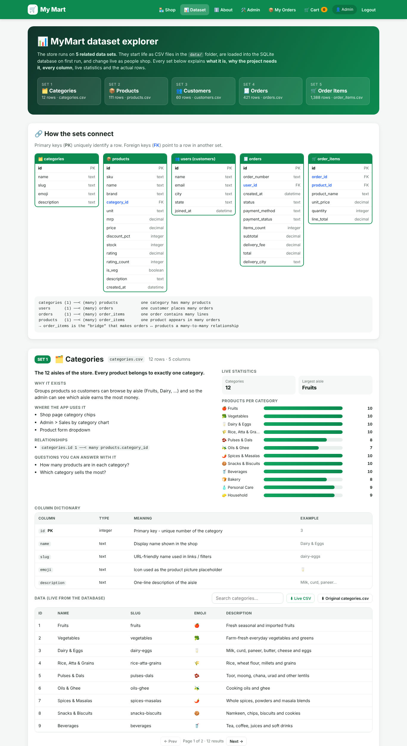
Figure 4 – Dataset Explorer: every set explained with live stats and rows

15. Step 13 – Automated Tests
Tests are small programs that check the app automatically. If a later change breaks something, a test fails and tells you straight away.
📄 backend/tests/test_api.py
class MyMartTestCase(unittest.TestCase):
def setUp(self):
self.app = create_app(TestConfig)
self.client = self.app.test_client()
self.ctx = self.app.app_context()
self.ctx.push()

setUp() runs before every test: it creates a fresh app with an in-memory database loaded with the dataset. self.client is a fake browser that can call the API without starting a server.
📄 backend/tests/test_api.py
def test_full_purchase_reduces_stock(self):
self.login()
product = self.in_stock_product()
stock_before = product.stock

r = self.client.post("/api/cart", json={"product_id": product.id, "quantity": 2})
self.assertEqual(r.status_code, 200)
self.assertEqual(r.json["items_count"], 2)

r = self.client.post("/api/orders", json={
"payment_method": "COD", "delivery_address": "12 MG Road", "delivery_city": "Hyderabad"})
self.assertEqual(r.status_code, 201, r.json)
order = r.json["order"]
self.assertEqual(order["status"], "Placed")
self.assertEqual(order["payment_status"], "Pending")
self.assertAlmostEqual(order["subtotal"], round(product.price * 2, 2))

db.session.refresh(product)
self.assertEqual(product.stock, stock_before - 2)
self.assertEqual(self.client.get("/api/cart").json["items_count"], 0)

# cancelling puts the stock back
r = self.client.post(f"/api/orders/{order['id']}/cancel")
self.assertEqual(r.json["order"]["status"], "Cancelled")
db.session.refresh(product)
self.assertEqual(product.stock, stock_before)

This test acts out a whole purchase: log in, add 2 units, place a COD order, check the totals, check that the stock went down by 2 and the cart is empty, then cancel and check the stock came back.
Test group | What is checked
TestCatalogue | Dataset loaded (12 categories, 111 products), search, filters, sorting, 404
TestAuth | Register → login → logout, duplicate e-mail (409), wrong password (401), cart needs login
TestCartAndCheckout | Full purchase + cancel/restock, stock limit, UPI needs a reference, ₹40 delivery fee, QR PNG
TestAdmin | Customer blocked (403), stats & analytics, product create/update/delete, invalid status move
TestDataset | 5 sets listed, phone hidden + email masked, CSV download

Run the tests
python -m unittest discover -s backend/tests -t . -v
...
Ran 19 tests in 9.7s
OK

16. Step 14 – Run the Project Locally

16.1 Easiest way (Windows)
- Open the MyMart folder.
- Double-click start.bat. It creates the venv, installs the libraries and starts the server.
- Open http://localhost:5000 in your browser.

16.2 Manual way
Command Prompt
cd C:\Users\ramks\OneDrive\Desktop\My_Projects\MyMart
python -m venv venv
venv\Scripts\activate
pip install -r requirements.txt
python run.py

First-run output:
* First run: loading the sample dataset from data/*.csv ...
Seeded: 12 categories, 111 products, 61 users, 420 orders, 1385 order items

MyMart is running -> http://localhost:5000

16.3 Logins
Role | Email | Password
Admin | admin@mymart.com | Admin@123
Customer | ananya.gupta1@example.com | Customer@123
Any demo customer | see data/customers.csv | Customer@123

16.4 Things to try
- Search “milk”, click a category chip, tick “Veg only”, sort by “Biggest discount”.
- Log in as the customer, add items, open the cart and watch the free-delivery bar.
- Check out with UPI (type any reference), then open My Orders.
- Log out, log in as admin, and look at the charts. Move your order to Packed → Shipped → Delivered.
- Add a new product, then find it in the shop.
- Open the Dataset page, search the orders set and download a CSV.

16.5 Troubleshooting
Problem | Fix
'python' is not recognized | Use py instead, or reinstall Python with “Add to PATH” ticked
PowerShell blocks venv activation | Run Set-ExecutionPolicy -Scope CurrentUser RemoteSigned or use Command Prompt
ModuleNotFoundError | Activate the venv, then pip install -r requirements.txt
Port 5000 in use | set PORT=5001 then python run.py
Want fresh data | python manage.py reset-db

17. Step 15 – Document and Publish on GitHub

17.1 Documentation files
File | Purpose
README.md | Front page of the repo: features, setup, libraries, dataset set by set, ER diagram, API table, screenshots
data/README.md | Data card: how the data was generated, every column, statistics, limitations
docs/API.md | Every endpoint with request/response examples
docs/DATABASE.md | Tables, constraints, design decisions, handy SQL queries
docs/UPGRADE_NOTES.md | What was fixed and added compared with version 1
LICENSE | MIT licence: others may use the code with credit
.gitignore | Keeps venv/, .env, the database file and __pycache__ out of Git

17.2 Create the repository
- On github.com click New repository, name it MyMart, choose Public, and do not add a README (we already have one).
- Open a terminal in the MyMart folder and run the commands below.
Terminal
git init
git add .
git commit -m "My Mart: full-stack grocery store with dataset explorer"
git branch -M main
git remote add origin https://github.com/<your-username>/MyMart.git
git push -u origin main

Refresh the GitHub page. The README with screenshots appears on the front page, and clicking any file in data/ shows the CSV as a searchable table.
💡 Tip: Before pushing, set your own MERCHANT_UPI_ID and a new ADMIN_PASSWORD in .env. The .env file is never uploaded, but the default password Admin@123 is written in the public README.

17.3 Make the repo look professional
- Add a short description and topics (flask, python, sqlite, ecommerce, rest-api, dataset) in the repo's About box.
- Pin the repository on your GitHub profile.
- Keep committing small changes with clear messages, e.g. “Add wishlist feature”.

18. Key Concepts Glossary
Concept | Simple explanation
Frontend / Backend | Frontend = what runs in the browser. Backend = the server program and database.
REST API | A set of URLs that return data (JSON) for each action: GET, POST, PUT, PATCH, DELETE.
JSON | Text format for data: {"name": "Milk", "price": 56}
Blueprint | A Flask group of related routes with a common URL prefix.
ORM | Object-Relational Mapper: Python classes ↔ database tables (SQLAlchemy).
Primary / Foreign key | PK uniquely identifies a row; FK points to a row in another table.
Transaction | Several database changes that succeed or fail together (commit / rollback).
Password hashing | One-way scrambling of passwords; the real password is never stored.
Session cookie | Small signed token the browser sends to prove who is logged in.
Decorator | @something above a function that adds behaviour (e.g. @login_required).
Soft delete | Hide a row with a flag (is_active=False) instead of deleting it.
Snapshot | Copying a value (price, name) at the moment of purchase.
Pagination | Returning data page by page instead of all at once.
State machine | Allowed moves between statuses (Placed → Packed → Shipped → Delivered).
Debounce | Waiting until the user stops typing before running a search.
XSS | Cross-site scripting; prevented by escaping text with esc().
Seed (data) | Initial data loaded into a new database.
Random seed | Fixed starting number that makes ‘random’ output repeatable.

19. Viva / Interview Questions with Answers
Q1. Why did you separate frontend and backend?
So each part has one job. The backend exposes a REST API, and any frontend (web, mobile app) could use it. It's also easier to test the API on its own.
Q2. Why SQLite?
It needs no server or installation; the database is one file. Because we use SQLAlchemy, switching to PostgreSQL or MySQL only needs a different DATABASE_URL.
Q3. How are passwords stored?
As salted hashes created by Werkzeug's generate_password_hash. At login we compare hashes with check_password_hash. The plain password is never saved.
Q4. What stops a customer opening the admin page?
The @admin_required decorator on every admin API route returns 403 unless current_user.role is 'admin'. Hiding the page in the browser alone wouldn't be secure, which is why the check is on the server.
Q5. How do you prevent selling more than the available stock?
Stock is checked when adding to the cart, and again at checkout inside the same transaction that reduces it. The database also has a CHECK (stock >= 0) constraint.
Q6. Why store product_name and unit_price in order_items?
They are snapshots. If a price changes later, old orders still show what the customer actually paid.
Q7. Why soft-delete products?
Old orders reference them. Hiding with is_active=False keeps history intact.
Q8. What is the relationship between orders and products?
Many-to-many. One order has many products and one product is in many orders. The order_items table is the bridge.
Q9. How is the dataset generated, and why a fixed seed?
generate_dataset.py uses random.Random(42) with business rules (delivery fee, status, payment). The fixed seed makes the output identical every time, so results are reproducible.
Q10. How did you test the project?
19 unittest tests use an in-memory database and Flask's test client to cover auth, catalogue, cart, checkout, cancel/restock, admin permissions and the dataset API.
Q11. Is the UPI payment real?
The QR code is a real UPI link, but the payment is not verified. A production app would integrate a payment gateway and confirm payment through a webhook.

20. Ideas to Extend the Project
- Product images upload (store files in frontend/uploads/).
- Wishlist and product reviews (a new reviews table linked to users and products).
- Coupons and discount codes at checkout.
- Real payment gateway (Razorpay / Cashfree test mode) with webhook verification.
- E-mail order confirmation with Flask-Mail.
- Password reset by e-mail.
- Deploy online (Render, Railway or PythonAnywhere) with PostgreSQL.
- A React or mobile frontend using the same REST API.
- Sales forecasting with pandas on the orders dataset.

Summary of the build
Step | What you built
1–3 | Tools, folder structure, virtual environment, libraries
4 | Reproducible 5-set dataset generator
5–6 | Configuration and the Flask app factory
7–9 | Database models, CSV seeding, helper utilities
10–11 | REST API (auth, products, cart, orders, admin, dataset) and entry points
12 | Frontend pages, shared JavaScript, SVG charts and styling
13 | 19 automated tests
14–15 | Running on localhost, documentation, publishing to GitHub

🎉 Congratulations, you've built a full-stack web application!

