LUMINA
Local Document AI
Step-by-step guide to building, running and publishing the project
This guide explains, step by step, how the project is created from an empty folder: which tools to install, which libraries are used and why, what every part of the backend and frontend does, how the animated interface works, how to run and test it, and how to publish it safely on GitHub.

Project | Lumina – private, local document summarizer and chat (formerly local-pdf-llm-summarizer)
Version | 6.0.0
Stack | Python 3.10+ · FastAPI · SQLite · NumPy · React 19 · Vite 7 · Ollama
Platforms | Windows 10/11, macOS, Linux
Updated | October 2026

Contents

If the page numbers are missing, right-click the table of contents in Word and choose Update Field.

1. What you are building
Lumina is a web application that runs completely on your own computer. You upload documents, the backend extracts their text, splits it into passages and builds a search index. When you ask a question, the most relevant passages are found and sent to a local AI model, which writes an answer that cites its sources. Nothing is uploaded to the internet.

1.1 Main features
- Chat with one or many documents at once, with numbered, clickable source passages.
- Streaming answers (words appear while the model writes) and a Stop button.
- 8 answer styles: Balanced, Concise, Detailed, Bullet points, Explain simply, Study notes, Table/compare, With exact quotes.
- Answers in 14 languages (English, Hindi, Tamil, Telugu, Kannada, Malayalam, Marathi, Bengali, Spanish, French, German, Arabic, Chinese, Japanese).
- Summaries and study tools: Overview, TL;DR, Section by section, Study notes, Quiz, Key terms, Action items, FAQ.
- 40+ file types: PDF, Word, PowerPoint, Excel, CSV, text, Markdown, JSON, XML, YAML, HTML, source code, and images/scanned pages via OCR.
- Instant answers for repeated questions (answer cache), suggested questions, chat history with export.
- Clean chat interface in white and black with one indigo accent, serif answers that flow onto the screen smoothly, an animated Lumina mark while it thinks, collapsible sidebar, light and dark themes.
- Works with Ollama, or with LM Studio / llama.cpp / vLLM through the OpenAI-compatible API.
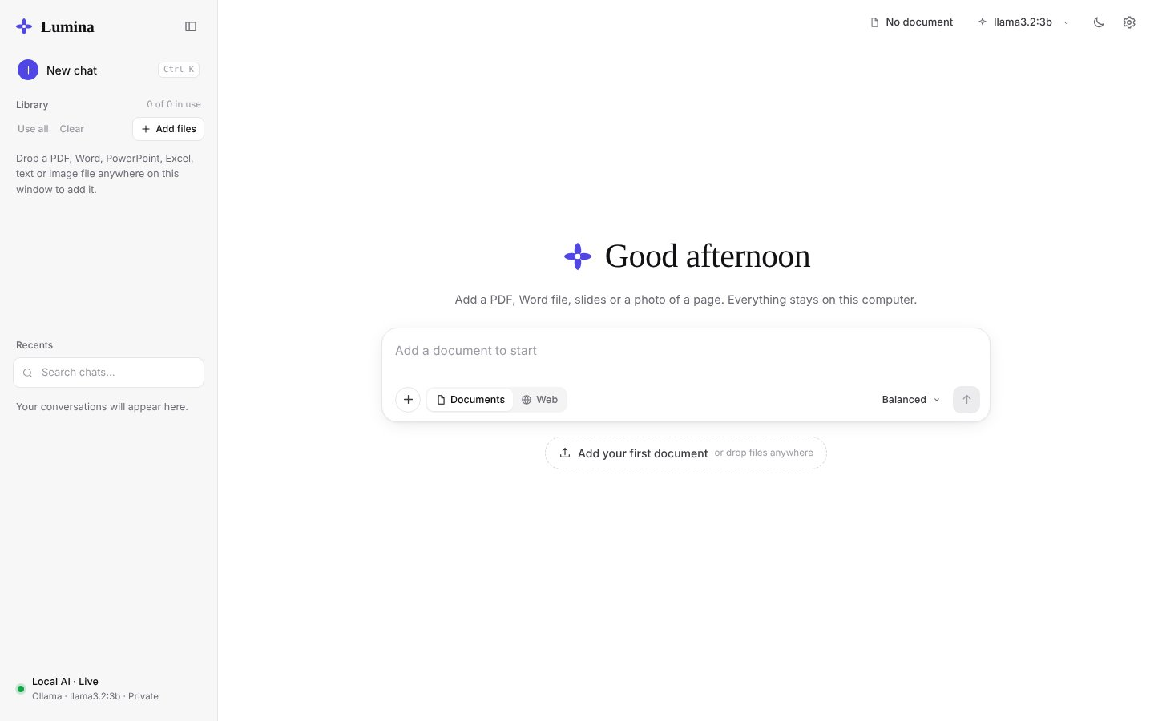
Figure 1 – The welcome screen with the animated background

1.2 Architecture
Data flow
Browser (React + Vite, port 5173)
| /api/* requests (Vite forwards them to the backend)
v
FastAPI backend (port 5001) ---------> SQLite database storage/app.db
| 1. extract text (PDF, Office, OCR ...)
| 2. split text into chunks
| 3. embed chunks --------------> storage/rag/<id>.npy (vector index)
v
Ollama (port 11434) - chat model (llama3.2:3b) + embedding model (embeddinggemma)
This pattern is called RAG – Retrieval-Augmented Generation: instead of giving the whole document to the model (slow, and often too long), only the best matching passages are retrieved and given to the model as context.

2. Install the tools
Install these programs once. The commands in the right column check that each one works – open a new terminal after installing so the PATH is refreshed.
Tool | Version | Where to get it | Check with
Python | 3.10+ (3.12 recommended) | python.org/downloads – on Windows tick Add python.exe to PATH | python --version
Node.js + npm | 20 or newer (LTS) | nodejs.org | node --version
Ollama | latest | ollama.com/download | ollama --version
Git | any | git-scm.com/downloads | git --version
VS Code (editor) | any | code.visualstudio.com | –
Tesseract OCR (optional) | 5.x | Windows: UB-Mannheim installer · macOS: brew install tesseract · Linux: sudo apt install tesseract-ocr | tesseract --version
Tip: 8 GB of RAM is enough for the default model llama3.2:3b. A graphics card (GPU) makes answers much faster but is not required.
Important: On Windows, if PowerShell refuses to run scripts ("Activate.ps1 cannot be loaded"), run this once: Set-ExecutionPolicy -Scope CurrentUser RemoteSigned

3. Step 1 – Create the project folder
- Create a folder and open it in VS Code: mkdir lumina then cd lumina then code .
- Start a Git repository: git init
- Create the folder structure shown below (empty folders are fine for now).
Project layout
lumina/
├── backend/
│ ├── app/
│ │ ├── main.py API routes and streaming
│ │ ├── core/config.py settings read from .env
│ │ ├── core/security.py safe file names, PDF signature check
│ │ ├── db/database.py SQLite engine
│ │ ├── models/ Document, DocumentChunk, ChatSession, ChatMessage
│ │ └── services/
│ │ ├── extraction/ pdf.py, office.py, spreadsheet.py, text.py, image.py, extractor.py
│ │ ├── chunking.py, indexer.py
│ │ ├── llm.py talks to Ollama / OpenAI-compatible servers
│ │ ├── rag_service.py embeddings + hybrid search
│ │ ├── answer_cache.py instant repeated answers
│ │ ├── suggest.py instant suggested questions (no AI call)
│ │ ├── summary.py, chat.py, web_research.py
│ ├── tests/
│ ├── requirements.txt
│ └── requirements-dev.txt
├── frontend/ React app (created in Step 11)
├── scripts/ setup / start / reindex / secret scan
├── docs/
├── storage/ your data (never committed)
├── .env.example
└── .gitignore
Every Python folder inside backend needs an empty __init__.py file so Python treats it as a package (for example backend/__init__.py, backend/app/models/__init__.py).

4. Step 2 – Python environment and backend libraries

4.1 Create and activate a virtual environment
A virtual environment keeps this project's libraries separate from the rest of your computer.
Windows (PowerShell)
python -m venv .venv
.\.venv\Scripts\Activate.ps1
python -m pip install --upgrade pip
macOS / Linux
python3 -m venv .venv
source .venv/bin/activate
python -m pip install --upgrade pip
When it is active, your prompt starts with (.venv).

4.2 requirements.txt
backend/requirements.txt
# ---- Web API ----
fastapi>=0.115,<1.0
uvicorn[standard]>=0.30
python-multipart>=0.0.9
pydantic-settings>=2.4
SQLAlchemy>=2.0.30
httpx>=0.27

# ---- Document extraction ----
PyMuPDF>=1.24 # PDF text + page rendering
python-docx>=1.1 # .docx
python-pptx>=1.0 # .pptx
openpyxl>=3.1 # .xlsx
xlrd>=2.0 # .xls
beautifulsoup4>=4.12 # .html / .htm

# ---- OCR (scanned PDFs and images) ----
pytesseract>=0.3.10
Pillow>=10.0

# ---- Retrieval ----
numpy>=1.26
Install everything with:
python -m pip install -r backend/requirements.txt

4.3 What each library does
Library | Purpose in Lumina
FastAPI | Defines the REST API (upload, ask, summarize, chats) and validates requests.
Uvicorn | The web server that runs the FastAPI app.
python-multipart | Lets FastAPI receive uploaded files.
pydantic-settings | Reads every setting from the .env file into a typed Settings object.
SQLAlchemy | Talks to the SQLite database (documents, chunks, chats).
httpx | Async HTTP client used to call Ollama and the web-search APIs; supports streaming.
PyMuPDF | Reads PDF text and renders pages to images for OCR (pypdfium2 / pypdf are automatic fallbacks).
python-docx / python-pptx | Read Word and PowerPoint files.
openpyxl / xlrd | Read Excel .xlsx and old .xls files.
beautifulsoup4 | Strips tags from HTML files.
pytesseract + Pillow | Run Tesseract OCR on scanned pages and photos.
NumPy | Stores embedding vectors and computes similarity with one matrix multiplication.
pytest, ruff, pip-audit (dev) | Tests, linting and a security audit of dependencies (requirements-dev.txt).

5. Step 3 – Configuration with .env
All settings live in backend/app/core/config.py as a Settings class. Each attribute can be overridden in a .env file in the project root. The real .env is never committed; instead you commit .env.example with safe defaults.
backend/app/core/config.py (shortened)
class Settings(BaseSettings):
app_name: str = "Lumina"
app_version: str = "6.1.0"
port: int = 5001

database_url: str = "sqlite:///./storage/app.db"
upload_dir: str = "storage/uploads"
max_file_size_mb: int = 25

llm_provider: str = "ollama" # or "openai" (LM Studio, llama.cpp ...)
ollama_base_url: str = "http://127.0.0.1:11434"
ollama_model: str = "llama3.2:3b"
llm_num_ctx: int = 4096 # smaller = faster on CPU
llm_keep_alive: str = "30m" # keep the model loaded
llm_timeout: int = 600 # seconds, counted only once the model starts
llm_max_parallel: int = 1 # one request on the model at a time (CPU)
adaptive_speed: bool = True # focus the reading on a slow computer
read_target_seconds: int = 15 # first words in about 15 s (answers keep full length)
answer_hard_limit_seconds: int = 0 # optional cap on writing time, 0 = never

rag_embedding_model: str = "embeddinggemma"
rag_top_k: int = 5
rag_max_context_chars: int = 5000 # smaller = first word appears sooner
chunk_size: int = 1400
chunk_overlap: int = 200

answer_cache_enabled: bool = True
llm_suggestions: bool = False # False = instant suggestions from key terms
google_api_key: str = "" # optional, keep real keys ONLY in .env

model_config = SettingsConfigDict(env_file=".env", extra="ignore")
Create your own copy:
Copy-Item .env.example .env # Windows
cp .env.example .env # macOS / Linux
Important: Put API keys and personal paths only in .env. The .gitignore file (Step 15) makes sure it never reaches GitHub.

6. Step 4 – Database and models
backend/app/db/database.py creates a SQLAlchemy engine for SQLite and switches on WAL mode, which lets the interface read while background jobs write – this prevents "database is locked" errors.
WAL mode
@event.listens_for(engine, "connect")
def _sqlite_pragmas(dbapi_connection, _record):
cursor = dbapi_connection.cursor()
cursor.execute("PRAGMA journal_mode=WAL")
cursor.execute("PRAGMA synchronous=NORMAL")
cursor.execute("PRAGMA foreign_keys=ON")
cursor.close()
Four tables (models) are defined in backend/app/models/:
Model / table | Stores
Document (documents) | file name, stored UUID name, type, size, status/stage, page count, OCR flag, extracted text, saved summary
DocumentChunk (document_chunks) | document id, chunk number, chunk text
ChatSession (chat_sessions) | title, the list of document ids used in the chat, timestamps
ChatMessage (chat_messages) | chat id, role (user/assistant), content, sources (JSON)
init_db() is called when the server starts and creates the tables automatically.

7. Step 5 – Extracting text from files
extraction/extractor.py looks at the file extension and calls the right extractor. Every extractor returns the text, the page count and whether OCR was used. Extraction runs in a background thread (asyncio.to_thread) so the API stays responsive.
File types | Extractor | How
.pdf | pdf.py | PyMuPDF reads native text page by page; pages with little text are rendered and OCR'd in parallel.
.docx / .pptx | office.py | python-docx paragraphs + tables; python-pptx slide text.
.xlsx / .xls / .csv | spreadsheet.py | Rows become Header: value lines per sheet.
.txt .md .json .xml .yaml .html, code | text.py | Tries several encodings; JSON/XML/HTML are flattened to readable text.
.png .jpg .tiff .webp … | image.py | Image is cleaned up with Pillow and read by Tesseract.

7.1 PDF engines with automatic fallback
PyMuPDF is the fastest engine. If it cannot be installed (for example on a brand-new Python version), Lumina automatically uses pypdfium2 or pypdf instead:
backend/app/services/extraction/pdf.py
def _open(path: Path) -> _Pdf:
if pymupdf is not None:
return _MuPdf(path)
if pypdfium2 is not None:
return _Pdfium(path)
if pypdf is not None:
return _PyPdf(path)
raise RuntimeError("No PDF library installed. Run: pip install pymupdf")

7.2 OCR for scanned pages
Pages with fewer than OCR_MIN_CHARS characters are rendered at OCR_DPI and recognised by Tesseract in a thread pool (OCR_WORKERS, default 4). Pages are processed in small batches, so memory use stays low even for long scans.
Tip: On Windows set TESSERACT_CMD=C:\Program Files\Tesseract-OCR\tesseract.exe in .env after installing Tesseract.

8. Step 6 – Splitting text into chunks
Long documents are split into overlapping passages ("chunks") of about CHUNK_SIZE characters (default 1400) with CHUNK_OVERLAP characters (200) shared between neighbours, so a sentence cut at a border still appears whole in one chunk. chunking.py prefers to split at paragraph and sentence boundaries. indexer.py saves the chunks to the document_chunks table.
Smaller chunks give sharper search results and shorter prompts, which makes answers faster on a CPU.

9. Step 7 – Talking to the local AI model
services/llm.py contains the client for Ollama. It uses one shared, pooled httpx.AsyncClient, so no new connection is opened per question. The model is loaded when the server starts (warm-up) and kept in memory with keep_alive, so even the first answer starts quickly.
Streaming from Ollama (simplified)
payload = {
"model": "llama3.2:3b",
"system": system_prompt, # rules + answer style + language
"prompt": "DOCUMENT CONTEXT: ... QUESTION: ... ANSWER:",
"stream": True, # tokens arrive one by one
"keep_alive": "30m",
"options": {"temperature": 0.15, "num_predict": 420, "num_ctx": 4096},
}
async with client.stream("POST", "/api/generate", json=payload) as response:
async for line in response.aiter_lines():
token = json.loads(line).get("response", "")
yield token

9.1 Answer styles and languages
Each answer style has its own instruction and a maximum number of tokens. Shorter styles finish faster. The default Balanced style gives a direct answer plus key bullet points (at most 420 tokens). A language instruction is added when the user picks a language in Settings.

9.2 Prompt-injection safety
The system prompt tells the model to use only the supplied context and to treat it as data – it must never follow instructions written inside a document.

9.3 OpenAI-compatible servers
With LLM_PROVIDER=openai the same functions call /v1/chat/completions instead, so LM Studio, llama.cpp's llama-server, vLLM, Jan or LocalAI can be used without changing anything else.

9.4 One request at a time – your question first
On a laptop without a graphics card the model can only work on one request at a time. If several requests arrive together (an answer, a summary and background work), Ollama queues them, and every queued request's timeout keeps running – this is what produced the error "Local Ollama streaming request failed" in early versions. Lumina therefore keeps its own small queue, called the model slot:
- Every call to the model first enters model_slot(). Only LLM_MAX_PARALLEL requests (default 1) may hold the slot at the same time.
- Requests the user is waiting for (answers, summaries) are interactive; nice-to-have work is background and waits until no interactive request is queued.
- The HTTP timeout only starts when a request actually reaches the model, so waiting in the queue can never cause a timeout. LLM_TIMEOUT is 600 seconds for slow PCs.
- Timeout and connection errors are turned into a clear message ("The AI model did not answer within … – try a smaller model") instead of a stack trace.
backend/app/services/llm.py (model slot)
@asynccontextmanager
async def model_slot(priority="interactive"):
slot = _get_slot() # asyncio.Semaphore(LLM_MAX_PARALLEL)
if priority == "background":
while _interactive_waiting > 0 or slot.locked():
await asyncio.sleep(0.25) # let questions go first
await slot.acquire()
else:
_interactive_waiting += 1
try:
await slot.acquire()
finally:
_interactive_waiting -= 1
try:
yield
finally:
slot.release()

async def generate_stream(prompt, ..., priority="interactive"):
async with model_slot(priority): # held for the whole answer
async for token in _ollama_stream(prompt, ...):
yield token

9.5 Faster answers that stay complete
On a CPU an answer takes two kinds of time: reading (the model must read every word of the prompt before it writes the first word) and writing (word by word, a few words per second on a laptop). Shortening the answer would save time but lose information, so Lumina never does that – answers always get their full length. Instead it speeds up everything around the writing:
- Measure the computer. At start-up measure_speed() sends a tiny test prompt; Ollama's reply contains prompt_eval_count/prompt_eval_duration (reading speed) and eval_count/eval_duration (writing speed). The profile is updated after every answer.
- Read less, but read the right things. answer_budget() works out how much text the model can read in about READ_TARGET_SECONDS (15 s). When the passages are longer than that, focus_text() keeps only the sentences that share words with the question (plus the sentence that follows a match, so explanations are not cut in half) – the facts stay, the filler goes.
- No padding. The system prompt asks for the complete answer with every relevant detail but no preamble, no restating of the question, no repeated points and no generic closing – every written word carries information.
- Answer first. Only one request reaches the model at a time and questions go before background work (Step 7.4); background indexing pauses while an answer is written; the model stays loaded for 2 hours (LLM_KEEP_ALIVE).
- Show progress. While the model reads, the answer shows "first words in about 12 s" counting down; then the words flow onto the screen as they are written.
- Tell the user the real fix. Writing speed depends on the processor and the model size. If a full answer would take longer than a minute, a tip shows the measured words per second and offers a one-click switch to a smaller installed model (llama3.2:1b writes 2–3× faster).
backend/app/services/llm.py and rag_service.py (simplified)
def answer_budget(model, style_max_tokens):
sp = speed_of(model) # measured tokens per second
tokens = style_max_tokens # the answer is never shortened
read_tokens = sp.prompt_tps * READ_TARGET_SECONDS - overhead
context_chars = clamp(read_tokens * 3.6, 1800, RAG_MAX_CONTEXT_CHARS)
return {"max_tokens": tokens, "context_chars": context_chars}

# when passages must be shortened, keep the sentences that match the question
text = focus_text(chunk_text, question_words, limit=share_of_budget)

10. Step 8 – Semantic search (RAG)
- As soon as a document is chunked it is marked ready – questions work immediately with keyword (BM25) search. This takes seconds, even for several files at once.
- Then a background task sends every chunk to the embedding model (embeddinggemma) in small batches of 4. Each chunk becomes a vector of numbers that represents its meaning. Only one document at a time is embedded, so the first file gets smart search first instead of all files sharing a slow CPU.
- While an answer or summary is being written the background task pauses (answer_priority()), so the AI model gets the full CPU. If the file is deleted, the task stops and its files are removed.
- The vectors are normalised and saved as a NumPy matrix in storage/rag/<document-id>.npy, plus the chunk texts in a .json file. Loaded indexes are cached in RAM.
- When a question arrives and at least one selected file has vectors, the question is embedded at the same time as the indexes are loaded, so the two waits overlap. Files without vectors yet simply use keyword search.
- A hybrid score is calculated for every chunk: 0.8 × cosine similarity + 0.2 × BM25 keyword score. Cosine similarity is a single matrix multiplication: scores = matrix @ question_vector.
- The best chunks (top-k) are combined into the context, making sure every selected document contributes at least its best passage, within RAG_MAX_CONTEXT_CHARS.
- If the embedding model is missing, Lumina falls back to keyword search automatically and only retries every 5 minutes, so questions are never slowed down by repeated failures.

10.1 Questions about the whole document
Search returns the few passages that best match the words of a question. That is perfect for "What is the CIA triad?" but wrong for "give a summary of this ppt", which needs the whole file. wants_overview() recognises such questions (summary, overview, key points, main ideas, TL;DR, outline, "what is this document about") and overview_context() then takes evenly spaced chunks from the beginning to the end of every selected document.

10.2 Instant suggested questions
The suggested questions under the title used to be written by the AI model. On a CPU-only PC that took one to two minutes and – worse – sat in front of the user's real question. services/suggest.py now builds them in a few milliseconds without any model call:
- Find key terms: repeated capitalised phrases ("Calvin cycle"), acronyms ("DoS", "NADPH") and frequent long technical words. Common words, verbs and words that only start a sentence are ignored.
- Fill the best terms into templates: "What is … and why does it matter?", "Explain … in simple words", "Summarize the key points of <file name>", "Make 5 exam questions from this material" (and "Compare the main ideas …" when several files are selected).
- Cache the result per selection. Set LLM_SUGGESTIONS=true if you prefer AI-written suggestions; they then run at background priority.

11. Step 9 – Summaries and the answer cache

11.1 Summaries that cover the whole document
Instead of summarising only the first pages, summary.py picks evenly spaced excerpts from the beginning, middle and end of the document and asks the model for one summary in a single call. summary_budget() sizes the excerpts so that the prompt plus the summary always fit into LLM_NUM_CTX – otherwise Ollama would silently drop the start of the prompt. Eight summary types are available: Overview, TL;DR, Section by section, Study notes, Quiz, Key terms (glossary table), Action items and FAQ.

11.2 Instant repeated answers
answer_cache.py keeps up to 300 recent answers in memory (an LRU cache). The key is a SHA-256 hash of the normalised question, the selected documents, style, model, language and chat history. Asking the same thing again returns the answer instantly – no model call. The cache entries of a document are removed when it is deleted or re-processed, so old answers are never shown.

12. Step 10 – The FastAPI backend and streaming
backend/app/main.py creates the FastAPI app, adds CORS and security headers, starts the model warm-up on startup and defines the routes.
Method | Endpoint | Purpose
POST | /api/documents/upload | Upload a file (size, type and PDF-signature checks), processing starts in the background
GET | /api/documents | List documents with status and progress
POST | /api/documents/{id}/summary/stream | Stream a summary
POST | /api/chats | Create a chat for the selected documents
POST | /api/chats/{id}/messages/stream | Ask a question and stream the answer
POST | /api/suggestions | Suggested questions for the selected documents
POST | /api/research/stream | Web research answer (optional)
GET | /api/health, /api/config, /api/models | Status, settings and installed models

12.1 Server-Sent Events
Answers are streamed with Server-Sent Events. The browser receives a sequence of small JSON messages:
SSE stream
data: {"type": "start", "model": "llama3.2:3b", "style": "balanced"}
data: {"type": "sources", "sources": [{"rank": 1, "filename": "Unit-2.pdf", ...}]}
data: {"type": "token", "content": "Photo"}
data: {"type": "token", "content": "synthesis"}
...
data: {"type": "done", "stats": {"first_token_ms": 412, "total_ms": 2300}}

12.2 Start the backend
python -m uvicorn backend.app.main:app --port 5001
Tip: While you change the Python code, add --reload --reload-dir backend so the server restarts on every save. Avoid plain --reload: it also watches frontend/node_modules and restarts in the middle of processing a file.
Open http://127.0.0.1:5001/docs to try every endpoint in the browser.

13. Step 11 – The React frontend

13.1 Create the Vite project
Terminal
npm create vite@latest frontend -- --template react
cd frontend
npm install
npm install @fontsource/inter @fontsource/source-serif-4 @fontsource/jetbrains-mono
The fonts are installed as npm packages, so they are bundled with the app – the interface never contacts Google Fonts and works offline.

13.2 Forward /api to the backend
frontend/vite.config.js
export default defineConfig({
plugins: [react()],
server: {
host: "127.0.0.1",
port: 5173,
proxy: { "/api": { target: "http://127.0.0.1:5001", changeOrigin: true } },
},
});

13.3 Components
File | Responsibility
App.jsx | Application state: documents, chats, settings; uploading; streaming answers
api.js | fetch helper, upload with progress (XMLHttpRequest), SSE stream reader
components/Mark.jsx | Lumina's four-petal mark; turns and breathes while Lumina thinks or writes
components/Sidebar.jsx | Library with checkboxes and progress bars, chat history, engine status
components/Welcome.jsx | Greeting, the centred message box, file chips with progress, suggested questions
components/Composer.jsx | Rounded message box: + (add files), Documents/Web switch, answer style, send/stop
components/Message.jsx | Your message bubble; the answer with smooth streaming, sources, copy / regenerate / export / quiz
components/DocDrawer.jsx | Summary types, streaming summary, extracted text
components/Markdown.jsx | Safe Markdown renderer (builds React elements, never innerHTML)
styles.css | Design tokens, dark + light theme, all animations

13.4 Reading the stream in the browser
streamSSE() in api.js reads the response body with a ReadableStream reader, splits it at blank lines and passes every JSON event to the app. Tokens are collected and the screen is updated once per animation frame (requestAnimationFrame), which keeps scrolling smooth even with fast models.
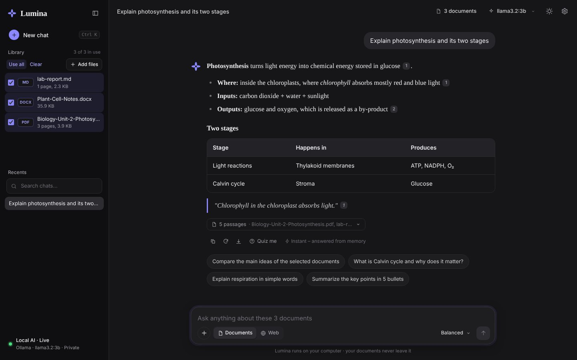
Figure 2 – An answer across three documents with numbered sources

14. Step 12 – The chat interface design
The interface follows the calm layout people know from modern AI chat apps: a narrow sidebar, one centred column for the conversation, a big rounded message box and plenty of white space. It uses only white and black plus one accent colour (indigo), so the answer itself is always the most important thing on the screen.

14.1 Colour and type tokens
Token | Light | Dark | Used for
--bg / --side | #ffffff / #f7f7f8 | #161618 / #0f0f11 | page and sidebar
--tx / --mut | #111113 / #6b6b73 | #ededef / #9d9da6 | text / secondary text
--acc | #4f46e5 (indigo) | #8b87ff | send button, New chat, mark, selected files, focus ring
--user-bubble | #f1f1f3 | #26262b | your messages
Fonts | Inter (interface), Source Serif 4 (answers, greeting), JetBrains Mono (code)
Every colour is a CSS variable; the dark theme simply redefines them under :root[data-theme="dark"].

14.2 Layout
- Sidebar – the Lumina mark, a *New chat* button, the document *Library* with tick boxes, *Recents* with search, and the engine status. It can be hidden with the panel button.
- Empty chat – a time-based greeting ("Good afternoon") in serif type, the message box in the middle of the screen, then your files as small chips and four suggested questions.
- Conversation – your message in a light grey bubble on the right; Lumina's answer without a bubble in serif type, next to the mark, with a collapsible list of sources, small icon actions and the timing.
- Message box – a rounded card: + to add files, a Documents / Web switch, the answer style and a round send button. It moves to the bottom once the chat starts.

14.3 The answer animation
- Thinking – the mark turns and breathes (@keyframes spin + breathe), and the status text ("Reading 5 passages") has a moving shimmer made with a gradient clipped to the text.
- Smooth text – words arrive from the model in bursts. useSmoothText() reveals them at an even pace with requestAnimationFrame and always catches up within a few frames, so the text flows instead of jumping.
- Blocks fade in – each new paragraph, list item or table row fades and rises in (@keyframes blockIn with a tiny blur). Existing blocks keep their React keys, so only the new ones animate.
- Writing indicator – a small indigo dot pulses at the end of the answer until it is complete; then the actions fade in.
frontend/src/components/Message.jsx
function useSmoothText(target, active) {
const [shown, setShown] = useState(active ? 0 : target.length);
const pos = useRef(shown);
useEffect(() => {
if (!active) { pos.current = target.length; setShown(target.length); return; }
let raf = 0;
const tick = () => {
if (pos.current < target.length) {
// move 1/6 of the remaining distance per frame -> smooth but never far behind
pos.current = Math.min(target.length, pos.current + Math.max(1, Math.ceil((target.length - pos.current) / 6)));
setShown(pos.current);
raf = requestAnimationFrame(tick);
}
};
raf = requestAnimationFrame(tick);
return () => cancelAnimationFrame(raf);
}, [target, active]);
return target.slice(0, shown);
}
frontend/src/styles.css
.msg.ai.is-streaming .md > *,
.msg.ai.is-streaming .md li { animation: blockIn .45s cubic-bezier(.22,1,.36,1) both; }
@keyframes blockIn { from { opacity: 0; transform: translateY(4px); filter: blur(2px); } }

.mark.is-active .mark-petals { animation: spin 2.4s linear infinite; }
.mark.is-active svg { animation: breathe 1.6s ease-in-out infinite; }
All animation stops when the operating system's *reduce motion* setting is on, or with ⚙ Settings → Animations.
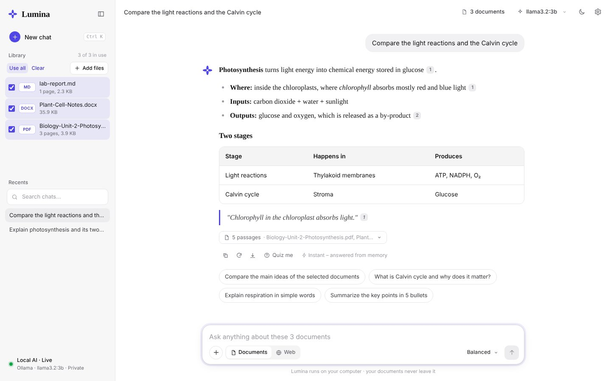
Figure 3 – An answer in the light theme

15. Step 13 – Download the models and run the app

15.1 Download the AI models (once)
ollama pull llama3.2:3b # chat model, about 2 GB (slow laptop: llama3.2:1b)
ollama pull embeddinggemma # embedding model, about 600 MB
ollama list # check that both are installed
Your computer | Suggested chat model
4–8 GB RAM, no GPU | llama3.2:1b or qwen2.5:1.5b
8–16 GB RAM | llama3.2:3b (default) or gemma3:4b
GPU with 8 GB+ VRAM | qwen2.5:7b or llama3.1:8b

15.2 Start both servers
Two terminals
# Terminal 1 – backend (project folder, venv active)
python -m uvicorn backend.app.main:app --port 5001

# Terminal 2 – frontend
cd frontend
npm run dev
Open http://127.0.0.1:5173. Or use the ready-made scripts: scripts\start.ps1 (Windows) or bash scripts/start.sh (macOS/Linux).

15.3 One-port mode
After npm run build in the frontend folder, the backend serves the built interface itself, so only one command is needed and the app opens at http://127.0.0.1:5001.

15.4 Using the app
- Drag files onto the window or click Add files; wait until the progress bar finishes.
- Tick one or more documents in the Library (or Use all).
- Type a question and press Enter, or click a suggested question.
- Click a numbered source chip to see the exact passage.
- Click the eye icon on a file for summaries, quizzes, glossaries and FAQs.
- Open ⚙ Settings to change the answer language, default style, theme and background animation.
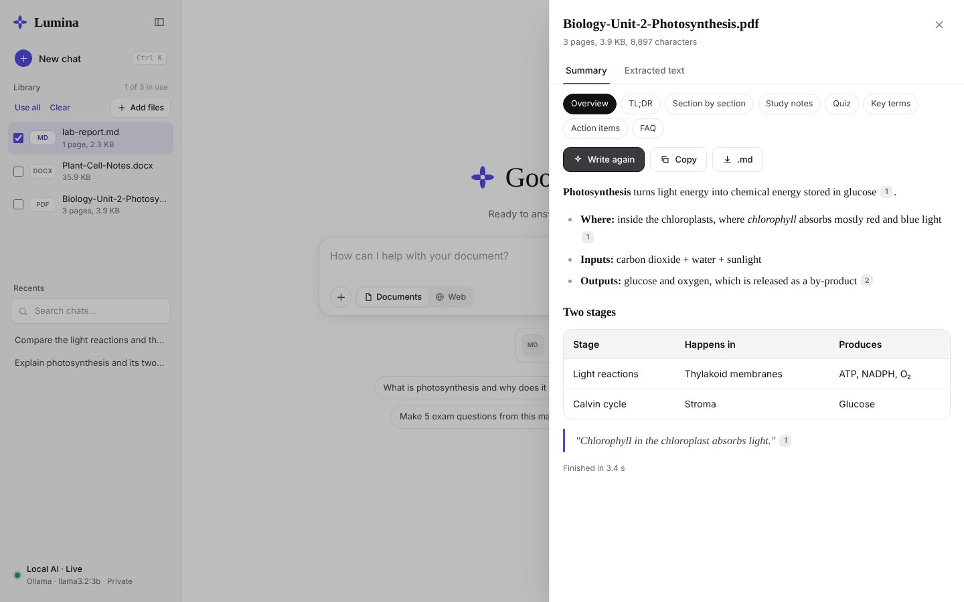
Figure 4 – Summaries and study tools

16. Step 14 – Test the project
The automated tests use a fake Ollama server, so all 33 tests run in a few seconds without downloading any model.
Run all checks
pip install -r backend/requirements-dev.txt
pytest backend/tests -q
ruff check backend --select E,F,W,B --ignore E501,B008
cd frontend && npm run lint && npm run build
The tests cover: uploads and validation, single- and multi-document streaming answers, chat memory and regenerate, summaries and download, keyword fallback when embeddings are missing, deleting documents, web research, the answer cache, languages, suggested questions, the OpenAI-compatible provider, and PDF/text/code extraction. Version 6.1 adds tests for: deleting a file while it is still being read, background indexing pausing while an answer is written, the model slot letting questions go before background work, instant suggestions using the document's key terms (and never calling the model), summary questions covering the whole document, and the summary always fitting the context window.

16.1 Load test that simulates a slow PC
To reproduce the "streaming request failed" problem, the fake model was made slow (3 s before the first word, one request at a time, like Ollama on a CPU) and the backend timeout was set to only 5 s. Then a summary, a question and suggested questions were requested at the same moment – exactly what the browser does.
Version | Suggestions | Summary | Question
6.0 (old) | 3.8 s (AI call) | failed – timeout | failed – timeout
6.1 (new) | 0.0 s (instant) | OK, first word 3.1 s | OK, waited in the queue, no timeout
A browser test (Playwright) then uploaded a PowerPoint, a PDF and a Word file together: all three were ready in about 2 seconds, the first words of the answer appeared after 1.5 s (with the fast fake model), the summary drawer worked and deleting a file produced no errors.

16.2 Speed test at the speed of a slow laptop
The fake model was set to behave like a slow laptop CPU running llama3.2:3b: it reads 40 tokens per second, writes 5 tokens per second, handles one request at a time and reports Ollama's timing fields. The same document and questions were sent to the previous version and to the new one. Both wrote answers of exactly the same length.
Answer style | Version | First word | Whole answer | Words
Balanced | before | 51.5 s | 152 s | 421
Balanced | now | 15.4 s | 116 s | 421
Detailed | before | 51.6 s | 233 s | 755
Detailed | now | 15.4 s | 197 s | 755
The first word now appears about 36 seconds sooner and every answer finishes 36 seconds sooner, with the same length and the facts that answer the question. The rest of the time is the model writing; on this kind of processor that can only be shortened with a smaller model (for example llama3.2:1b, about 2-3x faster) or a graphics card.

16.3 Effectiveness test on your own computer
The automated tests prove that the code works; they cannot tell how good the answers of *your* model are. scripts/evaluate.py does that. With the backend and Ollama running it uploads a small test document with known facts, asks 15 real questions and scores the answers:
Checks | Example question | Passes when
Accuracy | What does the CIA triad stand for? | the three words are in the answer
Honesty | Who is the principal of the college? | it says the document does not contain this
Whole document | Give me a summary of this document | facts from the first AND the last chapter
Follow-up memory | Why is it important…? | it understands what "it" refers to
Answer styles | Table, Bullet points, Detailed, Quotes… | the answer has the right form and facts
Completeness, citations, cache, speed | – | no cut-off answers, sources shown, repeats instant, timings recorded
Run the effectiveness test
python scripts\evaluate.py --quick # 6 core tests
python scripts\evaluate.py # all 15 tests -> evaluation-results.md
Run it once per model to compare quality and speed. The full list of automated, effectiveness and manual test cases (35 manual checks) is in docs/TEST_CASES.md.

16.4 Manual checklist
- The sidebar shows a pulsing red dot and "Local AI · Live".
- A PDF, a PowerPoint and a Word file become Ready within seconds; "Adding smart search…" disappears later.
- Suggested questions appear immediately and mention terms from your file.
- The backend log shows "Speed of … on this PC" at start-up, and answers show a first-word countdown.
- "Give a summary of this ppt" cites parts from the beginning AND the end of the file.
- Asking the same question twice shows "Instant answer" the second time.
- Selecting a language in Settings changes the answer language.
- Turning off Background animation stops the glowing blobs and the scan line.
- Deleting a document removes it and its chats.

17. Step 15 – Publish on GitHub safely

17.1 Keep private things out of Git
The .gitignore file lists what must never be uploaded:
.gitignore (excerpt)
# Secrets
.env
.env.*
!.env.example

# Your private data: uploads, database, search indexes
storage/*
!storage/.gitkeep
*.db

# Python / Node
__pycache__/
.venv/
node_modules/
frontend/dist/
Before every push, run the secret scanner. It stops with an error if an API key or a filled-in key line is found in the code:
python scripts/secret_scan.py
Important: Never paste a real API key into config.py, README.md or .env.example. If a key was ever pushed by mistake, revoke it on the provider's website – deleting the commit is not enough.

17.2 Create the repository and push
- Sign in to github.com and click New repository. Name it lumina (or your choice), leave "Add a README" unticked, and click Create repository.
- In the project folder run the commands below (replace <your-username>).
Terminal
git status # check .env and storage/ are NOT listed
git add .
git commit -m "Lumina 6.0 - private local document AI"
git branch -M main
git remote add origin https://github.com/<your-username>/lumina.git
git push -u origin main
- On GitHub, open About (gear icon) and add a description and topics such as rag, ollama, fastapi, react, local-llm, pdf, document-ai.
- The included GitHub Actions workflow (.github/workflows/ci.yml) runs the tests and the secret scan automatically on every push.
- Check the README on GitHub – screenshots and the demo GIF are loaded from docs/images/.

17.3 Renaming an existing repository
If your repository is still called local-pdf-llm-summarizer, open it on GitHub → Settings → Repository name, type lumina and click Rename. GitHub redirects the old address automatically. Then update your local remote:
git remote set-url origin https://github.com/<your-username>/lumina.git

18. Troubleshooting
Problem | Solution
"Ollama is not reachable" | Open the Ollama app or run ollama serve, then ollama list.
"Backend is not running" | Start terminal 1 with the uvicorn command; check port 5001 is free.
'vite' is not recognized | Run npm install inside the frontend folder first.
No module named 'docx' (or another module) | The virtual environment is missing or not active: python -m venv .venv, .\.venv\Scripts\Activate.ps1, pip install -r backend\requirements.txt.
Backend restarts by itself ("WatchFiles detected changes") | Start it without --reload, or with --reload --reload-dir backend.
Library shows "smart search…" | Normal – the file is already usable. Smart search is added in the background. On a slow PC use RAG_EMBEDDING_MODEL=nomic-embed-text.
model "llama3.2:3b" not found | ollama pull llama3.2:3b or change OLLAMA_MODEL in .env.
Sources show "keyword" search | ollama pull embeddinggemma, then python scripts/reindex_all_rag.py.
Scanned PDF has no text / "Tesseract not found" | Install Tesseract and set TESSERACT_CMD in .env. Normal PDFs work without it.
PyMuPDF does not install | Use Python 3.12, or pip install pypdfium2 – it is used automatically.
Activate.ps1 cannot be loaded | Set-ExecutionPolicy -Scope CurrentUser RemoteSigned
ModuleNotFoundError | Activate .venv and reinstall backend/requirements.txt.
A full answer takes a long time | Writing speed depends on your processor and model size. Lumina already starts sooner by reading only the relevant sentences. For 2-3x faster writing choose llama3.2:1b (button in the speed tip) – answers keep their full length.
Answers are slow | Choose a smaller model in ⚙ Settings (ollama pull llama3.2:1b or qwen2.5:1.5b – 2-3x faster on CPU), Concise style, RAG_MAX_CONTEXT_CHARS=3500, close other heavy apps.
"Local Ollama streaming request failed" / "did not answer within … seconds" | The PC was busy. Use v6.1 (requests are queued, waiting never times out), a smaller model, or a higher LLM_TIMEOUT. Test the model with ollama run llama3.2:3b "hi".

19. Command cheat sheet
Commands
# first time (Windows)
python -m venv .venv
.\.venv\Scripts\Activate.ps1
pip install -r backend\requirements.txt
Copy-Item .env.example .env
cd frontend; npm install; cd ..
ollama pull llama3.2:3b
ollama pull embeddinggemma

# every time
.\.venv\Scripts\Activate.ps1
python -m uvicorn backend.app.main:app --port 5001 # terminal 1
cd frontend; npm run dev # terminal 2

# maintenance
python scripts/reindex_all_rag.py # after changing chunk size / embedding model
python scripts/cleanup.py # remove temporary files
python scripts/secret_scan.py # before git push
pytest backend/tests -q # run the tests
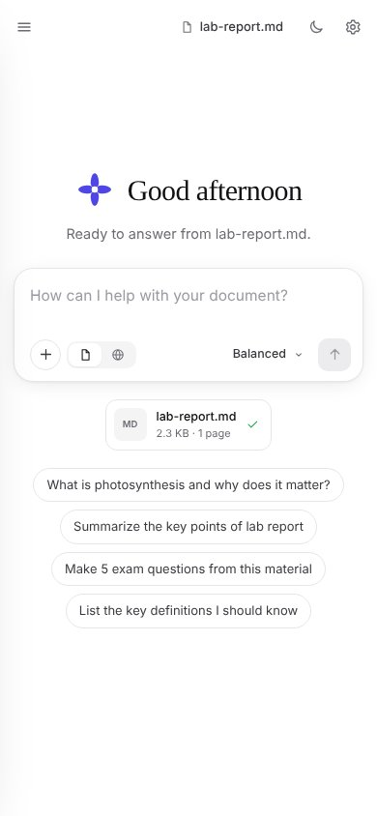
Figure 5 – Lumina on a phone

