1.Create a new process by invoking the appropriate system call. Get the process identifier of the currently

running process and its respective parent using system calls and display the same using a C program.

Program:

#include <stdio.h>

#include <sys/types.h>

#include <unistd.h>

int main()

{

printf("Hello world!\n");

return 0;

}

Output:

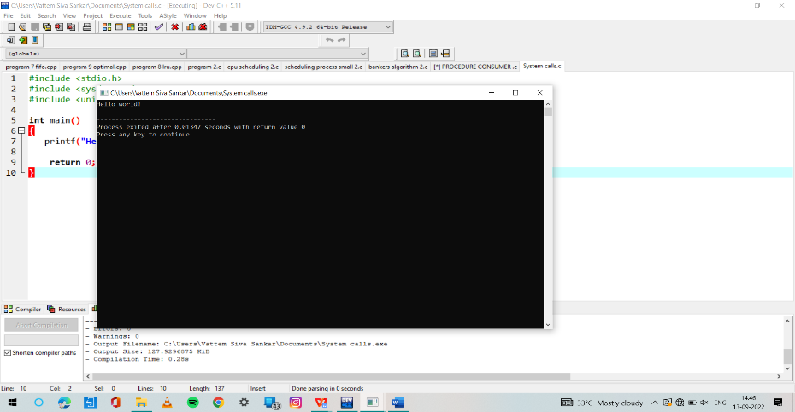

2.Identify the system calls to copy the content of one file to another and illustrate the same using a C program.

Program:

#include<stdio.h>

int main()

{

int bt[20],p[20],wt[20],tat[20],i,j,n,total=0,pos,temp;

float avg_wt,avg_tat;

printf("Enter number of process:");

scanf("%d",&n);

printf("\nEnter Burst Time:\n");

for(i=0;i<n;i++)

{

printf("p%d:",i+1);

scanf("%d",&bt[i]);

p[i]=i+1;

}

for(i=0;i<n;i++)

{

pos=i;

for(j=i+1;j<n;j++)

{

if(bt[j]<bt[pos])

pos=j;

}

temp=bt[i];

bt[i]=bt[pos];

bt[pos]=temp;

temp=p[i];

p[i]=p[pos];

p[pos]=temp;

}

wt[0]=0;

for(i=1;i<n;i++)

{

wt[i]=0;

for(j=0;j<i;j++)

wt[i]+=bt[j];

total+=wt[i];

}

avg_wt=(float)total/n;

total=0;

printf("\nProcess\t Burst Time \tWaiting Time\tTurnaround Time");

for(i=0;i<n;i++)

{

tat[i]=bt[i]+wt[i];

total+=tat[i];

printf("\np%d\t\t %d\t\t %d\t\t\t%d",p[i],bt[i],wt[i],tat[i]);

}

avg_tat=(float)total/n;

printf("\n\nAverage Waiting Time=%f",avg_wt);

printf("\nAverage Turnaround Time=%f\n",avg_tat);

}

Output:

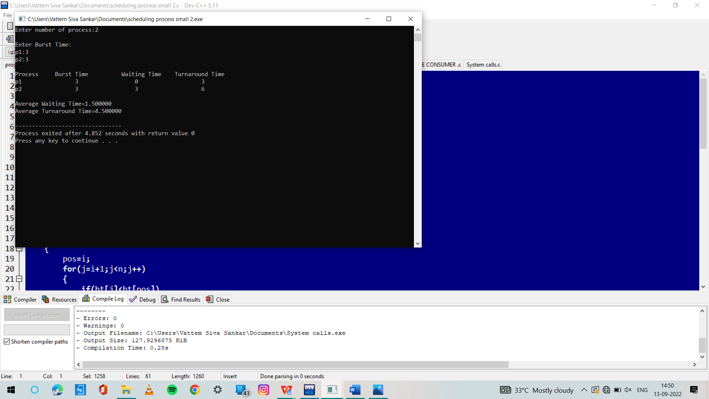

3. . Design a CPU scheduling program with C using First Come First Served technique with the following considerations.

a. All processes are activated at time 0.

b. Assume that no process waits on I/O devices.

Program:

#include<stdio.h>

int main()

{

int n,bt[20],wt[20],tat[20],avwt=0,avtat=0,i,j;

printf("Enter total number of processes(maximum 20):");

scanf("%d",&n);

printf("\nEnter Process Burst Time\n");

for(i=0;i<n;i++)

{

printf("P[%d]:",i+1);

scanf("%d",&bt[i]);

}

wt[0]=0;

for(i=1;i<n;i++)

{

wt[i]=0;

for(j=0;j<i;j++)

wt[i]+=bt[j];

}

printf("\nProcess\t\tBurst Time\tWaiting Time\tTurnaround Time");

for(i=0;i<n;i++)

{

tat[i]=bt[i]+wt[i];

avwt+=wt[i];

avtat+=tat[i];

printf("\nP[%d]\t\t%d\t\t%d\t\t%d",i+1,bt[i],wt[i],tat[i]);

}

avwt/=i;

avtat/=i;

printf("\n\nAverage Waiting Time:%d",avwt);

printf("\nAverage Turnaround Time:%d",avtat);

return 0;

}

Output:

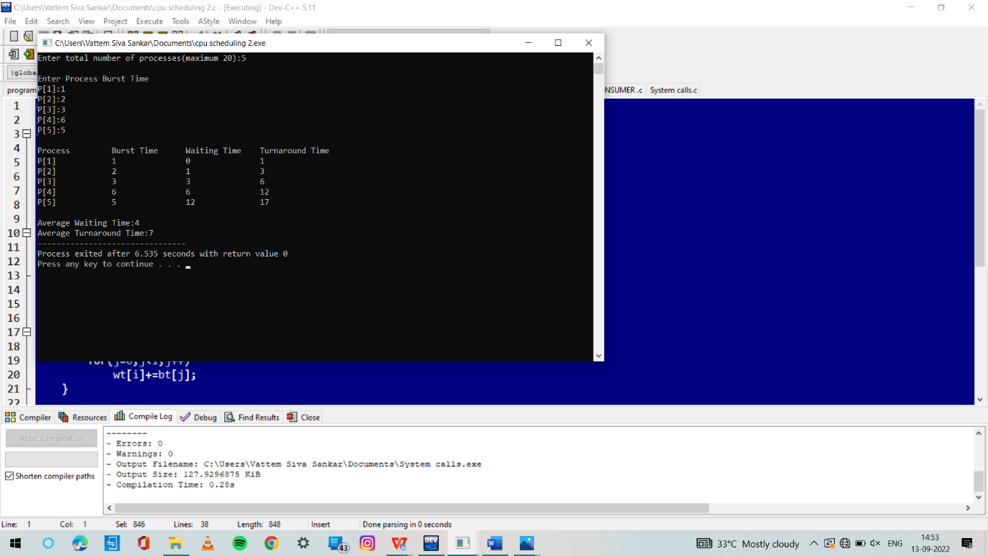

4. . Construct a scheduling program with C that selects the waiting process with the smallest execution time to execute next.

Program:

. #include<sys/types.h>

#include<fcntl.h>

#include<stdlib.h>

#include<string.h>

int main(int args,char *ar[])

{

char *source=ar[1];

char *dest="def.txt";

char *buf=(char *)malloc(sizeof(char)*120);

int fd1,fd2;

fd1=open(source,O_CREAT,0744);

fd2=open(dest,O_CREAT,0744);

while(read(fd1,buf,120)!=-1)

{

printf("%s",buf);

write(fd2,buf,120);

}

printf("Process Done");

close(fd1);

close(fd2);

}

Output:

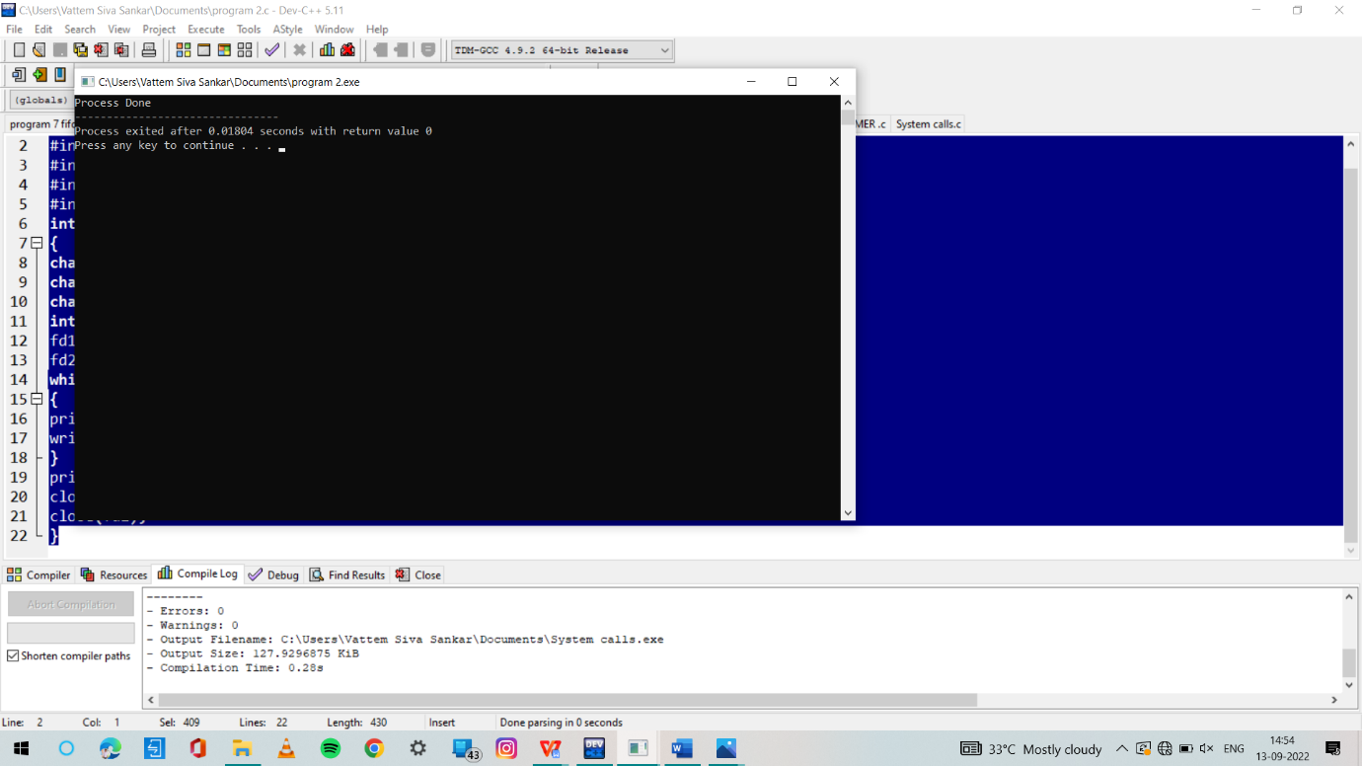

5. Illustrate the deadlock avoidance concept by simulating Banker’s algorithm with C.

Program:

#include <stdio.h>

int main()

{

// P0, P1, P2, P3, P4 are the Process names here

int n, m, i, j, k;

n = 5; // Number of processes

m = 3; // Number of resources

int alloc[5][3] = { { 0, 1, 0 }, // P0 // Allocation Matrix

{ 2, 0, 0 }, // P1

{ 3, 0, 2 }, // P2

{ 2, 1, 1 }, // P3

{ 0, 0, 2 } }; // P4

int max[5][3] = { { 7, 5, 3 }, // P0 // MAX Matrix

{ 3, 2, 2 }, // P1

{ 9, 0, 2 }, // P2

{ 2, 2, 2 }, // P3

{ 4, 3, 3 } }; // P4

int avail[3] = { 3, 3, 2 }; // Available Resources

int f[n], ans[n], ind = 0;

for (k = 0; k < n; k++) {

f[k] = 0;

}

int need[n][m];

for (i = 0; i < n; i++) {

for (j = 0; j < m; j++)

need[i][j] = max[i][j] - alloc[i][j];

}

int y = 0;

for (k = 0; k < 5; k++) {

for (i = 0; i < n; i++) {

if (f[i] == 0) {

int flag = 0;

for (j = 0; j < m; j++) {

if (need[i][j] > avail[j]){

flag = 1;

break;

}

}

if (flag == 0) {

ans[ind++] = i;

for (y = 0; y < m; y++)

avail[y] += alloc[i][y];

f[i] = 1;

}

}

}

}

int flag = 1;

for(int i=0;i<n;i++)

{

if(f[i]==0)

{

flag=0;

printf("The following system is not safe");

break;

}

}

if(flag==1)

{

printf("Following is the SAFE Sequence\n");

for (i = 0; i < n - 1; i++)

printf(" P%d ->", ans[i]);

printf(" P%d", ans[n - 1]);

}

return (0);

}

Output:

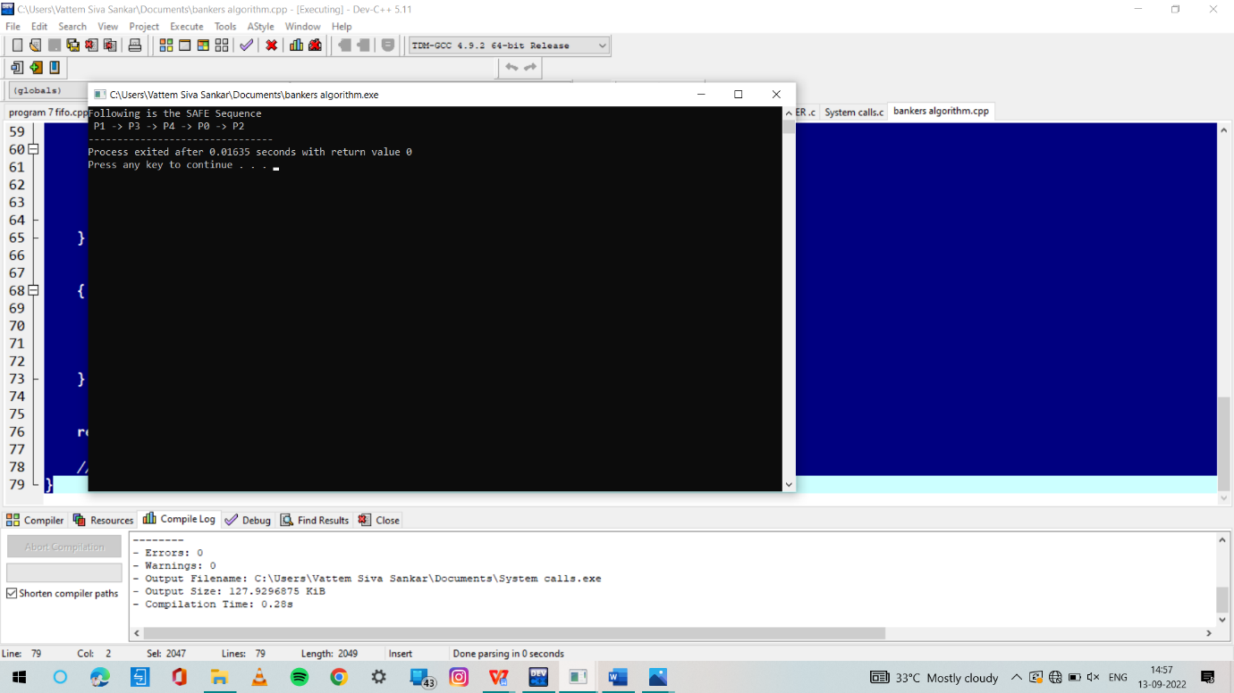

6. Construct a C program to simulate producer-consumer problem using semaphores..

Program:

#include<stdio.h>

#include<stdlib.h>

int mutex=1,full=0,empty=3,x=0;

int main()

{

int n;

void producer();

void consumer();

int wait(int);

int signal(int);

printf("\n1.Producer\n2.Consumer\n3.Exit");

while(1)

{

printf("\nEnter your choice:");

scanf("%d",&n);

switch(n)

{

case 1: if((mutex==1)&&(empty!=0))

producer();

else

printf("Buffer is full!!");

break;

case 2: if((mutex==1)&&(full!=0))

consumer();

else

printf("Buffer is empty!!");

break;

case 3:

exit(0);

break;

}

}

return 0;

}

int wait(int s)

{

return (--s);

}

int signal(int s)

{

return(++s);

}

void producer()

{

mutex=wait(mutex);

full=signal(full);

empty=wait(empty);

x++;

printf("\nProducer produces the item %d",x);

mutex=signal(mutex);

}

void consumer()

{

mutex=wait(mutex);

full=wait(full);

empty=signal(empty);

printf("\nConsumer consumes item %d",x);

x--;

mutex=signal(mutex);

}

Output:

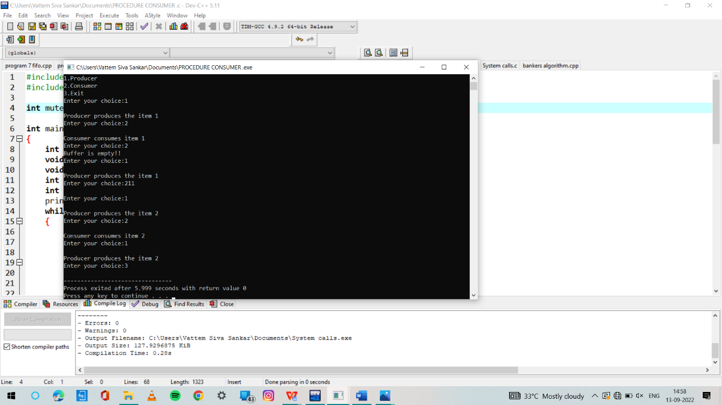

7. . Construct a C program to simulate the First in First Out paging technique of memory management.

Program:

#include <stdio.h>

int main()

{

int referenceString[10], pageFaults = 0, m, n, s, pages, frames;

printf("\nEnter the number of Pages:\t");

scanf("%d", &pages);

printf("\nEnter reference string values:\n");

for( m = 0; m < pages; m++)

{

printf("Value No. [%d]:\t", m + 1);

scanf("%d", &referenceString[m]);

}

printf("\n What are the total number of frames:\t");

{

scanf("%d", &frames);

}

int temp[frames];

for(m = 0; m < frames; m++)

{

temp[m] = -1;

}

for(m = 0; m < pages; m++)

{

s = 0;

for(n = 0; n < frames; n++)

{

if(referenceString[m] == temp[n])

{

s++;

pageFaults--;

}

}

pageFaults++;

if((pageFaults <= frames) && (s == 0))

{

temp[m] = referenceString[m];

}

else if(s == 0)

{

temp[(pageFaults - 1) % frames] = referenceString[m];

}

printf("\n");

for(n = 0; n < frames; n++)

{

printf("%d\t", temp[n]);

}

}

printf("\nTotal Page Faults:\t%d\n", pageFaults);

return 0;

}

Output:

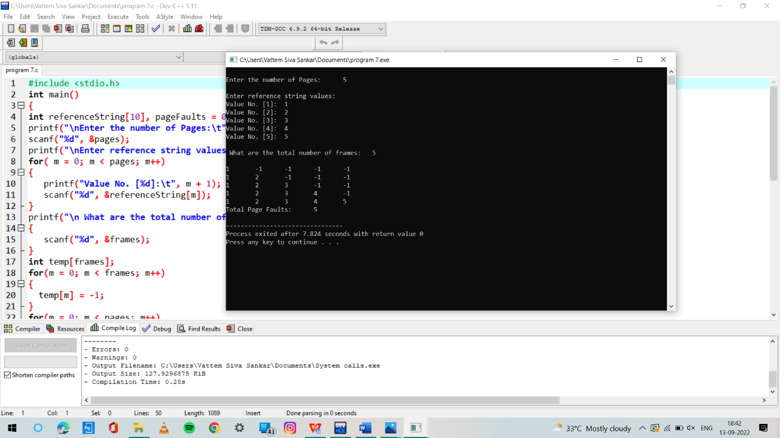

8. . Construct a C program to simulate the Least Recently Used paging technique of memory management.

Program:

#include<stdio.h>

int findLRU(int time[], int n){

int i, minimum = time[0], pos = 0;

for(i = 1; i < n; ++i){

if(time[i] < minimum){

minimum = time[i];

pos = i;

}

}

return pos;

}

int main()

{

int no_of_frames, no_of_pages, frames[10], pages[30], counter = 0, time[10], flag1, flag2, i, j, pos, faults = 0;

printf("Enter number of frames: ");

scanf("%d", &no_of_frames);

printf("Enter number of pages: ");

scanf("%d", &no_of_pages);

printf("Enter reference string: ");

for(i = 0; i < no_of_pages; ++i){

scanf("%d", &pages[i]);

}

for(i = 0; i < no_of_frames; ++i){

frames[i] = -1;

}

for(i = 0; i < no_of_pages; ++i){

flag1 = flag2 = 0;

for(j = 0; j < no_of_frames; ++j){

if(frames[j] == pages[i]){

counter++;

time[j] = counter;

flag1 = flag2 = 1;

break;

}

}

if(flag1 == 0){

for(j = 0; j < no_of_frames; ++j){

if(frames[j] == -1){

counter++;

faults++;

frames[j] = pages[i];

time[j] = counter;

flag2 = 1;

break;

}

}

}

if(flag2 == 0){

pos = findLRU(time, no_of_frames);

counter++;

faults++;

frames[pos] = pages[i];

time[pos] = counter;

}

printf("\n");

for(j = 0; j < no_of_frames; ++j){

printf("%d\t", frames[j]);

}

}

printf("\n\nTotal Page Faults = %d", faults);

return 0;

}

Output:

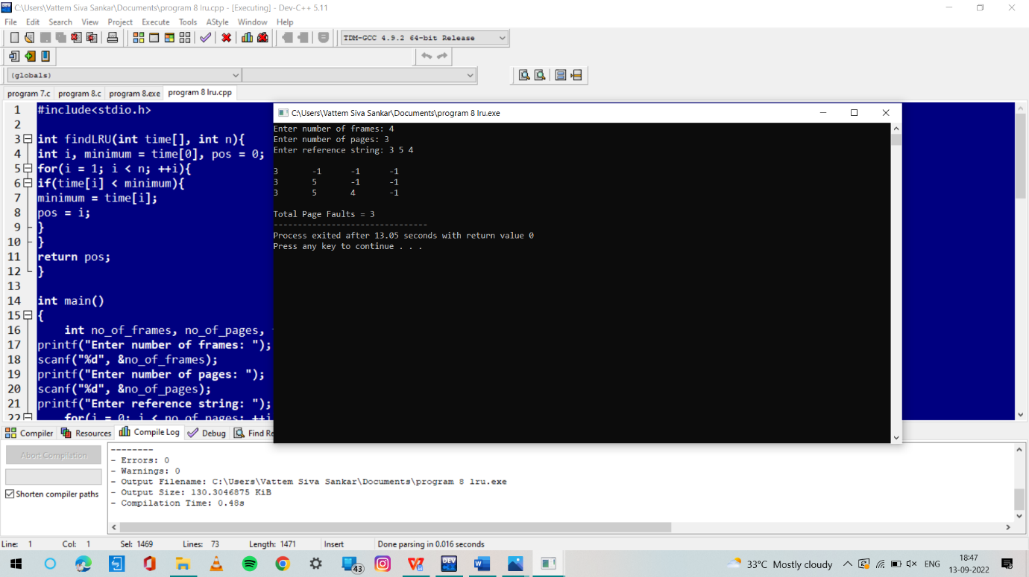

9. Construct a C program to simulate the optimal paging technique of memory management.

Program:

#include<stdio.h>

#define MAX 50

int main()

{

int page[MAX],i,n,f,ps,off,pno;

int choice=0;

printf("\nEnter the no of pages in memory: ");

scanf("%d",&n);

printf("\nEnter page size: ");

scanf("%d",&ps);

printf("\nEnter no of frames: ");

scanf("%d",&f);

for(i=0;i<n;i++)

page[i]=-1;

printf("\nEnter the page table\n");

printf("(Enter frame no as -1 if that page is not present in any frame)\n\n");

printf("\npageno\tframeno\n-------\t-------");

for(i=0;i<n;i++)

{

printf("\n\n%d\t\t",i);

scanf("%d",&page[i]);

}

do

{

printf("\n\nEnter the logical address(i.e,page no & offset):");

scanf("%d%d",&pno,&off);

if(page[pno]==-1)

printf("\n\nThe required page is not available in any of frames");

else

printf("\n\nPhysical address(i.e,frame no & offset):%d,%d",page[pno],off);

printf("\nDo you want to continue(1/0)?:");

scanf("%d",&choice);

}while(choice==1);

return 1;

}

Output:

