**Number of Trips Per day**

**Bussiest Day**

**Count the number of active vehicles per base**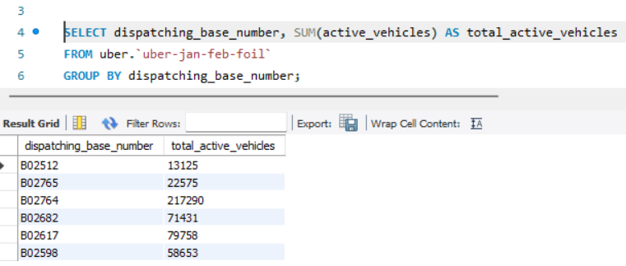

**. Calculate the average number of trips per vehicle**

**Retrieve records with more than a certain number of trips**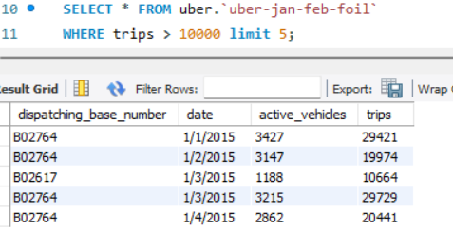

**Find the base with the most active vehicles**

