C fundamentals
Pointers
Pointer
Pointer arithmetic
Pointer-to-pointer
Function pointer
Void pointer
Common pitfalls
Dangling pointer
Uninitialized pointer
Wild pointer
Invalid pointer

Memory Layout
Text (code)
Data (Initialized globals/statics)
BSS(Uninitialized globals/statics)
Heap (Dynamic allocation)
Stack (function frames)

Concepts
Static vs global vs local
Stack overflow
Memory lifetime

Storage Classes
static
Internal linkage
Persistent lifetime
Memory placement
Extern
External linkage

across files
volatile
ISR-modified

variables
Memory-mapped
registers
Compiler
Optimization barrier

Bitwise Operations
Set/Clear/Toggle bit
Masking
Extracting bitfields
Packin signals
CAN/LIN Frame
operations
Shifting
Endianness + Bitfields
Storage order
Alignment

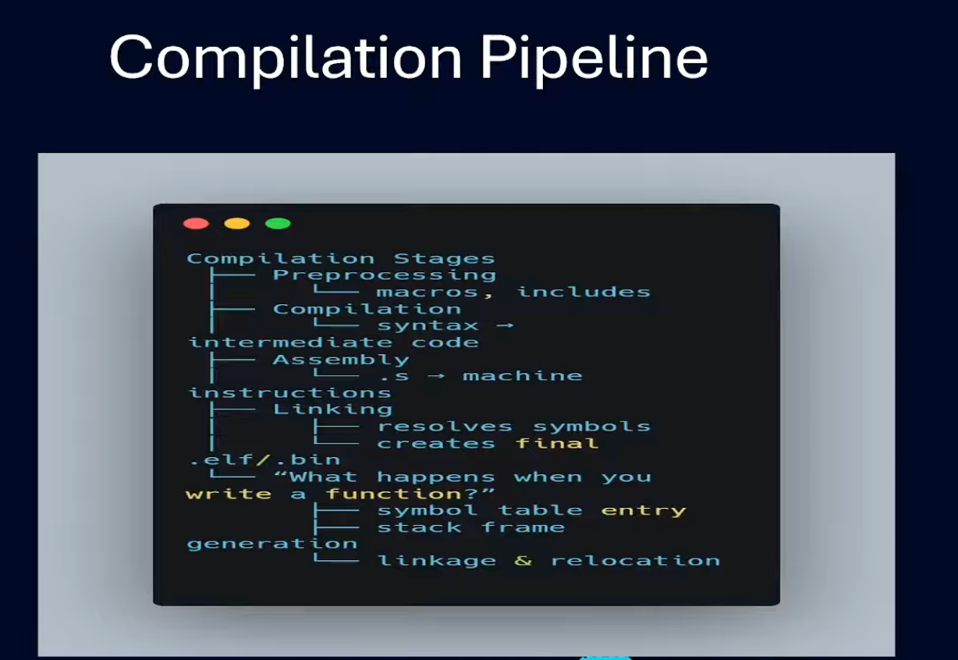

Compilation Stages
|
|-- Preprocessing
| |-- macros, includes
|
|-- Compilation
| |-- syntax →
| |-- intermediate code
|
|-- Assembly
| |-- .s → machine instructions
|
|-- Linking
| |-- resolves symbols
| |-- creates final
| |-- .elf / .bin
|
|-- "What happens when you write a function?"
|-- symbol table entry
|-- stack frame generation
|-- linkage & relocation

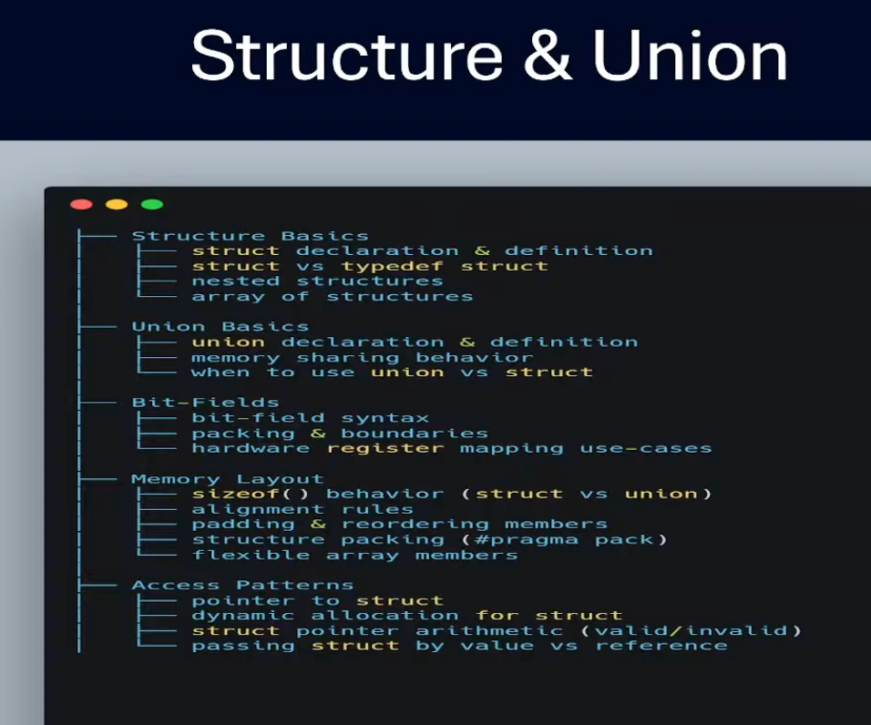

Structure Basics
├─ struct declaration & definition
├─ struct vs typedef struct
├─ nested structures
├─ array of structures

Union Basics
├─ union declaration & definition
├─ memory sharing behavior
├─ when to use union vs struct

Bit-Fields
├─ bit-field syntax
├─ packing & boundaries
├─ hardware register mapping use-cases

Memory Layout
├─ sizeof() behavior (struct vs union)
├─ alignment rules
├─ padding & reordering members
├─ structure packing (#pragma pack)
├─ flexible array members

Access Patterns
├─ pointer to struct
├─ dynamic allocation for struct
├─ struct pointer arithmetic (valid/invalid)
├─ passing struct by value vs reference

C programming practics

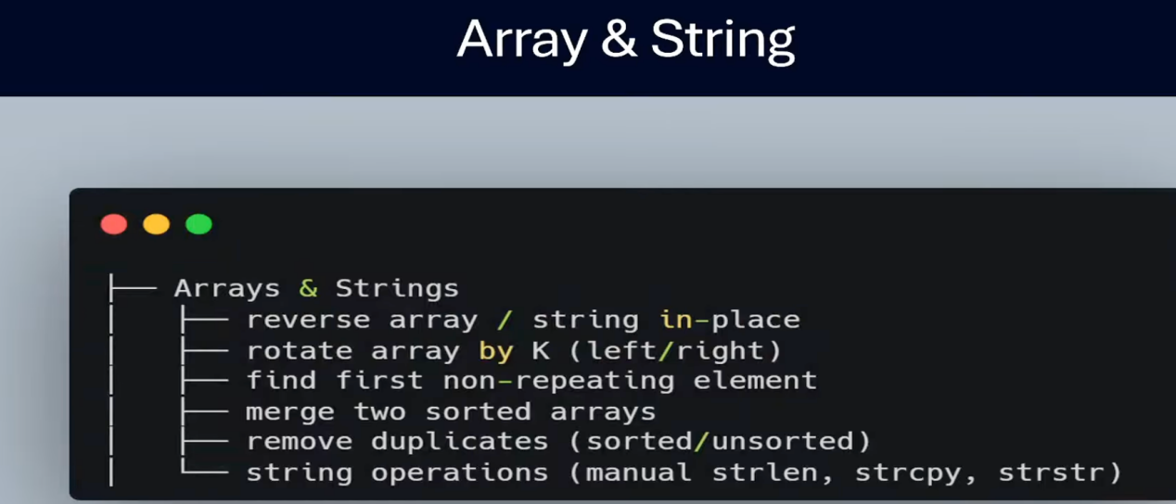

Arrays & Strings
├─ reverse array / string in-place
├─ rotate array by K (left/right)
├─ find first non-repeating element
├─ merge two sorted arrays
├─ remove duplicates (sorted/unsorted)
├─ string operations (manual strlen, strcpy, strstr)

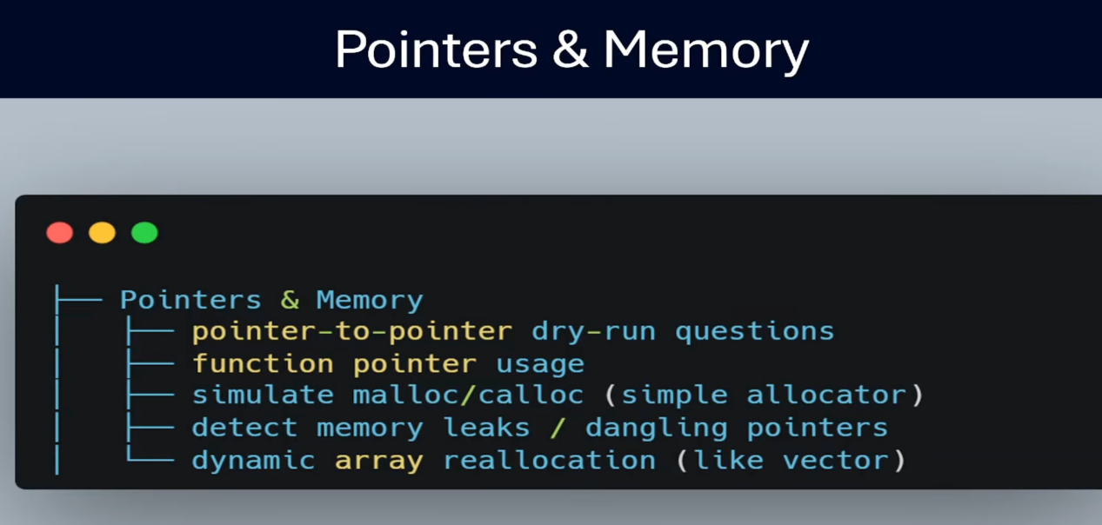

Pointers & Memory
├─ pointer-to-pointer dry-run questions
├─ function pointer usage
├─ simulate malloc/calloc (simple allocator)
├─ detect memory leaks / dangling pointers
├─ dynamic array reallocation (like vector)

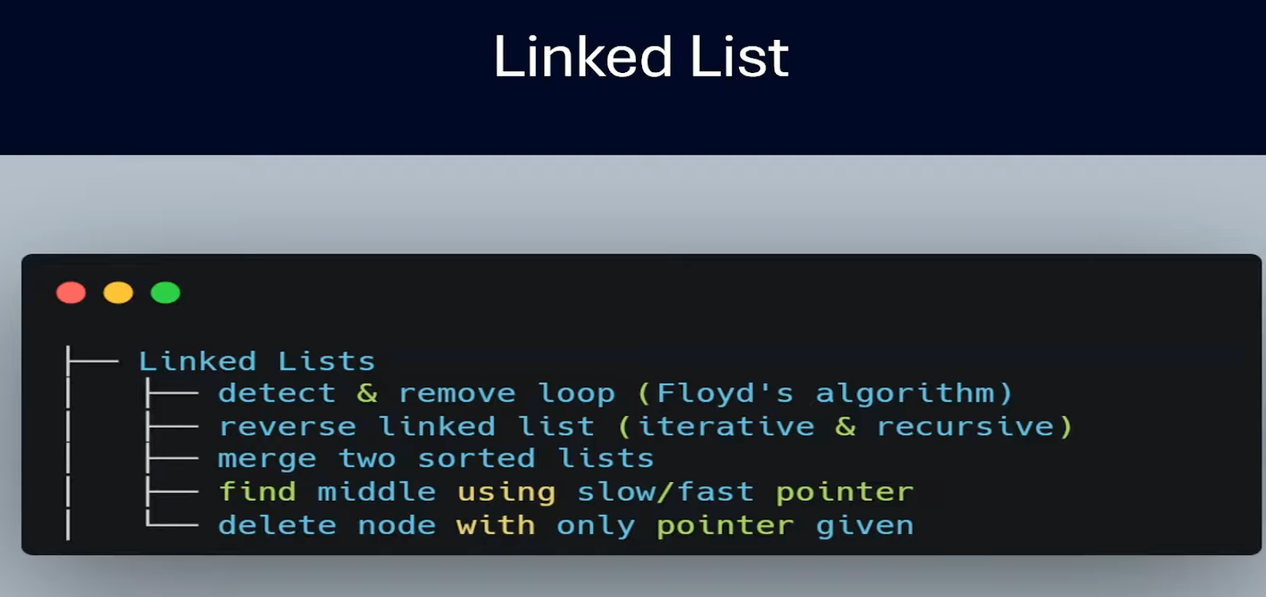
Linked Lists
├─ detect & remove loop (Floyd's algorithm)
├─ reverse linked list (iterative & recursive)
├─ merge two sorted lists
├─ find middle using slow/fast pointer
├─ delete node with only pointer given

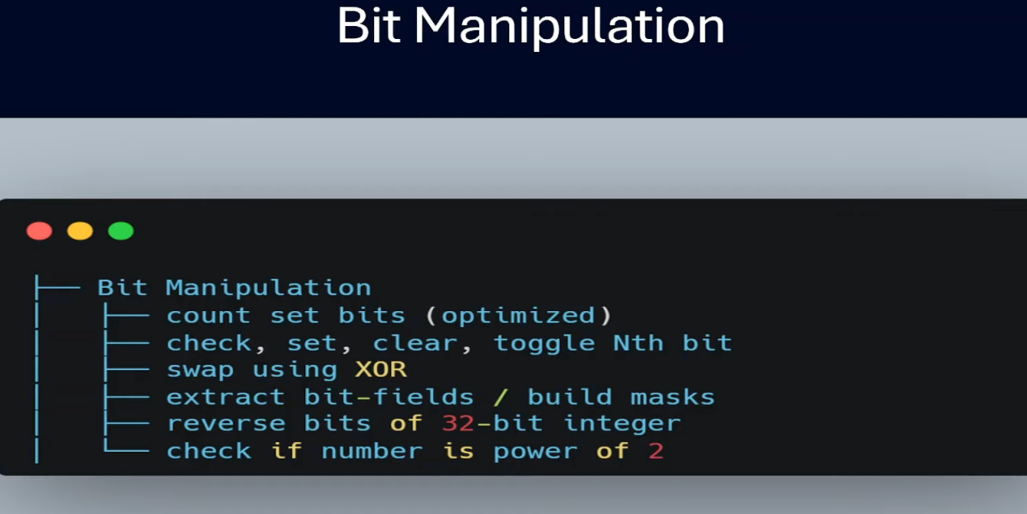
Bit Manipulation
├── count set bits (optimized)
├── check, set, clear, toggle Nth bit
├── swap using XOR
├── extract bit-fields / build masks
├── reverse bits of 32-bit integer
└── check if number is power of 2

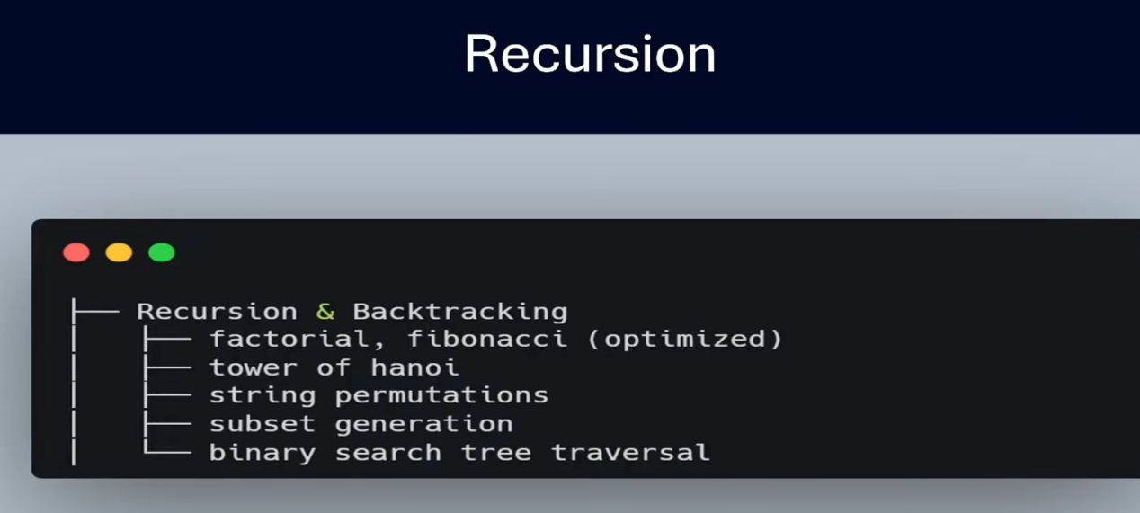

Recursion
├── Recursion & Backtracking
│ ├── factorial, fibonacci (optimized)
│ ├── tower of hanoi
│ ├── string permutations
│ ├── subset generation
│ └── binary search tree traversal

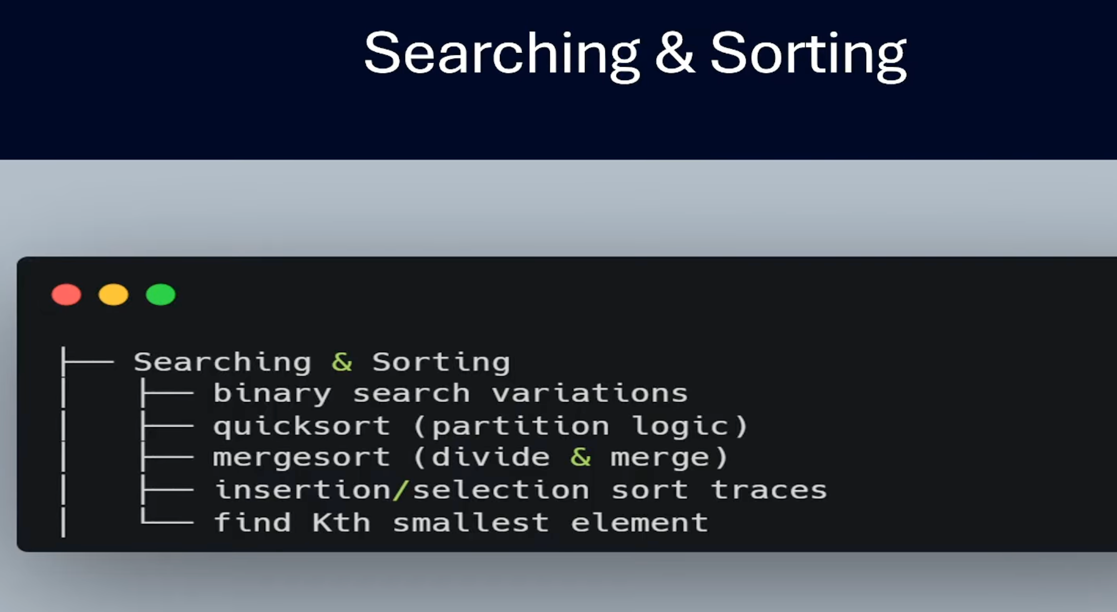
Searching & Sorting
├── binary search variations
├── quicksort (partition logic)
├── mergesort (divide & merge)
├── insertion/selection sort traces
└── find Kth smallest element

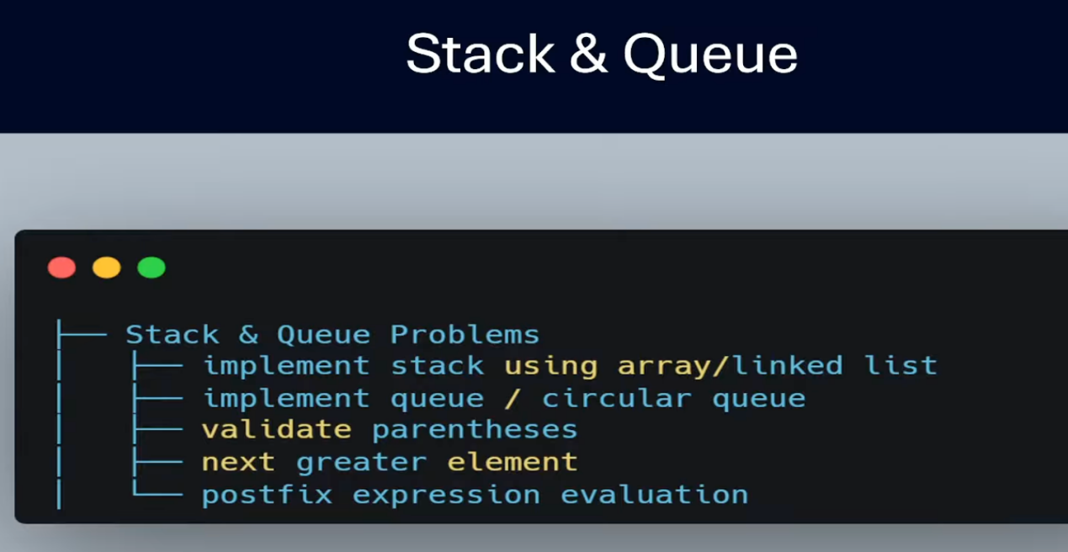
Stack & Queue

Stack & Queue Problems
├── implement stack using array/linked list
├── implement queue / circular queue
├── validate parentheses
├── next greater element
└── postfix expression evaluation

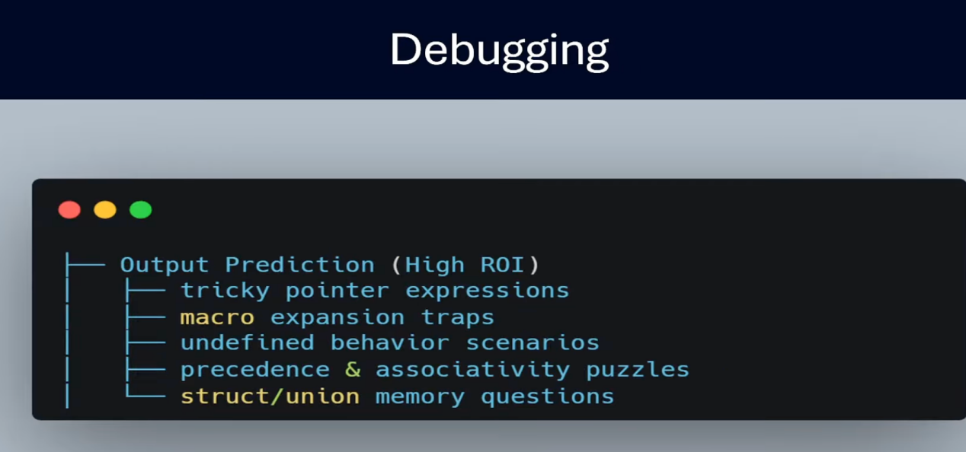
Debugging

Output Prediction (High ROI)
├── tricky pointer expressions
├── macro expansion traps
├── undefined behavior scenarios
├── precedence & associativity puzzles
└── struct/union memory questions

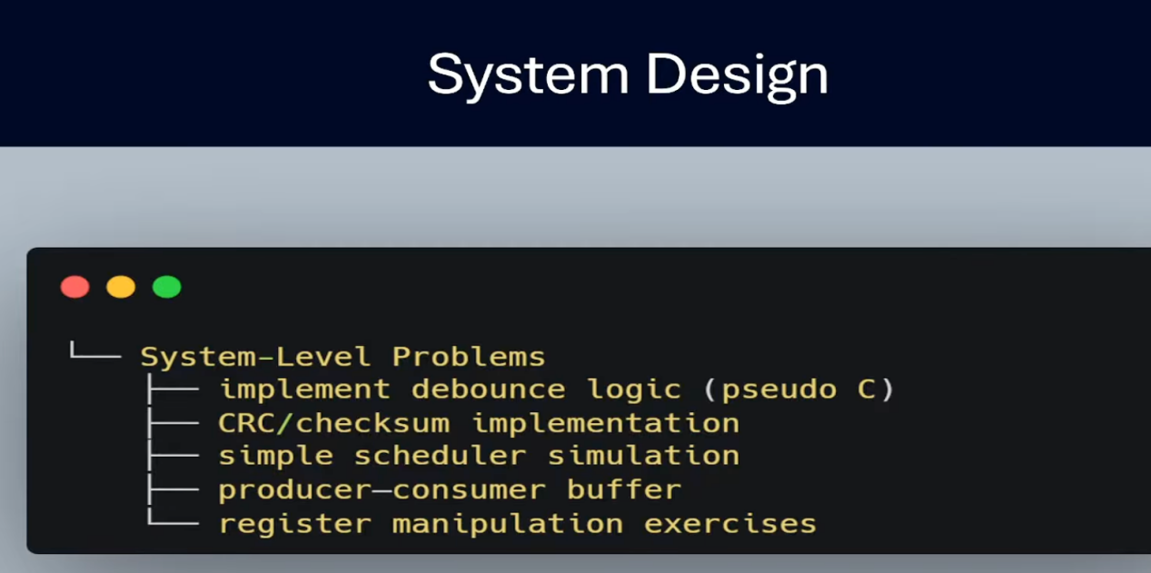

System Design

System-Level Problems
├── implement debounce logic (pseudo C)
├── CRC/checksum implementation
├── simple scheduler simulation
├── producer-consumer buffer
└── register manipulation exercises

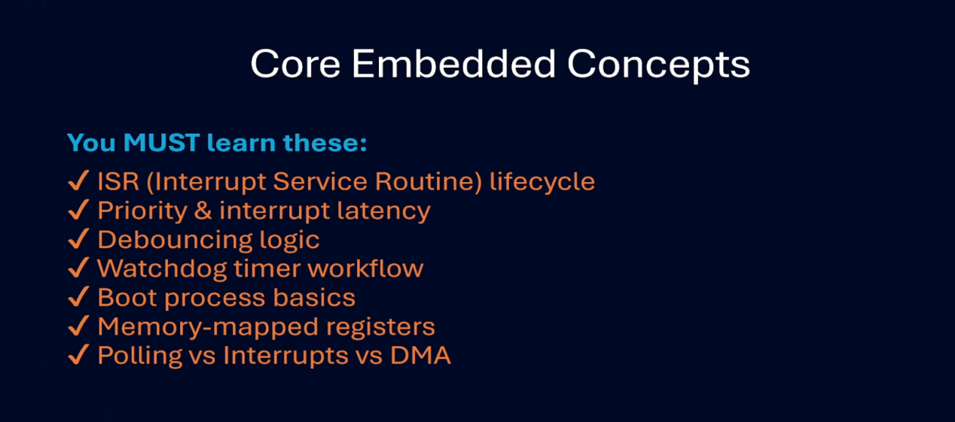

Core Embedded Concepts

You MUST learn these:
✓ ISR (Interrupt Service Routine) lifecycle
✓ Priority & interrupt latency
✓ Debouncing logic
✓ Watchdog timer workflow
✓ Boot process basics
✓ Memory-mapped registers
✓ Polling vs Interrupts vs DMA

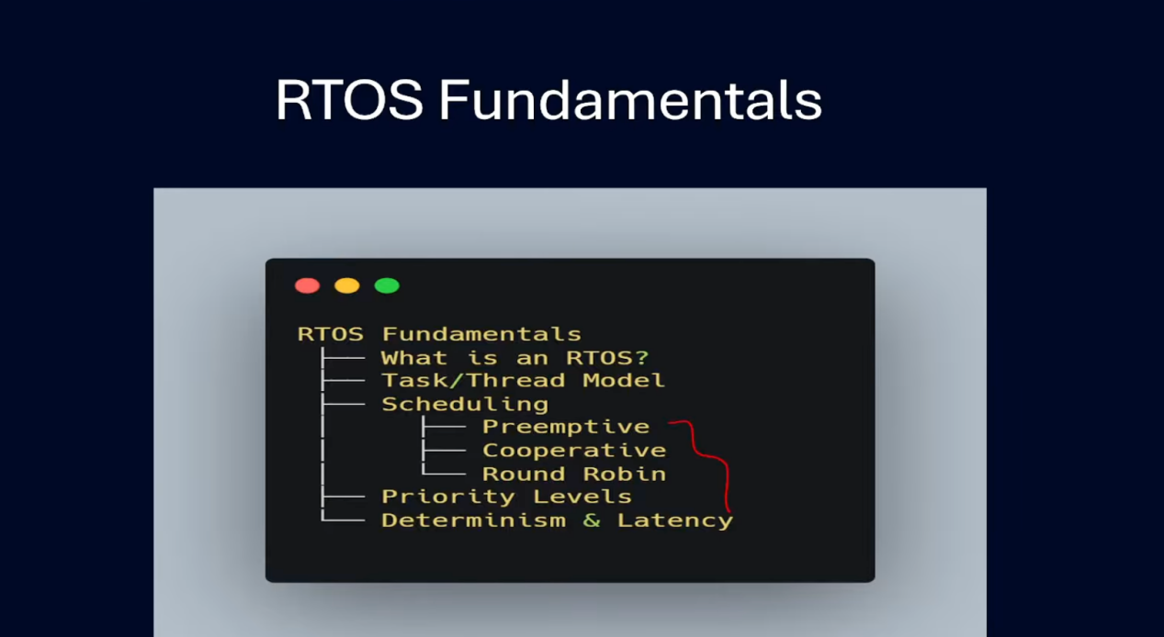

RTOS Fundamentals
├── What is an RTOS?
├── Task/Thread Model
├── Scheduling
│ ├── Preemptive
│ ├── Cooperative
│ └── Round Robin
├── Priority Levels
└── Determinism & Latency

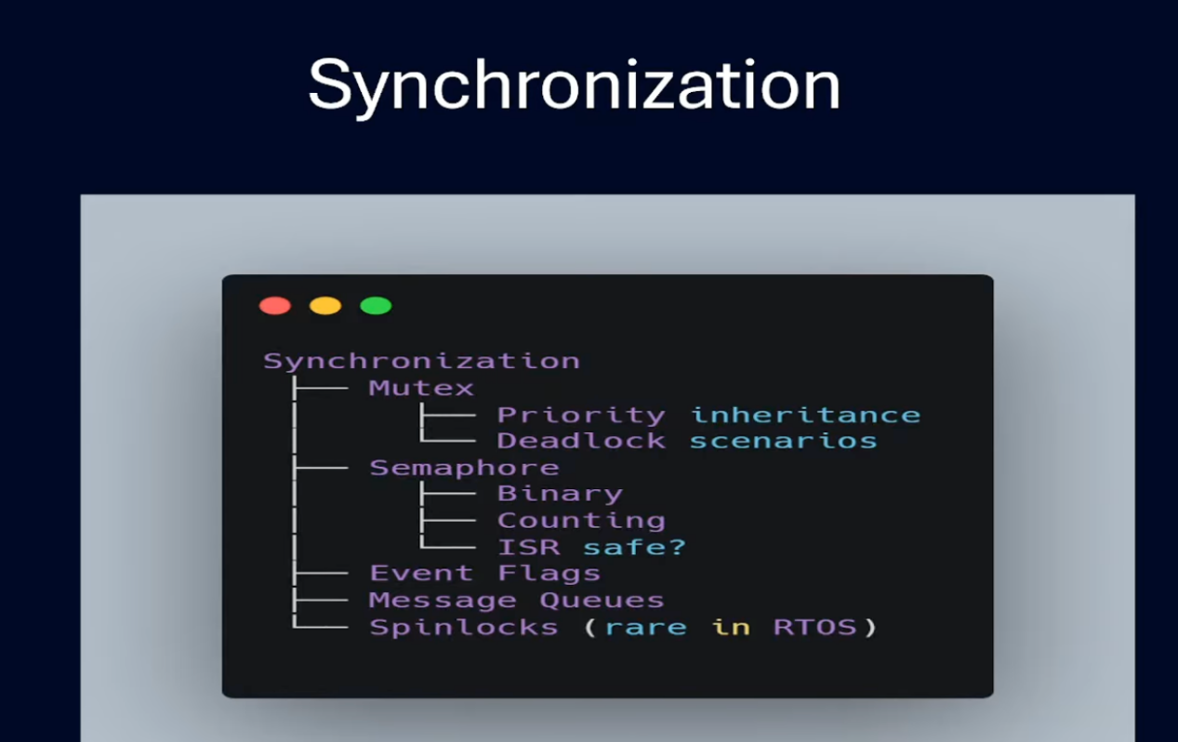
Synchronization
├── Mutex
│ ├── Priority inheritance
│ └── Deadlock scenarios
├── Semaphore
│ ├── Binary
│ ├── Counting
│ └── ISR safe?
├── Event Flags
├── Message Queues
└── Spinlocks (rare in RTOS)

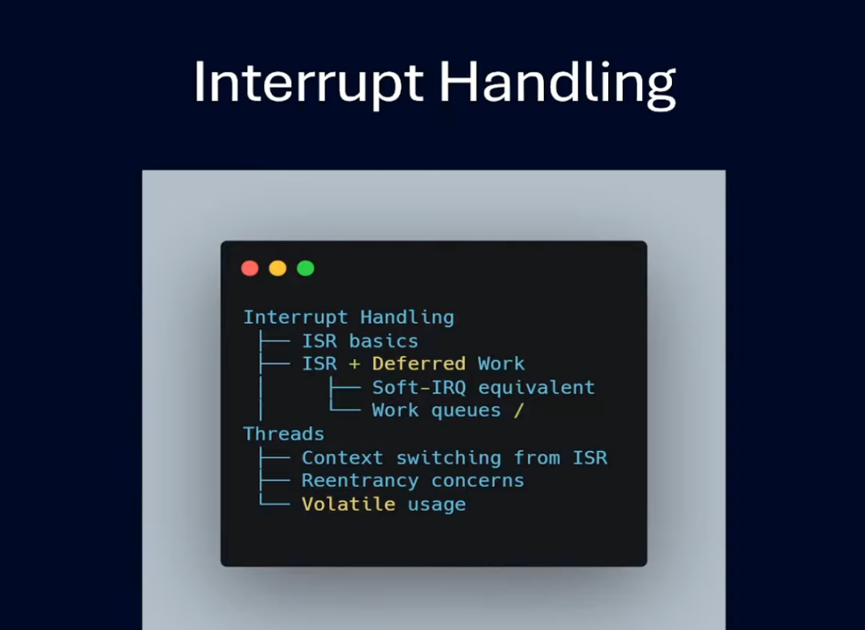
Interrupt Handling
├── ISR basics
├── ISR + Deferred Work
│ ├── Soft-IRQ equivalent
│ └── Work queues /
Threads
├── Context switching from ISR
├── Reentrancy concerns
└── Volatile usage

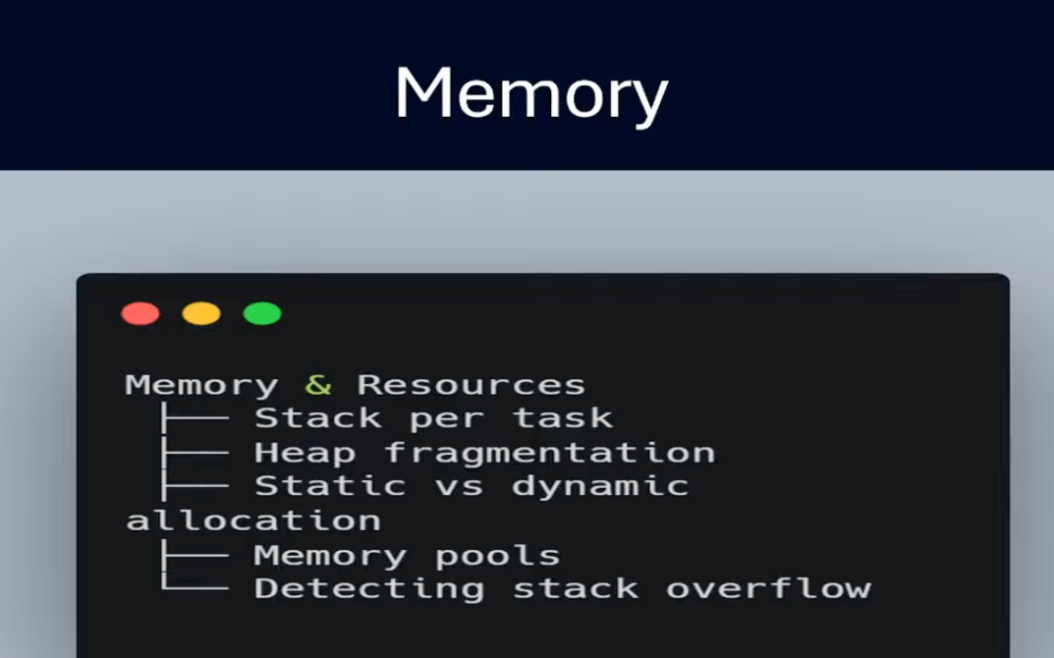
Memory & Resources
├── Stack per task
├── Heap fragmentation
├── Static vs dynamic allocation
│ ├── Memory pools
│ └── Detecting stack overflow

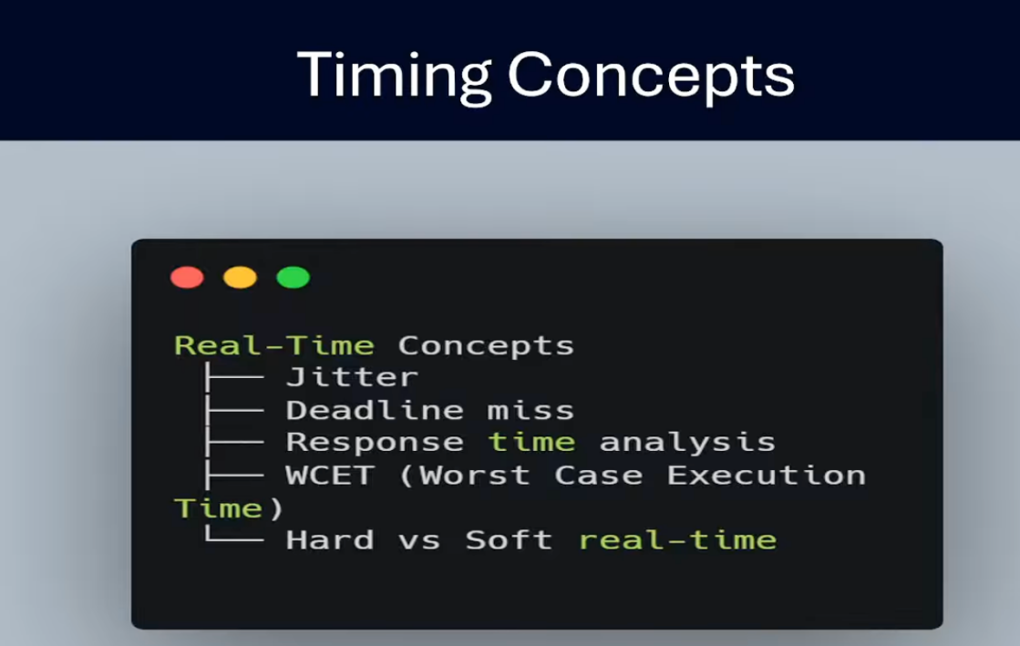
Timing Concepts

Real-Time Concepts
├── Jitter
├── Deadline miss
├── Response time analysis
├── WCET (Worst Case Execution Time)
└── Hard vs Soft real-time

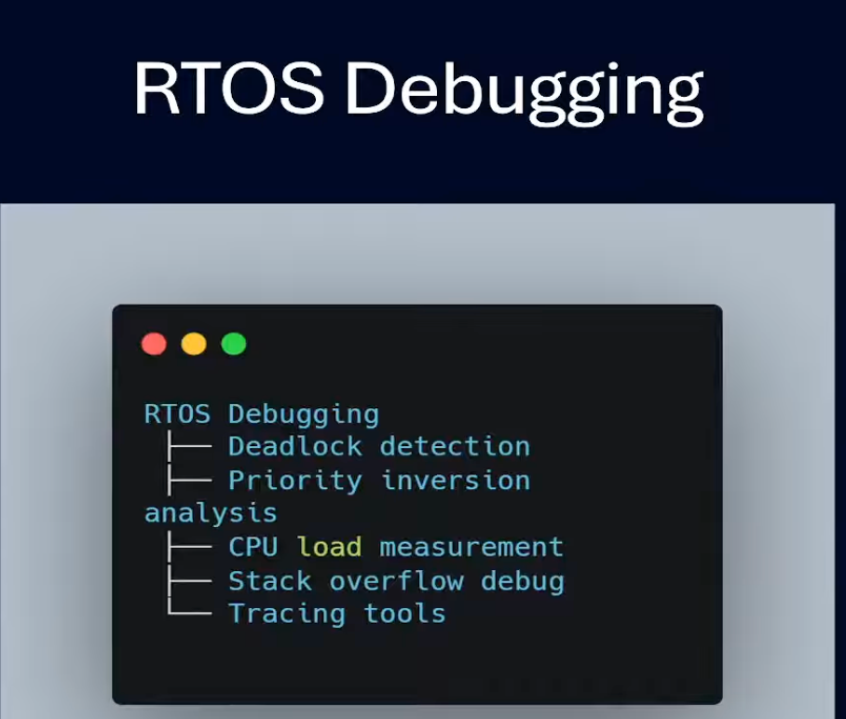
RTOS Debugging
├── Deadlock detection
├── Priority inversion analysis
├── CPU load measurement
├── Stack overflow debug
└── Tracing tools

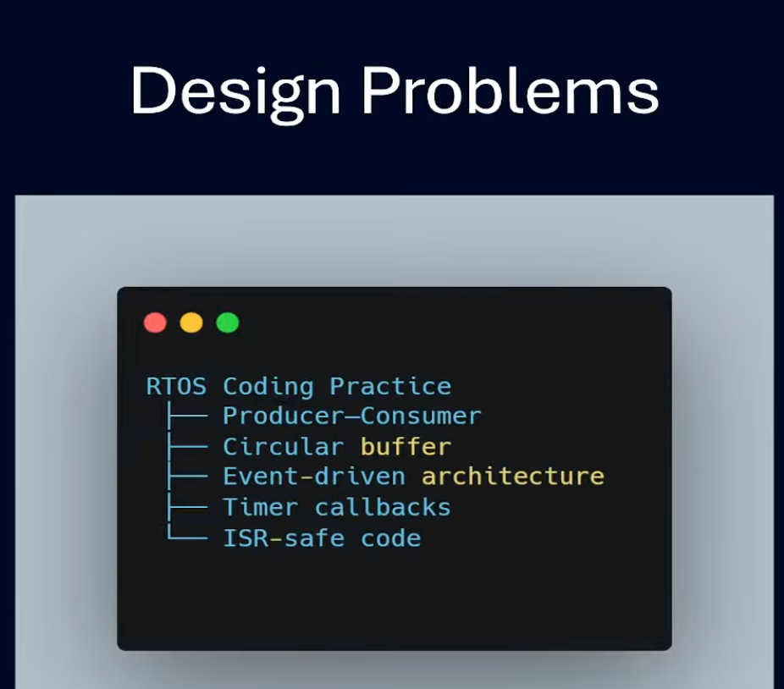
Design Problems

RTOS Coding Practice
├── Producer–Consumer
├── Circular buffer
├── Event-driven architecture
├── Timer callbacks
└── ISR-safe code

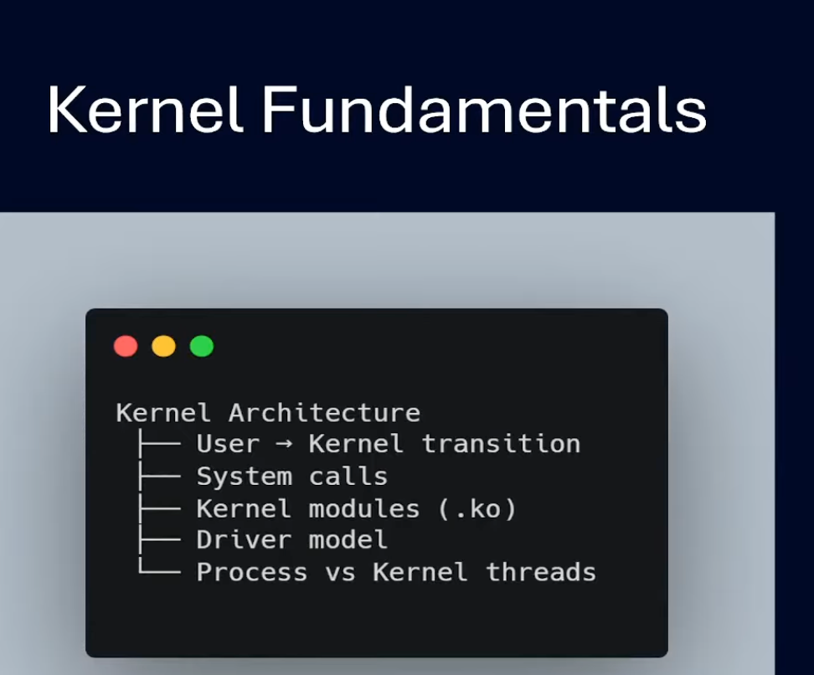

Kernel Fundamentals

Kernel Architecture
├── User → Kernel transition
├── System calls
├── Kernel modules (.ko)
├── Driver model
└── Process vs Kernel threads

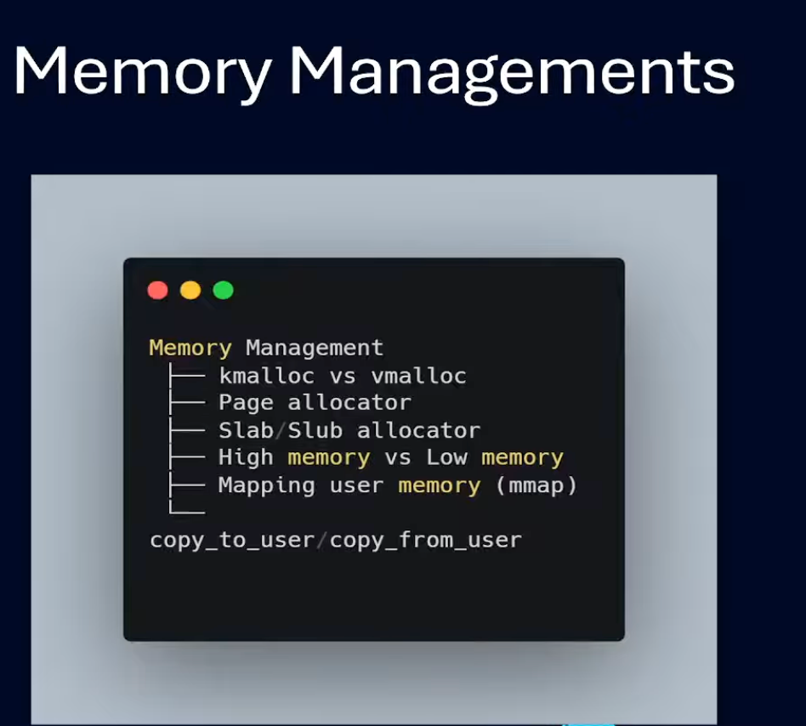
Memory Managements

Memory Management
├── kmalloc vs vmalloc
├── Page allocator
├── Slab/Slub allocator
├── High memory vs Low memory
├── Mapping user memory (mmap)
└── copy_to_user/copy_from_user

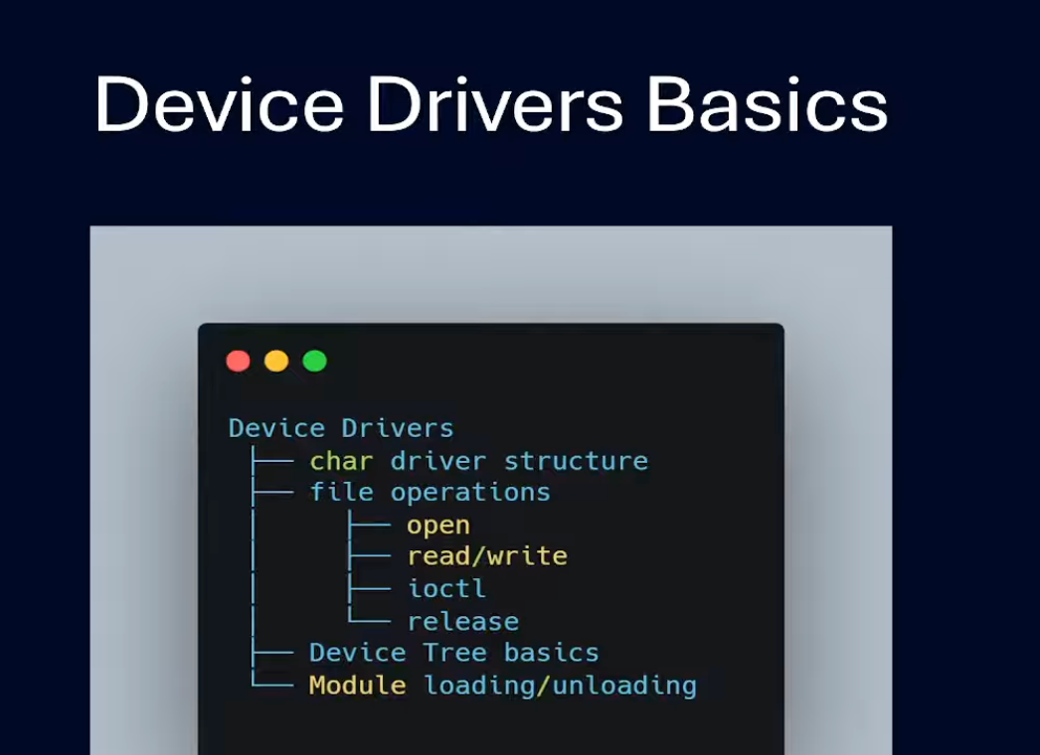
Device Drivers
├── char driver structure
├── file operations
│ ├── open
│ ├── read/write
│ ├── ioctl
│ └── release
├── Device Tree basics
└── Module loading/unloading

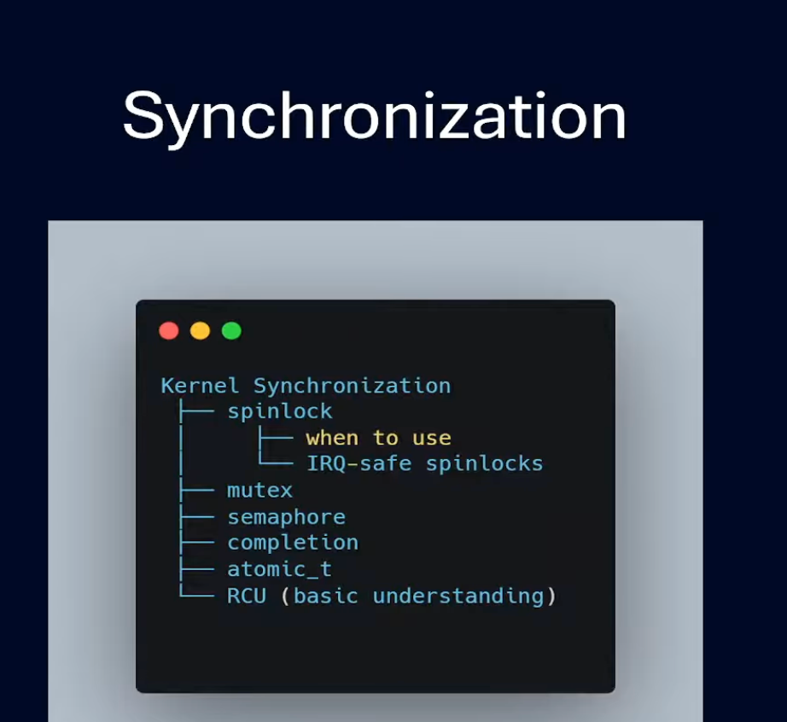
Kernel Synchronization
├── spinlock
│ └── when to use
│ └── IRQ-safe spinlocks
├── mutex
├── semaphore
├── completion
├── atomic_t
└── RCU (basic understanding)

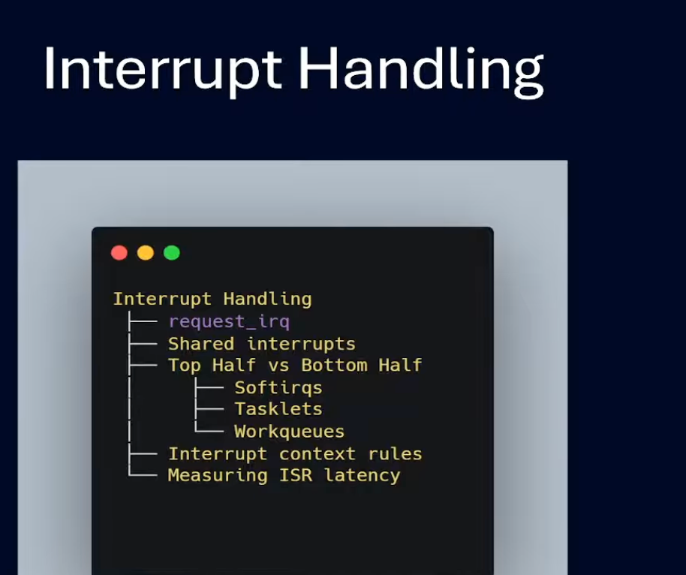
Interrupt Handling
├── request_irq
├── Shared interrupts
├── Top Half vs Bottom Half
│ ├── Softirqs
│ ├── Tasklets
│ └── Workqueues
├── Interrupt context rules
└── Measuring ISR latency

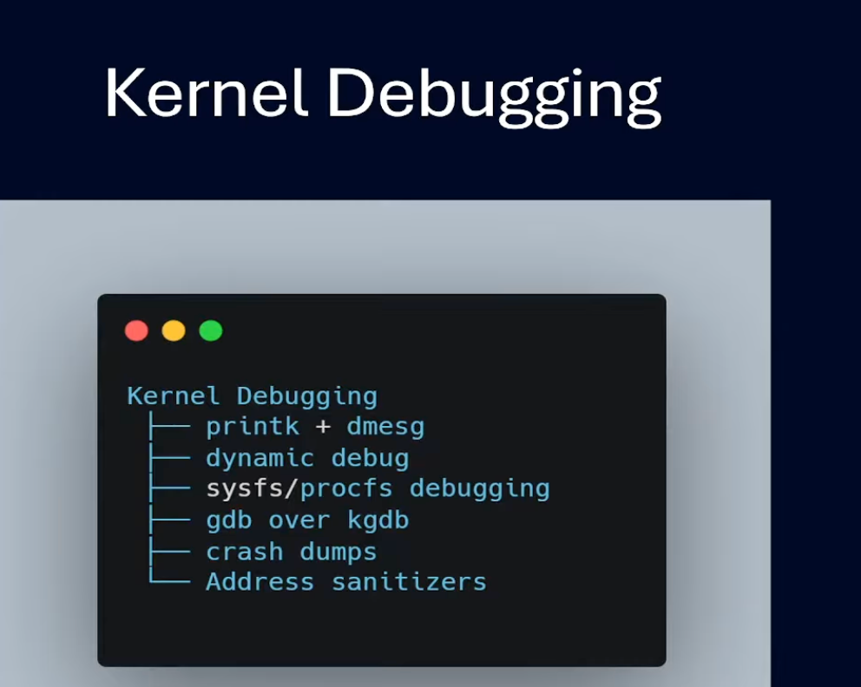
Kernel Debugging
├── printk + dmesg
├── dynamic debug
├── sysfs/procfs debugging
├── gdb over kgdb
├── crash dumps
└── Address sanitizers

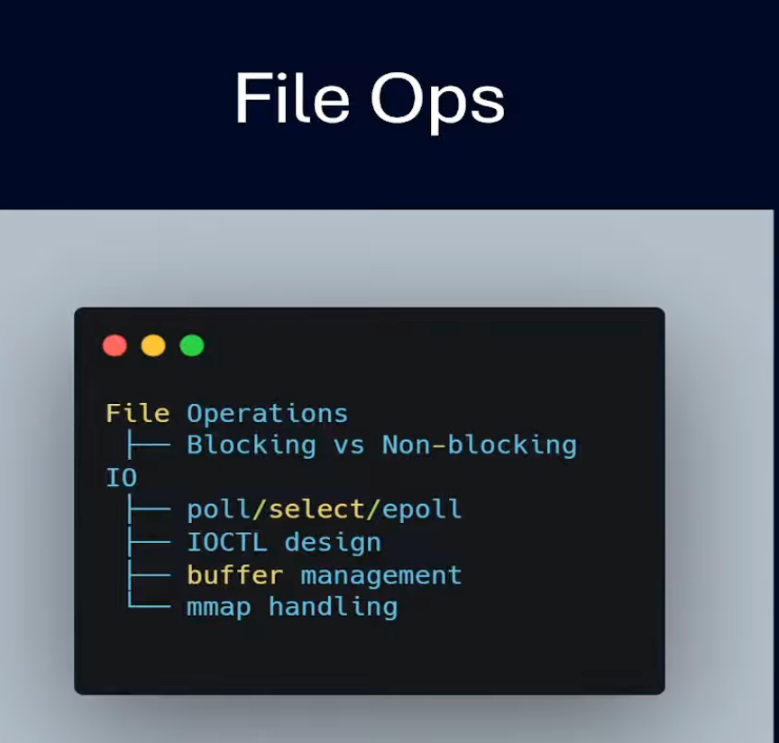
File Operations
├── Blocking vs Non-blocking IO
├── poll/select/epoll
├── IOCTL design
├── buffer management
└── mmap handling

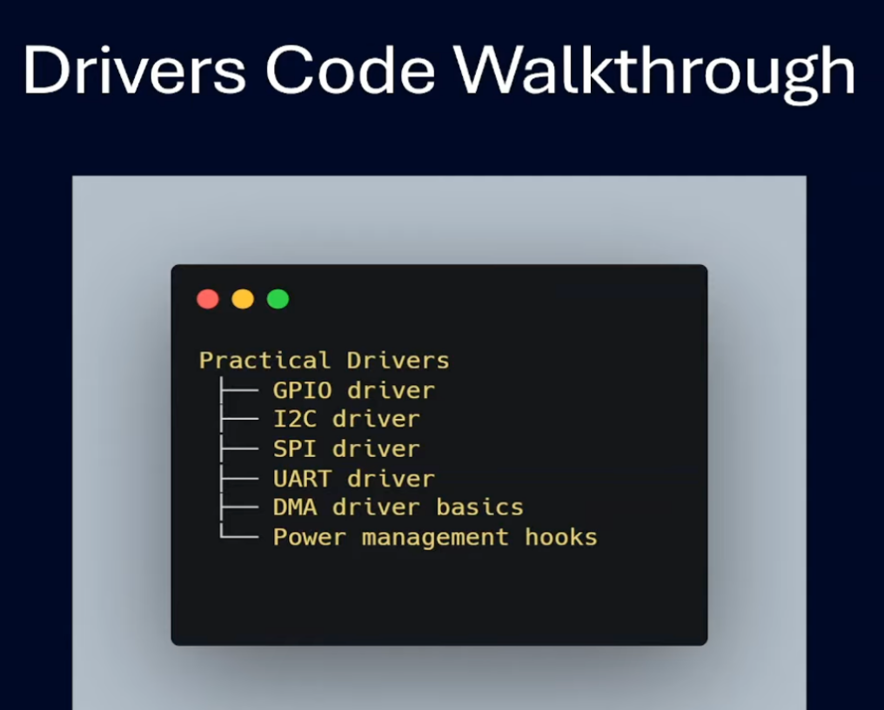
Drivers Code Walkthrough

Practical Drivers
├── GPIO driver
├── I2C driver
├── SPI driver
├── UART driver
├── DMA driver basics
└── Power management hooks

