🔹 1. Circuit Design & Basics
Q1: Explain Ohm’s Law and its importance.
Answer:
Ohm’s Law states: V = I × R.
It helps calculate voltage, current, and resistance in circuits and is fundamental for designing and analyzing circuits.
Q2: What are the key steps in PCB design?
Answer:
- Schematic design
- Component selection
- PCB layout (placement + routing)
- Design Rule Check (DRC)
- Manufacturing (Gerber generation)
Q3: What is the difference between analog and digital circuits?
Answer:
- Analog: continuous signals (e.g., audio)
- Digital: discrete signals (0 and 1)

🔹 2. PCB & Tools (Altium / OrCAD)
Q4: What is a ground plane and why is it important?
Answer:
A ground plane is a copper layer connected to ground.
It reduces noise, improves signal integrity, and provides a return path.
Q5: What is DRC in PCB design?
Answer:
Design Rule Check ensures spacing, width, and layout follow manufacturing rules to avoid errors.

🔹 3. Electronic Components
Q6: What is the difference between diode and transistor?
Answer:
- Diode: allows current in one direction
- Transistor: used for switching and amplification
Q7: What is an opto-isolator?
Answer:
It transfers signals using light to isolate two circuits electrically, improving safety.

🔹 4. Microcontrollers & Embedded Systems
Q8: What is a microcontroller?
Answer:
A microcontroller is a small computer on a chip (CPU + memory + peripherals) used to control embedded systems.
Q9: Difference between microcontroller and microprocessor?
Answer:
- Microcontroller: integrated system (used in embedded systems)
- Microprocessor: requires external components (used in computers)

🔹 5. Communication Protocols
Q10: Difference between I2C, SPI, and UART?
Answer:
Protocol | Type | Speed | Wires
I2C | Synchronous | Medium | 2
SPI | Synchronous | High | 4+
UART | Asynchronous | Low | 2

🔹 6. C Programming / RTOS
Q11: What is RTOS?
Answer:
A Real-Time Operating System ensures tasks execute within strict timing constraints.
Q12: What is a mutex?
Answer:
A mutex is used to protect shared resources and prevent race conditions between tasks.
Q13: What is stack vs heap?
Answer:
- Stack: fixed size, fast, used for function calls
- Heap: dynamic memory allocation

🔹 7. Debugging & Problem Solving
Q14: How do you debug a hardware issue?
Answer:
- Check power supply
- Verify connections
- Use oscilloscope/logic analyzer
- Test modules individually
Q15: How do you debug firmware issues?
Answer:
- Use breakpoints
- Print logs (UART)
- Check memory usage
- Analyze timing issues

🔹 8. Behavioral Questions
Q16: Describe a challenging project.
Answer (sample):
“I worked on an embedded system where communication was failing due to noise. I analyzed signals using an oscilloscope, improved grounding and shielding, and resolved the issue.”
Q17: How do you handle deadlines?
Answer:
“I prioritize tasks, break work into smaller steps, and focus on critical deliverables first.”

🔹 9. Testing & Standards
Q18: What is EMI/EMC?
Answer:
- EMI: electromagnetic interference
- EMC: ability of a device to operate without causing/interfering

🔹 10. Real-World Scenario
Q19: If your PCB is not working, what will you do?
Answer:
- Check power rails
- Verify clock signals
- Inspect soldering
- Test components
- Use debugging tools
If you want, I can next:
✅ Create advanced (company-level tricky questions)
✅ Give answers based on your experience (AUTOSAR, PIC32, OPC UA)
✅ Do a mock interview with you

more hardware interview question and answer
Show moreShow less
Good—let’s go deeper into hardware-focused interview questions (this level is closer to what companies actually ask).

🔹 Advanced Hardware Interview Q&A

🔸 1. Power & Circuit Design
Q1: What is decoupling capacitor and why is it used?
Answer:
A decoupling capacitor is placed close to IC power pins to filter noise and stabilize voltage.
It supplies instant current during switching and reduces voltage spikes.
Q2: Why do we use bulk capacitors and ceramic capacitors together?
Answer:
- Bulk capacitors → handle low-frequency noise
- Ceramic capacitors → handle high-frequency noise
Together they provide full-spectrum filtering.
Q3: What happens if grounding is poor in PCB?
Answer:
- Noise increases
- Signal integrity issues
- EMI problems
- Unstable circuit behavior

🔸 2. PCB Design (Very Important)
Q4: What are important PCB layout guidelines?
Answer:
- Keep traces short and direct
- Separate analog and digital grounds
- Proper grounding (ground plane)
- Avoid sharp 90° bends
- Place decoupling capacitors near ICs
- Proper trace width for current
Q5: What is impedance matching?
Answer:
Ensuring the source and load impedance are equal to avoid signal reflection, especially in high-speed signals.
Q6: What is crosstalk?
Answer:
Unwanted coupling between adjacent traces due to electromagnetic interference.

🔸 3. Signals & Noise
Q7: What is signal integrity?
Answer:
The quality of a signal as it travels through a circuit without distortion, noise, or delay.
Q8: What causes ringing in signals?
Answer:
- Impedance mismatch
- Long traces
- Fast switching edges
Q9: What is EMI and how do you reduce it?
Answer:
EMI is unwanted electromagnetic interference.
Reduction methods:
- Shielding
- Proper grounding
- Filtering (capacitors, ferrites)
- Short trace routing

🔸 4. Components & Practical Design
Q10: How do you select a resistor value?
Answer:
Based on current, voltage, and application (e.g., pull-up, current limiting).
Q11: What is pull-up and pull-down resistor?
Answer:
- Pull-up → keeps signal HIGH
- Pull-down → keeps signal LOW
Used to avoid floating inputs.
Q12: What is MOSFET vs BJT?
Answer:
- MOSFET → voltage-controlled, high efficiency
- BJT → current-controlled, used in amplification

🔸 5. Power Electronics
Q13: What is LDO vs Switching Regulator?
Answer:
- LDO → simple, low noise, low efficiency
- Switching → high efficiency, more complex, noisy
Q14: What is ripple in power supply?
Answer:
Small AC variation in DC output.
Q15: How do you reduce ripple?
Answer:
Using capacitors, filters, and better regulator design.

🔸 6. Microcontroller Hardware Interface
Q16: Why do we use crystal oscillator?
Answer:
To provide accurate clock frequency for microcontroller operation.
Q17: What is watchdog timer?
Answer:
A timer that resets the system if software hangs.
Q18: What is brown-out reset?
Answer:
Resets MCU when supply voltage drops below threshold.

🔸 7. Communication Hardware
Q19: Why use termination resistor in communication lines?
Answer:
To prevent signal reflection in high-speed communication (e.g., CAN, RS-485).
Q20: What is differential signaling?
Answer:
Signals transmitted using two complementary lines → reduces noise (e.g., CAN, RS-485).

🔸 8. Testing & Debugging
Q21: What tools do you use for hardware debugging?
Answer:
- Oscilloscope
- Multimeter
- Logic analyzer
- Spectrum analyzer
Q22: How do you check if MCU is working on board?
Answer:
- Check power pins
- Verify clock signal
- Check reset pin
- Try simple GPIO toggle

🔸 9. Real Scenario Questions (Very Important)
Q23: Your board powers on but not working. What will you do?
Answer:
- Check voltage rails
- Verify clock
- Check reset line
- Inspect PCB/soldering
- Debug firmware
Q24: UART communication not working. Why?
Answer:
- Wrong baud rate
- Wiring issue (TX/RX swapped)
- No common ground
- Noise

🔸 10. Design Thinking Questions
Q25: How do you design a power supply for a board?
Answer:
- Determine voltage/current requirements
- Select regulator (LDO/switching)
- Add filtering capacitors
- Ensure thermal considerations
If you want next level preparation, I can:
✅ Give very tricky real interview questions (AMD / Qualcomm level)
✅ Create answers using your PIC32 + AUTOSAR experience
✅ Do a mock interview (I ask, you answer, I correct)

need some basics electronics question and answer
Show moreShow less
Got it—let’s cover basic electronics interview questions in a simple and clear way (very useful for interviews 👇)

🔹 Basic Electronics Interview Q&A

🔸 1. Fundamentals
Q1: What is voltage?
Answer:
Voltage is the potential difference between two points. It pushes current through a circuit.
Q2: What is current?
Answer:
Current is the flow of electric charge (electrons) in a circuit. Measured in amperes (A).
Q3: What is resistance?
Answer:
Resistance opposes the flow of current. Measured in ohms (Ω).
Q4: State Ohm’s Law.
V=IRV = IRV=IR
III

RRR

V=IR=12V = IR = 12V=IR=12
Answer:
It defines the relationship between voltage, current, and resistance.

🔸 2. Basic Components
Q5: What is a resistor?
Answer:
A resistor limits current flow and controls voltage levels.
Q6: What is a capacitor?
Answer:
A capacitor stores electrical energy in an electric field and releases it when needed.
Q7: What is an inductor?
Answer:
An inductor stores energy in a magnetic field when current flows through it.

🔸 3. Diodes & Transistors
Q8: What is a diode?
Answer:
A diode allows current to flow in only one direction.
Q9: What is a Zener diode?
Answer:
A Zener diode is used for voltage regulation and allows reverse current after a set voltage.
Q10: What is a transistor?
Answer:
A transistor is used as a switch or amplifier.

🔸 4. AC & DC
Q11: What is DC?
Answer:
Direct Current flows in one direction (e.g., battery).
Q12: What is AC?
Answer:
Alternating Current changes direction periodically (e.g., household power).

🔸 5. Basic Laws
Q13: What is Kirchhoff’s Current Law (KCL)?
Answer:
The total current entering a node equals the total current leaving the node.
Q14: What is Kirchhoff’s Voltage Law (KVL)?
Answer:
The sum of all voltages in a closed loop is zero.

🔸 6. Circuit Types
Q15: What is a series circuit?
Answer:
Components are connected in a single path → same current flows through all.
Q16: What is a parallel circuit?
Answer:
Components are connected in multiple paths → same voltage across all.

🔸 7. Power
Q17: What is electrical power?
P=VIP = VIP=VI
Answer:
Power is the rate of energy consumption in a circuit.

🔸 8. Practical Basics
Q18: What is a short circuit?
Answer:
A direct connection with very low resistance causing high current.
Q19: What is an open circuit?
Answer:
A broken path where no current flows.
Q20: What is grounding?
Answer:
Connecting a circuit to earth for safety and stable reference voltage.

🔸 9. Measurement
Q21: What is a multimeter used for?
Answer:
To measure voltage, current, and resistance.

🔸 10. Simple Real Question
Q22: Why does a bulb glow?
Answer:
Because current flows through the filament, heating it and producing light.
If you want, I can next:
✅ Give basic + intermediate mixed questions (most asked in interviews)
✅ Provide quick revision notes (1-page cheat sheet)
✅ Or do a rapid-fire mock interview (very helpful before interview)

Give me basic + intermediate mixed questions most asked in interviews
Show moreShow less
Great—this is exactly what interviewers like: a mix of fundamentals + practical understanding. I’ll keep it simple, clear, and commonly asked 👇

🔹 Basic + Intermediate Electronics Interview Q&A

🔸 1. Fundamentals (Very Common)
Q1: What is the difference between voltage and current?
Answer:
- Voltage → pushes electrons
- Current → flow of electrons
Q2: State Ohm’s Law.
V=IRV = IRV=IR
III

RRR

V=IR=12V = IR = 12V=IR=12
Answer:
Voltage is equal to current multiplied by resistance.
Q3: What is power in a circuit?
P=VIP = VIP=VI
Answer:
Power is the rate of energy usage.

🔸 2. Components (Must Know)
Q4: Difference between capacitor and inductor?
Answer:
- Capacitor → stores energy in electric field
- Inductor → stores energy in magnetic field
Q5: What is ESR in a capacitor?
Answer:
Equivalent Series Resistance—internal resistance that affects performance and causes heat.
Q6: What is a pull-up resistor?
Answer:
It keeps a signal HIGH when no input is connected.

🔸 3. Diodes & Transistors
Q7: What is forward bias and reverse bias?
Answer:
- Forward → diode conducts
- Reverse → diode blocks current
Q8: What is saturation and cutoff in transistor?
Answer:
- Saturation → fully ON
- Cutoff → fully OFF
Q9: Why MOSFET is preferred in switching?
Answer:
High efficiency, fast switching, low power loss.

🔸 4. Circuit Theory
Q10: What is KCL?
Answer:
Sum of currents at a node = 0.
Q11: What is KVL?
Answer:
Sum of voltages in a loop = 0.
Q12: What happens to current in series vs parallel?
Answer:
- Series → same current
- Parallel → current splits

🔸 5. PCB & Practical Design
Q13: Why place decoupling capacitor near IC?
Answer:
To reduce noise and stabilize power supply instantly.
Q14: What is ground loop?
Answer:
Multiple ground paths causing noise/interference.
Q15: Why avoid 90° traces in PCB?
Answer:
They can cause signal reflection and EMI issues.

🔸 6. Signals & Communication
Q16: What is baud rate?
Answer:
Number of bits transmitted per second.
Q17: Difference between analog and digital signal?
Answer:
- Analog → continuous
- Digital → discrete (0/1)
Q18: What is noise in signals?
Answer:
Unwanted disturbance affecting signal quality.

🔸 7. Power & Regulators
Q19: Difference between LDO and SMPS?
Answer:
- LDO → simple, low noise, less efficient
- SMPS → high efficiency, more complex
Q20: What is voltage regulator?
Answer:
Maintains constant output voltage.

🔸 8. Embedded Hardware Basics
Q21: What is clock in microcontroller?
Answer:
It controls timing and execution speed.
Q22: Why use watchdog timer?
Answer:
To reset system if it hangs.

🔸 9. Debugging (Very Important)
Q23: How do you check power issue in board?
Answer:
- Measure voltage rails
- Check regulators
- Verify ground
Q24: Why circuit not working even if design is correct?
Answer:
- Wrong connections
- Noise
- Component failure
- PCB issues

🔸 10. Scenario-Based (Most Asked)
Q25: LED not glowing—what will you check?
Answer:
- Power supply
- Resistor value
- Polarity
- Connections
Q26: MCU not responding—what will you check?
Answer:
- Power
- Clock
- Reset pin
- Firmware

🔥 Quick Tip for Interview
If you don’t know answer fully:
👉 Start with basic concept + small example
👉 Keep answer short and confident
If you want next step:
✅ Top 20 tricky questions (very important)
✅ Only PCB + Hardware debugging questions
✅ Mock interview (I ask, you answer, I correct)

Power supply related question and answers
Show moreShow less
Good choice—power supply questions are very commonly asked in hardware interviews. I’ll give you simple + practical Q&A 👇

🔹 Power Supply Interview Questions & Answers

🔸 1. Basics
Q1: What is a power supply?
Answer:
A power supply converts electrical energy into a suitable form (voltage/current) to power a circuit.
Q2: What are types of power supplies?
Answer:
- Linear power supply
- Switching power supply (SMPS)
Q3: What is DC power supply?
Answer:
It provides constant DC voltage to electronic circuits.

🔸 2. Regulators
Q4: What is a voltage regulator?
Answer:
A device that maintains a constant output voltage despite input changes.
Q5: What is LDO?
Answer:
Low Dropout Regulator—works even when input voltage is slightly higher than output.
Q6: What is SMPS?
Answer:
Switch Mode Power Supply—uses switching components for high efficiency.
Q7: Difference between LDO and SMPS?
Answer:
- LDO → simple, low noise, low efficiency
- SMPS → high efficiency, more complex, noisy

🔸 3. Important Concepts
Q8: What is ripple voltage?
Answer:
Small AC variation present in DC output.
Q9: How do you reduce ripple?
Answer:
- Use capacitors (filtering)
- Use regulators
- Use LC filters
Q10: What is efficiency?
η=PoutPin×100%\eta = \frac{P_{out}}{P_{in}} \times 100\%η=Pin​Pout​​×100%
Answer:
Ratio of output power to input power.

🔸 4. Practical Design
Q11: What components are used in a power supply?
Answer:
- Transformer (for AC)
- Rectifier (diodes)
- Capacitor (filter)
- Regulator
Q12: What is a rectifier?
Answer:
Converts AC to DC (half-wave or full-wave).
Q13: What is a filter capacitor?
Answer:
Smooths the rectified DC by reducing ripple.

🔸 5. Protection
Q14: What is overvoltage protection?
Answer:
Prevents damage when voltage exceeds limit.
Q15: What is overcurrent protection?
Answer:
Limits current to protect components.
Q16: What is short-circuit protection?
Answer:
Shuts down or limits current during a short.

🔸 6. Batteries & Sources
Q17: What is battery vs regulated supply?
Answer:
- Battery → portable, voltage drops over time
- Regulated → stable output

🔸 7. Hardware Practical Questions
Q18: Why place capacitors near power pins?
Answer:
To provide instant current and reduce noise.
Q19: Why does voltage drop in circuit?
Answer:
Due to resistance, load current, or poor design.
Q20: What is load regulation?
Answer:
Ability to maintain output voltage when load changes.

🔸 8. Debugging (Very Important)
Q21: Power supply not working—what will you check?
Answer:
- Input voltage
- Output voltage
- Components (diodes, caps)
- Short circuit
Q22: Output voltage is low—possible reasons?
Answer:
- Overload
- Faulty regulator
- Input voltage low
Q23: Excessive heating in regulator—why?
Answer:
- High current
- Large voltage drop
- Poor heat dissipation

🔸 9. Real Interview Question
Q24: How do you design a 5V power supply?
Answer:
- Input source (e.g., 12V)
- Use regulator (7805 or SMPS)
- Add input/output capacitors
- Ensure heat handling

🔥 Quick Interview Tip
For power questions:
👉 Always mention efficiency + heat + noise
👉 That shows strong practical knowledge
If you want next:
✅ SMPS deep interview questions (very important for experienced roles)
✅ PCB power design interview questions
✅ Real debugging scenarios (very tough)

Important thinks to consider power supply design
Show moreShow less
Good—this is a very important interview topic. I’ll keep it simple, practical, and interview-ready 👇

🔹 Important Things to Consider in Power Supply Design

🔸 1. Input Requirements
- Input voltage range (min/max)
- AC or DC input
- Protection for surges/spikes
👉 Example: 9V–24V input variation

🔸 2. Output Requirements
- Required output voltage (e.g., 5V, 3.3V)
- Maximum load current
- Number of output rails
👉 Always design with margin (20–30%)

🔸 3. Power Rating
- Calculate total power needed
- Choose components that can handle load
👉 Power = Voltage × Current

🔸 4. Efficiency
- High efficiency reduces heat
- Choose SMPS for high power, LDO for low noise
👉 Important in battery-powered systems

🔸 5. Thermal Management
- Heat dissipation (heatsink if needed)
- Check regulator temperature
👉 Overheating = failure risk

🔸 6. Ripple & Noise
- Keep output voltage clean
- Use:
  - Capacitors (decoupling + bulk)
  - LC filters
👉 Very important for sensitive circuits (MCU, ADC)

🔸 7. Regulation
- Line regulation (input variation)
- Load regulation (load change)
👉 Output should remain stable

🔸 8. Protection Features
- Overvoltage protection (OVP)
- Overcurrent protection (OCP)
- Short-circuit protection
- Reverse polarity protection

🔸 9. Component Selection
- Capacitors (correct ESR, value)
- Inductor (for SMPS)
- Diodes (fast recovery for switching)
- Regulator IC selection

🔸 10. PCB Layout (Very Important)
- Keep power traces wide
- Place capacitors near IC
- Use solid ground plane
- Minimize loop area
- Separate analog & digital grounds
👉 Poor layout = noise + failure

🔸 11. Startup & Stability
- Soft-start (avoid inrush current)
- Stability (no oscillation)

🔸 12. EMI/EMC Considerations
- Reduce electromagnetic noise
- Use shielding, filtering, proper layout

🔸 13. Reliability & Safety
- Component derating (don’t use at max limits)
- Temperature range
- Long-term stability

🔸 14. Cost & Size
- Balance performance vs cost
- Compact design if required

🔥 Simple Interview Answer (Short Version)
If interviewer asks:
👉 “What do you consider in power supply design?”
You can say:
“I consider input/output requirements, efficiency, thermal management, ripple and noise, protection features, component selection, and PCB layout. I also ensure proper regulation, EMI control, and reliability for stable operation.”
If you want next level:
✅ I can give real design example (12V → 5V, 3.3V)
✅ Or SMPS design interview questions (advanced)
✅ Or common mistakes engineers make (very useful in interview)

Amplifiers types and different
Show moreShow less
Here’s a simple and interview-friendly explanation of amplifier types and their differences 👇

🔹 What is an Amplifier?
An amplifier increases the strength of a signal (voltage, current, or power).

🔹 Types of Amplifiers

🔸 1. Based on Signal Type

✅ Voltage Amplifier
- Increases voltage
- Used in audio circuits

✅ Current Amplifier
- Increases current
- Used to drive loads

✅ Power Amplifier
- Increases power (V × I)
- Used in speakers, motors

🔸 2. Based on Operation (Very Important)

🔹 Class A Amplifier
- Conducts for full 360°
- ✔ High quality signal
- ❌ Low efficiency (~25–30%)
- Used in audio systems

🔹 Class B Amplifier
- Conducts for 180°
- ✔ Better efficiency
- ❌ Distortion (crossover distortion)

🔹 Class AB Amplifier
- Conducts more than 180° but less than 360°
- ✔ Balance of efficiency + low distortion
- ✔ Most commonly used

🔹 Class C Amplifier
- Conducts less than 180°
- ✔ Very high efficiency
- ❌ High distortion
- Used in RF applications

🔹 Class D Amplifier (Modern)
- Works using switching (PWM)
- ✔ Very high efficiency (~90%)
- ✔ Less heat
- Used in portable/audio devices

🔸 3. Based on Configuration

✅ Common Emitter (CE)
- High gain
- Most widely used

✅ Common Base (CB)
- Low input impedance
- High frequency use

✅ Common Collector (CC) (Emitter Follower)
- Voltage gain ≈ 1
- Used as buffer

🔸 4. Based on Frequency

✅ Audio Amplifier
- Works in audio range (20Hz–20kHz)

✅ RF Amplifier
- Works in high-frequency (radio signals)

🔹 Key Differences (Interview Table)
Type | Efficiency | Distortion | Usage
Class A | Low | Very low | Audio
Class B | Medium | High | Basic audio
Class AB | Medium | Low | Most common
Class C | High | Very high | RF
Class D | Very high | Low | Modern audio

🔥 Simple Interview Answer
If asked:
👉 “Explain amplifier types”
“Amplifiers are classified based on signal type, operation, and configuration. Important types are Class A, B, AB, C, and D. Class A gives best signal quality but low efficiency, Class B improves efficiency but has distortion, Class AB is a balance and most commonly used, Class C is used in RF, and Class D is highly efficient using switching techniques.”
If you want next:
✅ Op-amp interview questions (very important)
✅ Real circuit examples (CE amplifier, audio amplifier)
✅ Tricky viva questions on amplifiers

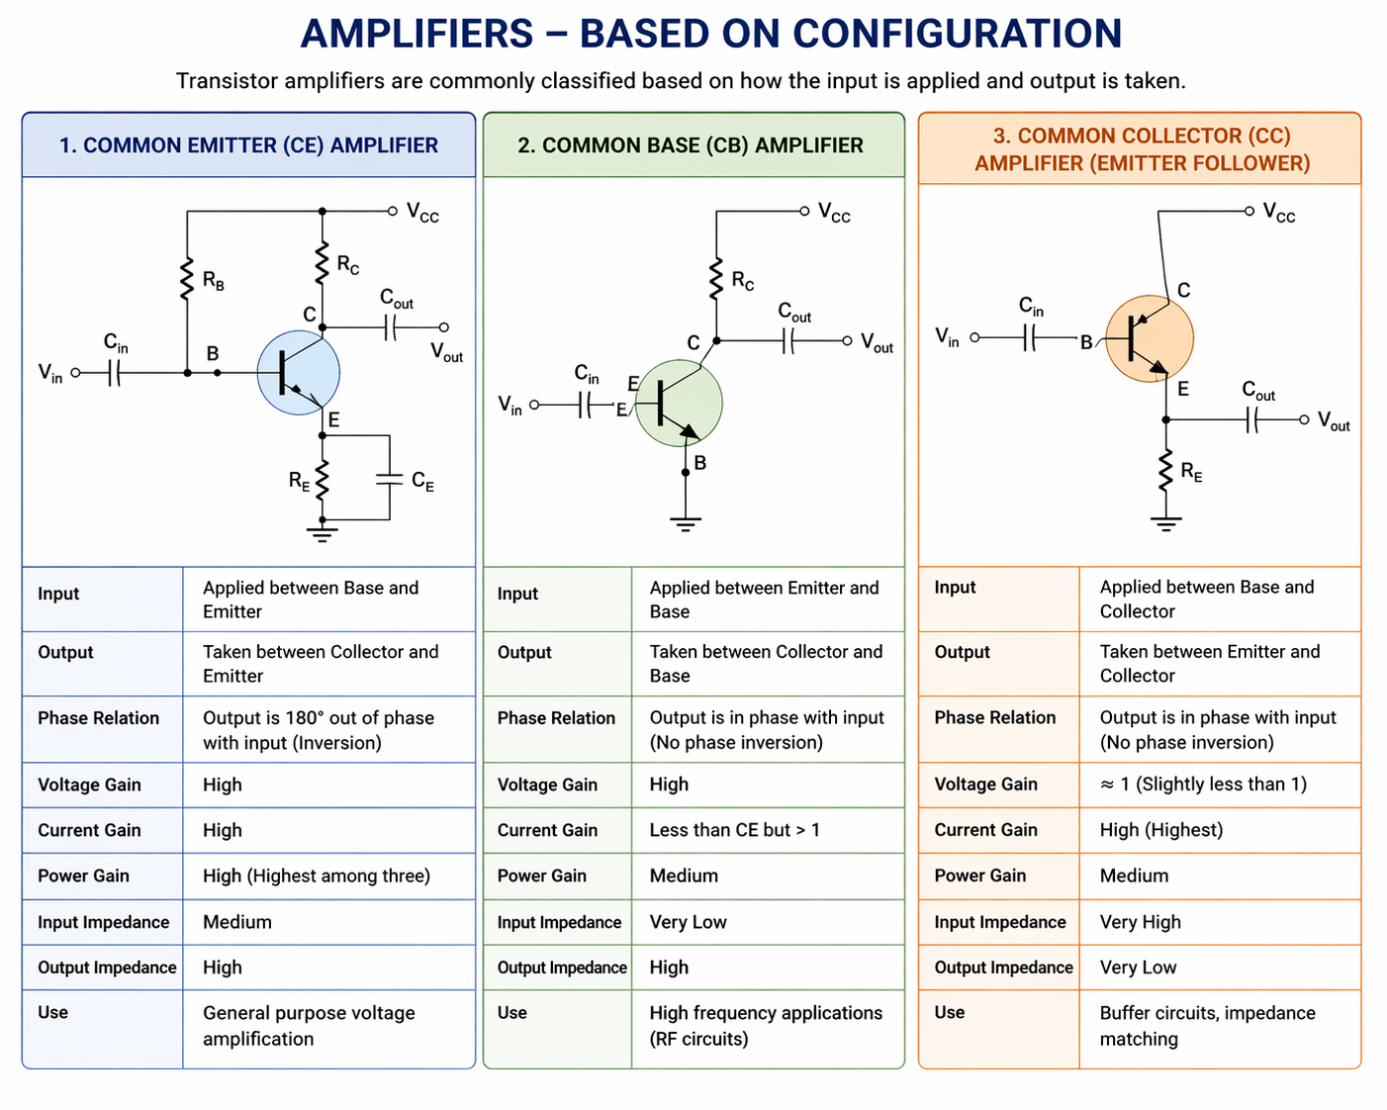

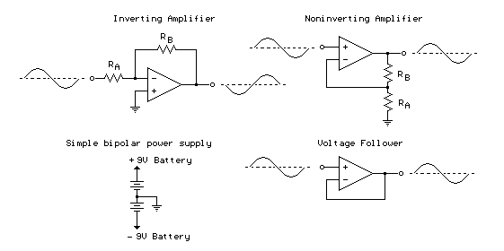

🔹 1. UART Interview Questions

Q1: What is UART?
Answer:
UART (Universal Asynchronous Receiver Transmitter) is a serial communication protocol used for asynchronous data transfer between two devices.

Q2: Why is UART called asynchronous?
Answer:
Because it does not use a clock signal. Both devices must agree on baud rate.

Q3: What are UART signals?
Answer:
- TX (Transmit)
- RX (Receive)

Q4: What are UART frame components?
Answer:
- Start bit
- Data bits
- Parity bit (optional)
- Stop bit

Q5: What are UART limitations?
Answer:
- Only 2 devices
- Limited distance
- Requires accurate baud rate matching

🔹 2. SPI Interview Questions

Q6: What is SPI?
Answer:
SPI (Serial Peripheral Interface) is a synchronous high-speed communication protocol.

Q7: Why SPI is faster than UART?
Answer:
Because SPI uses a clock signal (SCLK) for synchronization.

Q8: What are SPI signals?
Answer:
- MOSI (Master Out Slave In)
- MISO (Master In Slave Out)
- SCLK (Clock)
- SS/CS (Slave Select)

Q9: How many devices can SPI support?
Answer:
Multiple slaves, but each requires a separate chip select (CS) line.

Q10: Disadvantages of SPI?
Answer:
- More wires required
- No built-in error checking
- Short distance communication

🔹 3. I2C Interview Questions

Q11: What is I2C?
Answer:
I2C (Inter-Integrated Circuit) is a two-wire synchronous communication protocol.

Q12: What are I2C signals?
Answer:
- SDA (Data line)
- SCL (Clock line)

Q13: Why pull-up resistors are used in I2C?
Answer:
Because SDA and SCL are open-drain/open-collector, so pull-ups are needed to bring lines HIGH.

Q14: What is I2C addressing?
Answer:
Each slave has a unique 7-bit or 10-bit address.

Q15: Advantages of I2C?
Answer:
- Only 2 wires needed
- Supports multiple devices
- Easy expansion

Q16: Disadvantages of I2C?
Answer:
- Slower than SPI
- Limited distance
- Slower for high-speed data

🔹 4. Comparison Questions (VERY IMPORTANT)

Q17: Difference between UART, SPI, I2C?
Feature | UART | SPI | I2C
Type | Asynchronous | Synchronous | Synchronous
Speed | Medium | High | Medium
Wires | 2 | 4+ | 2
Devices | 2 only | Multiple (CS needed) | Multiple (addressing)
Clock | No | Yes | Yes

Q18: When do you use SPI over I2C?
Answer:
When you need high speed and fast data transfer (e.g., displays, ADCs).

Q19: When do you use I2C over SPI?
Answer:
When you need multiple devices with fewer wires.

Q20: When do you use UART?
Answer:
For simple point-to-point communication like debugging (serial console).

🔹 5. Hardware Debugging Questions

Q21: UART not working—what will you check?
Answer:
- Baud rate mismatch
- TX/RX swap
- Ground connection
- Voltage level mismatch

Q22: SPI not working—what will you check?
Answer:
- Clock signal (SCLK)
- Chip select (CS)
- MOSI/MISO connection
- Mode (CPOL/CPHA)

Q23: I2C not working—what will you check?
Answer:
- Pull-up resistors
- Device address
- SDA/SCL lines
- Clock speed compatibility
A buck converter reduces voltage and the output voltage is lower than the input voltage. See Figure
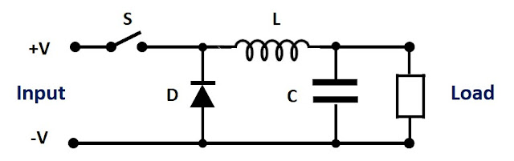

Figure 1: Buck converter
When transistor S is turned on, energy is stored in inductor L as the current flows to the load and capacitor C is charged. When S is off, the energy stored in L is released and current flows into the load and circulates via diode D. Capacitor C also provides energy to the load. This is repeated at a high frequencies, greater than 100,000 times a second. The length of the time S is turned on defines the output voltage.
A boost converter increases voltage and the output voltage is higher than the input voltage. See Figure 2.
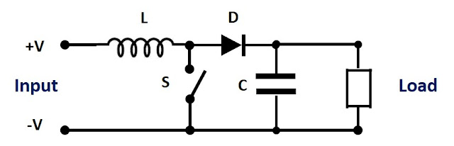
Figure 2: Boost converter
When transistor S is turned on, current flows through inductor L, through transistor S back to the input. During this period energy is stored in the inductor. When transistor S is off, the inductor acts a voltage source in series with the input voltage. The inductor’s stored energy is circulated through diode D to the load. This charges capacitor C to a higher level than the input voltage. Again, the length of the time S is turned on defines the output voltage.
This boost converter topology is also used in most Power Factor Control (PFC) sections of AC-DC power supplies. The control IC is different of course, as its purpose is to ensure the AC input current drawn is sinusoidal in shape. At high line voltages greater than 240Vac the DC input may be higher than the voltage on capacitor C. This will reduce the PFC boost converter’s performance and the power factor will be degraded slightly.
A buck-boost converter is a combination of a buck and boost converter. The output voltage can be higher or lower than the input voltage. See Figure 3.
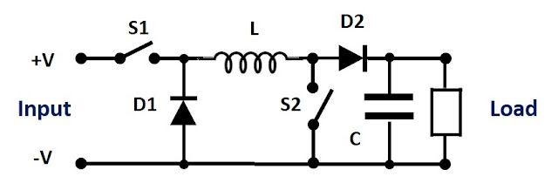
Figure 3: Buck-boost converter
As you can see the circuit is more complicated and has more components. S2, L, and D2 is the boost converter (S1 being on) and S1, L and D1 the buck section (S2 being off).
Many manufacturers like TDK-Lambda offer both buck and buck-boost converters. With less components and complexity, a buck converter will offer a lower cost, higher efficiency and either a smaller package or more output power.

MII and RMII
MII (Media Independent Interface) and RMII (Reduced MII) are standards to connect an Ethernet MAC to a PHY, both supporting 10/100 Mbps. MII uses 16+ pins at 25 MHz with 4-bit data paths, while RMII cuts pin count to ~8-9 by doubling the clock to 50 MHz and using 2-bit data paths, making RMII ideal for space-constrained, modern embedded systems.
Detailed Comparison Table
Feature | MII (Media Independent Interface) | RMII (Reduced MII)
Data Pins (TX/RX) | 4-bit TX, 4-bit RX | 2-bit TX, 2-bit RX
Clock Speed | 25 MHz | 50 MHz
Total Pins | ~16–18 | ~8–10
Signal Complexity | High | Low (fewer traces)
PCB Routing | Easier (lower frequency) | Requires more care (50MHz)
Typical Usage | FPGAs, older designs | STM32, Embedded systems

1. What is Ohm’s Law?
Answer:
Ohm’s Law states that voltage is directly proportional to current and resistance.
V=IRV = IRV=IR
Where:
- V = Voltage (Volts)
- I = Current (Amps)
- R = Resistance (Ohms)

2. What is Kirchhoff’s Current Law (KCL)?
Answer:
KCL states that total current entering a node = total current leaving the node.
👉 Based on conservation of charge.

3. What is Kirchhoff’s Voltage Law (KVL)?
Answer:
KVL states that the sum of all voltages in a closed loop is zero.
👉 Based on conservation of energy.

4. Difference between AC and DC?
Answer:
AC | DC
Alternating current | Direct current
Changes direction | Flows in one direction
Example: mains supply | Example: battery

5. What is Thevenin’s Theorem?
Answer:
Any linear circuit can be simplified into:
- A single voltage source (Vth)
- A series resistance (Rth)
👉 Helps simplify complex circuits.

6. What is Norton’s Theorem?
Answer:
Any linear circuit can be replaced by:
- A current source (In)
- A parallel resistance (Rn)

7. Difference between Thevenin and Norton?
Answer:
Thevenin | Norton
Voltage source + series R | Current source + parallel R
Vth = open circuit voltage | In = short circuit current

8. What is Superposition Theorem?
Answer:
In a linear circuit, response is sum of effects of each source acting alone.
👉 Turn off other sources:
- Voltage source → short circuit
- Current source → open circuit

9. What is Maximum Power Transfer Theorem?
Answer:
Maximum power is delivered when:
RL=RthR_L = R_{th}RL​=Rth​

10. What is impedance?
Answer:
Impedance is total opposition to AC current.
Z=R+jXZ = R + jXZ=R+jX
Where:
- R = Resistance
- X = Reactance

11. What is resonance in a circuit?
Answer:
Resonance occurs when inductive reactance equals capacitive reactance.
XL=XCX_L = X_CXL​=XC​
👉 Circuit behaves purely resistive.

12. What is power factor?
Answer:
Power factor is the ratio of real power to apparent power.
PF=cos⁡(ϕ)PF = \cos(\phi)PF=cos(ϕ)
👉 Indicates efficiency of power usage.

13. What is RMS value?
Answer:
RMS is the effective value of AC equivalent to DC heating effect.
VRMS=Vpeak2V_{RMS} = \frac{V_{peak}}{\sqrt{2}}VRMS​=2​Vpeak​​

14. What is transient response?
Answer:
Response of circuit during change in input before steady state.

15. Why do we use Laplace transform in circuits?
Answer:
To convert differential equations into algebraic equations for easier analysis.

If you want next level:
I can also give:
- 🔥 Tough circuit theory interview questions (company level)
- 🔥 Numerical problems (KVL/KCL/Thevenin)
- 🔥 RC, RL, RLC circuit analysis questions
- 🔥 Mixed electronics + circuit design interview set
Just tell 👍

hardware development lifecycle
Show moreShow less
Corrected sentence:
What is the hardware development lifecycle?

Hardware Development Lifecycle (HDLC)
The Hardware Development Lifecycle is the structured process used to design, develop, test, and manufacture electronic hardware products.
It ensures the product is reliable, manufacturable, and meets requirements.

1. Requirement Analysis
- Understand customer and system requirements
- Define electrical, mechanical, and environmental constraints
- Identify standards (e.g., EMC, safety)
👉 Output: Hardware Requirement Specification (HRS)

2. System Design / Architecture
- Break system into blocks (power, MCU, communication, sensors)
- Select microcontroller, ICs, power supply, interfaces
- Define system-level architecture
👉 Output: Block diagram + architecture design

3. Component Selection
- Choose components based on:
  - Voltage/current ratings
  - Availability
  - Cost
  - Reliability
- Example: LDO vs buck converter, sensor selection, MCU selection

4. Schematic Design
- Create circuit diagram using tools like:
  - Altium, OrCAD, KiCad
- Define:
  - Power circuits
  - Communication interfaces (I2C, SPI, UART)
  - Protection circuits (ESD, fuse, TVS)
👉 Output: Final schematic

5. PCB Layout Design
- Convert schematic to PCB
- Key considerations:
  - Signal integrity
  - Grounding strategy
  - Power routing
  - EMI/EMC control
- Stack-up design (2-layer, 4-layer, etc.)
👉 Output: Gerber files

6. Prototype Build
- Fabricate PCB
- Assemble components (SMT / through-hole)
- Initial power-up testing

7. Testing & Validation
- Functional testing
- Signal testing (oscilloscope, logic analyzer)
- Environmental testing (temperature, vibration)
- Compliance testing (EMI/EMC, safety standards)

8. Debugging & Iteration
- Fix design issues:
  - Noise problems
  - Power issues
  - Timing issues
- Update schematic/PCB if needed

9. Production / Manufacturing
- Finalize design for mass production (DFM – Design for Manufacturability)
- Create BOM (Bill of Materials)
- Assembly process setup

10. Maintenance & Support
- Field failure analysis
- Hardware revisions
- Product updates

