LAB 3 – COMPONENT MODELLING & ARCHITECTURAL PATTERN SELECTION
Smart Parking Space Rental & License Validator
1. Architectural Choice
Selected Architecture: Client-Server Architecture
The Smart Parking Space Rental & License Validator system uses a Client-Server architecture. The Parking User Interface acts as the client through which the Vehicle Owner interacts with the system, while the Parking Management System acts as the central server that coordinates parking requests, license validation, reservations, parking data, fee calculation and overstay detection.
2. Reasons for Choosing Client-Server Architecture
Reason 1 – Centralized Management:
Client-Server architecture provides a centralized Parking Management System that can manage parking reservations, vehicle validation, parking sessions and fee-related operations. This is suitable for the smart parking system because all parking information can be maintained and accessed from a central system.
Reason 2 – Simple Communication and Maintenance:
The architecture provides clear communication between the user interface and the central parking management system. The different services such as License Plate Validation Service, Parking Database and Fee & Overstay Management can be handled separately, making the system easier to maintain and update.
3. Security Advantage
Client-Server architecture allows important parking information and validation operations to be controlled centrally. Access to reservation data, vehicle information and parking records can be restricted through the central Parking Management System, reducing unauthorized access to sensitive data.
4. Performance Benefit
The architecture allows the Parking Management System to coordinate frequently required operations such as license-plate validation, reservation queries and parking-session processing. Separating these functions into dedicated components can reduce unnecessary processing and support quick vehicle validation and parking operations.

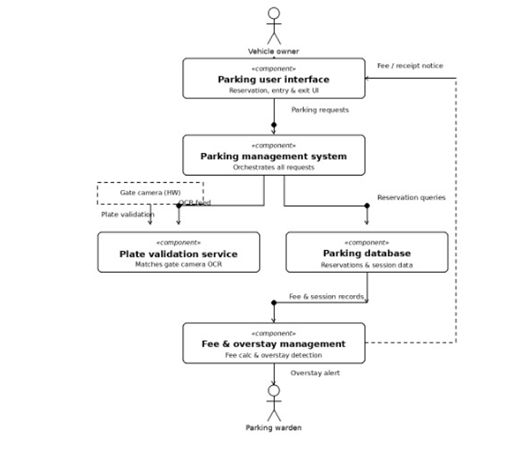
Component Diagram Description
The component diagram contains the following major components:
- Parking User Interface – provides the interface for parking reservation, entry and exit operations.
- Parking Management System – coordinates the major parking operations and requests.
- License Plate Validation Service – validates vehicle license plates using gate-camera input.
- Parking Database – stores reservation and parking-session information.
- Fee & Overstay Management – calculates parking fees and detects unauthorized overstays.
The diagram also includes the Vehicle Owner and Parking Warden actors and shows the interactions between the system components.

