Smart Parking Space Rental And License Validator
#22

1.Requirements Table – Smart Parking Space Rental & License Validator
ID | Type | Description | Priority | Acceptance Criteria | Rationale
FR-001 | Functional | The system shall allow the vehicle owner to reserve an available parking space for a selected time period. | High | Pass: A vehicle owner can successfully reserve an available parking space. Fail: The system allows a reservation for an unavailable space. | To allow vehicle owners to reserve parking spaces in advance.
FR-002 | Functional | The system shall validate the vehicle number plate using the gate camera when the vehicle arrives at the parking entrance. | High | Pass: A valid vehicle number plate is correctly identified and validated. Fail: An invalid or unregistered number plate is accepted. | To ensure that only vehicles with valid parking reservations can enter.
FR-003 | Functional | The system shall record the vehicle entry time and track the duration of the parking session. | High | Pass: The system records the correct entry time and parking duration. Fail: The entry time or duration is missing or incorrect. | To accurately determine how long a vehicle has occupied the parking space.
FR-004 | Functional | The system shall calculate the parking fee based on the duration of the parking session using progressive hourly rates. | High | Pass: The correct fee is calculated according to the applicable hourly rate. Fail: An incorrect rate or duration is used for billing. | To ensure accurate and fair parking charges.
FR-005 | Functional | The system shall detect and flag vehicles that remain parked beyond their authorized reservation period. | Medium | Pass: The system flags a vehicle when its authorized parking period is exceeded. Fail: An unauthorized overstay is not detected. | To help the parking warden identify unauthorized overstays.
NFR-001 | Performance | The gate camera license plate lookup and reservation validation shall be completed within 300 ms under normal operating conditions. | High | Pass: Testing confirms that validation is completed within 300 ms. Fail: Validation takes longer than 300 ms. | To prevent delays at the parking entrance.
NFR-002 | Security | The system shall allow only authorized vehicle owners and parking wardens to access parking and vehicle information. | High | Pass: Only authorized users can access the relevant information. Fail: An unauthorized user can access restricted information. | To protect vehicle, reservation, and parking information from unauthorized access.

2.UML Use-Case Diagram

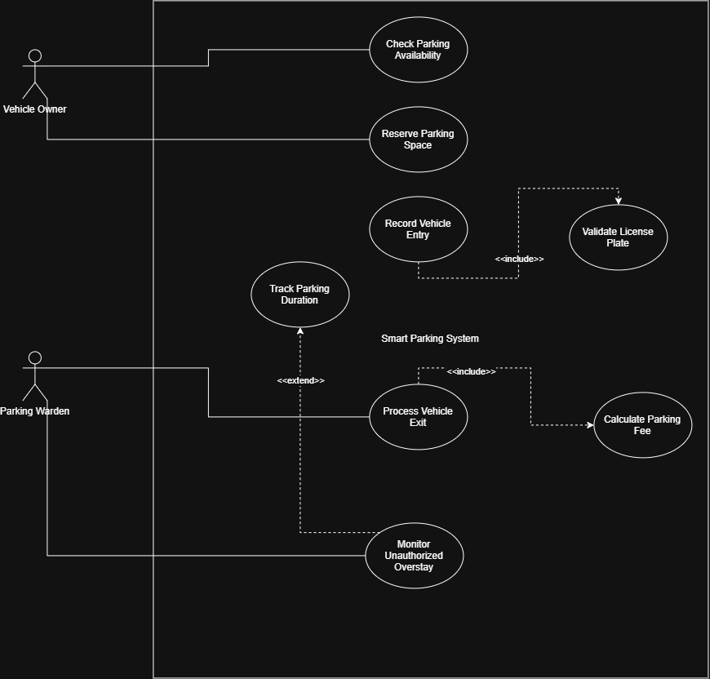

Primary Actor: Vehicle Owner
Secondary Actor: Parking Warden

Use Cases
- Check Parking Availability
- Reserve Parking Space
- Record Vehicle Entry
- Validate License Plate
- Track Parking Duration
- Process Vehicle Exit
- Calculate Parking Fee
- Monitor Unauthorized Overstay
Relationships
- «include» Record Vehicle Entry → Validate License Plate
- «include» Process Vehicle Exit → Calculate Parking Fee
- «extend» Monitor Unauthorized Overstay → Track Parking Duration

3.Use-Case Flow Specification
Smart Parking Space Rental & License Validator

Use Case: Reserve Parking Space
Primary Actor: Vehicle Owner

1. Preconditions

1. The vehicle owner has access to the smart parking system.
2. The vehicle owner has entered the required vehicle information.
3. Parking spaces are available for the requested time period.

2. Postconditions

1. The selected parking space is reserved for the vehicle owner.
2. The reservation details are recorded in the system.
3. The reserved parking space is no longer shown as available for that time period.

3. Main Success Scenario

1. The vehicle owner opens the smart parking system.
2. The vehicle owner enters the required parking details,
including the desired time period.
3. The system checks the availability of parking spaces.
4. The system displays the available parking spaces.
5. The vehicle owner selects an available parking space.
6. The system records the reservation.
7. The system confirms the reservation to the vehicle owner.

4. Alternate Flow – Parking Space Unavailable

1. At Step 3, the system finds that no parking spaces are
available for the requested time period.
2. The system informs the vehicle owner that no parking
space is available.
3. The vehicle owner may select a different time period
or cancel the reservation.
4. The system does not create a reservation.

