Software Requirements Specification (SRS)
Meeting Audio to Structured Meeting Minutes
Prepared by: SE Mini Project Team

Table of Contents
- 1. Introduction
- 2. Overall Description
- 3. External Interface Requirements
- 4. System Features and Functional Requirements
- 5. Non-functional Requirements
- 6. Security Objectives and Requirements
- 7. Quality Attributes and Acceptance Criteria
- 8. UML Use-Case Diagrams
- 9. Requirements Traceability Matrix
- 10. References

1. Introduction

1.1 Purpose
This Software Requirements Specification defines the functional, non-functional, interface, and security requirements for a prototype that converts meeting audio into a transcript and editable, structured meeting minutes. It is the shared requirements baseline for design, implementation, and testing.

1.2 Scope
The system accepts a supported meeting-audio file, transcribes speech into text, identifies discussion topics and explicit decisions, extracts action items, associates responsible people and deadlines when supported by the transcript, and generates structured meeting minutes. Users can review and correct the transcript and minutes before exporting the final draft as an editable DOCX document.
The initial release processes uploaded recordings only. Live meeting capture, automatic calendar integration, speaker biometrics, enterprise user management, multi-tenant cloud storage, and guaranteed speaker identification are outside the project scope.

1.3 Intended Audience
- Project team and team leader/reviewer
- Developers and test engineers
- Meeting organizers and reviewers
- Faculty members and project evaluators

1.4 Definitions and Acronyms
Term | Definition
ASR | Automatic Speech Recognition; conversion of spoken audio into text.
Transcript | Text produced from a meeting recording.
Meeting minutes | Structured record of meeting topics, decisions, and action items.
Action item | A task agreed during the meeting and captured for follow-up.
Owner | Person explicitly assigned or confirmed as responsible for an action item.
Deadline | Due date or time stated or confirmed by the user; it must not be invented.
SRS / SAD / STP | Software Requirements Specification / Software Architecture and Design Specification / Software Test Plan.

2. Overall Description

2.1 Product Perspective
The product is a single-user prototype with an upload interface, audio validation, speech-to-text processing, meeting-information extraction, a human review/editing interface, and DOCX export. Processing is session-scoped; long-term multi-user storage is not part of the baseline.

2.2 Major Product Functions
- Upload and validate meeting-audio files in supported formats.
- Transcribe supported audio and display the transcript and processing status.
- Identify and group discussion topics and distinguish explicit decisions from general discussion.
- Extract action items and attach owners/deadlines only when supported by the transcript.
- Flag missing or ambiguous fields for human review.
- Allow users to review and edit transcript text and structured minutes.
- Export the reviewed minutes as an editable DOCX document.
- Handle unsupported files and processing failures with clear messages.

2.3 User Roles and Characteristics
Role | Needs / Responsibilities
Meeting organizer (primary user) | Uploads a recording, reviews the transcript and extracted minutes, corrects errors, and exports the document.
Meeting participant / reviewer | Checks that topics, decisions, tasks, owners, and deadlines accurately reflect the meeting.
Project maintainer (prototype role) | Configures dependencies and resolves application-level errors; no separate admin console is required.

2.4 Operating Environment
Baseline demonstration environment: Windows 11, Python 3.11, and the current stable desktop version of Google Chrome. The application is designed for a developer laptop with at least 8 GB RAM; processing time depends on audio duration, model configuration, and available hardware.

2.5 Constraints and Assumptions
- Supported input formats are WAV, MP3, and M4A; maximum file size is 100 MB.
- The system processes uploaded recordings, not live meetings.
- Audio quality, accents, overlapping speech, background noise, and specialist vocabulary can affect transcript quality.
- Generated content is a draft and requires human review; the system must not fabricate owners or deadlines.
- Only recordings the user is authorized to process may be uploaded.
- The baseline implementation is designed around Python, a lightweight web UI, local speech recognition, rule-assisted extraction, and DOCX generation.

3. External Interface Requirements

3.1 User Interface
- Provide a clearly labelled upload control and show supported formats and the 100 MB size limit.
- Display processing status for validation, transcription, extraction, and export.
- Show the transcript and structured minutes in separate, clearly labelled sections.
- Provide editable fields for topics, decisions, tasks, owners, and deadlines.
- Show missing/ambiguous owner or deadline fields as blank or flagged for review.
- Provide a DOCX export control and clear success/failure feedback.

3.2 Hardware Interface
No specialized hardware is required. A standard computer and local storage are sufficient. Microphone capture is not included in the initial scope.

3.3 Software Interfaces
Interface | Purpose / Requirement
Audio decoding | Read supported WAV, MP3, and M4A recordings and detect unreadable inputs.
Speech-to-text engine | Convert the uploaded recording into a text transcript.
Extraction module | Transform transcript content into topics, decisions, action items, owners, deadlines, and review flags.
DOCX generation library | Create an editable Word document from reviewed structured minutes.
Local session / temporary storage | Hold input and draft data for processing; persistent multi-user storage is out of scope.

3.4 Communications
The baseline design uses local processing. If a remote service is introduced, all requests containing audio or meeting data must use HTTPS/TLS. Credentials must be supplied through local environment/configuration and excluded from source code, logs, and Git.

4. System Features and Functional Requirements
Priority: High = required for the core demonstration; Medium = supporting behavior expected where feasible. Each requirement is uniquely identified and mapped to a planned verification case.
Req ID | Functional requirement (shall) | Priority | Stakeholder | Acceptance criteria | Test case
MM-F-001 | The system shall accept audio recordings in WAV, MP3, or M4A format, up to 100 MB per file. | High | Meeting organizer | A valid supported file is accepted and processing starts. | TC-AUD-01
MM-F-002 | The system shall reject unsupported, empty, corrupt, or over-limit files and show a clear validation message. | High | Meeting organizer | Invalid files are rejected without an application crash. | TC-AUD-02
MM-F-003 | The system shall transcribe supported meeting audio into readable text using the configured speech-recognition engine. | High | Meeting organizer | A prepared clear-speech recording produces a non-empty transcript. | TC-TR-01
MM-F-004 | The system shall display the generated transcript and processing status to the user. | High | Meeting organizer | The transcript and completion state are visible after processing. | TC-TR-02
MM-F-005 | The system shall identify and group the main discussion topics represented in the transcript. | High | Meeting organizer | Topics in a prepared reference transcript are represented without unrelated topics being added. | TC-EXT-01
MM-F-006 | The system shall list explicit decisions separately from discussion points and proposals. | High | Meeting organizer | Explicit decisions appear in the decisions section; discussion-only statements are not labelled as decisions. | TC-EXT-02
MM-F-007 | The system shall extract action items as distinct task-oriented statements. | High | Meeting organizer | Each known task in the reference transcript appears as a separate action item. | TC-EXT-03
MM-F-008 | The system shall associate an action item with a responsible person only when supported by transcript evidence. | High | Meeting organizer | Explicitly assigned tasks show the correct owner; ambiguous ownership is flagged. | TC-EXT-04
MM-F-009 | The system shall capture deadlines explicitly stated in the transcript without changing their meaning. | High | Meeting organizer | Dates or times match the reference transcript; absent deadlines remain unspecified. | TC-EXT-05
MM-F-010 | The system shall flag missing or ambiguous owners and deadlines for human review rather than inventing values. | High | Meeting organizer | Unknown fields are blank or marked for review and are not fabricated. | TC-EXT-06
MM-F-011 | The system shall generate structured minutes with meeting metadata, discussion topics, decisions, and action items. | High | Meeting organizer | The output contains all required sections in a consistent structure. | TC-MIN-01
MM-F-012 | The system shall allow the user to edit topics, decisions, action items, owners, and deadlines before export. | High | Meeting organizer | Changed values are retained in the on-screen draft and used in the export. | TC-EDIT-01
MM-F-013 | The system shall export reviewed minutes as an editable Microsoft Word DOCX document. | High | Meeting organizer | The exported DOCX opens in a compatible editor and its text is editable. | TC-EXP-01
MM-F-014 | The system shall preserve the correct task-owner-deadline relationship when exporting minutes. | High | Meeting organizer | Each exported action item retains its correct owner and deadline. | TC-EXP-02
MM-F-015 | The system shall show meaningful status and error messages for transcription, extraction, and export failures. | Medium | Meeting organizer | A simulated processing failure is communicated and the application remains usable. | TC-ERR-01

5. Non-functional Requirements
Req ID | Category | Requirement / measurable target | Priority | Verification
MM-NF-001 | Performance | For a documented recording of up to 10 minutes, the complete transcription-and-structuring workflow should finish within three times the recording duration on the documented test machine, excluding external service outages. | Medium | TC-PERF-01
MM-NF-002 | Usability | A first-time user shall be able to upload audio, review the transcript, edit a minutes field, and export the result using clearly labelled controls. | High | TC-UX-01
MM-NF-003 | Reliability | Invalid input and processing failures shall be handled without an unhandled application crash, with a clear status or error shown to the user. | High | TC-REL-01
MM-NF-004 | Maintainability | Audio validation, transcription, extraction, editing, and export shall be separated into modules or functions that can be tested independently. | Medium | TC-MAINT-01
MM-NF-005 | Compatibility | The prototype shall support the current stable desktop version of Google Chrome on Windows 11 as the baseline demonstration environment. | Medium | TC-COMP-01

6. Security Objectives and Requirements

6.1 Security Objectives
ID | Objective | Intended outcome
SO-1 Confidentiality | Protect meeting recordings, transcripts, and generated minutes from unauthorized access or disclosure. | Data remains within the intended user session; secrets and sensitive content are not exposed.
SO-2 Integrity and accountability | Preserve reviewed minutes accurately and ensure that changes and exports use the user's reviewed version. | Exported task-owner-deadline associations match the reviewed structured data; uncertainty is visible.

6.2 Security Requirements
Req ID | Security requirement (shall) | Priority | Acceptance / verification
MM-SR-001 | When external services are used, the system shall transmit audio and meeting data only over HTTPS/TLS. | High | Configuration review and TC-SEC-01
MM-SR-002 | The system shall keep API keys, tokens, and passwords out of source code, logs, and Git commits; secrets shall be supplied through local environment/configuration. | High | Repository and configuration review; TC-SEC-02
MM-SR-003 | The system shall keep uploaded audio, transcripts, and generated minutes within the active user session and shall not expose one session's data to another session. | High | Session isolation test; TC-SEC-03
MM-SR-004 | The system shall not write raw audio, full transcripts, credentials, or unnecessary sensitive meeting content to application logs. | High | Log inspection; TC-SEC-04
MM-SR-005 | The system shall validate file extension, size, and basic readability before processing and safely reject malformed inputs. | High | Invalid-file and boundary tests; TC-SEC-05

7. Quality Attributes and Acceptance Criteria
The prototype is ready for demonstration when the core upload-to-export workflow is available, every high-priority functional requirement has a corresponding test, the exported DOCX is editable, invalid inputs and processing failures are handled safely, and no unresolved critical security issue is known. Test outcomes must be recorded only after tests are executed.
Quality attribute | Acceptance criteria
Functional completeness | The upload, transcription, extraction, review/edit, and DOCX export workflow is demonstrated end to end.
Content integrity | The system separates topics, decisions, and action items; it does not silently invent owners or deadlines.
Usability | A first-time user can complete the core workflow using clearly labelled controls.
Reliability | Invalid inputs and controlled processing failures produce understandable messages without an unhandled crash.
Security | File validation, session isolation, secret handling, and log minimization are checked.
Export quality | The DOCX opens in a compatible editor and preserves task-owner-deadline relationships.

8. UML Use-Case Diagrams

8.1 Main workflow
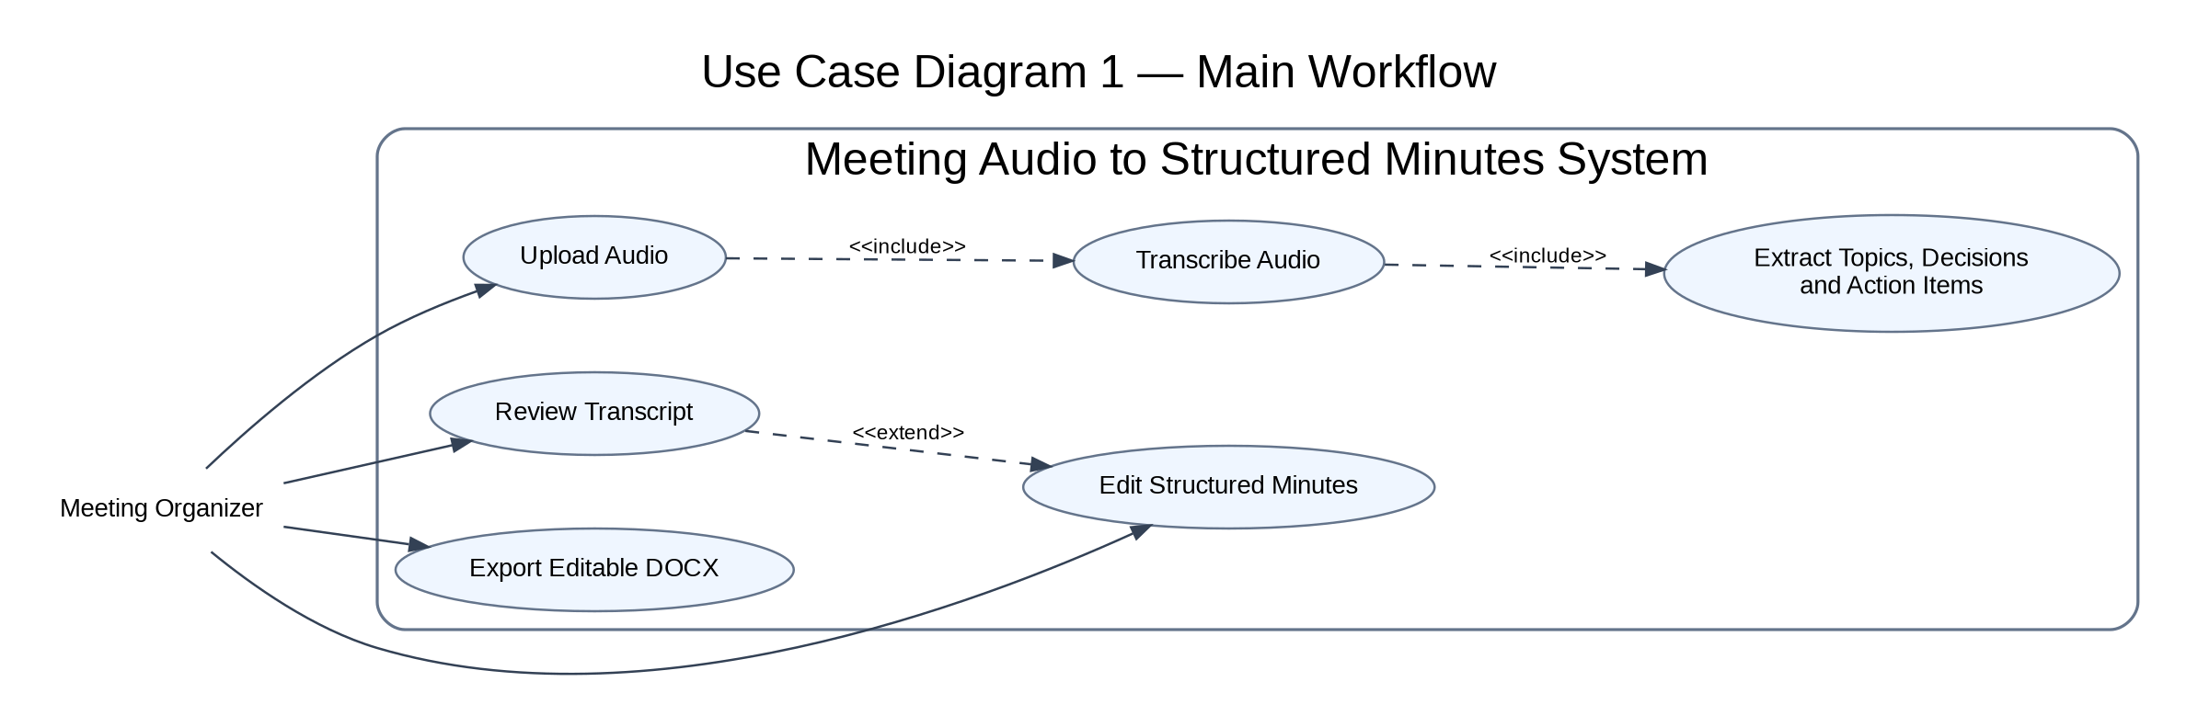
Figure 1. Primary upload, transcription, review, editing, and export use cases.

8.2 Validation and human-review workflow
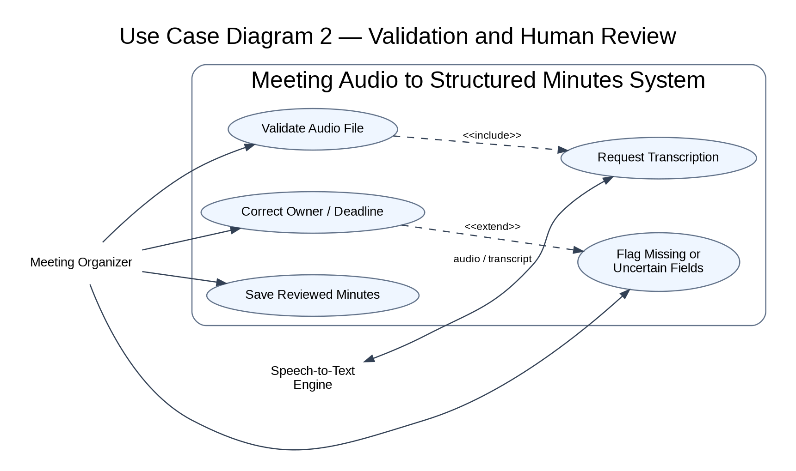
Figure 2. File validation, transcription service interaction, uncertainty flags, and corrections.
The diagrams use UML use-case notation and show «include» for behavior required by another use case and «extend» for optional/conditional behavior.

9. Requirements Traceability Matrix (RTM)
Requirement ID | SRS section | Verification reference | Module / area
MM-F-001 | Section 4 | TC-AUD-01 | Application workflow
MM-F-002 | Section 4 | TC-AUD-02 | Application workflow
MM-F-003 | Section 4 | TC-TR-01 | Application workflow
MM-F-004 | Section 4 | TC-TR-02 | Application workflow
MM-F-005 | Section 4 | TC-EXT-01 | Application workflow
MM-F-006 | Section 4 | TC-EXT-02 | Application workflow
MM-F-007 | Section 4 | TC-EXT-03 | Application workflow
MM-F-008 | Section 4 | TC-EXT-04 | Application workflow
MM-F-009 | Section 4 | TC-EXT-05 | Application workflow
MM-F-010 | Section 4 | TC-EXT-06 | Application workflow
MM-F-011 | Section 4 | TC-MIN-01 | Application workflow
MM-F-012 | Section 4 | TC-EDIT-01 | Application workflow
MM-F-013 | Section 4 | TC-EXP-01 | Application workflow
MM-F-014 | Section 4 | TC-EXP-02 | Application workflow
MM-F-015 | Section 4 | TC-ERR-01 | Application workflow
MM-NF-001 | Section 5 | TC-PERF-01 | Performance
MM-NF-002 | Section 5 | TC-UX-01 | Usability
MM-NF-003 | Section 5 | TC-REL-01 | Reliability
MM-NF-004 | Section 5 | TC-MAINT-01 | Maintainability
MM-NF-005 | Section 5 | TC-COMP-01 | Compatibility
MM-SR-001 | Section 6.2 | Configuration review and TC-SEC-01 | Security
MM-SR-002 | Section 6.2 | Repository and configuration review; TC-SEC-02 | Security
MM-SR-003 | Section 6.2 | Session isolation test; TC-SEC-03 | Security
MM-SR-004 | Section 6.2 | Log inspection; TC-SEC-04 | Security
MM-SR-005 | Section 6.2 | Invalid-file and boundary tests; TC-SEC-05 | Security

10. References
- Faculty-provided Software Requirements Specification template and project problem statement.
- Official documentation for Python, Streamlit, the selected speech-recognition engine, and python-docx, as applicable to the final implementation.

