Software Architecture and Design Specification (SAD)
Meeting Audio to Structured Meeting Minutes
Prepared by: SE Mini Project Team

1. Introduction

1.1 Purpose
This document defines the proposed architecture and detailed design for the Meeting Audio to Structured Meeting Minutes system, including components, data flow, interfaces, data structures, security controls, and design decisions.

1.2 Scope
The design covers uploaded-audio validation, transcription, extraction of discussion topics, explicit decisions, action items, owners and deadlines, human review/editing, and editable DOCX export. Processing is session-scoped; persistent multi-user storage is excluded from the baseline.

1.3 Audience and Related Documents
- Developers and project team
- Test engineers and reviewers
- Faculty and project evaluators
- Related documents: SRS_Meeting_Audio_to_Structured_Minutes_FINAL.docx and STP_Meeting_Audio_to_Structured_Minutes_FINAL.docx

1.4 Definitions
Term | Meaning
ASR | Automatic Speech Recognition.
NLP | Natural Language Processing.
API | Application Programming Interface.
DTO | Data Transfer Object; structured data passed between components.
RTM | Requirements Traceability Matrix.

2. Architecture

2.1 Goals and Constraints
- Keep audio validation, transcription, extraction, review, and export independently testable.
- Provide clear progress states and recoverable errors for long-running processing.
- Require human review for uncertain people, deadlines, and decisions.
- Minimize retention of recordings and meeting content.
- Use a lightweight architecture that a student team can run and demonstrate locally.

2.2 Stakeholders and Concerns
Stakeholder | Primary concern
Meeting organizer | Accurate, editable minutes and clear uncertainty flags.
Meeting participant | Faithful representation of topics, decisions, owners, and deadlines.
Development team | Simple integration, modularity, testability, and manageable setup.
Evaluator | Traceability to requirements, readable UML diagrams, and testable interfaces.
People mentioned in recordings | Confidential handling of personal and meeting information.

2.3 Component Architecture
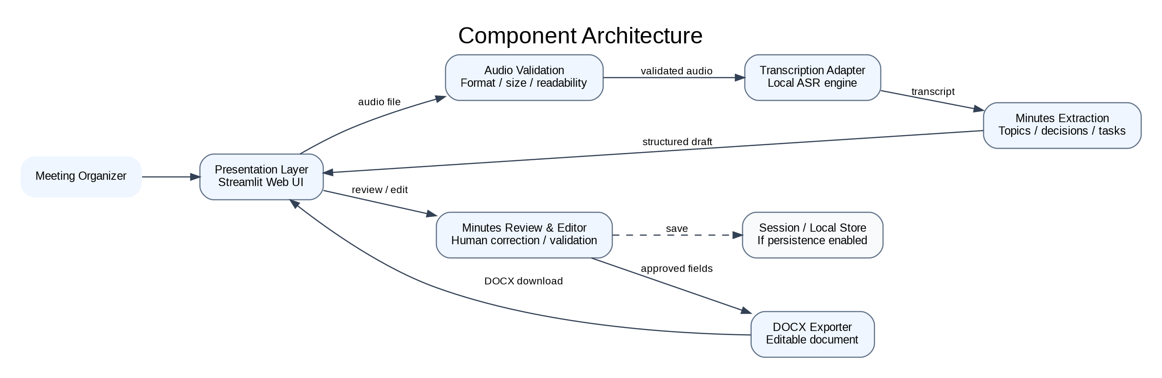
Figure 1. Component architecture and the primary data flow.
Component | Responsibility | Related requirements
Presentation layer / Streamlit UI | Accept upload, show status/errors, display transcript and structured draft, provide edit and export controls. | MM-F-001, MM-F-004, MM-F-012, MM-F-015
Audio validator | Validate extension, file size, and basic readability before processing. | MM-F-001, MM-F-002, MM-SR-005
Transcription adapter | Call the configured ASR engine and normalize the output transcript. | MM-F-003, MM-F-004
Minutes extraction service | Identify topics, decisions, action items, owners, deadlines, and uncertainty flags. | MM-F-005 to MM-F-010
Minutes editor / validator | Maintain structured fields and apply user corrections before export. | MM-F-011, MM-F-012, MM-F-014
DOCX exporter | Generate an editable Word document from reviewed structured data. | MM-F-013, MM-F-014
Session state / temporary storage | Hold the current draft during the session; clear temporary files when no longer required. | MM-SR-003, MM-SR-004
Configuration and logging | Load configuration safely and log status/error categories without sensitive meeting content. | MM-SR-001, MM-SR-002, MM-SR-004

2.4 Architecture Pattern and Rationale
A modular layered architecture is selected: presentation, workflow/orchestration, processing adapters, and export. A single application process is preferred over microservices because the project is a local prototype and does not require independent service deployment. Component boundaries still allow unit testing and replacement of the ASR or extraction implementation.

2.5 Technology Baseline
Area | Baseline choice | Rationale / constraint
Runtime | Python 3.11 | Common ecosystem for audio, NLP, and document generation.
User interface | Streamlit | Fast development of upload, progress, review, and download screens.
Speech recognition | Local ASR adapter using faster-whisper; model size configured for available hardware | Avoids requiring an external API key; quality and speed depend on local hardware.
Extraction | Python module using sentence processing and rule-assisted extraction; structured validation for missing/ambiguous fields | Keeps the baseline reproducible and ensures unknown owners/deadlines are not fabricated.
Editable export | python-docx | Produces a Word document users can edit.
Persistence | Session state and temporary files only | Avoids unnecessary retention; a persistent database is outside baseline scope.
Test environment | Windows 11, Python 3.11, current stable Chrome | Matches the baseline demonstration environment in the SRS.

2.6 Key Design Decisions
Decision ID | Decision | Reason / consequence
ADR-01 | Use a single-process modular application rather than microservices. | Reduces setup and deployment complexity; modules remain independently testable.
ADR-02 | Use local speech recognition for the baseline. | Avoids API credentials and remote transmission; processing may be slower on CPU.
ADR-03 | Treat generated minutes as an editable draft. | Human review is necessary because transcription and extraction can be imperfect.
ADR-04 | Leave uncertain owners/deadlines blank and flag them. | Prevents fabricated assignments and dates.
ADR-05 | Export reviewed data only to DOCX. | Keeps the required deliverable editable and reduces scope.

2.7 Risks and Mitigations
Risk | Mitigation
Noisy audio / overlapping speakers | Display transcript for correction and include varied test recordings.
Incorrectly extracted owner or deadline | Require evidence-based extraction; blank or flag uncertain fields.
Slow local transcription | Use a configurable model and record the test machine and processing time.
Sensitive meeting content exposed | Use session-scoped processing, avoid sensitive logs, and remove temporary files when processing ends.
DOCX loses field relationships | Generate from structured action-item objects and verify exports using TC-EXP-02.

3. Design Details

3.1 Processing Workflow
- User selects a WAV, MP3, or M4A file not exceeding 100 MB.
- Audio validator checks the file extension, size, and readability; invalid files are rejected.
- Transcription adapter sends valid audio to the configured local ASR engine and receives transcript text.
- Extraction service identifies topics, explicit decisions, action items, owners, deadlines, and review flags.
- The UI presents transcript and structured minutes for human review and correction.
- Structured validation checks required fields and preserves task-owner-deadline relationships.
- DOCX exporter creates an editable document from the reviewed data and offers it for download.
- Temporary audio and processing artifacts are cleared when no longer required by the session workflow.

3.2 Sequence Diagram 1 — Upload and Transcription
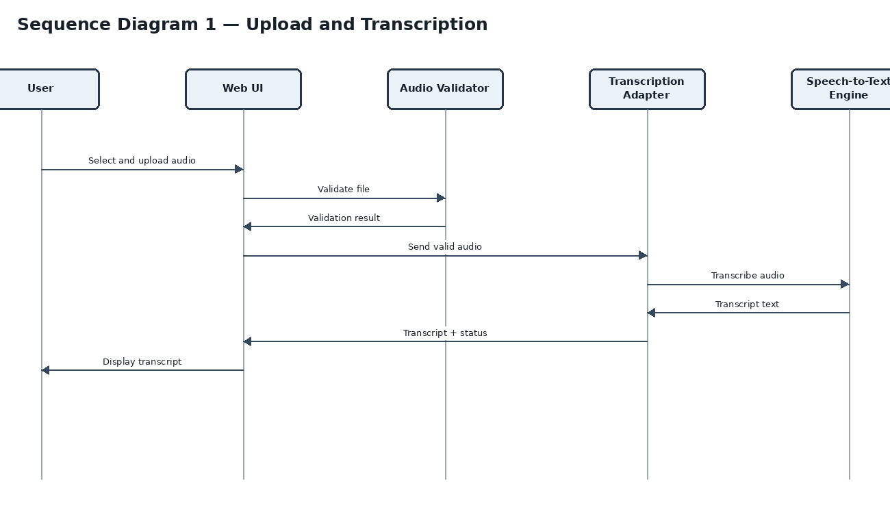
Figure 2. Upload validation and transcription sequence.

3.3 Sequence Diagram 2 — Extraction, Review, and Export
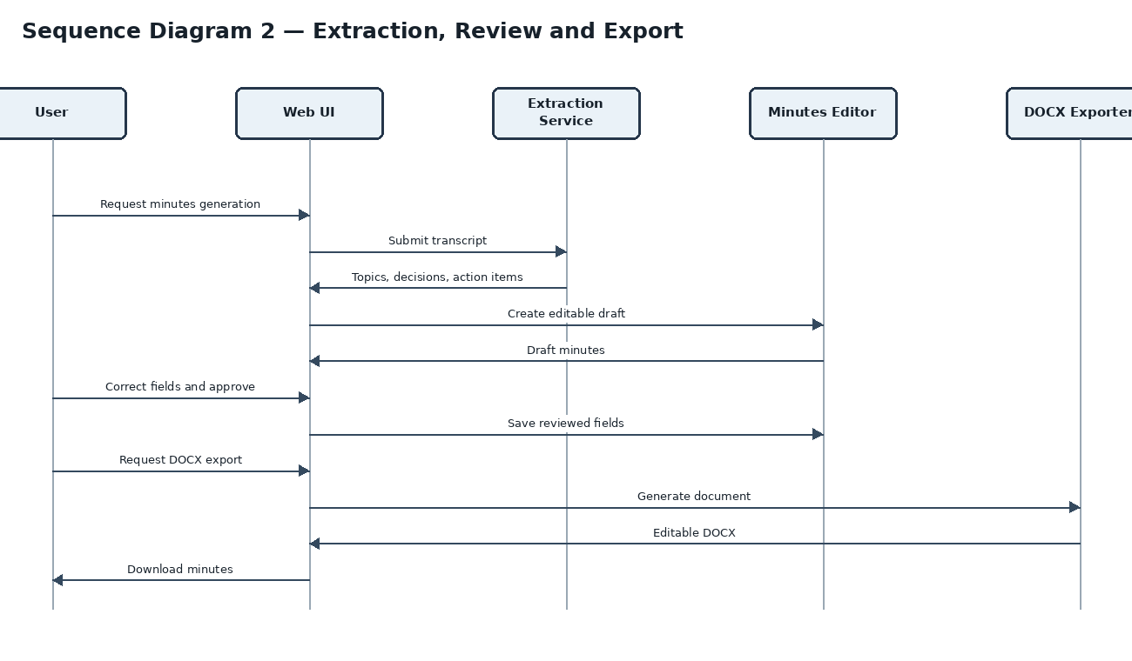
Figure 3. Extraction, human review, and DOCX export sequence.

3.4 Data Model
Object | Fields | Validation / notes
MeetingDraft | draft_id, title (optional), meeting_date (optional), source_filename, status | Metadata may be blank if not supplied by the user.
Transcript | draft_id, transcript_text, processing_status | Transcript must be shown for review; failures are recorded as status, not fabricated text.
DiscussionTopic | topic_id, title, summary, supporting_text (optional) | Topics should reflect transcript content.
Decision | decision_id, description, supporting_text (optional) | Only explicit decisions are listed as decisions.
ActionItem | action_id, task, owner, deadline, status, review_flag | Owner/deadline may be blank; ambiguity must be flagged.
MinutesDocument | draft_id, topics[], decisions[], action_items[], exported_at | Export must use the reviewed version of structured data.

3.5 API / Component Interface Design
The baseline is a single-process Streamlit application; the following are logical component contracts. They can be implemented as Python functions rather than public HTTP endpoints. If an HTTP API is added later, the same request/response contracts apply.
Component / operation | Input | Output | Validation / errors
AudioValidator.validate(file) | Uploaded file object; filename; byte size | ValidationResult(valid, format, size, message) | Reject unsupported extension, empty/corrupt file, or file over 100 MB.
TranscriptionAdapter.transcribe(validated_audio) | Validated audio path/bytes | TranscriptResult(text, status, duration) | Return a controlled failure status for unreadable audio or ASR failure; do not return fabricated text.
MinutesExtractor.extract(transcript) | Transcript text | MinutesDraft(topics, decisions, action_items, review_flags) | Malformed/empty transcript is rejected; uncertain owner/deadline is flagged.
MinutesEditor.validate_and_update(draft, edits) | Structured draft plus user edits | ValidatedMinutes | Reject invalid field types; preserve action-item relationships.
DocxExporter.export(validated_minutes) | Reviewed structured minutes | DOCX byte stream / temporary file path | Return a clear export error if document generation fails.

3.6 Optional HTTP API Mapping
Endpoint | Method | Request | Successful response | Error behavior
/api/audio | POST | multipart audio file | upload_id, status | 400 invalid file; 413 too large; 500 processing setup failure
/api/transcriptions/{id} | GET | Upload/transcription ID | transcript, status | 404 unknown ID; 500 transcription failure
/api/minutes | POST | JSON with transcript and optional metadata | topics, decisions, action_items, review_flags | 400 malformed request; 422 invalid extraction input
/api/minutes/{id} | PUT | Edited structured minutes JSON | validated minutes / confirmation | 400 invalid fields; 404 unknown ID
/api/minutes/{id}/export | GET | Minutes ID | Editable DOCX file | 404 unknown ID; 500 export failure

3.7 Security, Logging, and Error Handling
- Validate file type, size, and readability at the application boundary; do not trust extension alone.
- Keep credentials outside source code and Git; if remote services are added, use HTTPS/TLS.
- Do not log raw audio, full transcripts, credentials, or unnecessary sensitive meeting content.
- Use session-scoped draft state and remove temporary files when no longer needed.
- Show clear errors for validation, transcription, extraction, and export failures.
- Do not mark a generated draft as approved until the user has reviewed it.

3.8 Requirement Traceability
SRS requirement IDs | Design element | Verification
MM-F-001, MM-F-002, MM-SR-005 | AudioValidator + upload UI | TC-AUD-01, TC-AUD-02, TC-SEC-05
MM-F-003, MM-F-004 | TranscriptionAdapter + transcript view | TC-TR-01, TC-TR-02
MM-F-005 to MM-F-010 | MinutesExtractor + review flags | TC-EXT-01 to TC-EXT-06
MM-F-011, MM-F-012 | MinutesEditor + structured draft | TC-MIN-01, TC-EDIT-01
MM-F-013, MM-F-014 | DocxExporter + structured action items | TC-EXP-01, TC-EXP-02
MM-F-015, MM-NF-003 | Workflow status and exception handling | TC-ERR-01, TC-REL-01
MM-NF-001, MM-NF-002, MM-NF-004, MM-NF-005 | Performance, UI, modular code, browser baseline | TC-PERF-01, TC-UX-01, TC-MAINT-01, TC-COMP-01
MM-SR-001 to MM-SR-004 | Configuration, session handling, log policy | TC-SEC-01 to TC-SEC-04

4. References
- Software Requirements Specification (SRS), Meeting Audio to Structured Meeting Minutes, Version 1.0.
- Software Test Plan (STP), Meeting Audio to Structured Meeting Minutes, Version 1.0.
- Official documentation for Python 3.11, Streamlit, faster-whisper, and python-docx.

