**VETRI IT SYSTEMS PRIVATE LIMITED**

**PROJECT REPORT**

**PROJECT TITLE: EarthBubs(Baby Products)**

**1. Project Overview**

**Project Name:** EarthBubs  
**Project Assigned Date:** [21/07/2025]  
**Planned Completion Date:** [26/07/2025]  
**Delivery Date:** [28/07/2025]

**2. Project Team**

* **Project Manager:** Alagu Mari
* **Designer:** Malathy
* **Developer(s):** [S.Ramalakshmi]
* **Testing Team:** Yogavarshini

**3. Technology Stack**

* **Frontend Technologies:** HTML,CSS,JavaScript
* **Infrastructure:** Nginx, Gunicorn, VPS Hosting

**4. Project Scope**

The Earthbubs project aims to develop a comprehensive eCommerce platform that allows users to browse and purchase baby products seamlessly. The system will provide an intuitive user interface, secure payment processing, and an efficient order management system for administrators.

**Key Objectives:**

* Develop a user-friendly and responsive website for Earthbubs.
* Implement a robust authentication and authorization system.
* Ensure a secure and reliable payment gateway.
* Enable real-time order tracking and inventory management.
* Provide detailed sales reports and analytics.
* Deploy the platform on a secure VPS with high availability.

**5. Project Modules**

* **Home**
* **Products**

1. **Pampers**
2. **Boy’s Fashion**
3. **Girl’s Fashion**
4. **Soap**
5. **Stroller**
6. **bottle**

* **About us**
* **Offers**
* **Contact us**
* **Add to Cart**
* **Checkout**
* **Payments**
* **Order Confirmed**

**6. Project Code**

**Frontend Code (HTML,CSS,JavaScript):**

<!DOCTYPE html>

<html lang="en">

<head>

    <meta charset="UTF-8">

    <meta name="viewport" content="width=device-width, initial-scale=1.0">

    <title>Baby shop</title>

     <link href='https://fonts.googleapis.com/css?family=Poppins' rel='stylesheet'>

<link rel="stylesheet" href="https://cdnjs.cloudflare.com/ajax/libs/font-awesome/6.4.0/css/all.min.css" />

<link rel="stylesheet" href="https://cdnjs.cloudflare.com/ajax/libs/font-awesome/4.7.0/css/font-awesome.min.css">

    <style>

       body {

    font-family: 'Poppins';font-size: 22px;

}

        .main-content{

            display:grid;

            font-size: 26px;

            font-family:poppins;

            grid-template-columns: repeat(3,1fr);

            justify-content: center;

            grid-auto-rows: minmax(auto,auto);

            grid-template-areas:

                                "hd hd hd"

                                "pc pc pc"

                                "pc pc pc"

                                "ft ft ft";

        }

        .header{

            grid-area: hd;

            height:60vh;

            position:absolute;

            width:100%;

            overflow:hidden;

            flex-direction: column;

            background-color: white;

        }

        .nav{

            display:flex;

            flex-direction: row;

            position: sticky;

            top:0;

            left:0;

            justify-content: space-between;

            border:1px solid grey;

            padding:12px 15px;

        }

        .active{

          background-image: linear-gradient(to top,#B0E4F4,white);

        }

        .active1:hover{

           background-image: linear-gradient(to top,#B0E4F4,white);

        }

        a{

            text-decoration: none;

             color:black;

        }

.flex-container{

            display:grid;

            grid-template-columns:1fr 1fr 1fr;

           row-gap: 100px;

           align-content: space-between;

            justify-content:space-between;

           font-size: 18px;

        }

        .flex-card1{

            display:flex;

            flex-direction:column;

             width:300px;

            height:390px;

            border:2px solid #B0E4F4;

            justify-content:space-between;

            align-items: center;

             border-radius: 15px;

             box-shadow: 0 4px 12px rgba(0,0,0,0.1);

             font-size: 18px;

             font-weight: bold;

            position: relative;

            overflow: hidden;

            /* flex-wrap: wrap; */

        }

.container1 {

  --height: 6.5rem;

  perspective: 100px;

  isolation: isolate;

  display: inline-flex;

  flex-direction: row;

}

.main1,

.angle1 {

  display: inline-flex;

  align-items: center;

  padding-left: 1rem;

  background-color: #B0E4F4;

  border-radius: 0.5rem;

}

.main1 {

  height: 6.5rem;

  width: 190px;

}

@media (max-width: 768px) {

  body {

    font-size: 18px;

    padding: 30px;

  }

  .flex-container{

   grid-template-columns:1fr ;

  }

  .main-content{

    grid-template-columns:1fr ;

  }

}

        </style>

        </head>

        <body>

            <div class="main-content">

        <div class="header">

            <div class="nav">

                <img src="logoearth.png">EarthBubs

                    <a href="home.html" class="active">Home</a>

                     <div class="dropdown">

  <span>Products</span>

  <div class="dropdown-content">

   <p><a href="pampers.html">Pampers</a></p>

  <p><a href="boy.html">Boy's Fashions</a></p>

  <p><a href="girl.html">Girl's Fashions</a></p>

  <p><a href="soap.html">Soap</a></p>

  <p><a href="stroller.html">Stroller</a></p>

  <p><a href="bottle.html" >Bottle</a></p>

  </div>

</div>

                    <a href="Offers.html" class="act">Offers</a>

                    <a href="about.html" class="act">About</a>

                    <a href="contact.html" class="act">Contact Us</a>

                    <input type="search" class="search" placeholder="Search..."/>

                    </div>

                  </div>

                    </div><br><br><br><br><br><br><br><br><br><br><br>

        <div class="best">

            Home > Products > Girls Fashion<br><br>

            <div class="flex-container">

            <div class="flex-card1"><div class="label">NEW</div><br><img src="girl1.png" class="pic3"><br><br>

            <div class="container1">

  <div class='main1'><div class="info-box"><strong>Halemons Floral</strong>

  <div class="stars">

        <i class="fas fa-star"></i>

        <i class="fas fa-star"></i>

        <i class="fas fa-star"></i>

        <i class="fas fa-star"></i>

        <i class="far fa-star"></i>

      </div>

      <div class="price">

        <span class="mrp">MRP ₹1466.00</span>

        <div class="an"></div>

        <span class="final-price">Price ₹1399.00</span>

      </div>

    </div>

</div><div class="angle1"></div>

 <button class="btn ">Buy</button>

</div>

</div>

 <div class="ftr">

                    <div class="faq-item1"></div>

                    <center>  copyright  &copy; 2025 All Rights Reserved</center></div>

                  </div>

            </div>

</body>

</html>

**7. Output & Screenshots(Add your website screenshots here)**

* **Homepage:** Displays featured baby products.
* **Product Page:** Shows detailed descriptions and prices.
* **Cart & Checkout:** Users can add items and proceed with secure payments.
* **Checkout:** Displays user data, and order status.
* **Screenshots**

1.Home Page

* 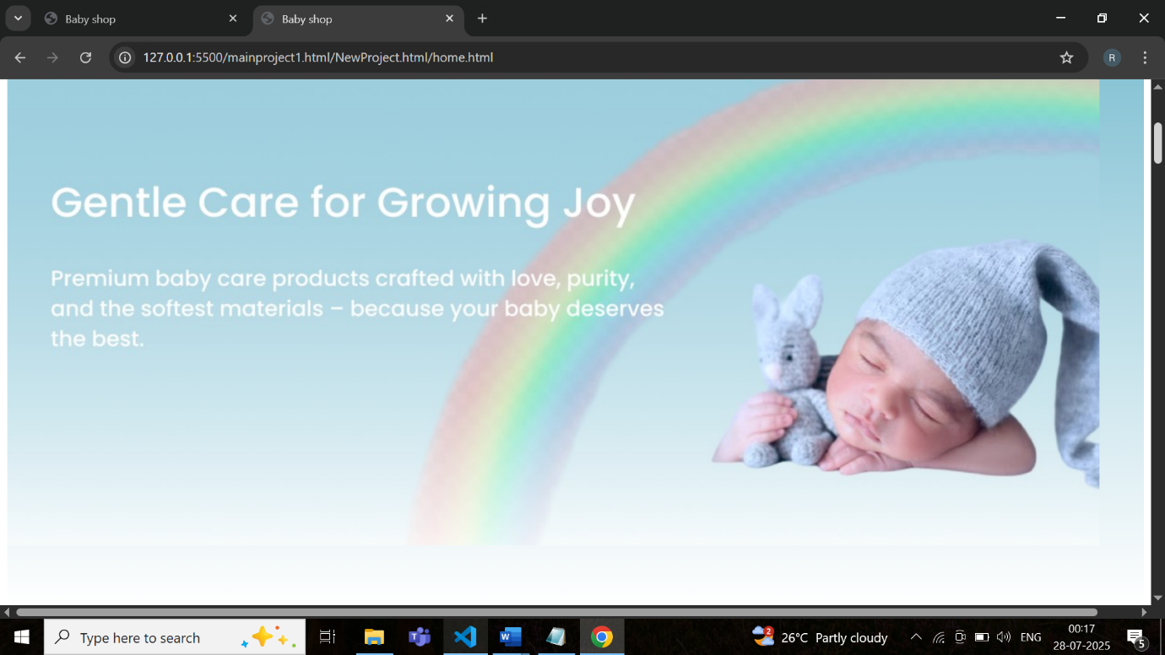

2.Girls Fashion

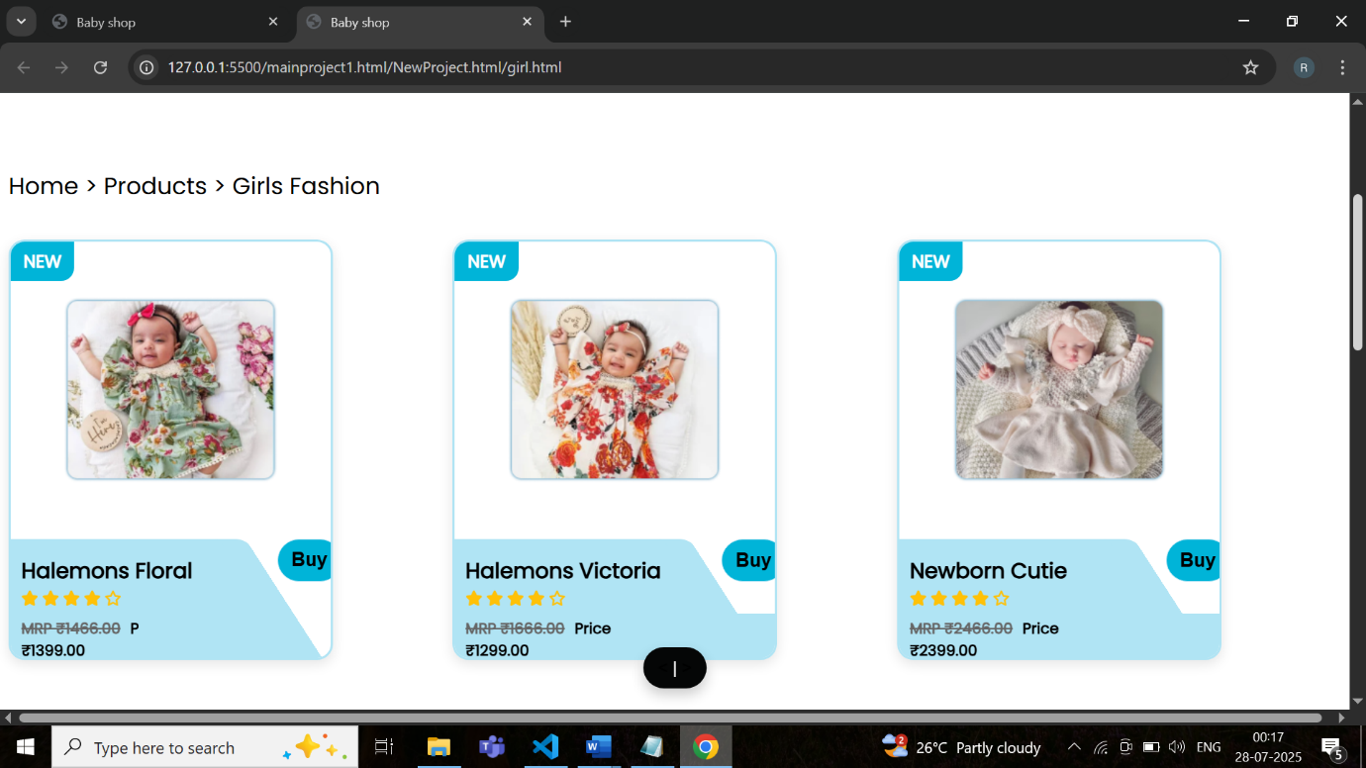

3.Offers

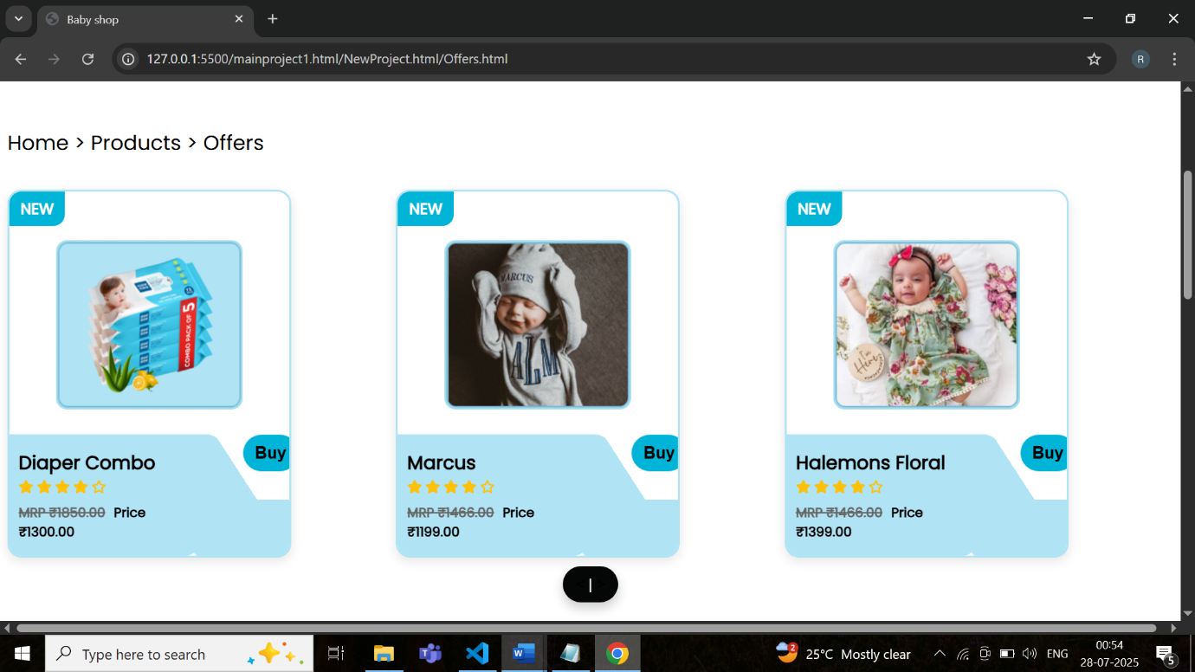

4.pampers

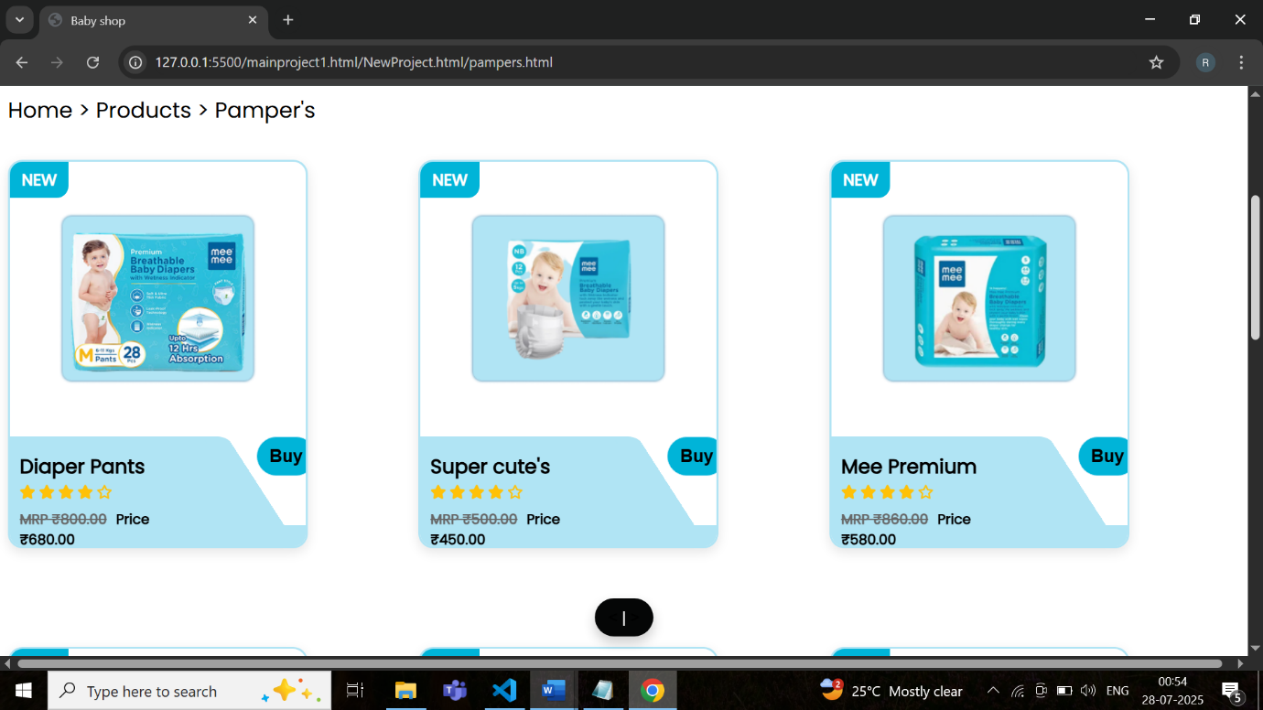

5.Soap

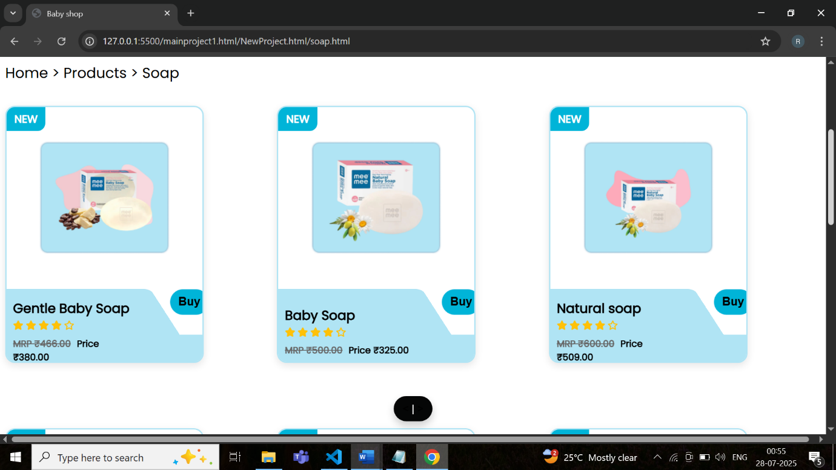

6.About Us

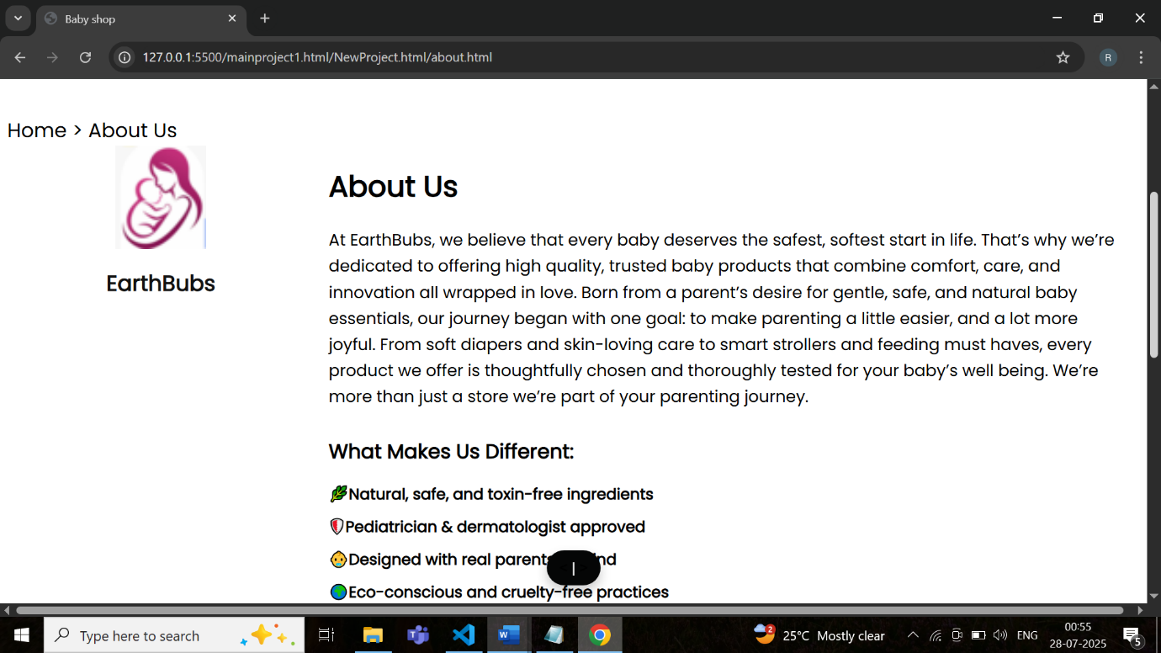

7.Contact Us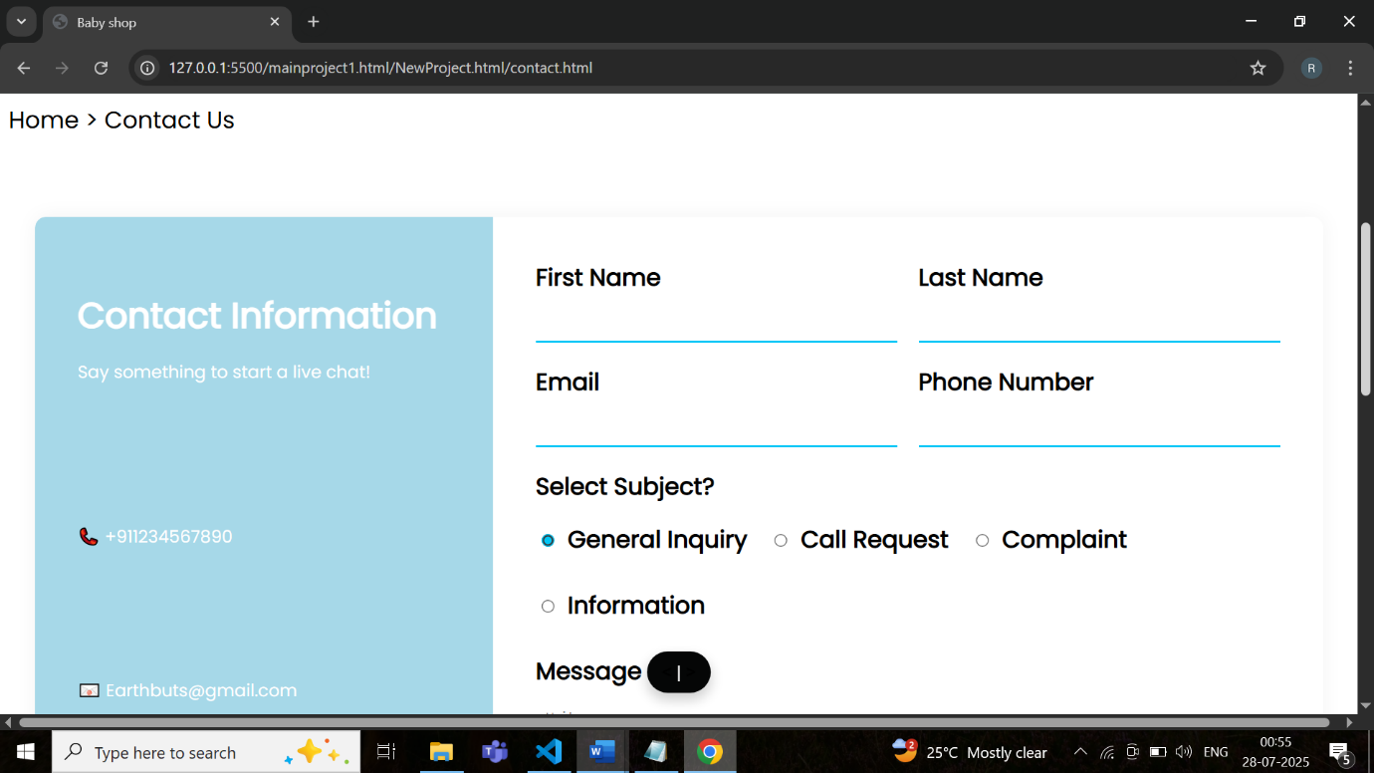

8.Add to Cart

* 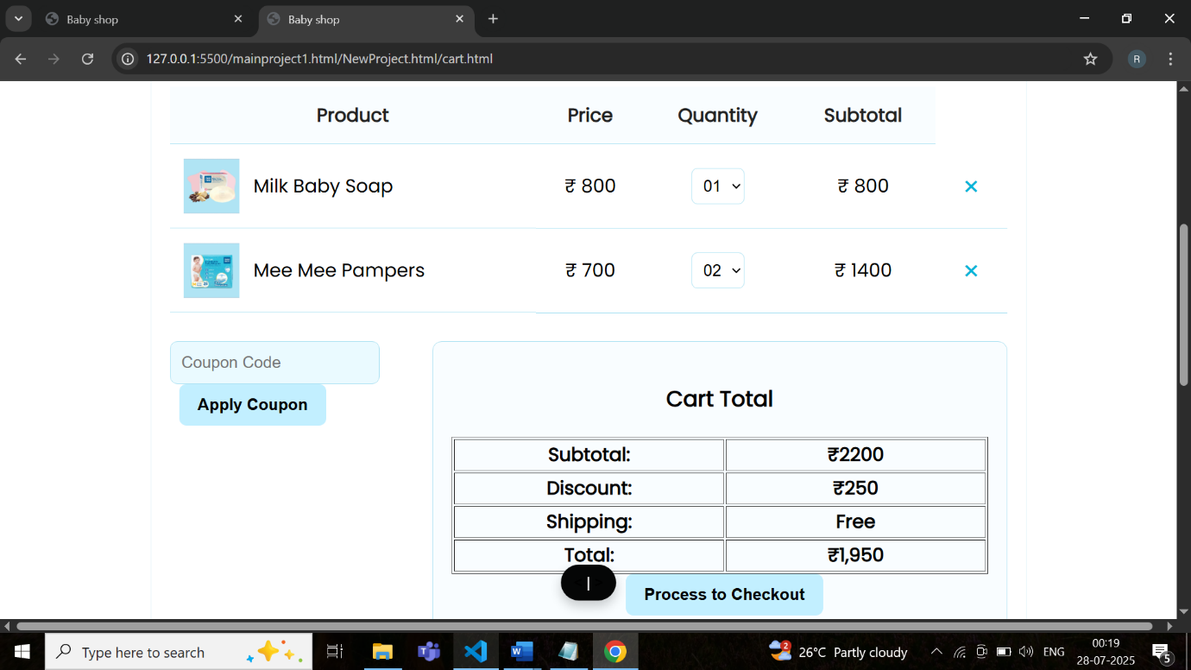
* 9.Checkout
* 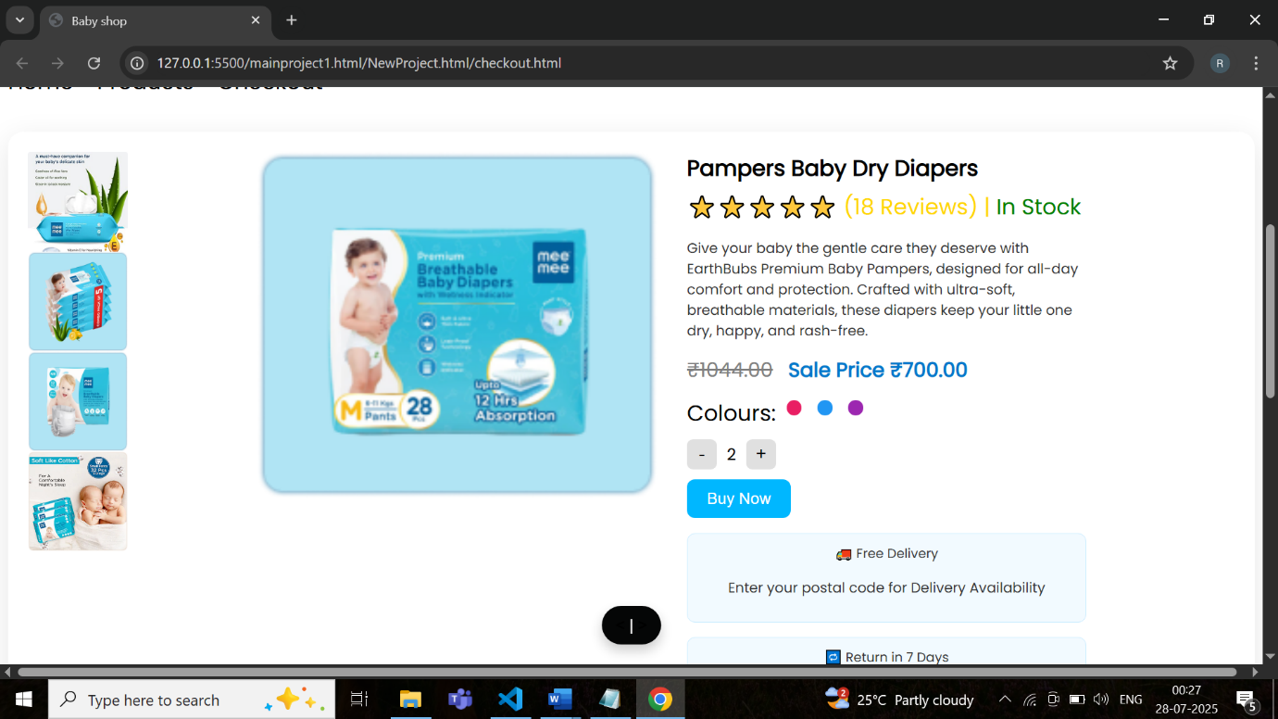

9.Payments

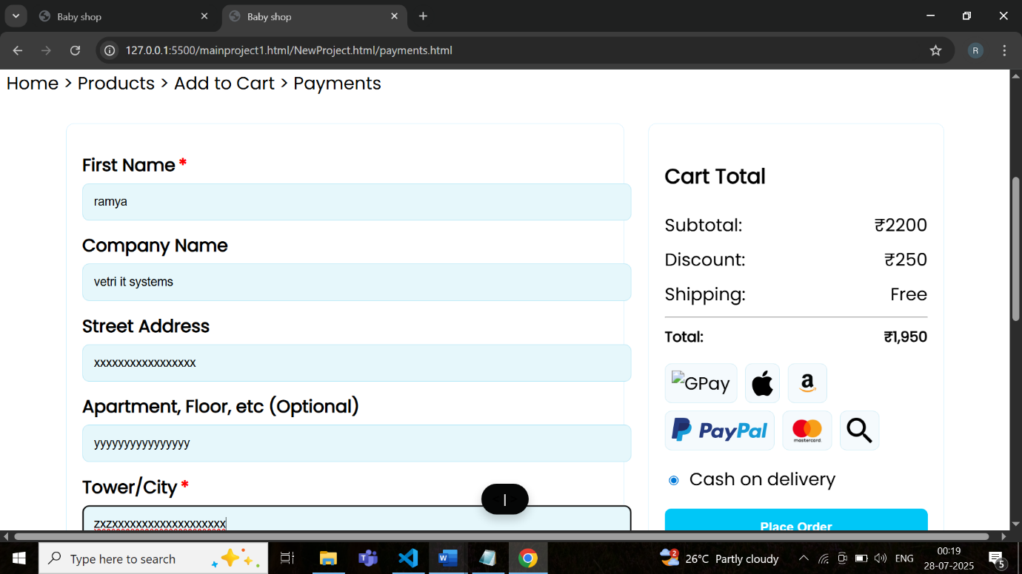

10.Order Confirmed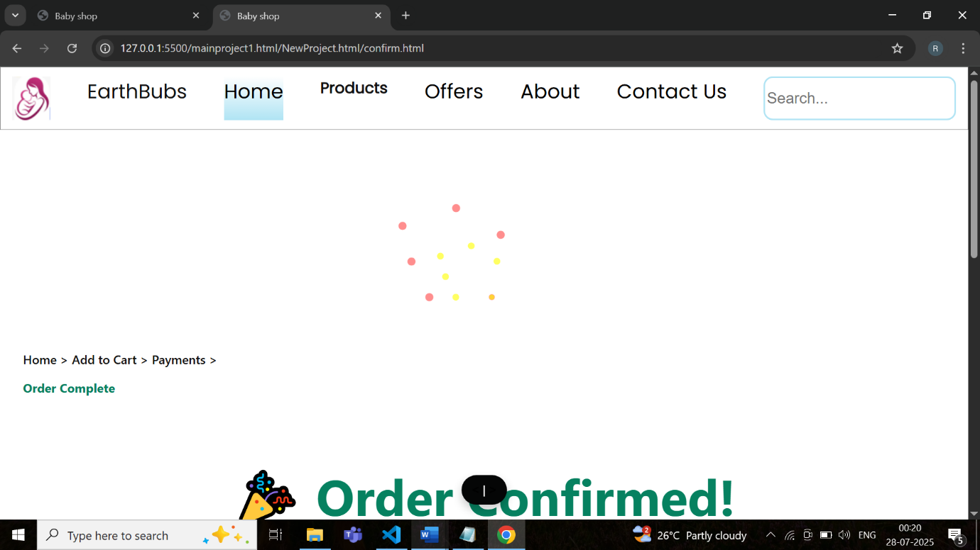

**8. Conclusion**

The Earthbubs project aims to deliver a robust and scalable eCommerce platform leveraging modern technologies. The successful implementation of this project will provide an efficient and seamless experience for users and administrators. The platform will ensure secure transactions, efficient order processing, and insightful analytics for business growth.

**Prepared By:** [S Ramalakshmi]  
**Date:** [28/07/2025]  
**Reviewed By:** [Alagu Mari Trainer]  
**Approved By:** [Alagu Mari Trainer]