JSON API data

1. How to compare two JSON have the same properties without order?
  - var obj1 = { name: "Person 1", age:5 };
  - var obj2 = { age:5, name: "Person 1" };

coding
var obj1 = { name: "Person 1", age:5 };
var obj2 = { age:5, name: "Person 1" };
var flag=true;

if(Object.keys(obj1).length==Object.keys(obj2).length){
for(key in obj1) {
if(obj1[key] == obj2[key]) {
continue;
}
else {
flag=false;
break;
}
}
}
else {
flag=false;
}
console.log("is object equal: "+flag);

Output:
is object equal: true

2. Use the rest countries API url -> https://restcountries.eu/rest/v2/all and display all the country flags in console
Code:
obj.forEach((x)=>{
for(var key in x){
console.log(x.flag);
}
}
);

Output
In Browser Flag URL only display. If we click that show some API key access
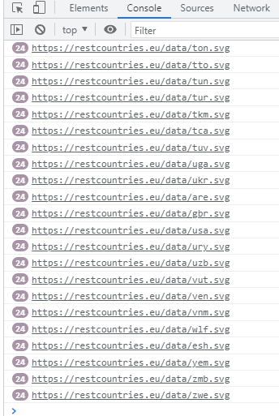
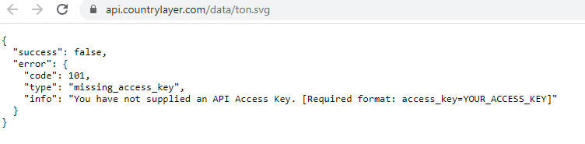

3. Use the same rest countries and print all countries name, region, sub region and population
Code:
obj.forEach((x)=>{
for(var key in x){
console.log(x.name,x.region,x.subregion, x.population);
}
}
);
Output
