JSON API data

1. How to compare two JSON have the same properties without order?
  - var obj1 = { name: "Person 1", age:5 };
  - var obj2 = { age:5, name: "Person 1" };

Method 1:
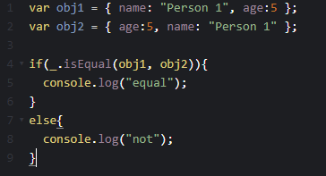

Method 2:
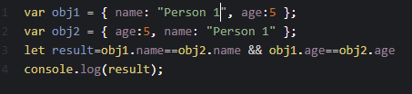
Output:


- Use the rest countries API url ->https://raw.githubusercontent.com/rvsp/restcountries-json-data/master/res-countries.json and display all the country flags in console
Code:
const req = new XMLHttpRequest();
req.open("GET", "https://restcountries.com/v3.1/all");
req.send();
req.onload = () => {
let final = JSON.parse(req.response);
console.log(final);
final.forEach((element) => {
console.log("Country flag:" + element.flags.svg);
});
};

Output
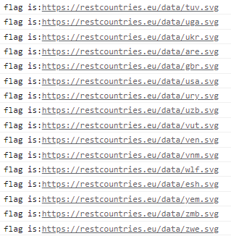

3. Use the same rest countries and print all countries name, region, sub region and population
Code:
const req = new XMLHttpRequest();
req.open("GET", "https://restcountries.com/v3.1/all");
req.send();
req.onload = () => {
let final = JSON.parse(req.response);
console.log(final);
final.forEach((element) => {
// console.log("Country flag:" + element.flags.svg);
console.log("Country name:" + element.name.common);
console.log("Country Region:" + element.region);
console.log("Country SubRegion:" + element.subregion);
console.log("Country Population:" + element.population);
});
};

Output:
