1.http://localhost:8080/Random-Sorting/sorting.html

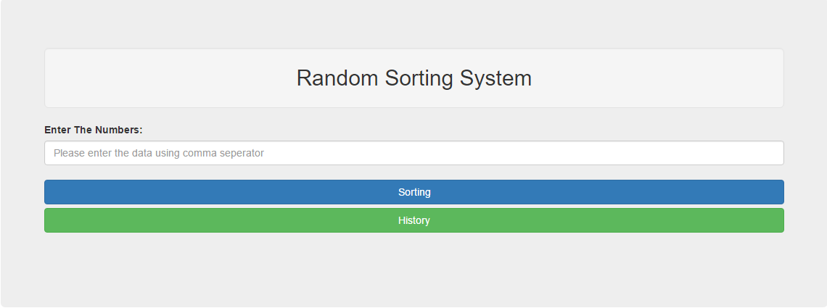

2.Click on sorting button without entering any values

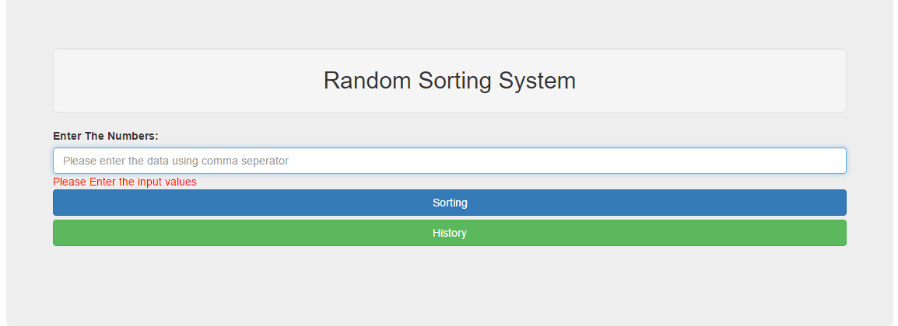

3.Enter any character in the input field

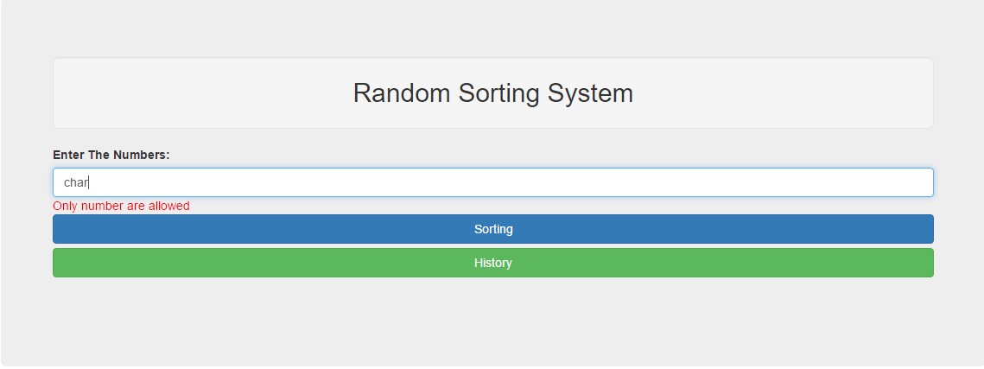

4.Enter 1,5,4,3,2 values to the input field

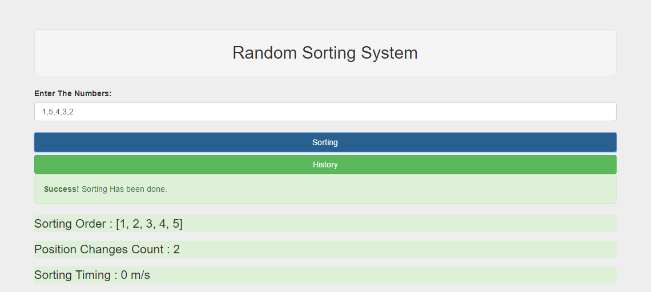

5.Click on History button

