Shop Online
Shop Online is an online auction platform that allows users to buy and sell items through auctions.
HTML Files
index.html: Default screen to navigate login and register screen.
bidding.html: Enables users to bid on items in the auction.
listing.html: Allows users to create listings for auctioned items.
login.html: Provides a login interface for users.
logout.html: Greets users upon logging out of Shop Online.
maintenance.html: Interface for admins to generate reports and view processed auction items.
register.html: Allows users to register on Shop Online.

JavaScript Files
bidding.js: Loads and displays auction items from auction.xml using XMLHttpRequest object.
listing.js: Handles the creation of new auction listings.
login.js: Facilitates user login functionality.
logout.js: Enables users to log out of Shop Online.
maintenance.js: Allows admins to view processed auction items and generate reports.

PHP Files
buynow.php: Handles user requests to buy an item in an online auction.
loaditems.php: Loads data from auction.xml.
placebid.php: Manages user requests to place bids on items.
listing.php: Handles user requests related to creating listings.
login.php: Processes user login requests.
logout.php: User logout functionality.
generate_report.php: Generates a list of auction items.
process_items.php: Processes auction items in Shop Online.
register.php: Manages user registration requests.
utility.php: Generates unique IDs for new auction items and checks auction expiry.

Xml files
customer.xml: Storing customer data like name, email and password.
auction.xml: Storing item data for auction.

Output Screenshots

Registration page:
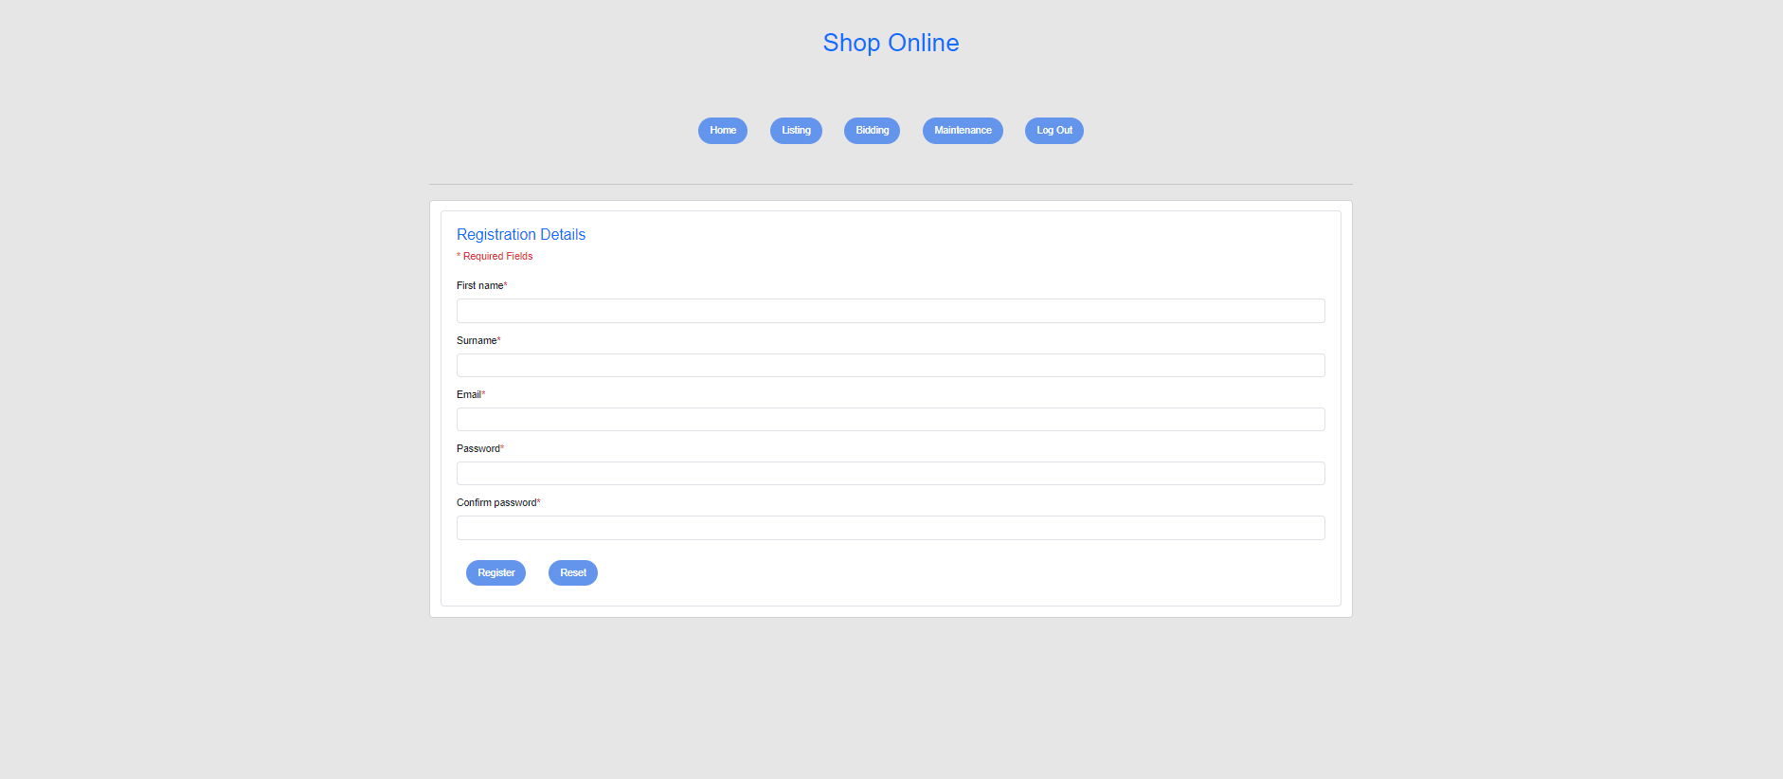

Login Page:
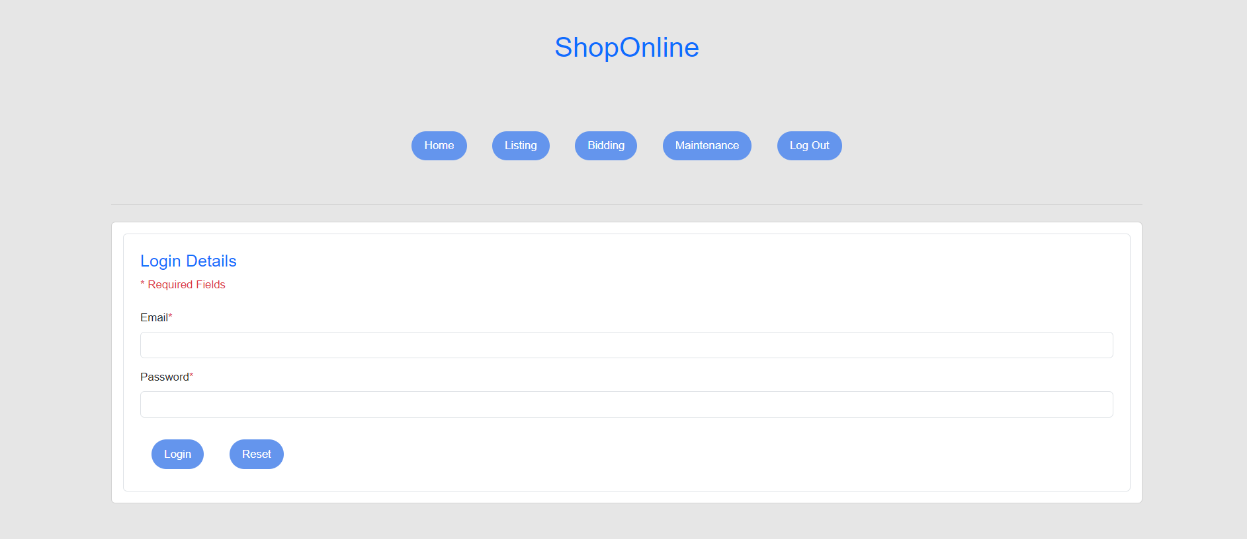
Bidding Page:
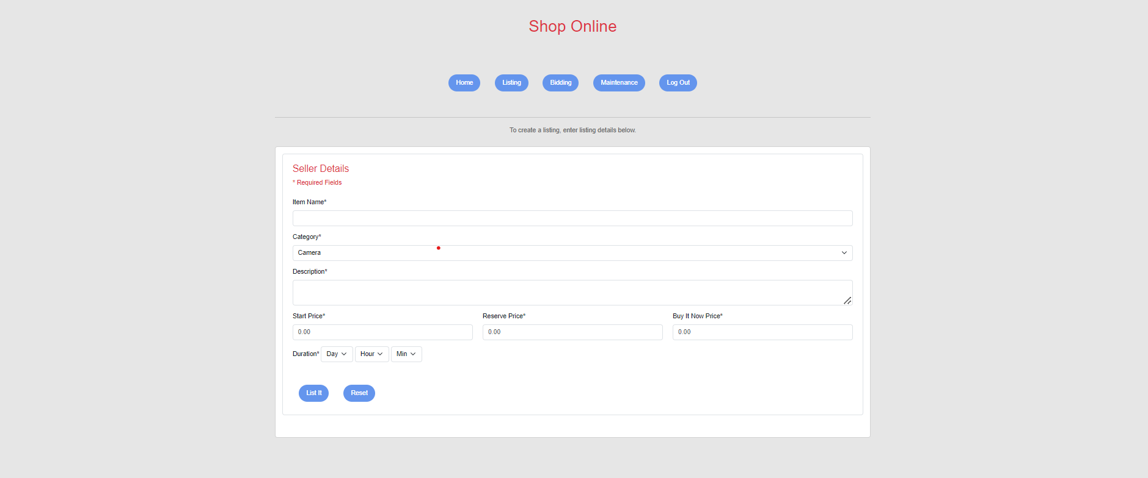
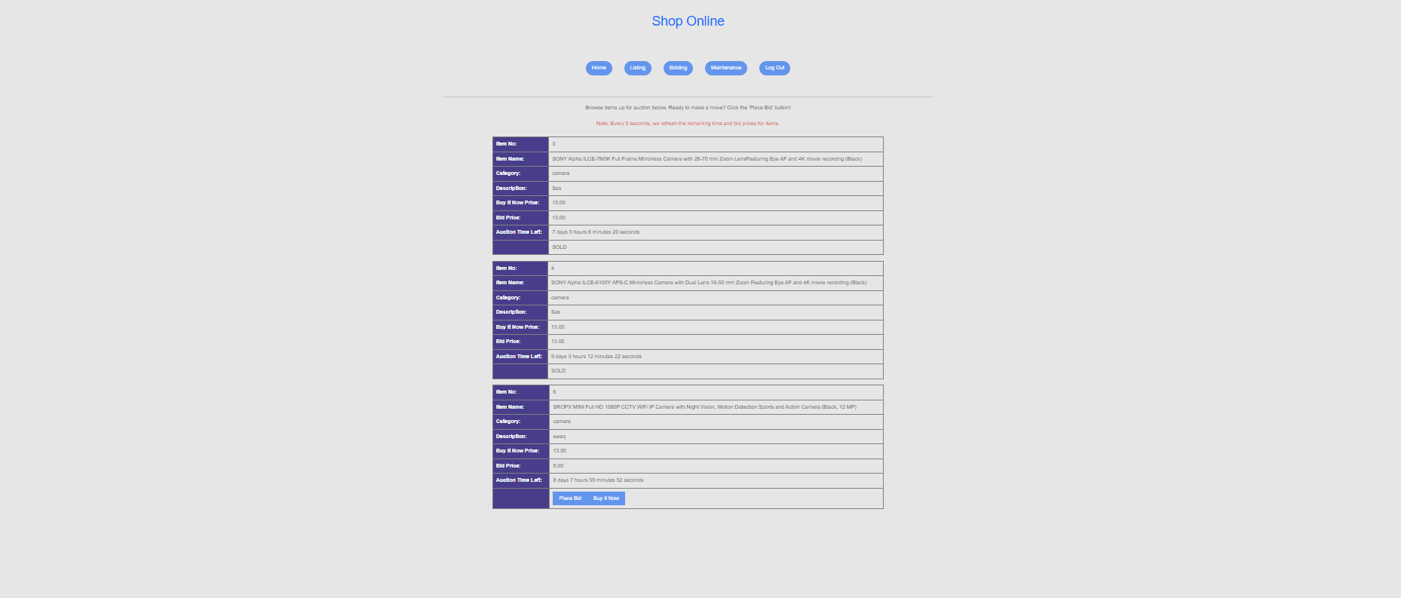

Listing Page:

Maintenance Page:


Generate Report Screenshot:
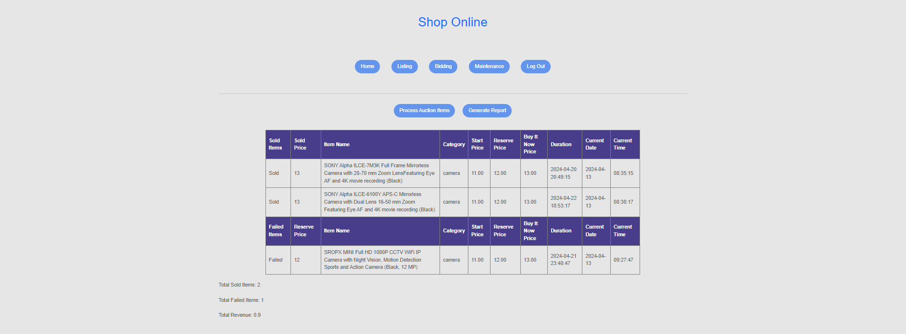
Logout Page Screenshot:



