

K. R. Mangalam University
School of Engineering and Technology
Data structure Lab file

SUBMITTED BY- SUBMITTED TO-
NAME–RAMAN DR. Swati Gupta
ROLL NO.-2401420021
COURSE-BTECH CSE(DS)

Lab Task 2
1. Process Sales: Decrease stock of specific SKUs based on sales, ensuring updates in real time. 2. Identify Zero Stock: Detect out-of-stock items and move them to the end for easy monitoring.

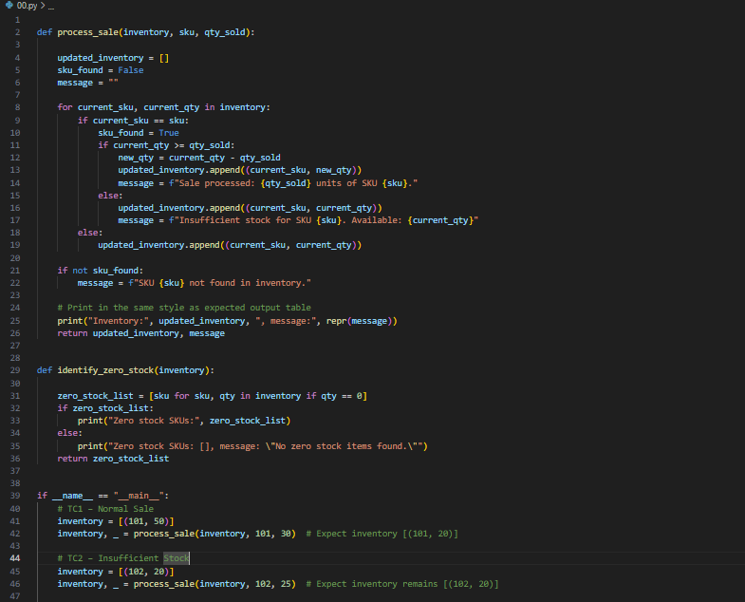

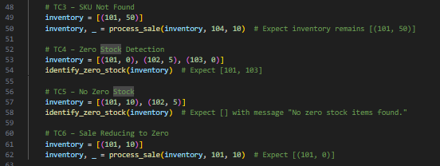
Output-
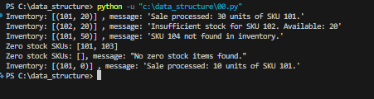

Lab Assignment 3
Objective: Inventory system with two functionalities: 1. Calculate Total & Average Stock 2. Find Maximum Stock Item
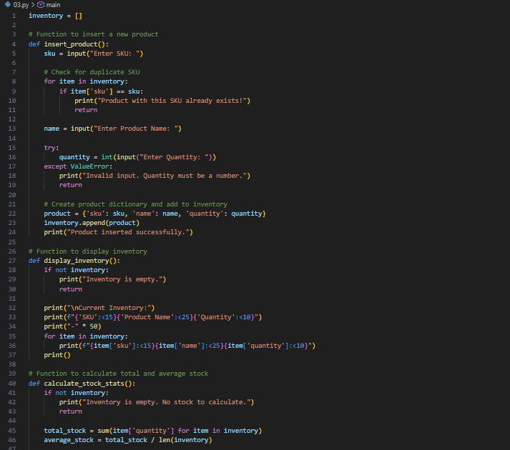

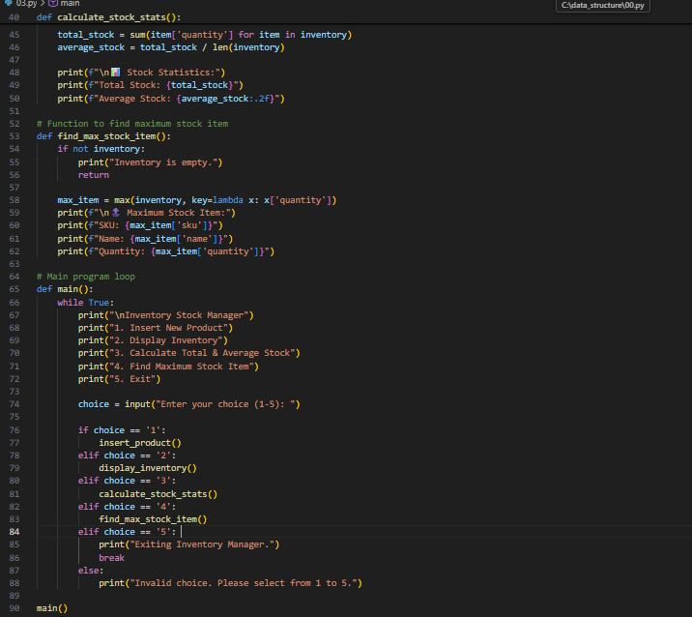
Output-
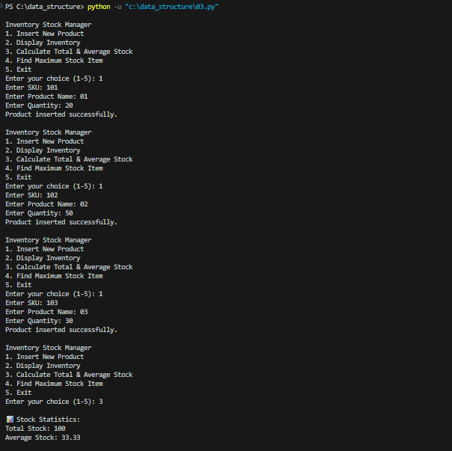
Stack Operations (Push, Pop, Peek, Display, Exit)
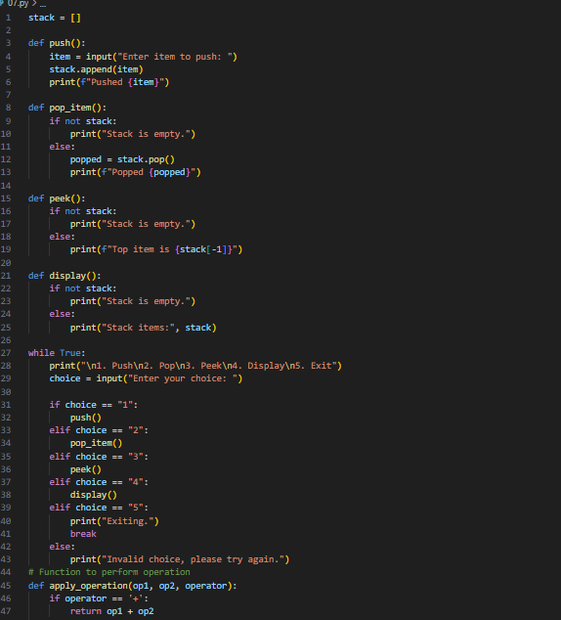
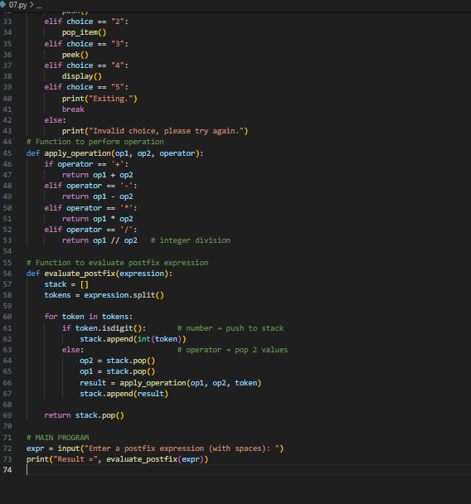
Output-
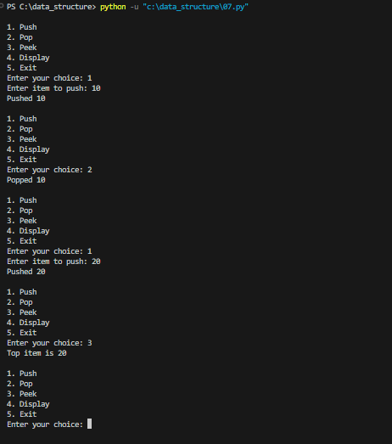
Task:-
Add a Function to Search for a Value in the Linked List Description
• Write a method search(self, key) inside the LinkedList class.
• It should: 1. Traverse the list. 2. If it finds a node with data == key, return True (or print "Found"). 3. If the loop ends without finding it, return False (or print "Not Found").

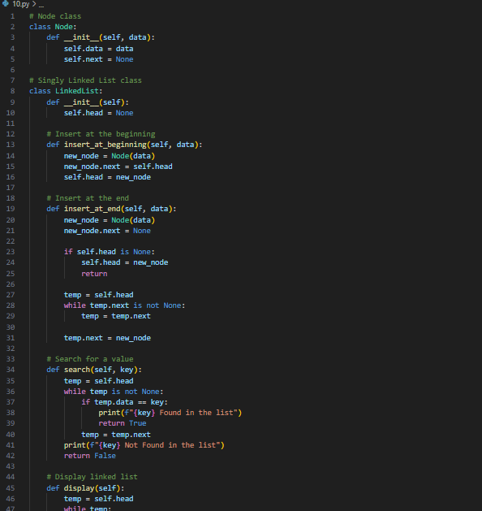
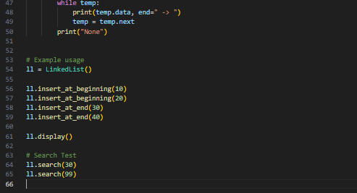
output-
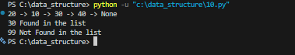

Program: Insertion in a Circular Linked List (Beginning and End)
Operations Performed:
- Create a Circular Linked List
- Insert nodes at the end
- Insert a node at the beginning
- Display the list after each operation
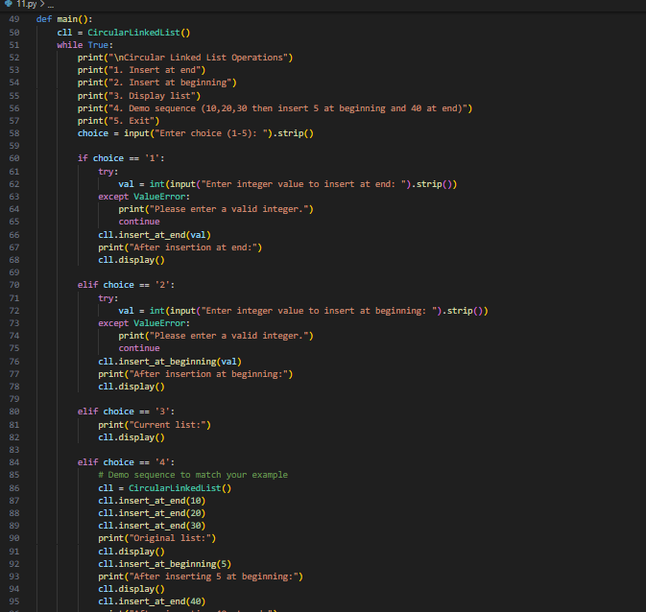
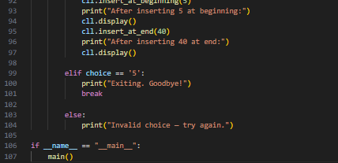
Output-
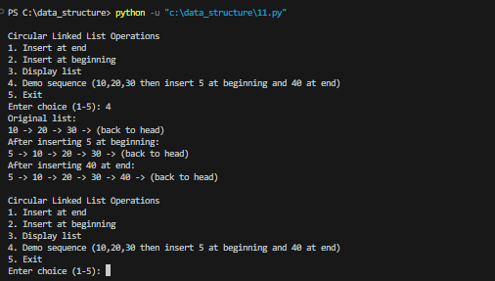
Objective:
To implement a Circular Linked List in Python and perform:
- Deletion of a node at the beginning.
- Deletion of a node at the end. 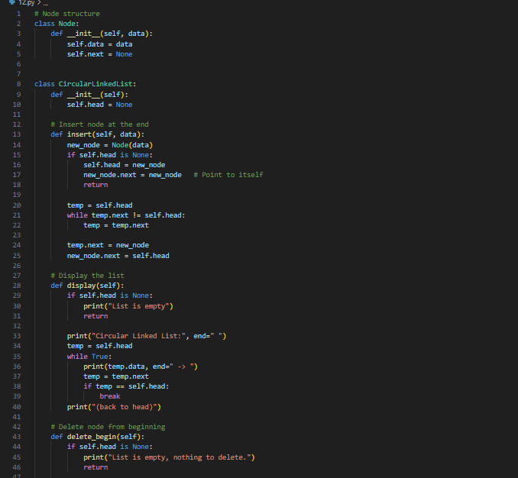
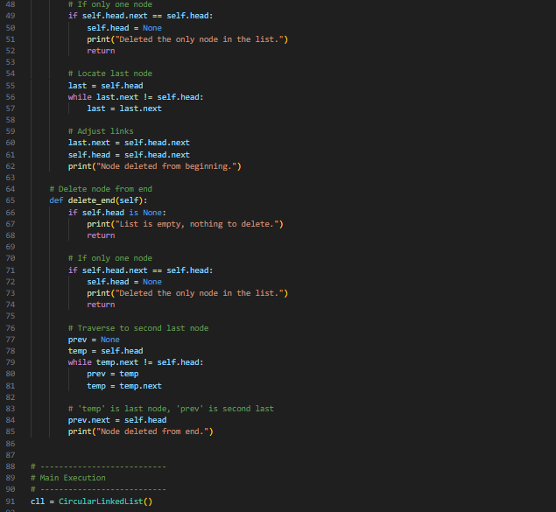

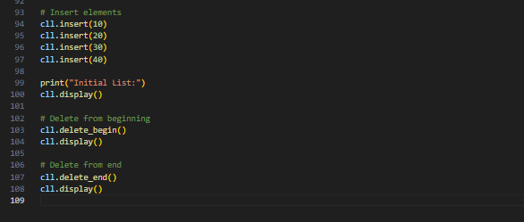
Output-
