Agile Group Project

Find New Recipes

By

Ramandeep Kaur Cheema

Randeep Kaur

Pranshu

Sushmita

Contents

Introduction 3

Project Members 3

Agile Methodology 4

Pages and Mock-ups 5

Start 5

Home 5

Favourite List 6

Recipe Page 6

Internet Search Page 7

Conclusion 7

# Introduction

The main aim of this project is to develop a mobile application using agile/scrum methodology. We have developed a find new recipes application using RestSharp Library. RestSharp is a comprehensive, open-source HTTP client library that works with all kinds of DotNet technologies.  It can be used to build robust applications by making it easy to interface with public APIs and quickly access data without the complexity of dealing with raw HTTP requests. RestSharp combines myriad advantages and time-saving features with a simple, clean interface, making it one of the hottest REST tools being used today.

With its simple API and powerful library, REST architecture is the tool of choice for programmers looking to build detailed programs and applications. RESTful architecture provides an information-driven, resource-oriented approach to creating Web applications. It also offers common tasks such as URI generation, payload parsing, and authentication, as configurable options, ensuring that application developers no longer have to worry about low-level tasks such as networking.

In this find new recipes application a user can search various recipes which includes the methods, ingredients of the recipe. Moreover, user can add those recipes in their favourite list so that they can access them later. With the help of RestSharp Library user can directly access the recipes from the internet.

# Project Members

In order to increase the effectiveness of the application, four team members are participating in a different role that is given in the below table:

|  |  |
| --- | --- |
| Name of team Member | Role |
| Ramandeep Kaur | Team Leader/ Back End Developer (API) |
| Sushmita | Front End Developer |
| Pranshu | Web Designer |
| Randeep Kaur | Application Tester |

All the participles will provide their own efforts to complete the project in an effective manner as well as to satisfy the customer needs by providing a food recipe application.

# Agile Methodology

In this project, the agile methodology is used as an alternative to traditional methods. This approach is quite helpful and handy and can cope up with the changing needs of the software. This methodology is cost effective, fast and provides delivery with continuous improvement.

Here in this project our team has used the agile/scrum methodology. In the beginning, all requirements are identified and discussed by the team members. After that team decided to implement the special feature in the find New recipes app so that it can fulfil the needs of the users. During implementing the functionalities, the team has tested the features such as connecting with internet and searching for the recipe. Once tested, it has given the user to check and give feedback for improvements. On the recommendation of users some changes have been done in the application to make it more user-friendly and attractive. After incorporating and implementing all changes, the app is ready to use by the users.

# Pages and Mock-ups

## Start

This is a landing page of the application which appears only for 3000mili seconds. It contains an image. After 3000 milliseconds, it reroutes to the home page.



## Home

This is the main page of the application. On this page there are four buttons search, like, dislike and favourite. Whenever user searches any recipes by adding the name of the recipe, the application will display all relevant recipes. If user likes any recipe and clicks on like button, it will be added to the favourite list and if user doesn’t like any recipe, it moves to the next one. Moreover, if user clicks on favourite button, he/she can route to the favourite page where they can access the list of their favourite recipes.

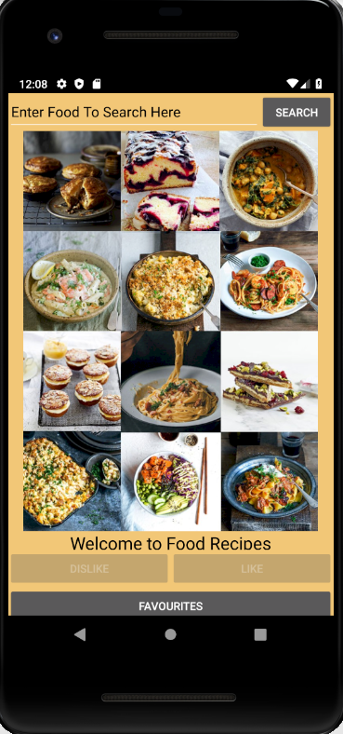 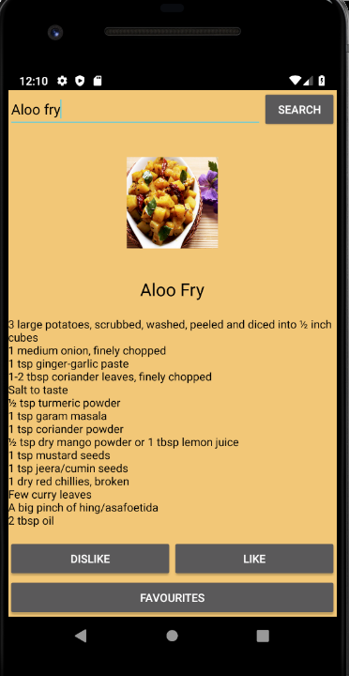

## Favourite List

On this page user can see the list of the recipes which they have liked on the home page. Also, when they will click on any recipe, recipe page will open.

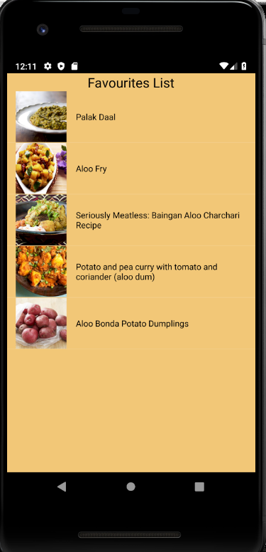

## Recipe Page

It will show the detailed recipe along with ingredient details and name of recipe. Here user can see GotoRecipe button, when user click on this button, the API will direct user to the root page of the recipe on internet.

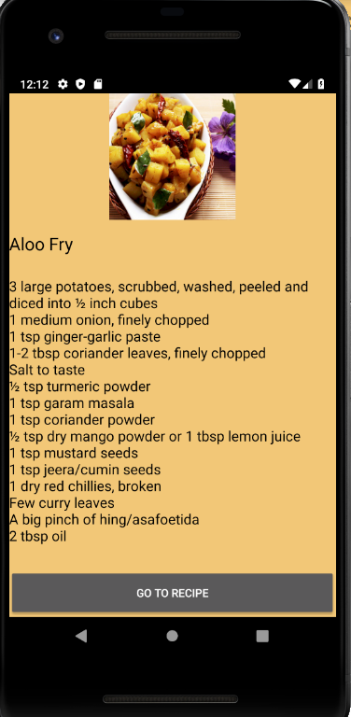

## Internet Search Page

When user click on GotoRecipe button on recipe page, food recipe app redirect user to the internet search page where user can find the details of that particular recipe.

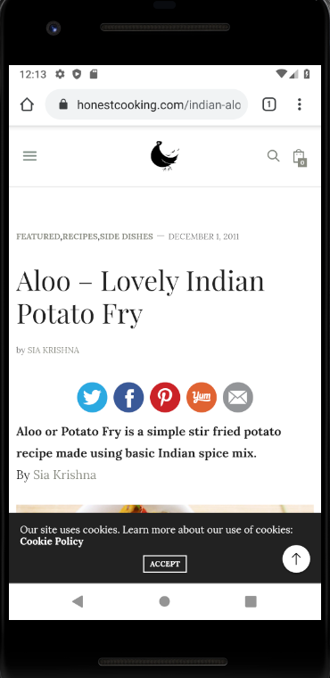

# Conclusion

In nutshell, this project is based on agile scrum methodology. Where IT team has designed an android application called find new recipes. In this project all team members contributed equally and collaboratively.