Safe Route Navigator: A Crime Rate-Based Algorithm for Optimal and Secure Path finding

Dr. Sarika Deokate (Guide), Pranali Patil, Sayali Pawar, Raman Randive, Yash Sonje

**Abstract**

The currently used route navigators prioritize speed over safety. However, due to rising crime rates in India necessity for safety tools for citizens is needed. The important term like ‘Safety’ is neglected by the existent systems. It suggests only the shortest distance but doesn’t include any safety concerns or information about the areas. To avoid the minimal risk score for security of the road travellers, the Safe Route Navigator ideology comes into picture.

The Safe Route Navigator System will fill the gap by providing a system that alerts users about unsafe locations and offers safer alternatives. In this system, Geo coordinate mapping approach will be done to examine the safest route. A safety score will be assigned to different zones which will help the road travellers to travel safely with peacefulness.

Ultimately, this project will make rural and urban travel into safer and more reliable experience for everyone.

**Introduction**

Currently Route Recommendation Systems only consider the terminologies like cost, time and shortest distance. Without thinking about how safe the route is, the road travellers put themselves in danger. The Safe Route Navigator System will be built by considering the above challenges. The System finds safest route by using crime data which is collected from police stations and traffic officers.

The system will use APIs like Google Direction API and Places API to lead the travellers to their destinations. It will use geo-mapping technology to analyse crime areas and assign risk scores. The system will highlight safe paths and key public places such as hospitals, emergency contacts, friends, relatives, and parents. In case a user enters a high- risk area, there will be an emergency button that, when pressed, will automatically call pre-set contacts, sharing the user's location for quick help. Users will also be able to download routes with safety details and important landmarks, making navigation easier even in areas with poor internet connectivity.

Safe Route Navigator will help people to be safe while travelling due the support of features like locating public hotspots like hospital, police stations, emergency contact to guardian and police services, help in offline travel support of map download, the system would provide its results on the basis of frequently updated dataset of FIR reports and public services updates

This system would be designed to put safety first. It will make travel safer, easier, and more reliable by providing secure routes and quick access to help when needed.

# Objectives

* **Enhance Personal Safety**: For choosing safer routes as well as avoiding the risky areas, our system will include live track of criminal data.
* **Provide Emergency Assistance**: In emergency situations the users will be able to locate the nearby hospitals, police stations, safe places.
* **Support Offline Navigation**: In the poor internet connectivity areas , the route and safety details would be available offline for assistance.
* **Maintain Data Privacy**: Fir the privacy and security of the users , careful measures would be taken.

# About data collection

We surveyed the PCMC Police Station and the Traffic Officer of the PCMC Traffic Police to gain a better understanding of route safety in the PCMC area of Pune. We asked several questions about our system and their suggestions on what should be included according to their perspective. They provided insightful information on various safety issues, traffic patterns, rules and regulations, and necessary precautions to be taken during the day.

We categorized the collected information, on which this system depends, as follows:

* **Safety Patterns in the Morning**

Crime Levels: Lower crime rates with minor disturbances.

Traffic Focus: Heavy traffic near schools due to increased pedestrian activity.

* **Safety Issues at Night**

Crime Risks: Robberies, assaults, and public area aggressions are highly probable.

Traffic Problems: During the night, incidents of drunk driving, speeding, and accidents increase, especially on poorly illuminated stretches.

Additionally, they shared important insights, such as the high accident rate on Chakan Road due to its narrow structure. This area, being home to many industries, experiences heavy traffic congestion both in the morning and at night.

* **Traffic Patterns**

Morning: Between 8 AM and 11 AM, road usage peaks. Traffic regulations are strictly enforced, and pedestrian crossings are more frequent.

Night: Visibility decreases, speeding increases, and attention is focused on accident-prone spots.

Furthermore, a reference dataset was created based on the conducted surveys. This dataset will allow us to apply real-time data analysis in the future while maintaining confidentiality.

The data structure is divided into fields, as shown in Figure 1.

A reference dataset was also created based on surveys. This data will help the system identify safe and risky areas more accurately.

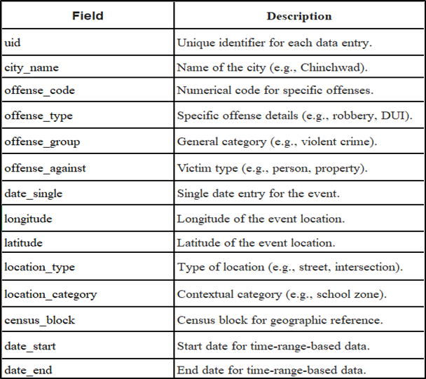

Fig 1. Dataset Description

# Methodology

* + **Information Gathering:** For information gathering we are considering sources like FIR reports, updates from safety departments police stations etc. Additionally we assign the gravity / rating / score to crime and accident to measure the severity.
  + **Integration with Mapping APIs:** To find the appropriate path we are using the google maps APIs, for these purpose we are using DIRECTION API, PLACES API from google maps.
  + **Route Scoring:** The system will use approach of geo-coordinate mapping method, were crime coordinate are mapped with the coordinates of route. When the match is found the gravity of that crime is added to routes threat score, this process is repeated for each route provided by API call.
  + **Route Ranking:** The routes will be ranked will be ranked in safe, moderate, risk by comparing their final score after score are added by mapping. The route with high threat score is marked risky, next is marked as moderate, and the route with minimal score is marked as safe route.
  + **Dynamic Updates:** This system cannot be depended on static dataset, the database needs to update and gravity of crime is need to be reduced over the period of time. This will ensure that system is monitoring the safety for travelers we trusted data building the trust.
  + **User Accessibility:** Users would be able to find safe travel route, mark their personal safety spots, get locations of public hotspots, schedule for public transports nearby them, for low network areas would have features like maps download which would mention public hotspots and their safest route. The Architectural Diagram (Fig. 2) visually represents the flow of data and decision-making in the system.

# Architectural diagram

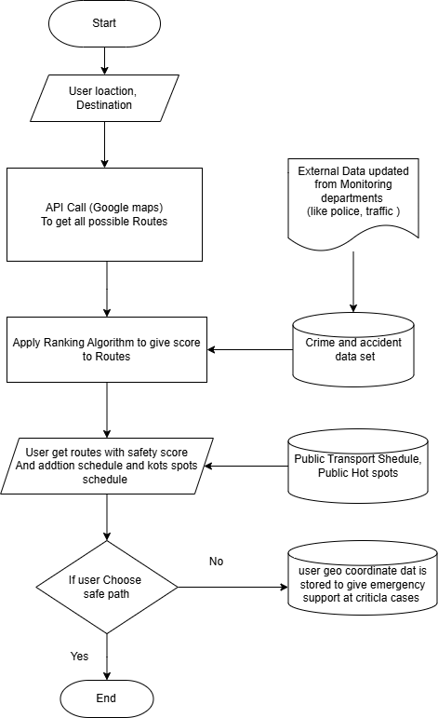

Fig 2. Architectural Diagram

# Conclusion

Safety will improve greatly with a safe route finder that blends modern maps with crime data. The system will keep track of routes and rate them according to safety, offering users the least-risk route. Public transport schedules, real-time alerts about emergencies, and offline maps will add particular value to travelers who are in unfamiliar territory or, indeed, might be subject to certain dangers in an area. This solution will offer a user-friendly interface that provides intrinsically safe, reliable, and accessible travel options for everyone.