**Introduction to Databases**

Concepts in Focus

* Data
* Database
* Database Management System(DBMS)
  + Advantages
* Types of Databases
  + Relational Database
  + Non-Relational Database

Data

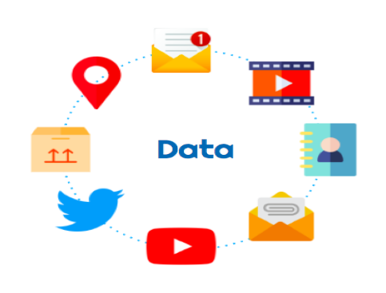

Any sort of information that is stored is called data.

**Examples:**

* Messages & multimedia on WhatsApp
* Products and orders on Amazon
* Contact details in telephone directory, etc.

Database

An organised collection of data is called a database.

Database Management System (DBMS)

A software that is used to easily store and access data from the database in a secure way.

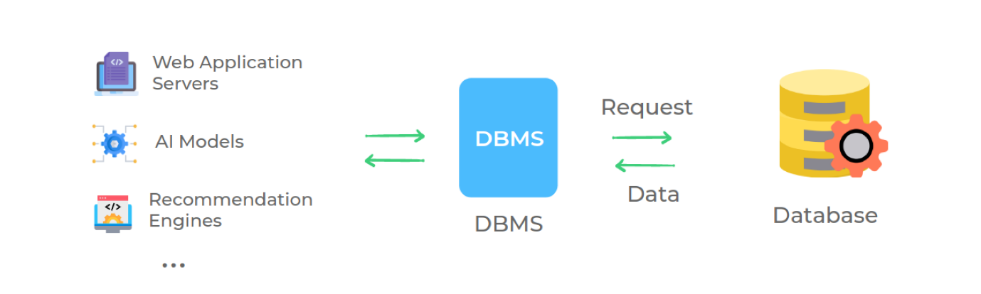

Advantages

* **Security:** Data is stored & maintained securely.
* **Ease of Use:** Provides simpler ways to create & update data at the rate it is generated and updated respectively.
* **Durability and Availability:** Durable and provides access to all the clients at any point in time.
* **Performance:** Quickly accessible to all the clients(applications and stakeholders).

Types of Databases

There are different types of databases based on how we organize the data.

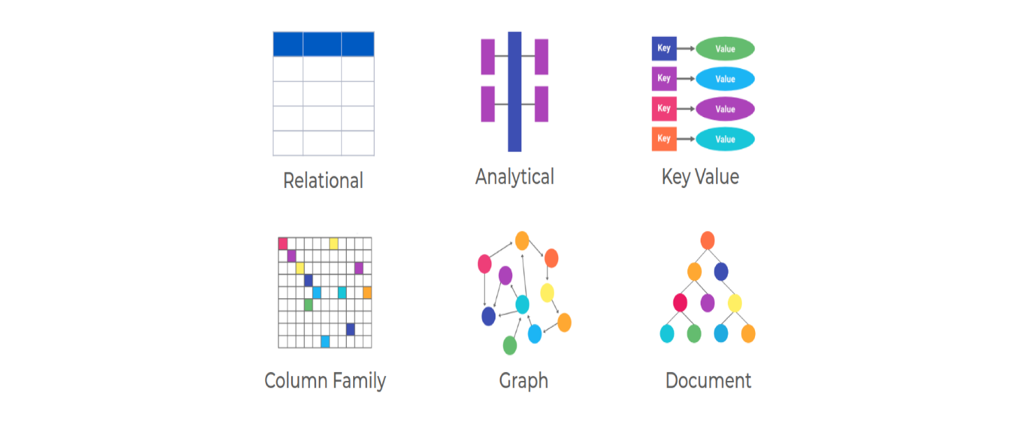

Relational Database



In relational databases, the data is organised in the form of tables.

Non-Relational Database

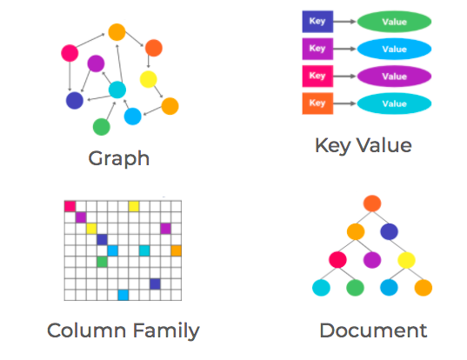

These four types are commonly referred as non-relational databases.

**Note**

* Choice of database depends on our requirements.
* Relational database is the most commonly used database.

Relational DBMS

A

Relational DBMS

is a DBMS designed specifically for relational databases. Relational databases organise the data in the form of tables.

Examples: Oracle, PostgreSQL, MySQL, SQLite, SQL Server, IBM DB2, etc.

Non-Relational DBMS

A

Non-relational DBMS

is a DBMS designed specifically for non-relational databases. Non-relational databases store the data in a non-tabular form.

Examples: Elasticsearch, CouchDB, DynamoDB, MongoDB, Cassandra, Redis, etc.

What is data?

Any sort of information that is stored.

What is database?

An Organised Collection of Data.

What is DBMS?

A Software that is used to easily store and access data from the database in a secure way.