**Pre Requisite:**

SonarQuber Server

Jenkins Server

**Step 1)** Install **"SonarQube Scanner"** plugin in Jenkins as follow.

**Step 2)** Integrate SonarQube server with Jenkins as follows.

**Manage Jenkins ---> Configure System** ---> **SonarQube servers**

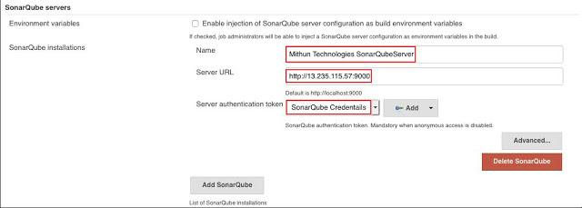

**Generate the SonarQube server authentication token**

Login into SonarQube with Admin user.

[http://<<IP Address>>:9000/](http://localhost:9000/)

Default Credentials:

**User:** admin

**Password:** admin

Click on Administration tab.

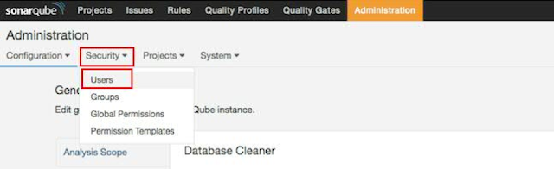

**Click on Tokens**

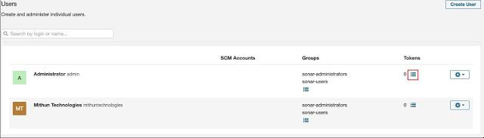

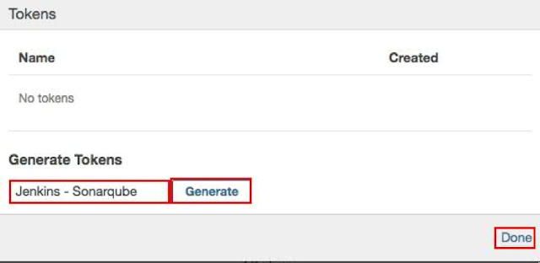

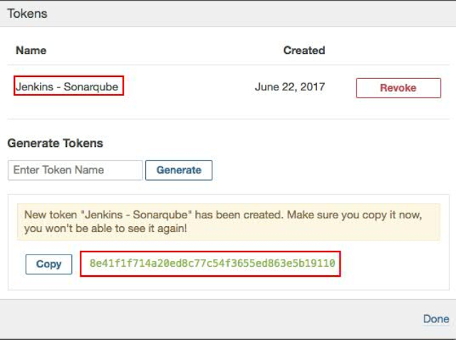

**Step3)** Execute the SonarQube report for Maven Java Project.

Select the job , to which we need to run the sonarqube report, click on configure, in Post-build Actions options, click on Add post-build action --> Select the SonarQube report for Maven project.

================================================================================

**#Hardware Requirements for SonarQube**

**#----------------------------------------------------**

#The SonarQube server requires at least 2GB of RAM to run efficiently and 1GB of free RAM for the OS.

**#Login as a root user.**

sudo su -

**#Download the SonarqQube Server software.**

cd /opt

yum install wget unzip -y

wget https://binaries.sonarsource.com/Distribution/sonarqube/sonarqube-7.8.zip

unzip sonarqube-7.8.zip

**#As a good security practice, SonarQuber Server is not advised to run sonar service as a root user, so create a new user called nexus and grant sudo access to manage nexus services as follows.**

useradd sonar

**Give the sudo access to sonar user**

visudo

sonar ALL=(ALL) NOPASSWD: ALL

**Change the owner and group permissions to /opt/sonarqube-7.8/ directory.**

chown -R sonar:sonar /opt/sonarqube-7.8/

chmod -R 775 /opt/sonarqube-7.8/

su - sonar

cd /opt/sonarqube-7.8/bin/linux-x86-64/

./sonar.sh start

**Troubleshooting**

**--------------------**

sonar service is not starting?

a)make sure you need to change the ownership and group to /opt/sonarqube-7.6/ directory for sonar user.

b)make sure you are trying to start sonar service with sonar user.

c)check java is installed or not using java -version command.

Unable to access SonarQube server URL in browser?

a)make sure port 9000 is opened in security groups - AWS ec2 instance.

**Create SonarQube server as a sonar service**

**--------------------------------------------------------**

ln /opt/sonarqube-7.8/bin/linux-x86-64/sonar.sh /etc/init.d/sonar

vi /etc/init.d/sonar

**#add below lines in /etc/init.d/sonar**

SONAR_HOME=/opt/sonarqube-7.8

PLATFORM=linux-x86-64

WRAPPER_CMD="${SONAR_HOME}/bin/${PLATFORM}/wrapper"

WRAPPER_CONF="${SONAR_HOME}/conf/wrapper.conf"

PIDDIR="/opt/sonarqube-7.8/"

**#Enable the sonar service**

sudo systemctl enable sonar

**#Start the sonar service**

sudo systemctl start sonar

**#Check the status of the sonar service**

sudo systemctl status sonar