1. **Write a program to Generate Association rules by using Apriori Algorithm**

**Output:**

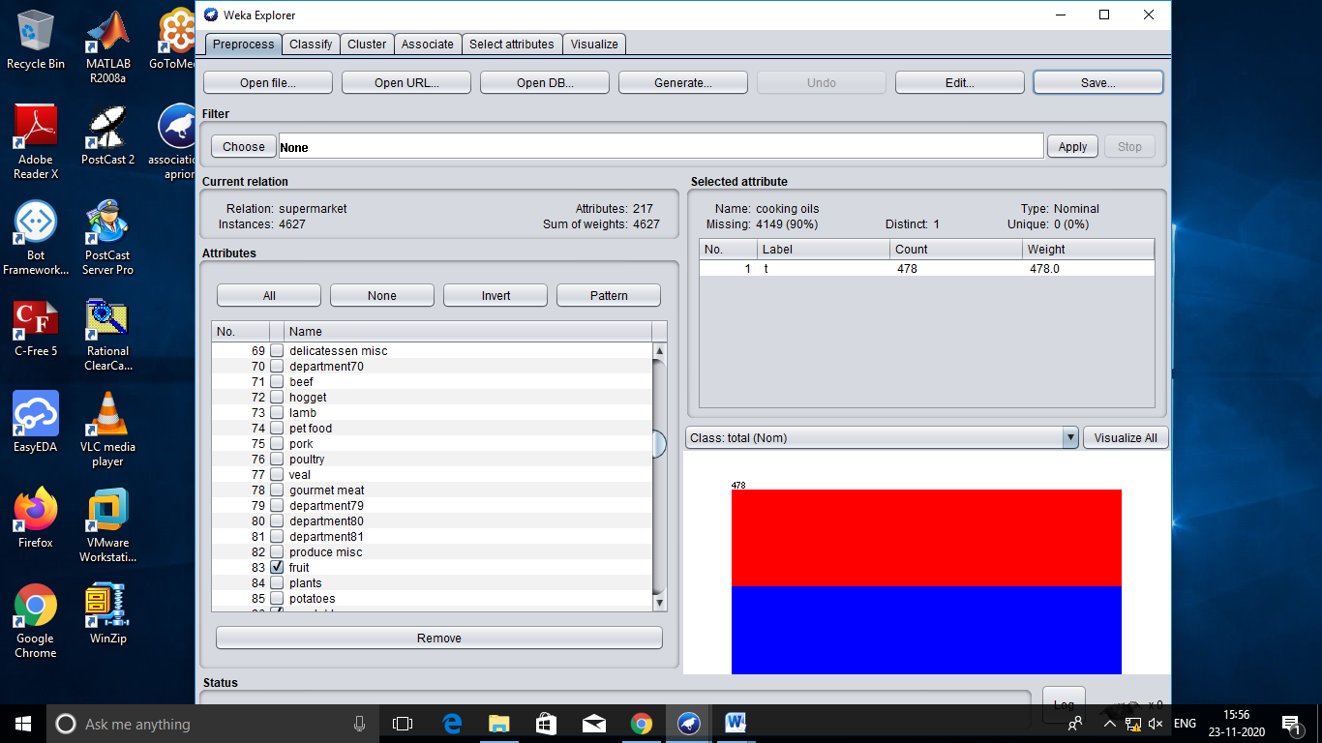

=== Run information ===

Scheme: weka.associations.Apriori -N 10 -T 0 -C 0.9 -D 0.05 -U 1.0 -M 0.1 -S -1.0 -c -1

Relation: supermarket

Instances: 4627

Attributes: 217

[list of attributes omitted]

=== Associator model (full training set) ===

Apriori

=======

Minimum support: 0.15 (694 instances)

Minimum metric <confidence>: 0.9

Number of cycles performed: 17

Generated sets of large itemsets:

Size of set of large itemsets L(1): 44

Size of set of large itemsets L(2): 380

Size of set of large itemsets L(3): 910

Size of set of large itemsets L(4): 633

Size of set of large itemsets L(5): 105

Size of set of large itemsets L(6): 1

Best rules found:

1. biscuits=t frozen foods=t fruit=t total=high 788 ==> bread and cake=t 723 <conf:(0.92)> lift:(1.27) lev:(0.03) [155] conv:(3.35)

2. baking needs=t biscuits=t fruit=t total=high 760 ==> bread and cake=t 696 <conf:(0.92)> lift:(1.27) lev:(0.03) [149] conv:(3.28)

3. baking needs=t frozen foods=t fruit=t total=high 770 ==> bread and cake=t 705 <conf:(0.92)> lift:(1.27) lev:(0.03) [150] conv:(3.27)

4. biscuits=t fruit=t vegetables=t total=high 815 ==> bread and cake=t 746 <conf:(0.92)> lift:(1.27) lev:(0.03) [159] conv:(3.26)

5. party snack foods=t fruit=t total=high 854 ==> bread and cake=t 779 <conf:(0.91)> lift:(1.27) lev:(0.04) [164] conv:(3.15)

6. biscuits=t frozen foods=t vegetables=t total=high 797 ==> bread and cake=t 725 <conf:(0.91)> lift:(1.26) lev:(0.03) [151] conv:(3.06)

7. baking needs=t biscuits=t vegetables=t total=high 772 ==> bread and cake=t 701 <conf:(0.91)> lift:(1.26) lev:(0.03) [145] conv:(3.01)

8. biscuits=t fruit=t total=high 954 ==> bread and cake=t 866 <conf:(0.91)> lift:(1.26) lev:(0.04) [179] conv:(3)

9. frozen foods=t fruit=t vegetables=t total=high 834 ==> bread and cake=t 757 <conf:(0.91)> lift:(1.26) lev:(0.03) [156] conv:(3)

10. frozen foods=t fruit=t total=high 969 ==> bread and cake=t 877 <conf:(0.91)> lift:(1.26) lev:(0.04) [179] conv:(2.92)

