**2.Write a program to implement Naïve Bayesian classification**

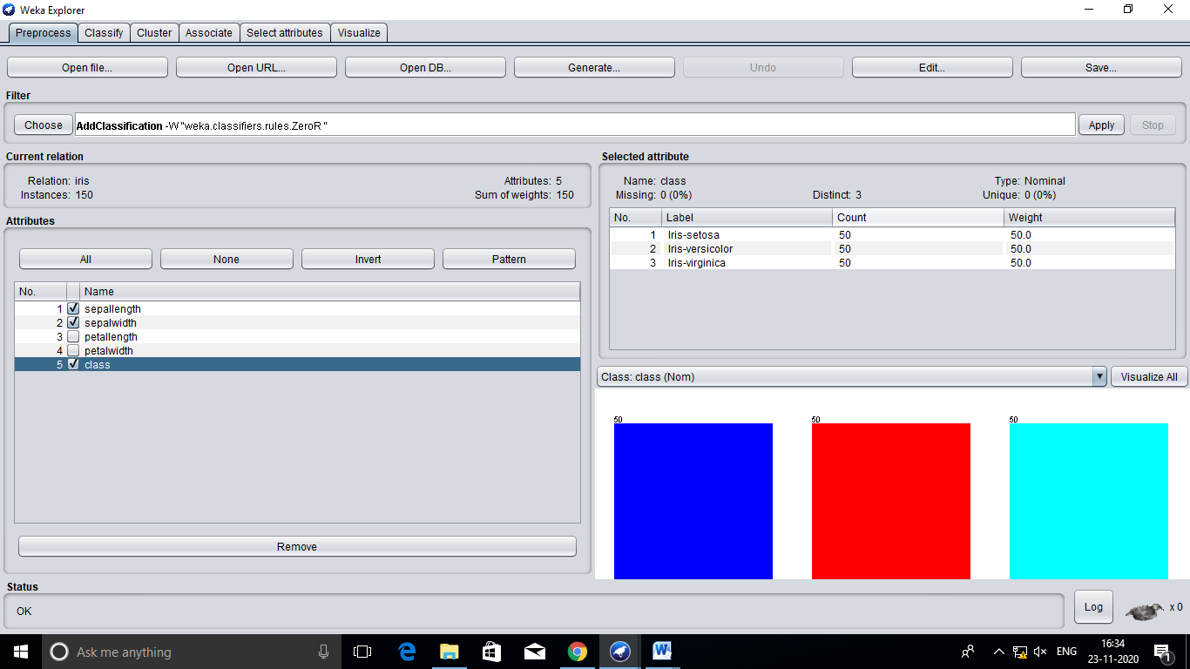

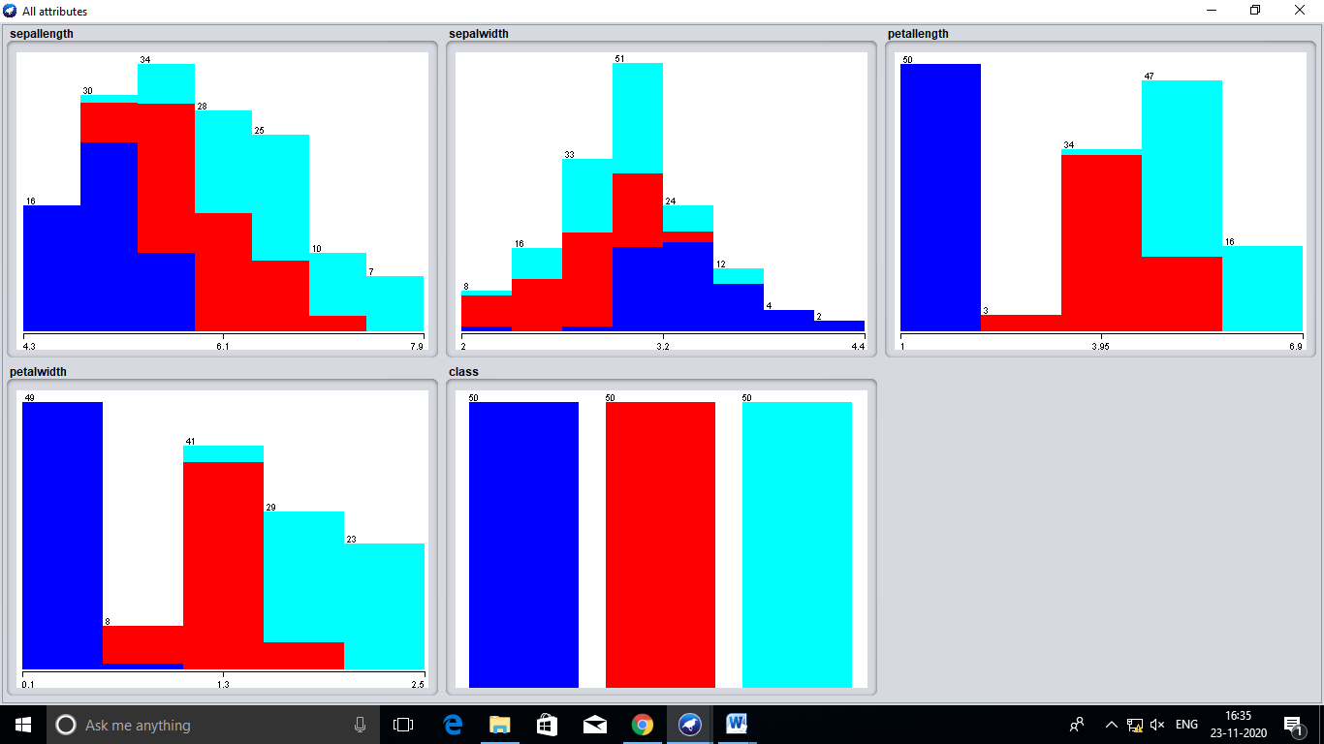

=== Run information ===

Scheme: weka.classifiers.bayes.NaiveBayes

Relation: iris

Instances: 150

Attributes: 5

sepallength

sepalwidth

petallength

petalwidth

class

Test mode: 10-fold cross-validation

=== Classifier model (full training set) ===

Naive Bayes Classifier

Class

Attribute Iris-setosa Iris-versicolor Iris-virginica

(0.33) (0.33) (0.33)

===============================================================

sepallength

mean 4.9913 5.9379 6.5795

std. dev. 0.355 0.5042 0.6353

weight sum 50 50 50

precision 0.1059 0.1059 0.1059

sepalwidth

mean 3.4015 2.7687 2.9629

std. dev. 0.3925 0.3038 0.3088

weight sum 50 50 50

precision 0.1091 0.1091 0.1091

petallength

mean 1.4694 4.2452 5.5516

std. dev. 0.1782 0.4712 0.5529

weight sum 50 50 50

precision 0.1405 0.1405 0.1405

petalwidth

mean 0.2743 1.3097 2.0343

std. dev. 0.1096 0.1915 0.2646

weight sum 50 50 50

precision 0.1143 0.1143 0.1143

Time taken to build model: 0 seconds

=== Stratified cross-validation ===

=== Summary ===

Correctly Classified Instances 144 96 %

Incorrectly Classified Instances 6 4 %

Kappa statistic 0.94

Mean absolute error 0.0342

Root mean squared error 0.155

Relative absolute error 7.6997 %

Root relative squared error 32.8794 %

Total Number of Instances 150

=== Detailed Accuracy By Class ===

TP Rate FP Rate Precision Recall F-Measure MCC ROC Area PRC Area Class

1.000 0.000 1.000 1.000 1.000 1.000 1.000 1.000 Iris-setosa

0.960 0.040 0.923 0.960 0.941 0.911 0.992 0.983 Iris-versicolor

0.920 0.020 0.958 0.920 0.939 0.910 0.992 0.986 Iris-virginica

Weighted Avg. 0.960 0.020 0.960 0.960 0.960 0.940 0.994 0.989

=== Confusion Matrix ===

a b c <-- classified as

50 0 0 | a = Iris-setosa

0 48 2 | b = Iris-versicolor

0 4 46 | c = Iris-virginica