**4.Write a program to implement k-mediods clustering algorithm**

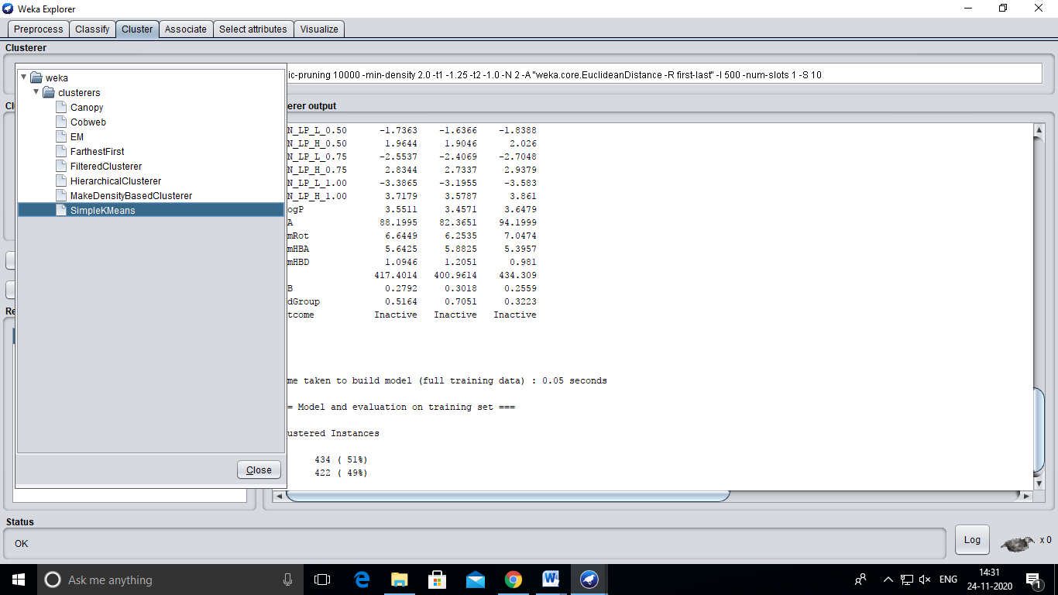

**Output:**

== Run information ===

Scheme: weka.clusterers.SimpleKMeans -init 0 -max-candidates 100 -periodic-pruning 10000 -min-density 2.0 -t1 -1.25 -t2 -1.0 -N 2 -A "weka.core.EuclideanDistance -R first-last" -I 500 -num-slots 1 -S 10

Relation: unbalanced

Instances: 856

Attributes: 33

WBN_GC_L_0.25

WBN_GC_H_0.25

WBN_GC_L_0.50

WBN_GC_H_0.50

WBN_GC_L_0.75

WBN_GC_H_0.75

WBN_GC_L_1.00

WBN_GC_H_1.00

WBN_EN_L_0.25

WBN_EN_H_0.25

WBN_EN_L_0.50

WBN_EN_H_0.50

WBN_EN_L_0.75

WBN_EN_H_0.75

WBN_EN_L_1.00

WBN_EN_H_1.00

WBN_LP_L_0.25

WBN_LP_H_0.25

WBN_LP_L_0.50

WBN_LP_H_0.50

WBN_LP_L_0.75

WBN_LP_H_0.75

WBN_LP_L_1.00

WBN_LP_H_1.00

XLogP

PSA

NumRot

NumHBA

NumHBD

MW

BBB

BadGroup

Outcome

Test mode: evaluate on training data

=== Clustering model (full training set) ===

kMeans

======

Number of iterations: 11

Within cluster sum of squared errors: 816.9893947742129

Initial starting points (random):

Cluster 0: -2.3987,1.3515,-2.5265,2.0104,-2.7638,2.8582,-3.5261,3.7241,-0.7662,1.5357,-1.5565,2.3667,-2.3657,3.2222,-3.1904,4.0893,-1.0868,1.0701,-1.9162,1.8886,-2.7607,2.7375,-3.6126,3.6025,1.309,102.55,8,8,1,426.535,0,0,Inactive

Cluster 1: -1.4544,2.279,-1.9823,2.7362,-2.7293,3.5025,-3.5518,4.3763,-0.7837,2.4019,-1.5852,2.6771,-2.4576,3.2654,-3.3478,4.1813,-1.0489,1.1315,-1.8608,2.0166,-2.7446,2.9442,-3.6403,3.885,3.912,113.06,5,6,2,462.359,0,1,Inactive

Missing values globally replaced with mean/mode

Final cluster centroids:

Cluster#

Attribute Full Data 0 1

(856.0) (434.0) (422.0)

================================================

WBN_GC_L_0.25 -2.0831 -2.1472 -2.0171

WBN_GC_H_0.25 1.7947 1.7986 1.7907

WBN_GC_L_0.50 -2.3175 -2.332 -2.3026

WBN_GC_H_0.50 2.331 2.2964 2.3665

WBN_GC_L_0.75 -2.7597 -2.6676 -2.8543

WBN_GC_H_0.75 3.0835 3.0005 3.1688

WBN_GC_L_1.00 -3.4255 -3.2248 -3.6319

WBN_GC_H_1.00 3.9192 3.7917 4.0504

WBN_EN_L_0.25 -0.7891 -0.7785 -0.8

WBN_EN_H_0.25 1.5287 1.3895 1.6718

WBN_EN_L_0.50 -1.6045 -1.5723 -1.6375

WBN_EN_H_0.50 2.2032 2.0441 2.3668

WBN_EN_L_0.75 -2.4343 -2.3724 -2.4979

WBN_EN_H_0.75 2.992 2.8095 3.1798

WBN_EN_L_1.00 -3.2713 -3.1756 -3.3697

WBN_EN_H_1.00 3.8529 3.6305 4.0816

WBN_LP_L_0.25 -0.9692 -0.9232 -1.0166

WBN_LP_H_0.25 1.1365 1.1242 1.1491

WBN_LP_L_0.50 -1.7363 -1.6366 -1.8388

WBN_LP_H_0.50 1.9644 1.9046 2.026

WBN_LP_L_0.75 -2.5537 -2.4069 -2.7048

WBN_LP_H_0.75 2.8344 2.7337 2.9379

WBN_LP_L_1.00 -3.3865 -3.1955 -3.583

WBN_LP_H_1.00 3.7179 3.5787 3.861

XLogP 3.5511 3.4571 3.6479

PSA 88.1995 82.3651 94.1999

NumRot 6.6449 6.2535 7.0474

NumHBA 5.6425 5.8825 5.3957

NumHBD 1.0946 1.2051 0.981

MW 417.4014 400.9614 434.309

BBB 0.2792 0.3018 0.2559

BadGroup 0.5164 0.7051 0.3223

Outcome Inactive Inactive Inactive

Time taken to build model (full training data) : 0.05 seconds

=== Model and evaluation on training set ===

Clustered Instances

0 434 ( 51%)

1 422 ( 49%)