**5.Write a program to implement dbscan algorithm**

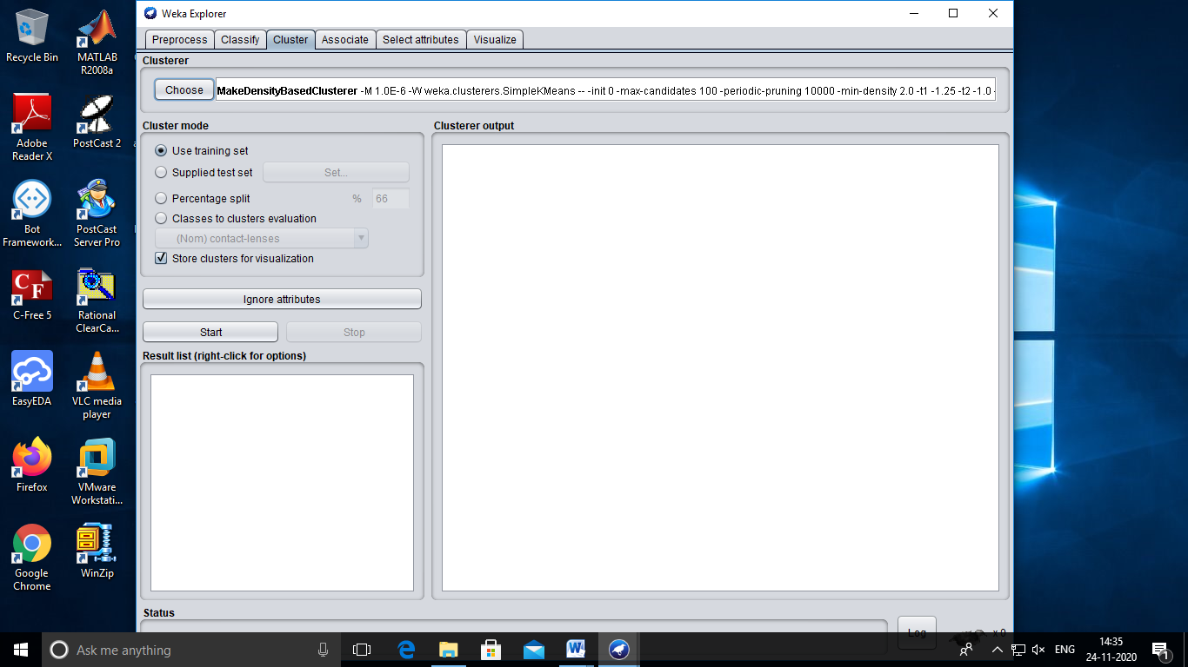

**Output:**

=== Run information ===

Scheme: weka.clusterers.MakeDensityBasedClusterer -M 1.0E-6 -W weka.clusterers.SimpleKMeans -- -init 0 -max-candidates 100 -periodic-pruning 10000 -min-density 2.0 -t1 -1.25 -t2 -1.0 -N 2 -A "weka.core.EuclideanDistance -R first-last" -I 500 -num-slots 1 -S 10

Relation: contact-lenses

Instances: 24

Attributes: 5

age

spectacle-prescrip

astigmatism

tear-prod-rate

contact-lenses

Test mode: evaluate on training data

=== Clustering model (full training set) ===

MakeDensityBasedClusterer:

Wrapped clusterer:

kMeans

======

Number of iterations: 2

Within cluster sum of squared errors: 47.0

Initial starting points (random):

Cluster 0: pre-presbyopic,myope,no,normal,soft

Cluster 1: pre-presbyopic,myope,no,reduced,none

Missing values globally replaced with mean/mode

Final cluster centroids:

Cluster#

Attribute Full Data 0 1

(24.0) (12.0) (12.0)

=====================================================

age young young young

spectacle-prescrip myope myope myope

astigmatism no no no

tear-prod-rate reduced normal reduced

contact-lenses none soft none

Fitted estimators (with ML estimates of variance):

Cluster: 0 Prior probability: 0.5

Attribute: age

Discrete Estimator. Counts = 5 5 5 (Total = 15)

Attribute: spectacle-prescrip

Discrete Estimator. Counts = 7 7 (Total = 14)

Attribute: astigmatism

Discrete Estimator. Counts = 7 7 (Total = 14)

Attribute: tear-prod-rate

Discrete Estimator. Counts = 1 13 (Total = 14)

Attribute: contact-lenses

Discrete Estimator. Counts = 6 5 4 (Total = 15)

Cluster: 1 Prior probability: 0.5

Attribute: age

Discrete Estimator. Counts = 5 5 5 (Total = 15)

Attribute: spectacle-prescrip

Discrete Estimator. Counts = 7 7 (Total = 14)

Attribute: astigmatism

Discrete Estimator. Counts = 7 7 (Total = 14)

Attribute: tear-prod-rate

Discrete Estimator. Counts = 13 1 (Total = 14)

Attribute: contact-lenses

Discrete Estimator. Counts = 1 1 13 (Total = 15)

Time taken to build model (full training data) : 0 seconds

=== Model and evaluation on training set ===

Clustered Instances

0 12 ( 50%)

1 12 ( 50%)

Log likelihood: -3.81814