Week 1 – 1:

-Overview of C, Constant, Variable and Data Types

ROLL NO.:241501164

1. Name: Ramana.R

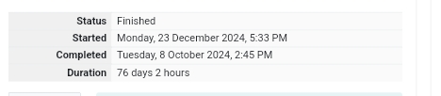

Q1) This is a simple challenge to help you practice printing to stdout.

We're starting out by printing the most famous computing phrase of all time! In the editor

below, use either printf or cout to print the string **Hello, World!** to stdout.

**Input Format**

You do not need to read any input in this challenge.

**Output Format**

Print **Hello, World!** to stdout.

**Sample Output 1**

Hello, World!

Code:

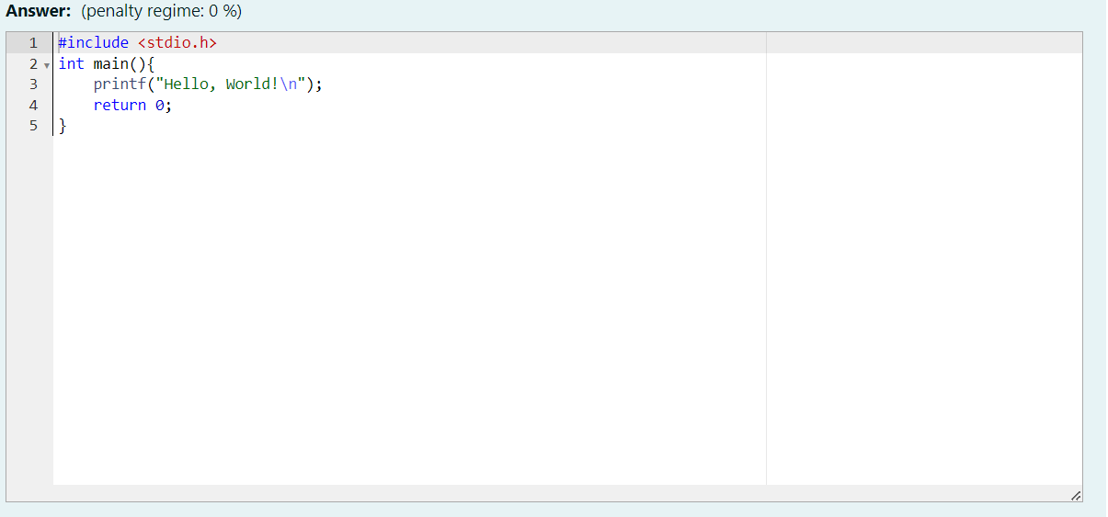

OUTPUT:

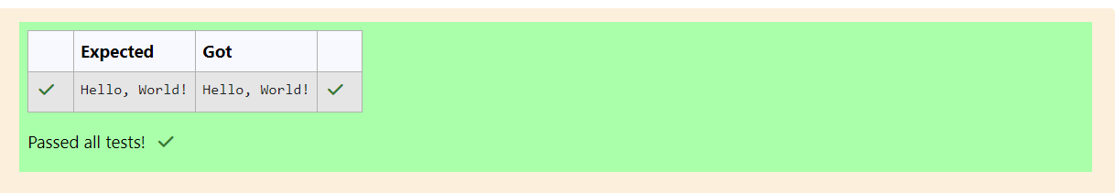

Q2) This challenge will help you to learn how to take a character, a string and a sentence as input in C.

To take a single character ch as input, you can use scanf("%c", &ch); and printf("%c", ch) writes a character specified by the argument char to stdout:

char ch;

scanf("%c", &ch);

printf("%c", ch);

This piece of code prints the character **ch.**

**Task**

You have to print the character, **ch.**

**Input Format**

Take a character, **ch** as input.

**Output Format**

Print the character, **ch**

Code:

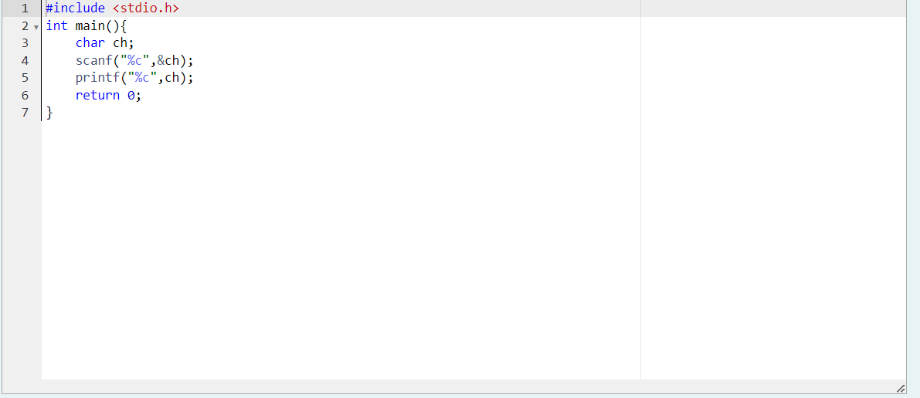

OUTPUT:

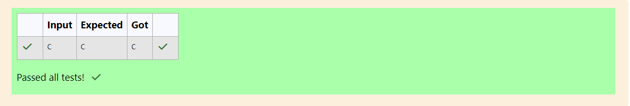

Q3) Problem Statement:

The fundamental data types in c are int, float and char. Today, we're discussing int and

float data types.

The printf() function prints the given statement to the console. The syntax is printf("format

string",argument_list);. In the function, if we are using an integer, character, string or float

as argument, then in the format string we have to write %d (integer), %c (character), %s

(string), %f (float) respectively.

The scanf() function reads the input data from the console. The syntax is scanf("format

string",argument_list);. For ex: The scanf("%d",&number) statement reads integer

number from the console and stores the given value in variable number.

To input two integers separated by a space on a single line, the command is scanf("%d

%d", &n, &m), where n and m are the two integers.

**Task**

Your task is to take two numbers of int data type, two numbers of float data type as input

and output their sum:

1. Declare 4 variables: two of type int and two of type float.

2. Read 2 lines of input from stdin (according to the sequence given in the 'Input Format'

section below) and initialize your 4 variables.

3. Use the + and - operator to perform the following operations:

• Print the sum and difference of two int variable on a new line.

• Print the sum and difference of two float variable rounded to one decimal place on

a new line.

**Input Format**

The first line contains two integers. The second line contains two floating point numbers.

**Constraints**:

1 ≤ integer variables ≤ 104, 1 ≤ float variables ≤ 104

**Output Format**

Print the sum and difference of both integers separated by a space on the first line, and

the sum and difference of both float (scaled to 1 decimal place) separated by a space on

the second line.

**Sample Input**

10 4

4.0 2.0

**Sample Output**

14 6

6.0 2.0

**Code:**

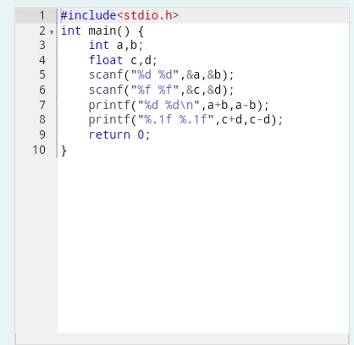

OUTPUT:

