CHANGEFLOW
Change management delivery software
Change Programme Report
Meridian Water Corporation
Customer Billing Transformation
As at 22 July 2026 · Fortnightly programme update · Generated by CORA
SAMPLE REPORT
Built from a demonstration programme. Every figure below is real data from this sample — nothing is invented, and where a number is missing the report says so.

Executive summary
The Customer Billing Transformation is 40% complete — two of the five phases in scope are closed and Engage is underway. Go-Live is set for 15 February 2027, with a business readiness gate on 29 January 2027.
Where it stands
▪ Progress — two of five phases closed (Diagnose, Design); Engage underway.
▪ People — five audiences identified, 390 people counted. Field Services has no headcount recorded, so the true reach is higher.
▪ Readiness — every audience is impact-assessed across four domains; the heat map is built from real ratings, not assumed.
▪ Comms — nine communications anchored to Go-Live — 2 sent, 1 overdue, 1 blocked, 5 planned.
What needs attention
▪ the "Awareness follow-up" communication is overdue and has no owner.
▪ "Champion-led team briefings" is blocked, waiting on the Change champion network (ends 30 October 2026) — blocked, not merely late.
▪ Field Services impact is rated high on technology but no headcount is recorded, so its weight is understated.
Integrated insight
A composed read of the programme, in CORA’s words — grounded in the data above, and honest about what it cannot yet see.
Meridian is tracking to plan at 40% complete, with Engage the active phase. The delivery and change workstreams share one timeline, and everything downstream is anchored to Go-Live on 15 February 2027 — move that date and the whole cascade moves with it.
Readiness is genuinely strong across the assessed audiences, but two things are worth naming before the January gate. First, one communication is overdue with nobody’s name against it — that is a different problem from a message that is blocked, and it needs an owner, not an extension. Second, "Champion-led team briefings" is blocked because the Change champion network does not finish until 30 October; chasing the sender would achieve nothing.
One gap I will not average away: Field Services carries a high technology impact but no headcount, so the 390 people this report counts is who I can see, not everyone affected. Capture that number and the impact picture sharpens.

Programme status
Five phases are in scope for this programme; completion is measured against those five.
Phase | Focus | Status
01 · Diagnose | What is changing, who it lands on, and how ready they are today. | Complete
02 · Design | The change approach, the audiences, the impact ratings and the plan to close them. | Complete
03 · Engage | Communications, sponsors and champions — bringing people with you. | Underway
04 · Embed | Training, go-live support and the readiness gates that decide if you go. | Not started
05 · Evaluate | Did it stick? Adoption, residual gaps and lessons for the next programme. | Not started

Key milestones
▪ 26 Jun 2026 — Design authority sign-off (Delivery)
▪ 1 Jul – 30 Oct 2026 — Change champion network (Change)
▪ 16 Nov 2026 – 5 Feb 2027 — End-user training (Change)
▪ 29 Jan 2027 — Business readiness gate
▪ Anchor — 15 Feb 2027 — Go-Live
▪ 16 Feb – 27 Mar 2027 — Hypercare (Delivery)

Programme timeline
Change and delivery on one timeline. Every milestone is placed by its real dates, and everything is anchored to Go-Live on 15 February 2027 — move that date and the whole cascade moves with it.
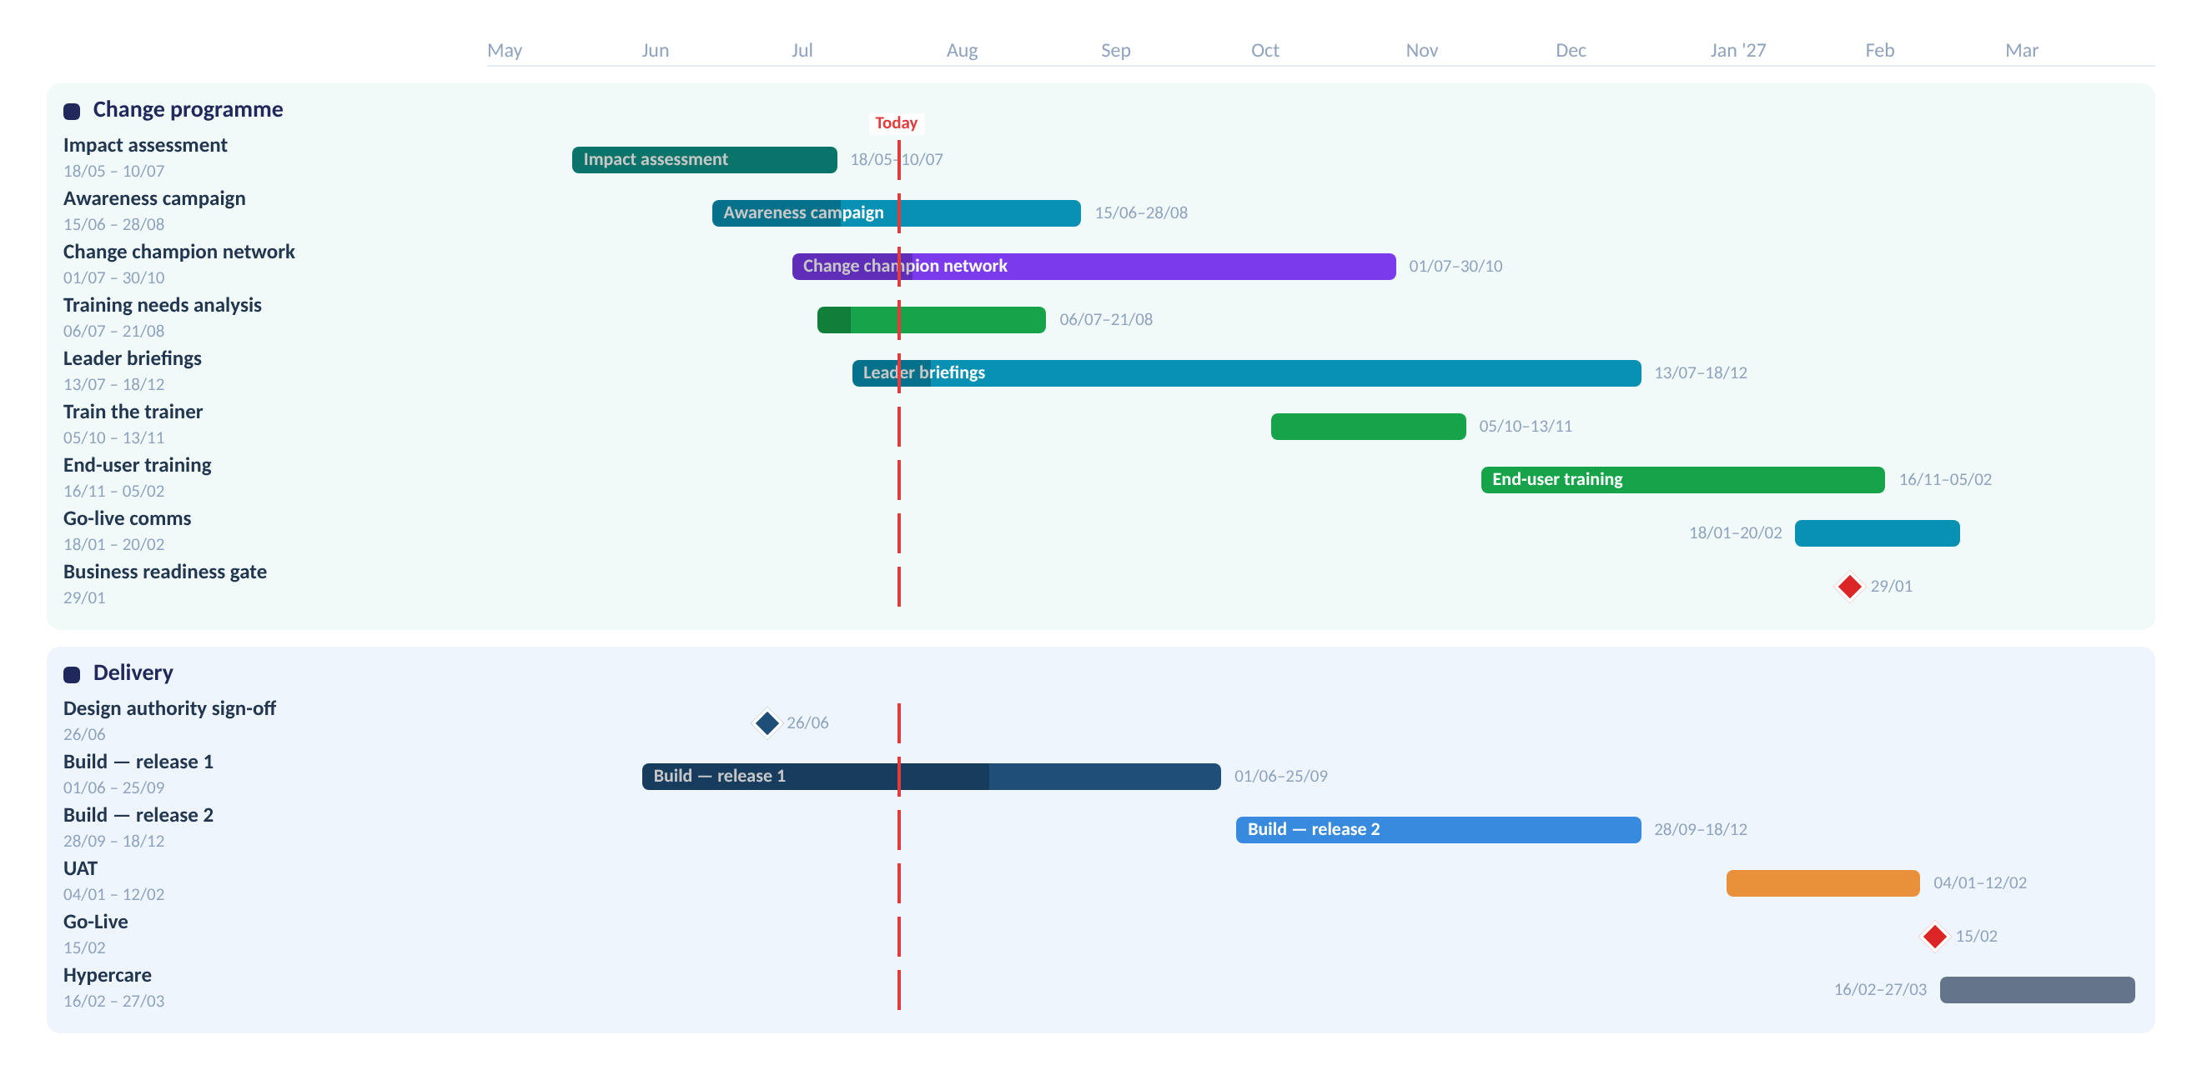
Each item in its own colour, milestones as diamonds, the red line marking today — the same view you work in.
Stakeholder impact & readiness
Each audience is scored across People, Process, Information and Technology. The heat map is generated from these ratings; an unrated cell reads as not assessed, never as no impact.
Audience (headcount) | People | Process | Information | Technology
Billing Operations 180 | V.High | V.High | High | High
Contact Centre 140 | High | High | High | Med
Field Services — | Med | Med | Low | High
Finance 45 | Low | High | Med | Low
Information & Technology 25 | Low | Med | High | V.High

Billing Operations carries the most change — very high on both people and process — and at 180 people it is the largest impacted group with a number attached. Field Services is rated high on technology but has no headcount recorded; it is shown as impacted, not as low.

Communications status
Nine communications, each anchored to Go-Live with an offset. Move Go-Live and every date shifts. Where a message is past due, the plan asks why — a message waiting on an upstream output reads as blocked, not merely late.
Message | Audience | Date | Status
What is changing and why | All impacted staff | 10 Jun 2026 | Sent
Leader talking points | People leaders | 10 Jul 2026 | Sent
Awareness follow-up | All impacted staff | 15 Jul 2026 | Overdue
Champion-led team briefings | Billing Operations | 19 Jul 2026 | Blocked
Monthly programme newsletter | All impacted staff | 3 Aug 2026 | Planned
Training enrolment reminder | Contact Centre | 17 Nov 2026 | Planned
Day-one walkthrough | Billing Operations | 20 Jan 2027 | Planned
What happens on day one | All impacted staff | 8 Feb 2027 | Planned
Where to get help | All impacted staff | 16 Feb 2027 | Planned

▪ Summary — 2 sent, 1 overdue, 1 blocked, 5 planned.
▪ Overdue — "Awareness follow-up" is overdue and unowned — assign an owner.
▪ Blocked — "Champion-led team briefings" waits on the Change champion network (30 Oct). Not late — blocked.
Trend
Completion over time, from snapshots — exactly as it appears in the platform. The solid line is actual progress to 40%; the dashed line projects the current pace to 100%.
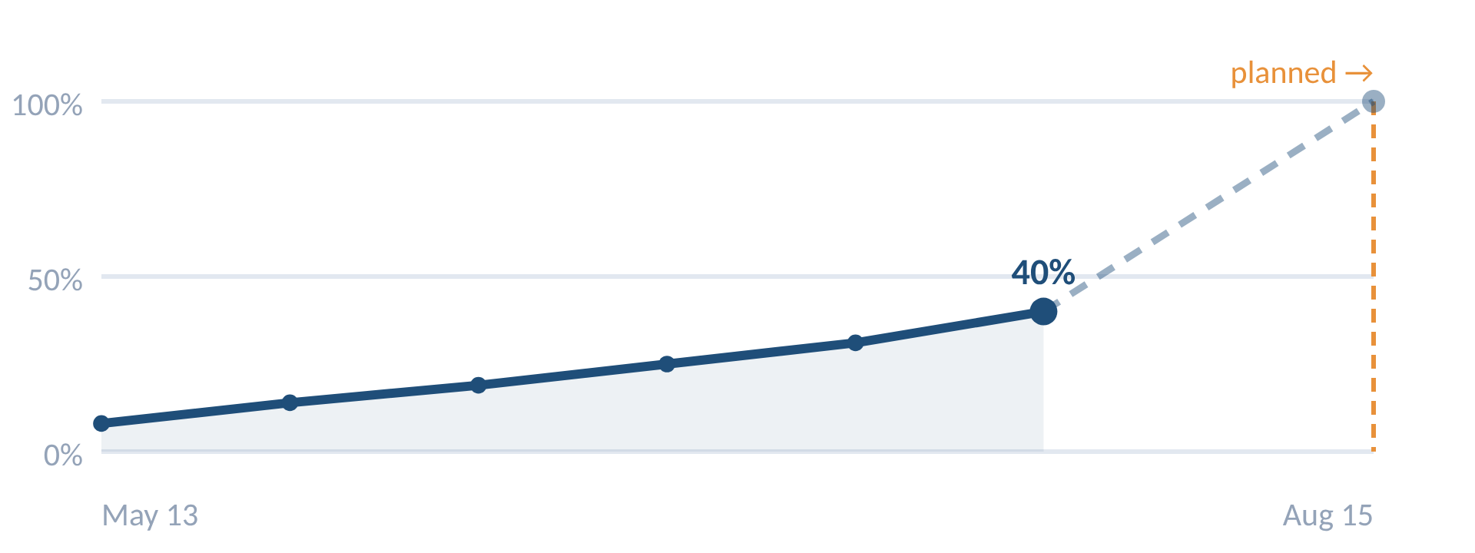
The amber marker is the planned end. It sits off to the right, past the drawn axis, because the plan runs well beyond the history captured so far — the chart shows what is measured rather than stretching the axis to flatter a distant date.
Recommendations
▪ Assign an owner to the overdue "Awareness follow-up" communication this week.
▪ Capture Field Services headcount so its impact reflects real people, not just a rating.
▪ Track the Change champion network (ends 30 Oct) — it is blocking champion-led briefings and gates downstream engagement.
▪ Confirm readiness thresholds with the business ahead of the 29 January readiness gate.

This is a sample report generated by ChangeFlow from a demonstration programme. Your own reports draw on your live data and can be scheduled — weekly, fortnightly or monthly — as native Word or PowerPoint. See it on your own programme — book a demo.

