1. **INTRODUCTION:**

Human attire is a symbol that represents people’s internal perceptions through their outer appearance. It conveys information about their choices, faith, personality, profession, social status, and attitude towards life. Therefore, clothing is believed to be a nonverbal way of communicating and a major part of people’s outer appearance. Recent technology advancements have enabled consumers to track current fashion trends around the globe, which influence their choices.

* 1. **Overview:**

In the current era, keeping ourselves with the latest fashion is very challenging. Also, it is confusing for the customers to choose the suitable outfits. Numerous E-commerce sites provide recommendations of the current market trends to the consumers. However, what is perfect for individual’s physic and personality still remains a hovering doubt in the customers’ mind, till he tries the outfit physically. The present project addresses the same need and provides innovative solution where the system analyzes the user's physical appearance, processes the information, and recommends the outfit that will hopefully satisfy the consumer’s needs.

* 1. **Purpose:**

Fashion preferences vary not only from country to country but also from city to city. Therefore, analyzing consumers’ choices and recommendations is valuable to fashion designers and retailers. The prime objective of this project is, to help consumers to select the outfits according to their physical appearance. Using this web application the customers are not introduced to the outfits which are not suitable to them this results in time-saving and also the customer is sure about their selection.

1. **LITERATURE SURVEY:**
   1. **Existing problem:**

There are many online fashion applications are available. However, none of them has the filter, where module recommends according to the physical appearance. Existing systems do not provide personalized recommendations. This may result in waste of time.

* 1. **Proposed solution:**

To overcome the existing problem, the project team has come up with an innovative solution where the system asks some basic informative questions using IBM assistants such as regarding their gender, event details, age group, and any size group. The system will take an image and analyze their skin tone and after processing this data together it recommends the outfits which probably satisfy the user's need.

1. **THEORETICAL ANALYSIS:**
   1. **Block diagram:**

DATA COLLECTION

PRE-PROCESSING

FEATURE-

EXTRACTION

CNN

MODEL

TEST AND

TRAIN DATA

RESULT

ANALYSIS

INPUT

OUTPUT

WEB INTERFACE

* 1. **Hardware/Software designing:**

|  |  |  |
| --- | --- | --- |
| **Component** | **Minimal size** | **Description** |
| CPU | 4 cores | CPU usage depends on the number of concurrent users. A minimum of four cores is recommended. |
| Memory | 32 GB | The memory usage depends on the amount of data per application and the number of concurrent users. |
| Storage | *Variable* | The disk needs to be large enough for operating system, and cache files. |
| Processor | Variable | Usually i5,i7,i9,i3 or any updated |
| Graphics Card | 1 GB | dedicated Graphics card |
| RAM | 4 0r 6 or 8 Gb |  |

* Database: SQLite
* Browser: Google Chrome, Microsoft edge, Mozilla Firefox, Internet Explorer
* Server software: Windows
* Programming Languages: Python, flask, HTML, CSS, JS
* Minimum requirements:
* Desktop
* Good Internet connection
* Browser – Web based client

1. **EXPERIMENT INVESTIGATIONS:**

**Stage 1:**  The user has to interact with the IBM Assistant, where Chabot asks some basic questions related to the event details, gender, age, and size. These responses will be sent to the python code with the help of the ngrok application. The system web application will store the responses for further use.

**Stage 2:**  The user has to upload his/her image either using the gallery button or else the user can click the image, store it on the local disk with the help of the camera button and then upload with the help of the gallery button. The image will be sent to the CNN module where the module determines the skin tone using train and test dataset.

**Stage 3:**  The module will analyse all the results obtained from the above two stages and will recommend the outfit that most probably satisfies user expectations.

1. **FLOWCHART:**

START

LOGIN INTO

APPLICATION

INTERACT WITH

IBM ASSISTANT

UPLOAD IMAGE

Process the

Information

OUTFIT

RECOMMENDATION

USER SATISFIED?

NO

YES

END

1. **RESULT:**

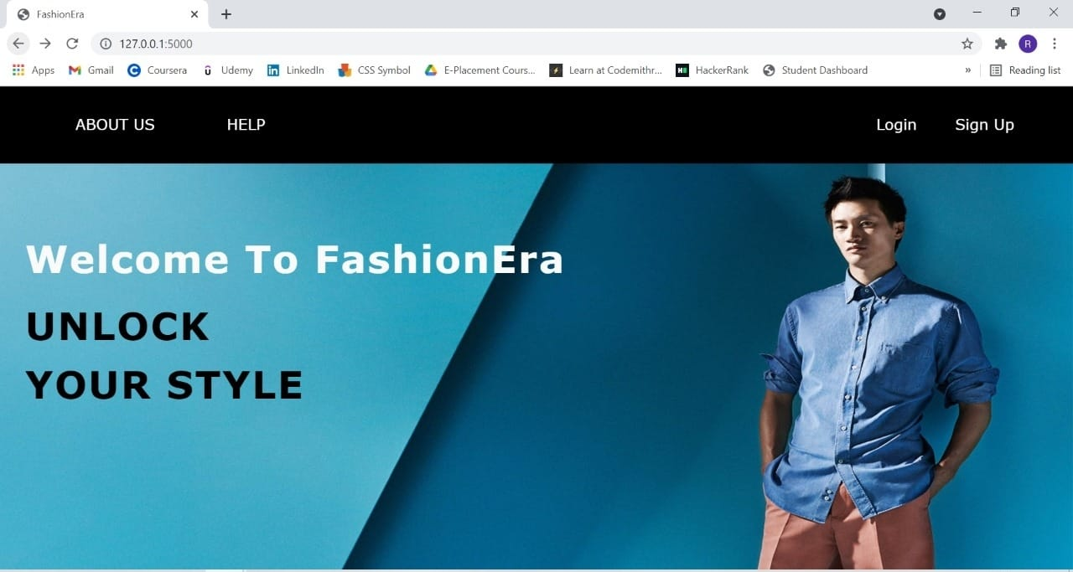

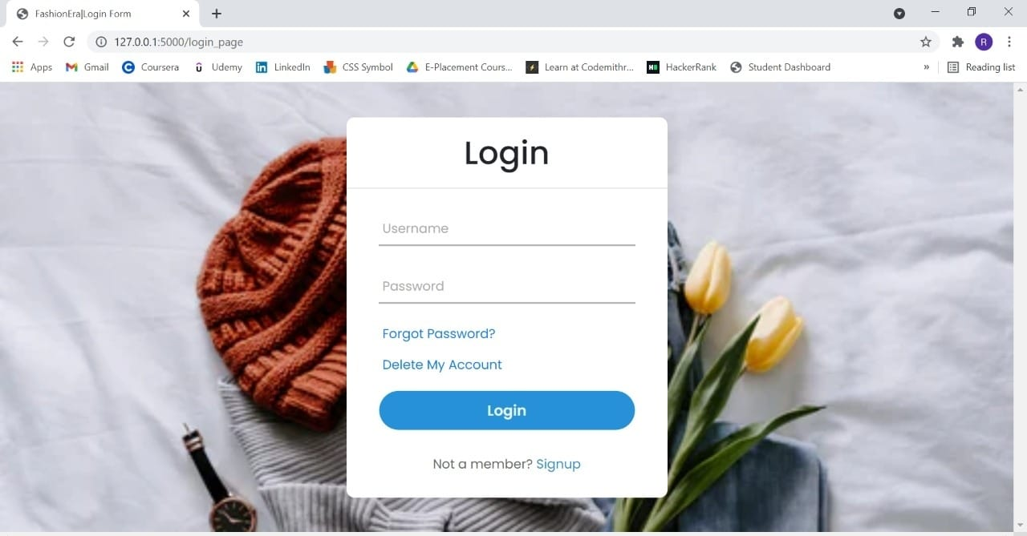

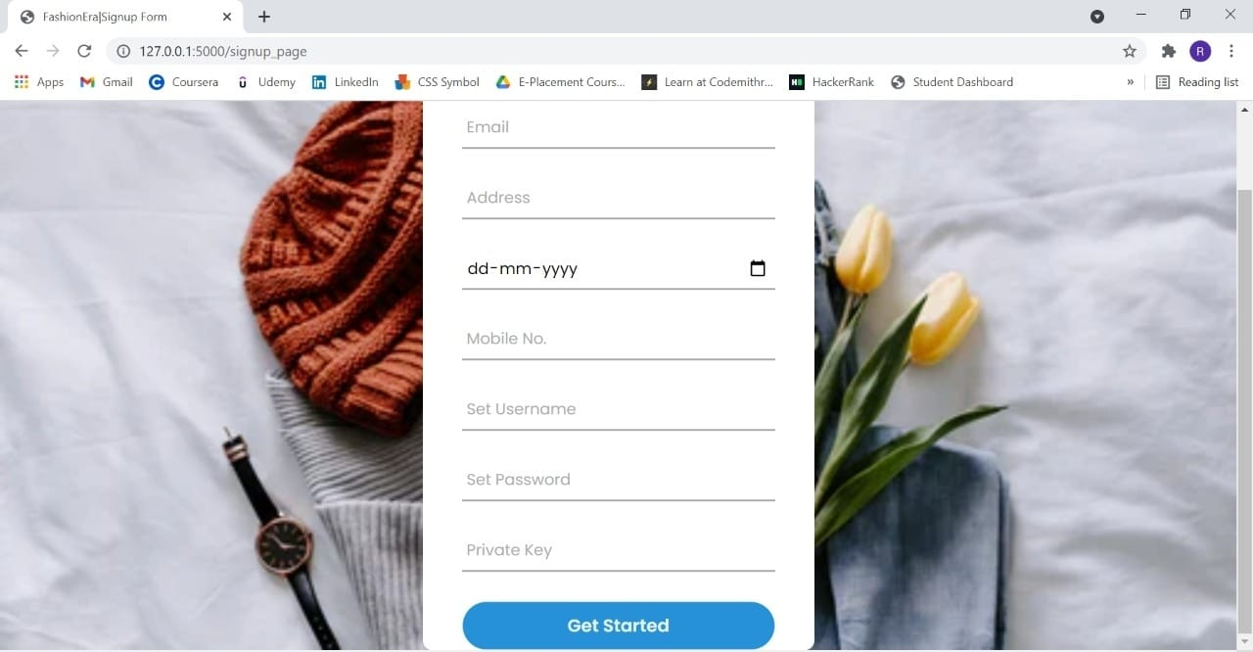

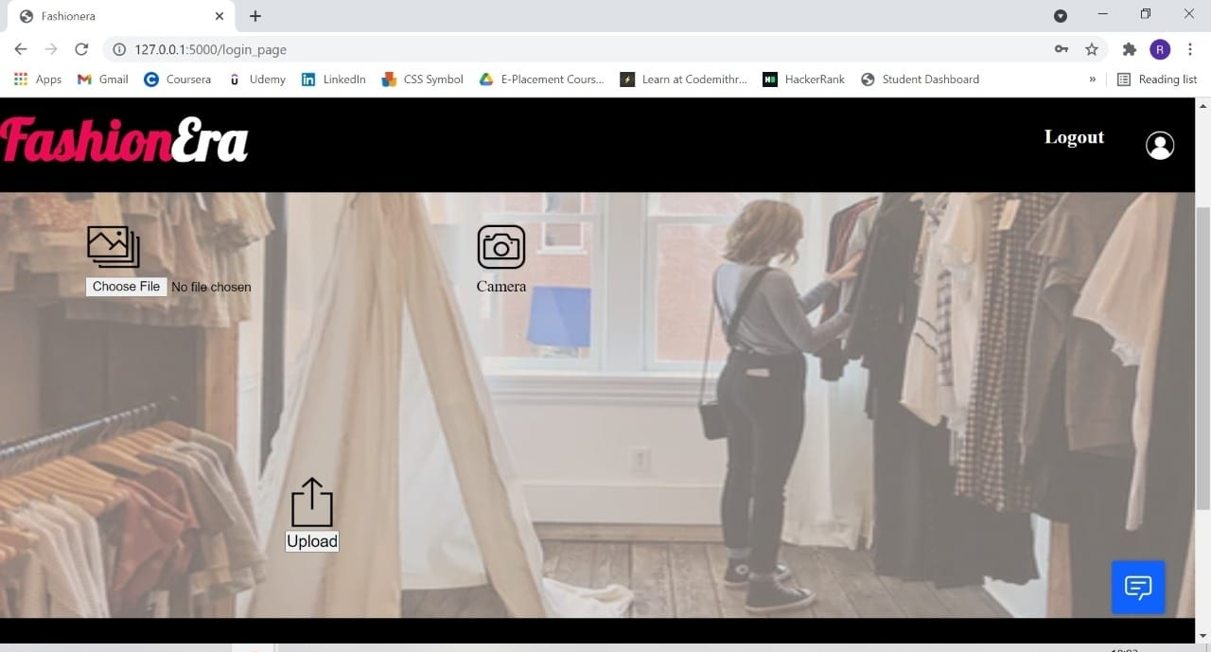

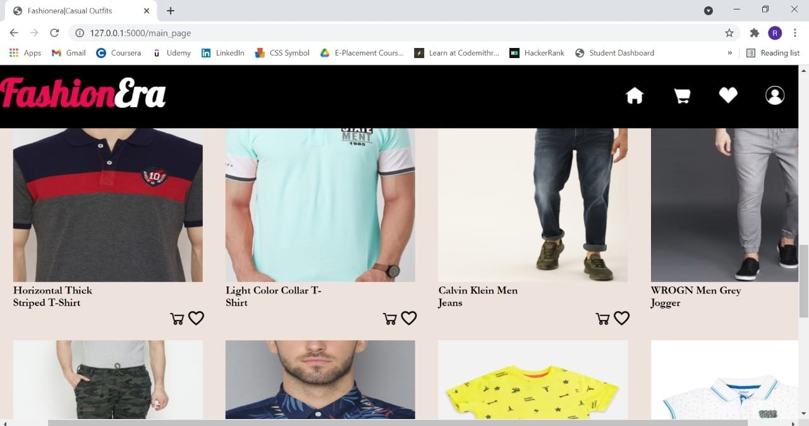

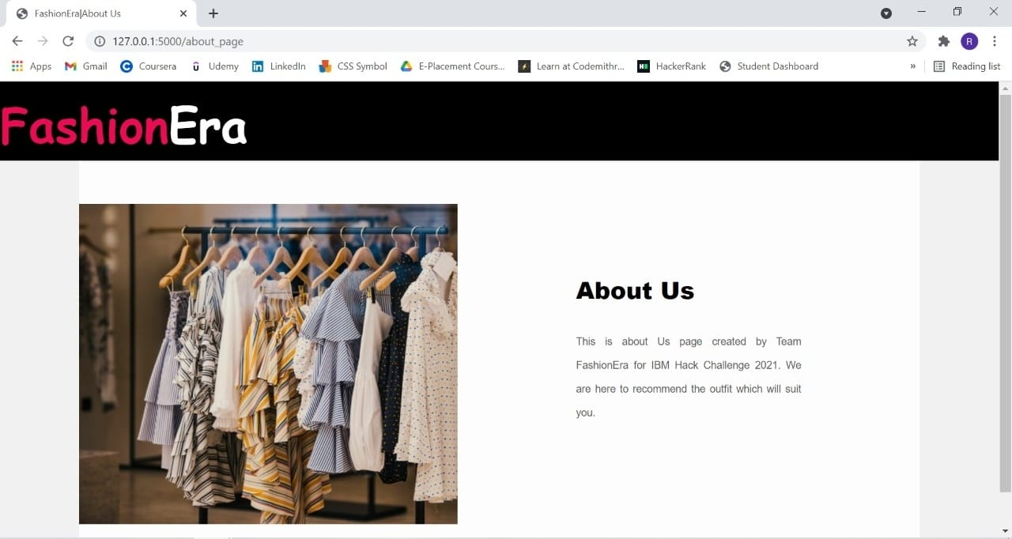

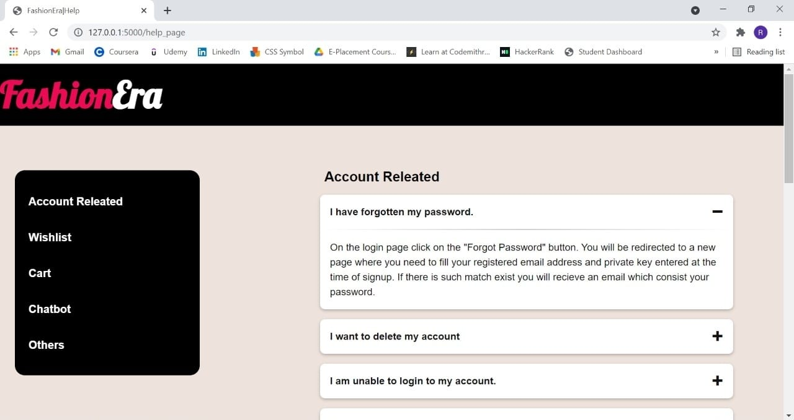

1. **ADVANTAGES & DISADVANTAGES:**

**Advantages**

1. **Consumes less time –**

The system will take user details, event details, and his/her image and analyze the physical appearance, and suggest the most probable suitable outfit, which results in a quick selection of the outfit. Users may not have to visit other applications and get confused. User gets the access to its desire outfit at one place within less amount of time, that’s why is less time-consuming.

1. **Customer preferences can be fickle and change rapidly –**

As trends come and go the taste may change, so do people’s clothing preferences. Nowadays people’s lifestyle can be judged according to their fashion sense. Our system will always suggest the latest trending outfit, which keeps the user updated.

1. **Wide variety of choices –**

There is a large variety of outfit recommendations stored in the system according to different conditions, physical appearances, and event details. The module will always give a different variety of outfits that most probably reach the user's need.

1. **Upload Image –**

Our system analyses physical appearance with the help of user images. If the user do not have the image present at the time of use, he/she can capture the image with the help of camera feature and save it on the local disk and then upload by browsing to particular location.

**Disadvantages**

1. **Limited for desktop view only –**

Our system front end is designed for limited desktop view only. With the large/small screen resolution, only the front end appearance may vary, but the system will work properly without any problem.

1. **Limited event outfit –**

This system is developed for IBM Hack Challenge – 2021, so there is limited outfit according to the condition. That’s the reason users will always introduce with a max. Of 20 fashion recommendations at a time.

1. **Unsatisfaction with the fashion recommendation –**

We have created the fashion recommendation condition after many case studies, even though there are few cases remaining as exceptions.

1. **System may fail with improper images –**

If the user uploads, any filtered image or black and white image or the image with less exposure to the sunlight, our module may fail in analyzing the physical appearance. In other cases, if the user's response to the IBM assistant and the image uploaded by the user does not match with gender, age, and size parameters then the user gets the wrong outfit recommendation.

1. **APPLICATIONS:**
2. **Easy to pick the outfit –**

The system recommends the outfit to the user by processing the responses and physical appearance that most probably matches the user's need, so the user can easily and quickly pick the outfit.

1. **Help dealers in decide their export –**

If the physical appearance report is generated then dealers can decide which outfit to be exported according to the region. Which helps in the fast growth of the business.

1. **No need to visit different sites –**

Users may not have to visit other applications to find the best outfit, our system tries to reach the customer's need most probably.

1. **Recommendation with physical appearance filter –**

As there is a new feature where outfit recommendations can be set with the filter of physical appearance. As there is no module exists which has the physical appearance as the filter.

1. **CONCLUSION:**

This web application helps the user to get their desired outfits at easy access. The additional Chabot feature helps get required responses only, which saves time. As the system itself analyzes the physical appearance and recommends the outfit, the most probably user satisfaction completes.

1. **FUTURE SCOPE:**
2. **Augmented Reality as a feature –**

In future update, users can have the trail of the selected outfit at any remote place, which helps users to check their appearance in the particular outfit.

1. **Voice Chabot –**

If we find any way to connect the IBM assistant with a microphone we are thinking to create a voice assistant where the case in which the user is able to speak English but unable to write English. This feature may help the user a lot.

1. **Advance outfit recommendation –**

We are suggesting outfits with some conditions in JavaScript code, in this update, we are going to store all the outfits with their conditions into the dataset from their system can fetch the outfit which most probably satisfies the conditions.

1. **Proper front end on any desktop –**

Due to time limitations, we have created our web application which properly appears in some of the desktops. We are going to create our application which will appear properly on any desktop.

1. **Additional features –**

The additional features are where users can add their favourite outfit to either cart and buy or else add to wish list and later have access to it. Users can also update his/her profile image.

1. **BIBLIOGRAPHY:**

[1] <https://www.youtube.com/watch?v=ikoL1FT6i4s>

[2] <https://www.youtube.com/watch?v=BzouqMGJ41k>

[3] <https://www.youtube.com/watch?v=CSEmUmkfb8Q>

[4] <https://www.youtube.com/watch?v=k0FyEXNUBZc>