# 

# SIX WEEKS SUMMER TRAINING

**REPORT**

on

***Android App Development***

Submitted by :

**Akash Kumar**

Registration No :

# 11702349

Programme Name :

**Bachelor of Technology in Computer Science and Engineering.**

Under the Guidance of :

**Mr. Satyajit Pradhan**

# Name of the Industry Coordinator :

**School of Computer Science & Engineering Lovely Professional University, Phagwara**

(June-July, 2019)

**DECLARATION**

I hereby declare that I have completed my six weeks summer training at **Internshala Trainings** from **1st June 2019**  (start date) to  **13th July 2019**  (end-date) under the guidance of **Mr. Satyajit Pradhan**. I declare that I have worked with full dedication during these six weeks of training and my learning outcomes fulfill the requirements of training for the award of the degree of **B.tech Computer Science and Engineering**, Lovely Professional University, Phagwara.

(Signature of student)

Name of Student : Akash Kumar

Registration no : 11702349

Date: 3rd August 2019

**ACKNOWLEDGMENT**

I take this opportunity to express my gratitude and sincere thanks to all those people who helped me in completing this project successfully. First of all, I would like to thank **Mr. Sawal Tandon (HOD)** for creating opportunities for us to enhance our skills through the project.

Further, I would like to thank **Mr. Satyajit Pradhan** (instructor) at Internshala for providing me an opportunity to do my internship and my project work to make a music player **“Musicfy”** in **“Android App Development”**. Under his guidance, I have completed my project and tried my best to implement what I learned until now.

I would like to thank **Ms. Sripada Manasa Lakshmi** (mentor) for her guidance and encouragement to do my internship. She also updated us about the information of hat to do and not to do during our internship and help us with all.

I would like to thank my parents and my brother for guiding and encouraging me throughout the duration of the project.

|  |  |
| --- | --- |
| Topics | Page no. |
|  |  |
| 1. Introduction |  |
| 1. Profile of the Problem |  |
| 1. Existing system |  |
| 1. Problem Analysis  * Product Definition * Feasibility Study |  |
| 1. Software Requirement Analysis |  |
| 1. Design  * Tables and their relationships * Flow charts/ Pseudo code |  |
| 1. Testing |  |
| 1. Implementation |  |
| 1. Gantt Chart |  |
| 1. Conclusion |  |
| 1. Bibliography |  |
|  |  |

**TABLE OF CONTENTS**

**INTRODUCTION**

Android is an operating system designed primarily for touchscreen mobile devices such as smartphones and tablets. It is purely open-sourced, it means we can modify existing code to add new cool features, build apps and publish them online so that others can use them.

In **October 2003**, when people were still using old phones, four guys named **Andy Rubin, Rich Miner,**

**Nick Sears** and **Chris White** got an idea and they started working on it. The idea was to build an advanced

operating system for digital cameras. This lead to the foundation of **Android Inc.** As they started developing it, they soon realized that the market they were targeting wasn’t large enough.

So they diverted their efforts towards building an operating system for smartphones. In **2005**, Android Inc. was acquired by Google for **$50 million**.

After years of research and development, **HTC Dream** was launched in **September 2008**. It was the first commercially released device to use the Android operating system **version 1**.

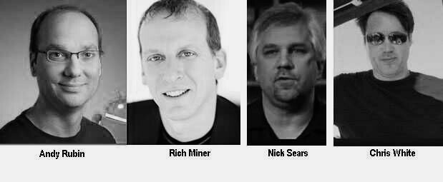

**Fig 1** – Founders of Android

Android captures 80% of the mobile OS market. One application that falls into this category is Android Music Player for Android Phones.

Android captures 80% of the mobile OS market. One

application that falls into this category is Android Music Player for Android Phones.

**Fig 2** – OS market share

**Project Summary**

Nowadays everyone listens to music and have the need to install a player in their devices to play desired songs. The music player is one candidate among all the players which enables a user to listen and play songs/music whenever he/she wants. Media Player allows a normal user to open the media files in which the most popular formats include .mp3.

“Musicfy” is an Android Mobile music player application used to play songs with entitled song title and song artist name. The objective behind developing this application was it provides user facility to enjoy the music beats and pass their leisure time. They even get a notification to remind that “A track is playing in the background”.

This is the app which is basically made for music lovers.

**Practical Usage and Feature**

• Fetches list of all songs present on the device with sorting feature (either sorting by recently added or by name).

• Plays song in another screen when that particular song is clicked.  **Fig 3** - Logo

• Prompts a notification in notification bar with the app logo and its name that “A track is playing in the background.”

• While listening to the music, if the user dials a number then the song automatically pauses or even if there is an incoming call then the song pauses.

• A cool audio visualizer library, WaveInApp by Cleveroad, implemented in our project with wave effects.

• Allows the user to add the current playing song as a favourite one and all the favourite songs can be accessed via navigating to the navigation drawer and clicking the Favourites. User can even remove a song from the favourites.

• A seek bar to quickly navigate to a particular timing of the song.

• Play/Pause button to play/pause the song.

• Next button and previous button to quickly move to the next song to be played or the previous song playing respectively. If the shuffle button is on the next/previous button will play random songs.

• Shuffle button to shuffle the songs to be played. Loop button to play the particular song again and again in a loop.

• If the user didn’t like the song currently playing he/she may change the song but there’s a catch they can do so without clicking any button. Users can just shake their phone to change the song. Before doing so this feature must be enabled by switching on the switch in “Settings” tab in the navigation drawer.

• About Us page has all the details of the company, its policies and contact information.

**Project Profile**

|  |  |
| --- | --- |
| Project Title: | **Musicfy** |
| Organization: | **Internshala**  http://internshala.com |
| Developed By: | Akash Kumar |
| Duration: | June 2019 – July 2019 |
| Instructor: | **Mr. Satyajit Pradhan** |

**Project Tools:**

|  |  |
| --- | --- |
| Front-end Tools: | XML |
| Back-end Tools : | Kotlin |
| Platform: | Android |

**Software Requirements:**

|  |  |
| --- | --- |
| Application Frontend | Android Studio |
| Database Backend | SQLite |
| Kit | JDK (Java Development Kit)  Android SDK |

**Hardware Requirements:**

|  |  |
| --- | --- |
| Application Installation | Android enabled GSM/VoLTE phone |
| CPU | Core i3 processor. |
| RAM | 4 GB |
| Hard Disk | 500GB |
| Android Version | >=5.0 |
| Memory | 128MB |

**User Requirements :**

* User should know how to operate a smartphone with android OS and he should be familiar with the functioning of android applications.
* He should know how to navigate and select options. Musicfy is simple and easy to understand which is written in English language even a child can operate it easily and enjoy the song being played.
* To achieve the visualize effect and pausing the song during an outgoing call / incoming call and even to access the application further from the splash screen, the user must grant the permissions of storage access, call access and audio.

**Existing System**

As we know that in existing system we use our mobile phone to play our Song. We can play, pause, loop a song, shuffle songs, sort songs list, make a song favourite, even can remove from favourites, change song just by shaking the phone, etc.. We in exiting system have too much of option and new technique in audio system who can play anything on our fingertip.

**Limitations of Existing System**

This project only works on mobile devices which have android operating system. The current application is not available in market so its away from reach of the users. Musicfy is used only for playing song as it is a music player not a video player. It neither shows lyrics of the song nor can delete or search a song. To delete the songs or update the artist or song name then user need to move to the file manager.

**Feasibility Study**

* + **Operational Feasibility:**

From the user point of view, Musicfy here is easy to operate because it only uses simple step by step to perform any task. The application is simple for a smartphone user. So there's no need to give any instruction on how to use these systems. There is no need to learn any special command and training to use this system.

* + **Technical Feasibility:**

Musicfy uses existing technology only. It uses accelerometer of the device for calculating sensor change using Euclid's formula so that the “shake to change song” feature can work. Now a day these technologies are improved day by day. So it’s convenient for us to use these technologies. So there is no need to develop any hardware to provide these facilities. Musicfy runs on an android operating system which is available in most of the smartphone devices. So there is no need to install any software or driver to run this application.

* + **Economical Feasibility:**

For declaring that the system is economically feasible, the system will be cost-effective and budgetary constraints, it should be cheap and quick. There isn’t any extra requirement of peripheral or software for the development of the system as it can be completed with the available resource.

**Software Requirement Specification**

**Goal of Proposed System**

The primary goal of the project is to design, develop and test an Android Application “Musicfy Music Player App”. The proposed system designed to make listening to music easier with simple and easy to navigate designed screens.

Our goals in developing the proposed Android Application are:

**Accuracy:** The level of accuracy in the proposed system will be higher. All operation would be done correctly and it ensures that whatever information is coming from the center is accurate.

**Access:** The Music player has a specially designed interface that will let us listen to the tunes in our hands easily.

**Immediate retrieval of information:** The main objective of the proposed system is to provide for quick and efficient retrieval of information.

**Easy to Operate:** The system should be easy to operate and should be such that it can be developed within a short period of time and fit in the limited budget of the user.

**Scope**

* Big, easy to use buttons.
* Full access to all of your Music files in the form of a playlist.
* Big friendly button, great for quickly getting some tunes going.
* A cool reminder of a song being played in the background via a notification in the notification bar.
* Large text, brilliant for getting the info as such which song is being played and who is the artist.
* List of song with just a click on the screen.
* Lock orientation. Don't like your player constantly changing orientation in your hand? So orientation is locked to portrait mode.
* Ability to pause and start from a paused state.
* Ability to shuffle and sort the song playlist.
* Loved the song being played? User can set the song as a favourite to quickly access them and can even play the song in a loop using the loop feature.
* In a hurry? User can change the song just on a shake of the device.
* Easy to access options with just a swipe of the screen
* Shiny, reflective, catchy app screen.
* Cool visualizer with wave effects on control with the volume of the song being played.

**Design**

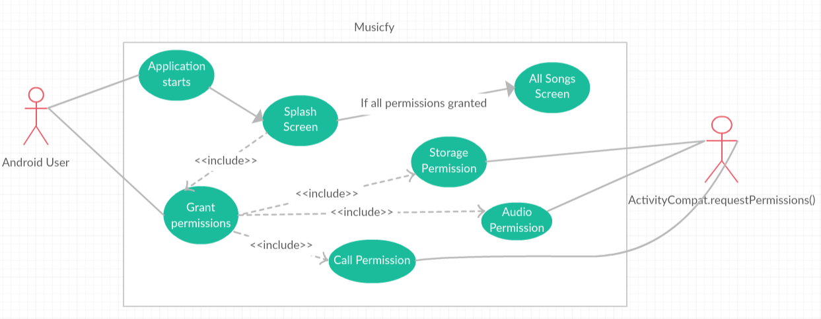**Use Case Diagrams :**

**Fig 4 –** Use case diagram of Application

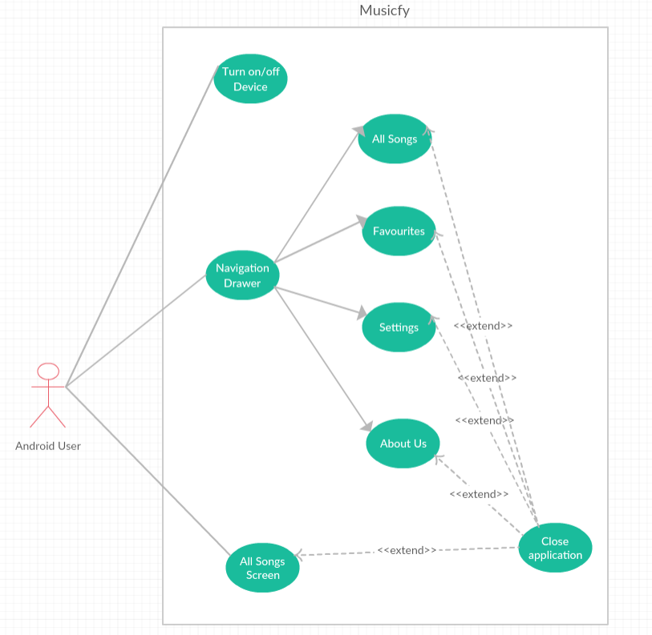

**Fig 5 –** Use Case of the application

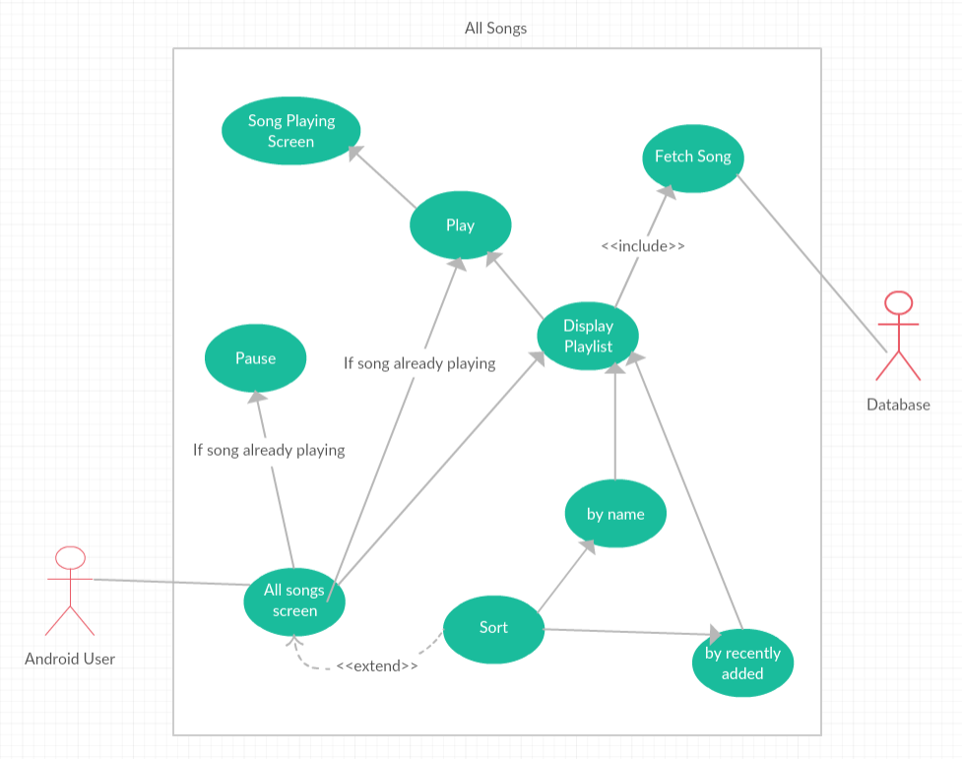

**Fig 6** – Use Case - All Songs Screen

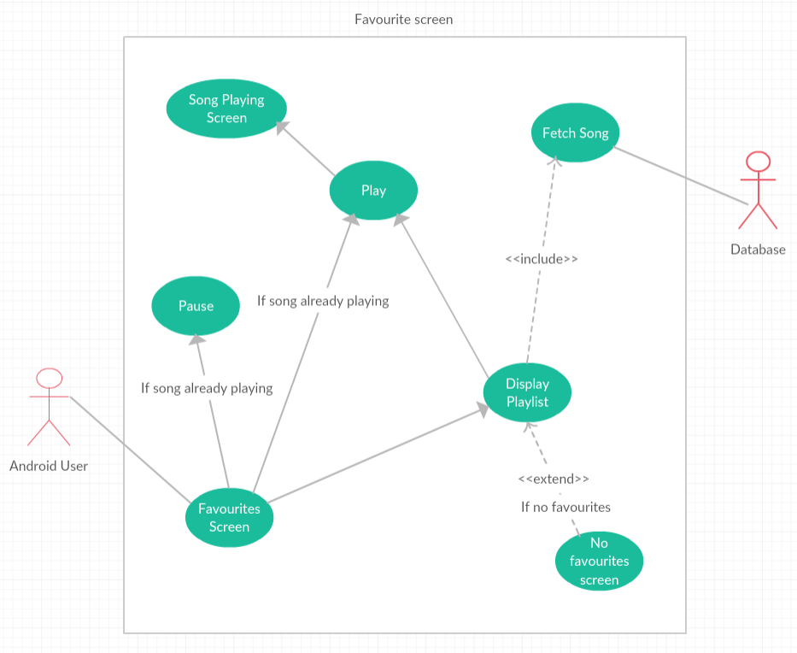

**Fig 7** – Use Case - Favourites Screen

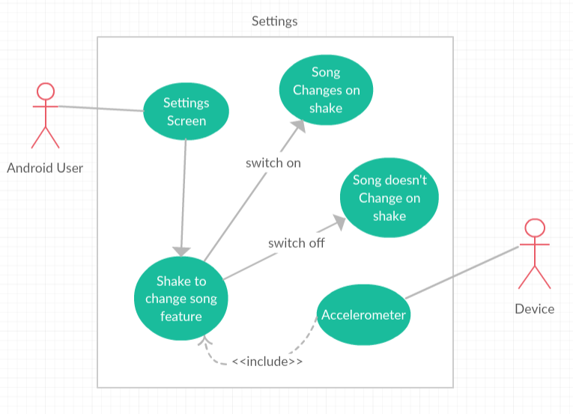

**Fig 8** – Use Case - Settings Screen

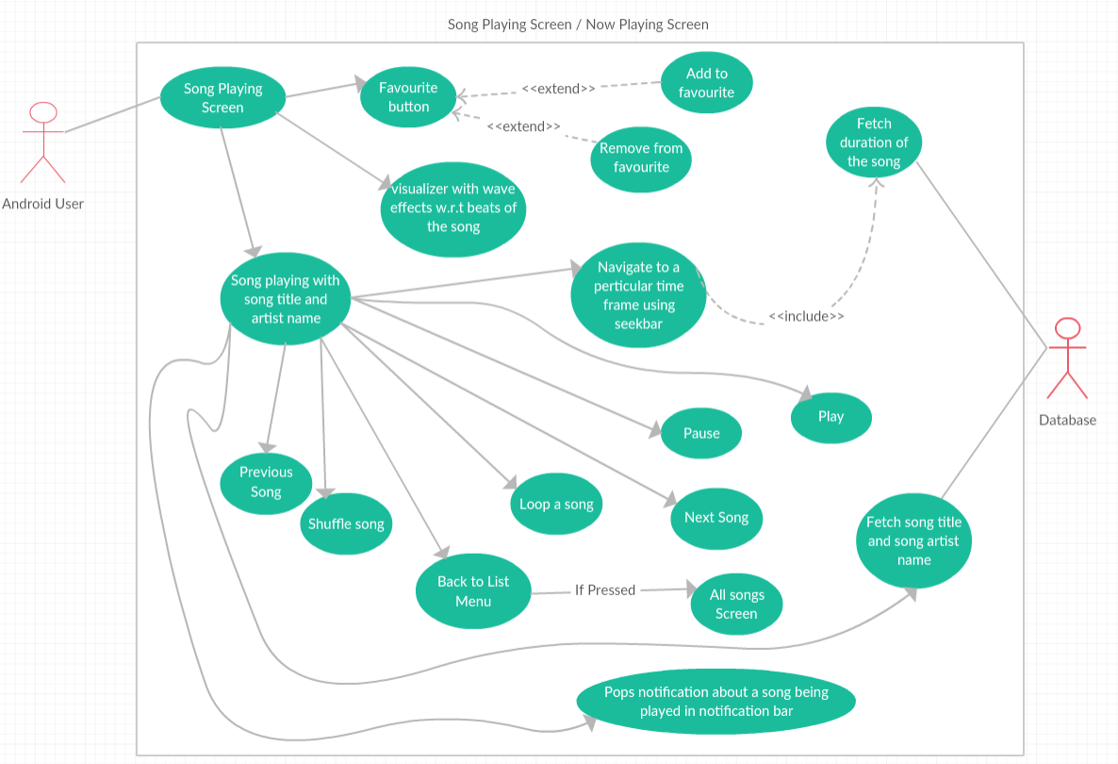

**Fig 9** – Use Case – Song Playing screen / Now Playing screen

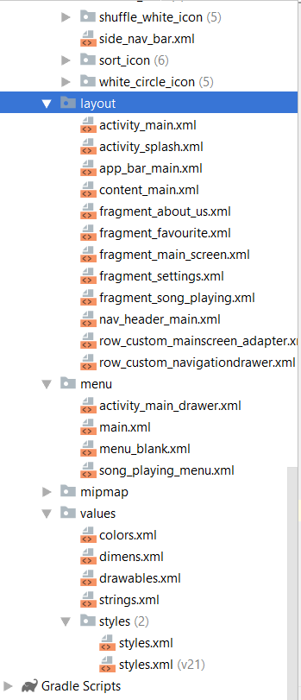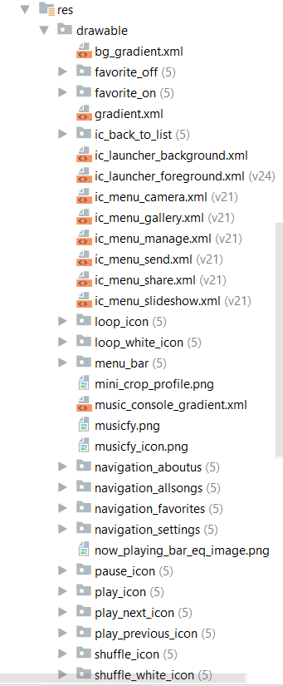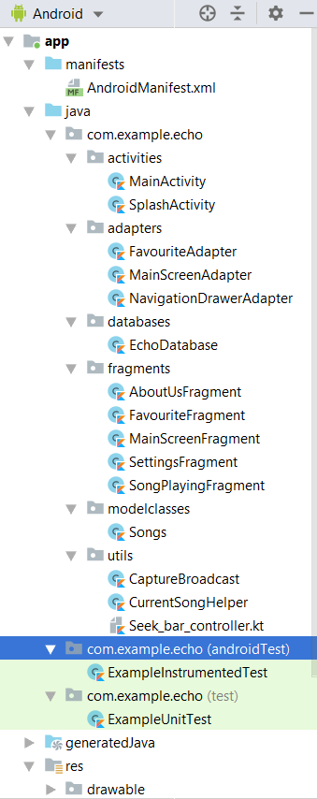**Project Structure :**

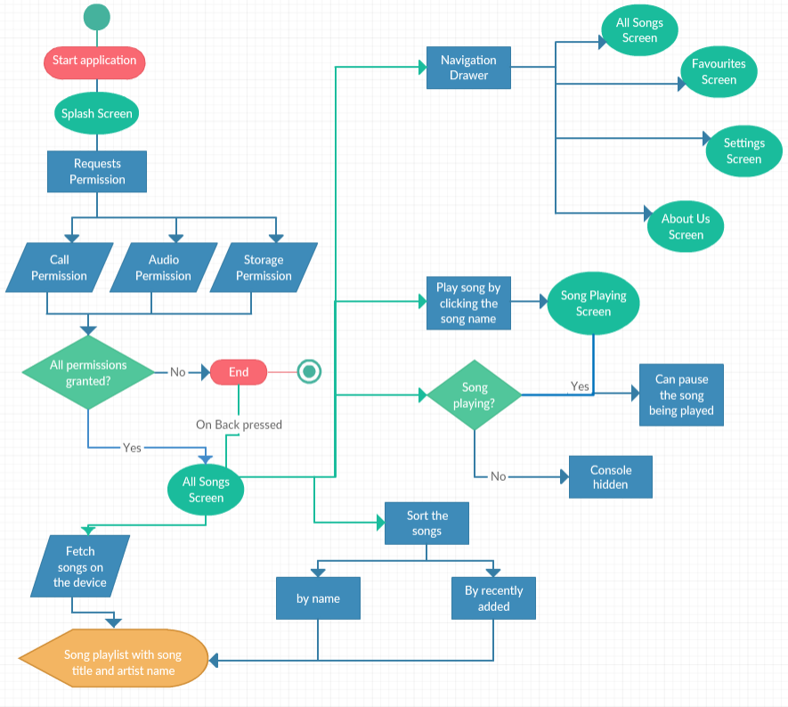**Flow Charts :**

**Fig 10 –** Flow Chart of Musicfy App – All Songs Screen

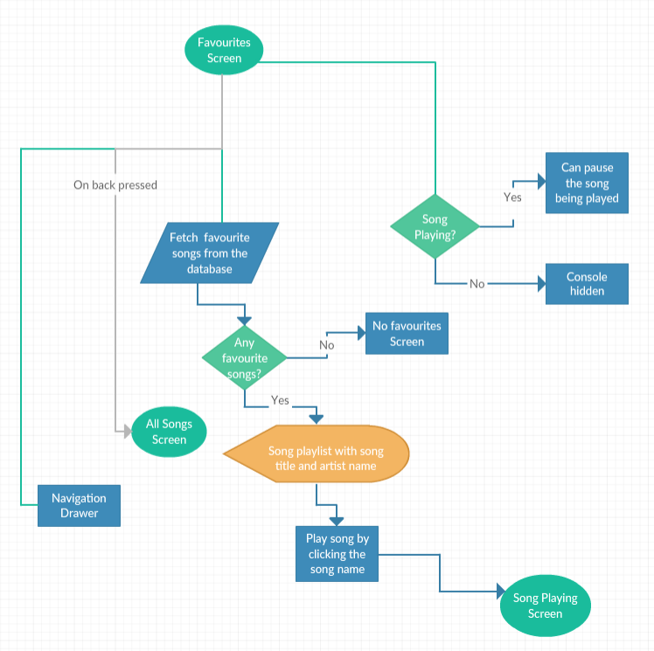

**Fig 11 –** Flow Chart – Favourites Screen

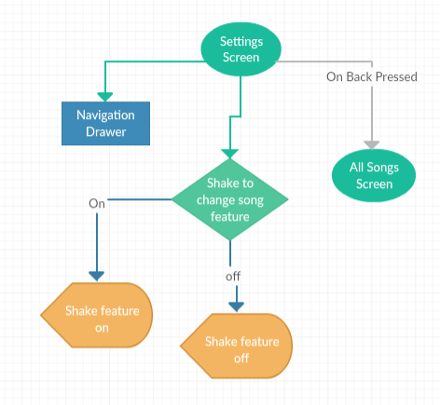

**Fig 12 –** Flow Chart – Settings Screen

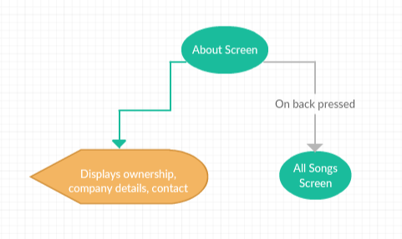

**Fig 13 –** Flow Chart – About Screen

**Database**

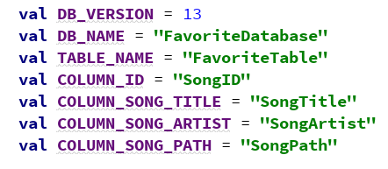

sqliteDatabase?.execSQL(**"CREATE TABLE "** + Staticated.**TABLE_NAME** + **" ( "** + Staticated.**COLUMN_ID** + **" INTEGER, "** + Staticated.**COLUMN_SONG_ARTIST** + **" STRING, "** + Staticated.**COLUMN_SONG_TITLE** + **" STRING, "** + Staticated.**COLUMN_SONG_PATH** + **" STRING);"**)

**Database name :** FavoriteDatabase

**Table name :** FavoriteTable

|  |  |  |  |
| --- | --- | --- | --- |
| SongID | SongArtist | SongTitle | SongPath |

**Testing**

|  |  |  |  |
| --- | --- | --- | --- |
| **Ref No.** | **Test Data** | **Expected Outcome** | **Final Result** |
| 1. | Install the Android Application on the Android Operating System >=5.0 | Application is installed on the Android Device Successfully | Pass |
| 2. | Start the Application  by clicking its icon | Application is  started | Pass |
| 3. | Prompts for 3 permission :  User granted some permissions not all. | Application should close with a toast message “Grant all permissions” | Pass |
| 4. | Prompts for 3 permission :  User granted all permissions. | Splash screen opens | Pass |
| 5. | Splash Screen Of the Application | Splash Screen is coming after the starting of  Application | Pass |
| 6. | Coming of Home Screen (All Screen) after the  Splash Screen (after 2 sec) | Intent has been successfully working | Pass |
| 7. | All screen | Should display list of all songs on device | Pass |
| 8. | Sort feature:  By recently added | Sorts by recently added and displays list of all songs on device | Pass |
| 9. | Sort feature:  By name | Sorts by name and displays list of all songs on device | Pass |
| 10. | Clicking navigation toggle / swiping right | Navigation drawer opens | Pass |

|  |  |  |  |
| --- | --- | --- | --- |
| 11. | Favourites Screen | Fetches favourite songs stored in database. If no favourites, no favourites screen appears | Pass |
| 12. | Clicking About Us tab | About Us screen open up | Pass |
| 13. | Clicking Settings tab | Settings screen opens up | Pass |
| 14. | Clicking the shake to change song switch | Shake feature becomes active | Pass |
| 15. | Clicking any song | Now playing Screen opens and plays the song | Pass |
| 16. | Pause song | Song paused | Pass |
| 17. | Play song | Song resumes | Pass |
| 18. | Navigating to a particular timing of the song through seekbar | Seekbar working properly | Pass |
| 19. | When song plays visualizet makes wave effects. | Visualizer working properly | Pass |
| 20. | Shuffle button | Random song plays next or previous. | Pass |
| 21. | Loop button clicked | Shuffle becomes off and song plays in a loop | Pass |
| 22. | Favourite button clicked | Button becomes red hearted and a toast message that added to favourites , if not already added | Pass |
| 23. | Favourite button clicked | Button becomes red hearted and a toast message that removed from favourites, if already added | Pass |
| 24. | Back to list menu clicked | Moves back to All song Screen, Intent working properly | Pass |
| 25. | Shaking the phone | Song changes as per shuffle on/off | Pass |
| 26. | Previous button clicked | Plays previous song | Pass |
| 27. | Next button clicked | Plays next song | Pass |

**Implementation**



**Fig 14 –** App icon

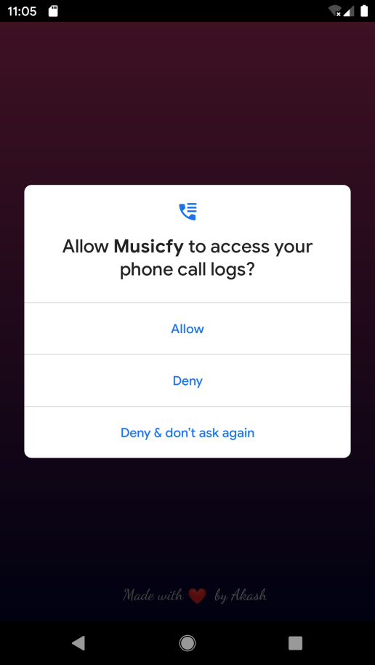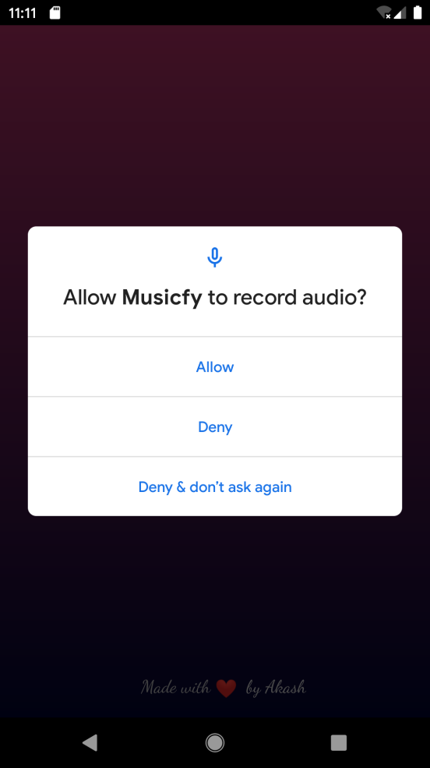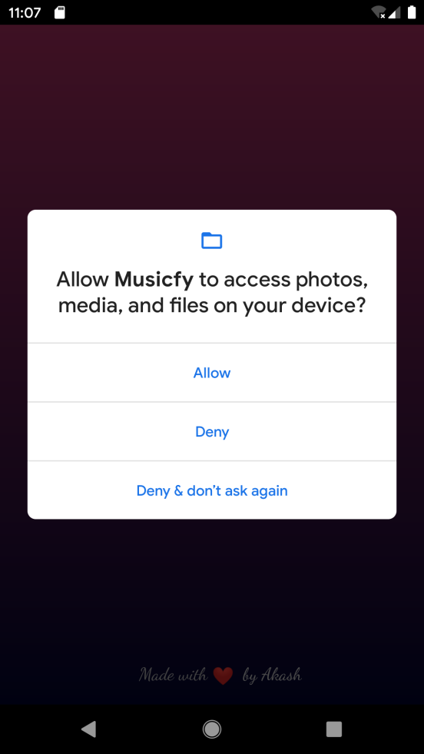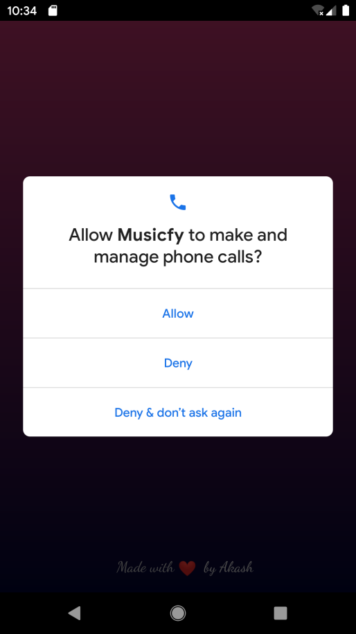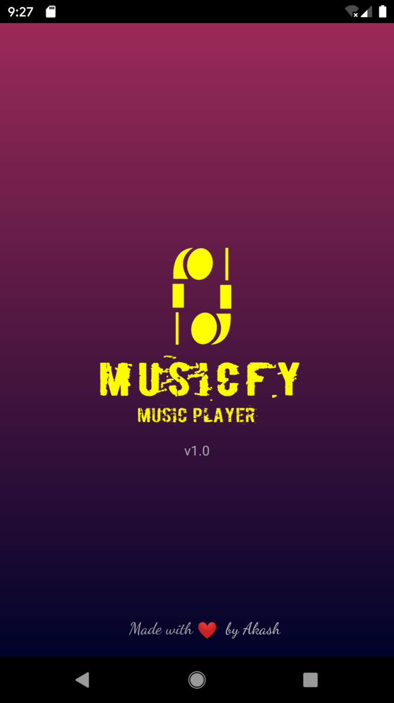

Fig 19 Audio Permission

Fig 17 Call Log Permission

Fig 16 Call Permission

Fig 15 Splash Screen

Fig 18 Storage Permission

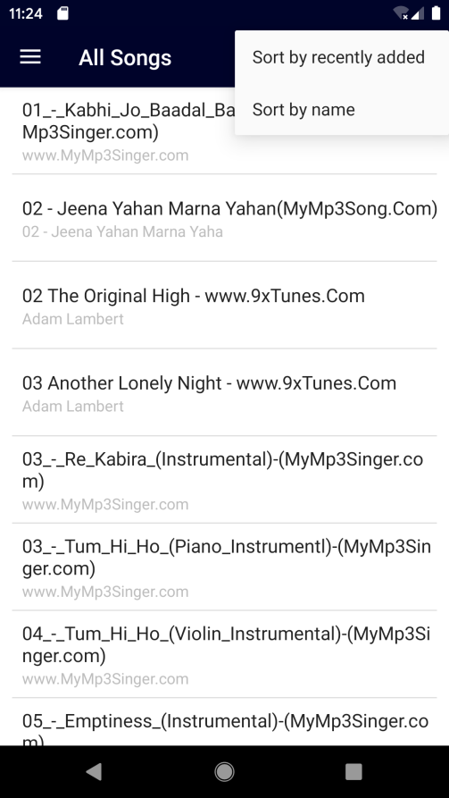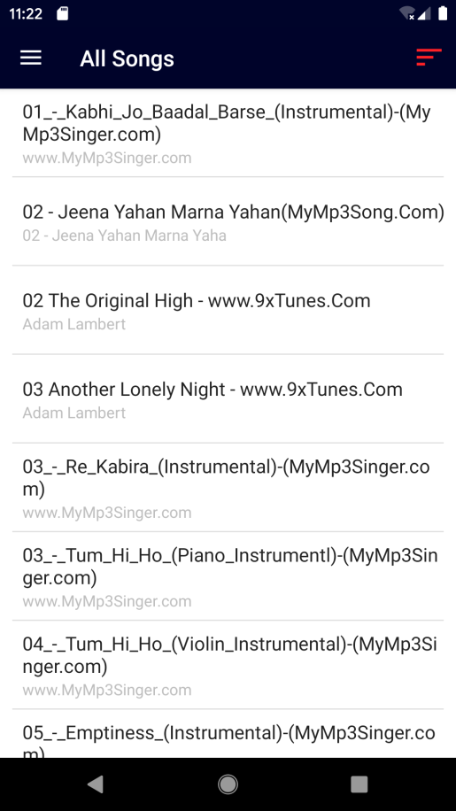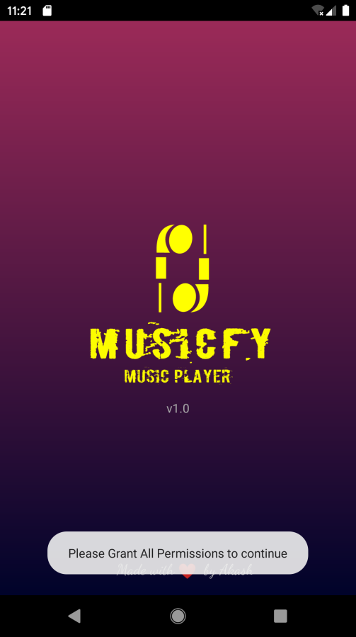

Fig 21 All Songs Screen when user granted all the permissions

Fig 20 Permissions not granted

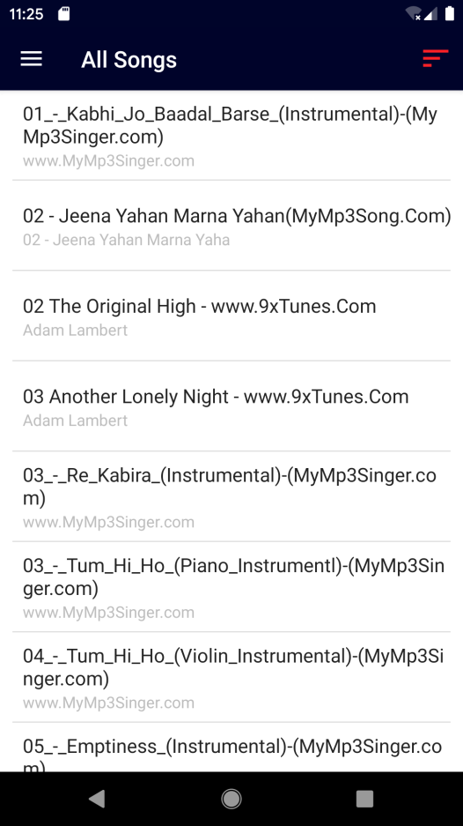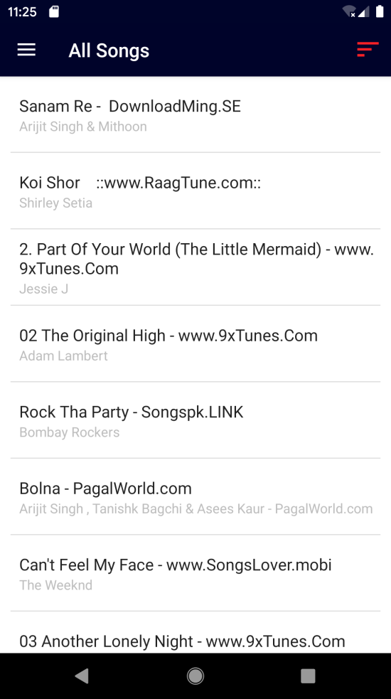

Fig 24 Sort by recently added result

Fig 23 Sort by name result

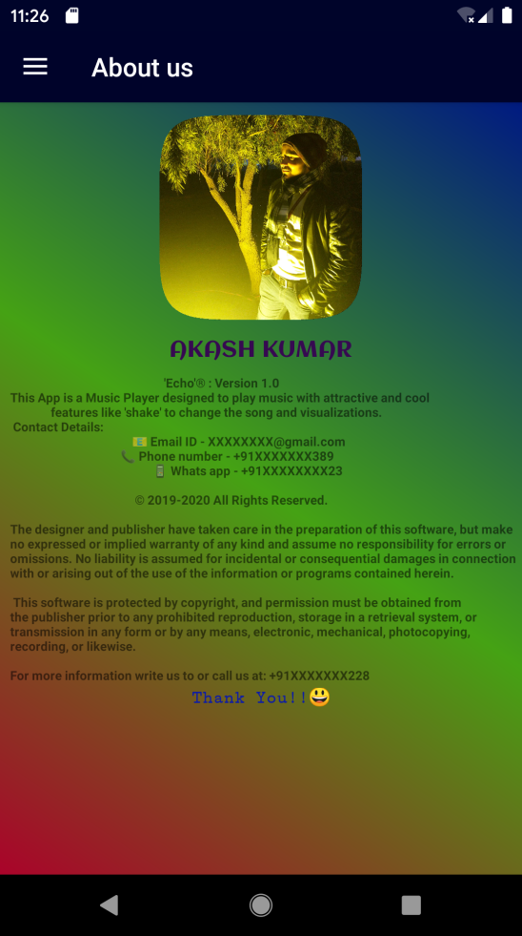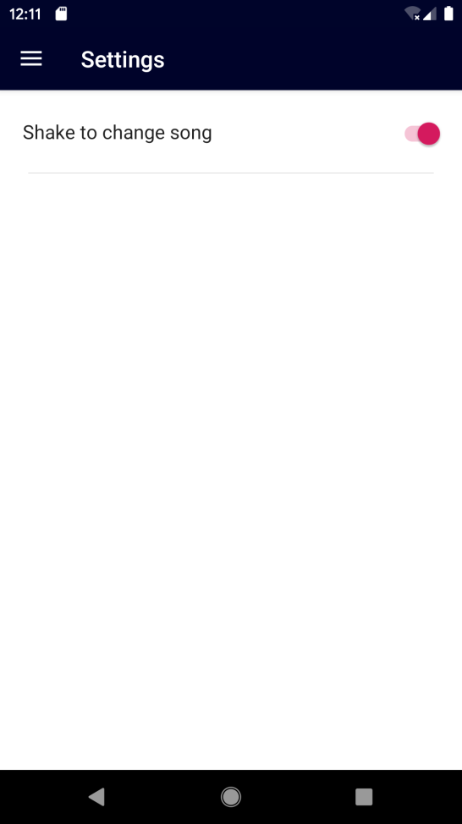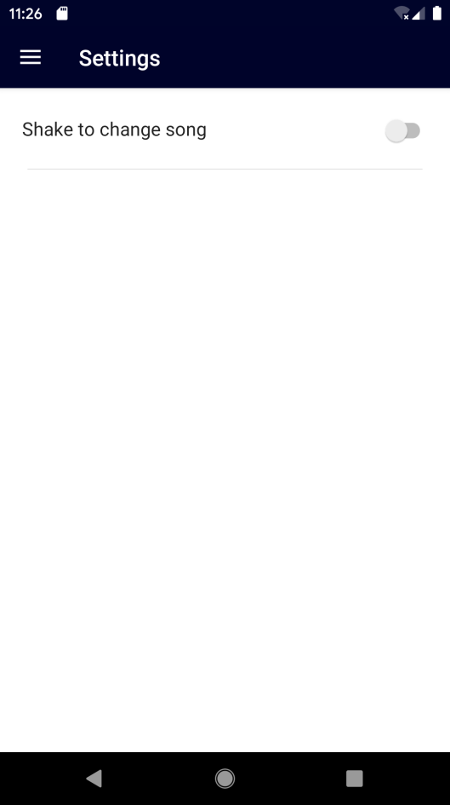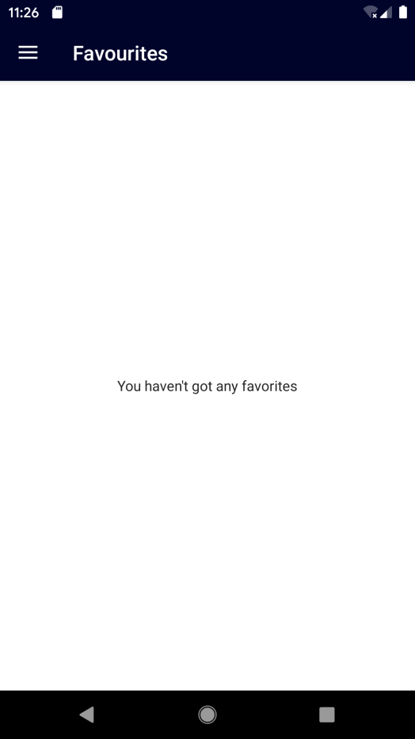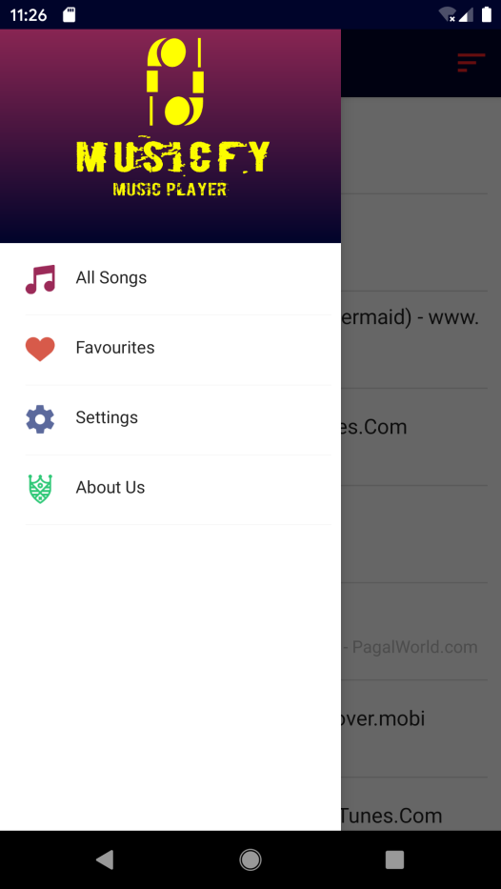

Fig 29 About Us Screen

Fig 28 Shake feature ON

Fig 27 Settings Screen with shake feature off

Fig 26 No favourites in database

Fig 25 Navigation Drawer

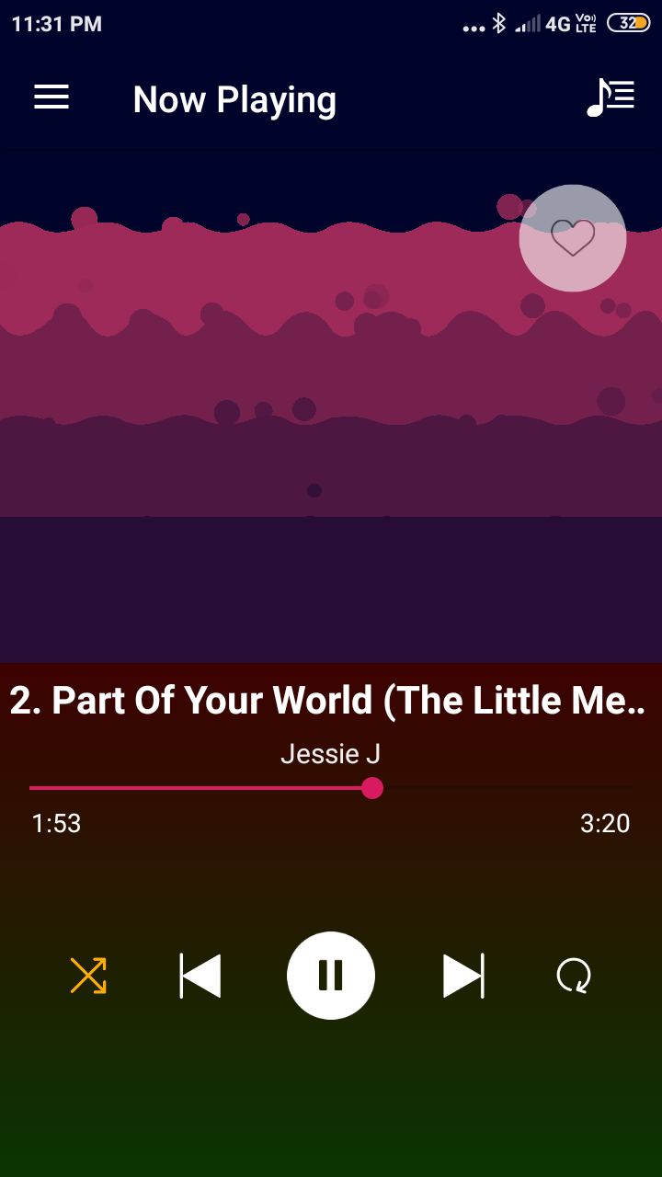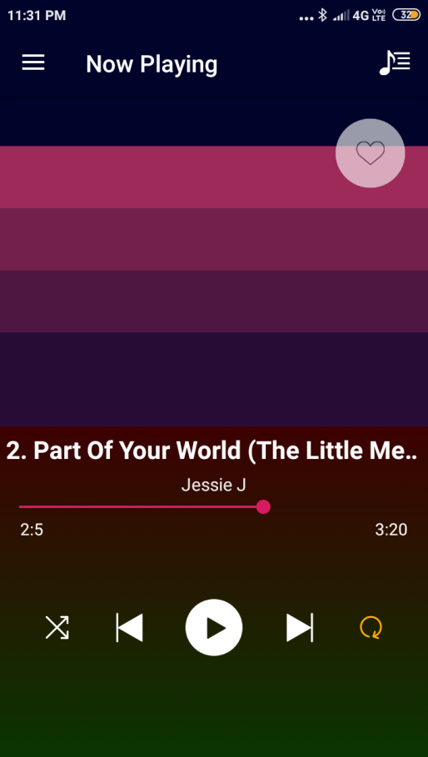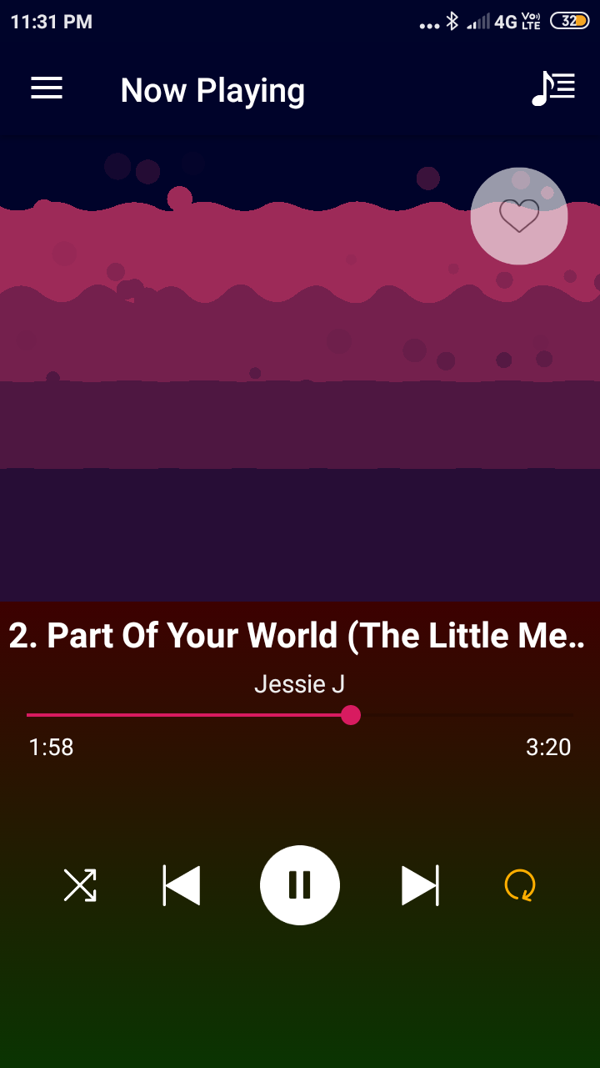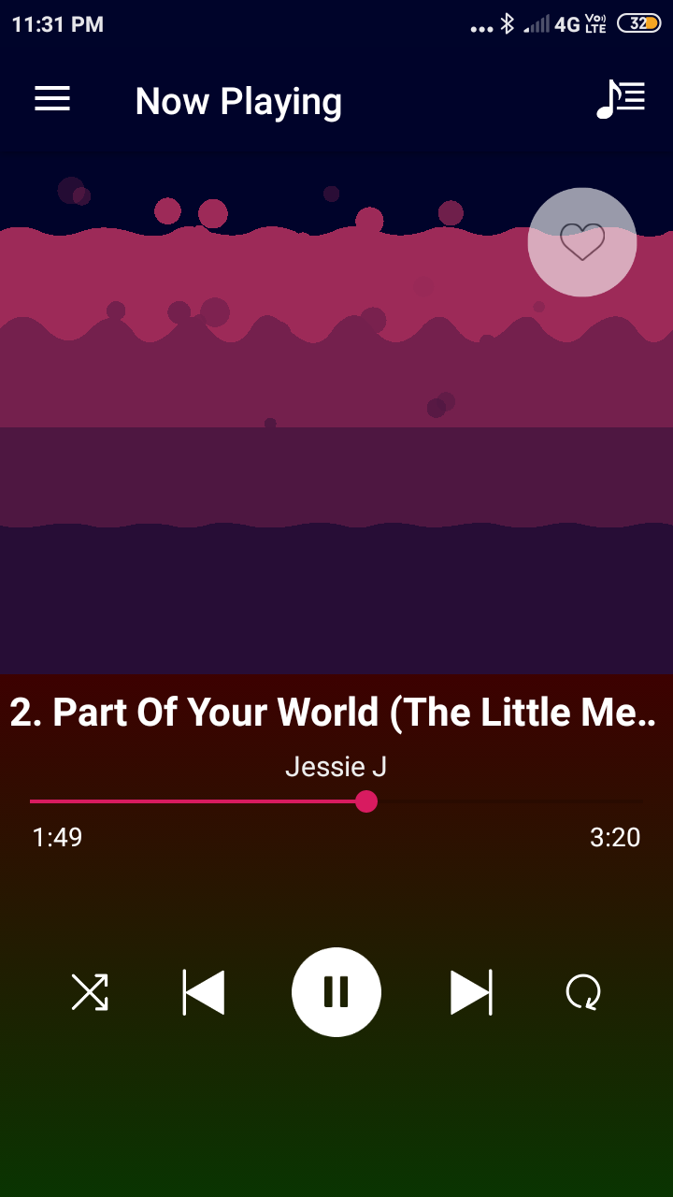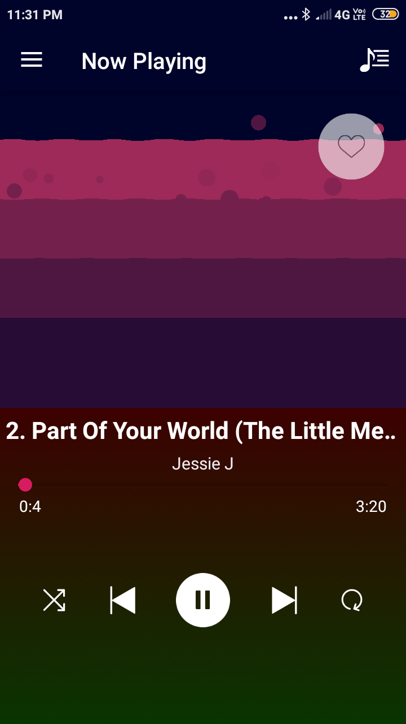

Fig 32 Shuffle feature ON

Fig 31 Cool Visualizer with waves and seekbar working smoothly, shows exact duration of the song

Fig 30 Now Playing Screen

Fig 34 Song paused via pause button

Fig 33 Loop feature ON

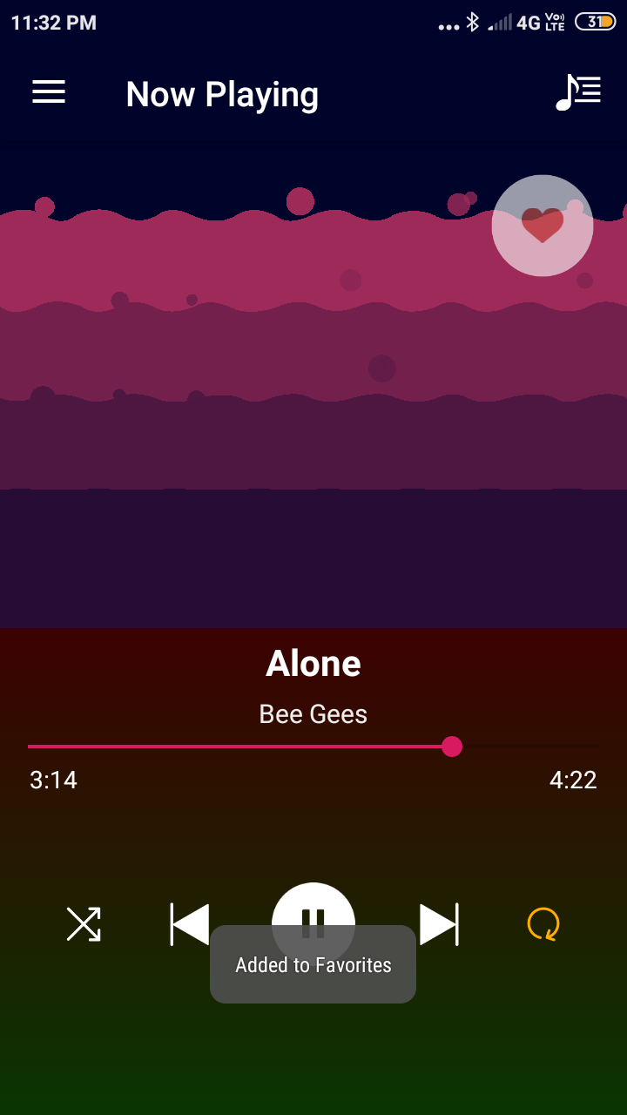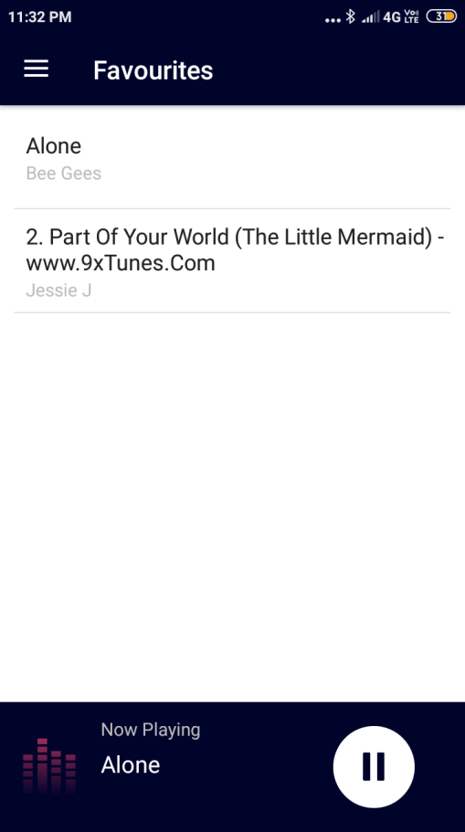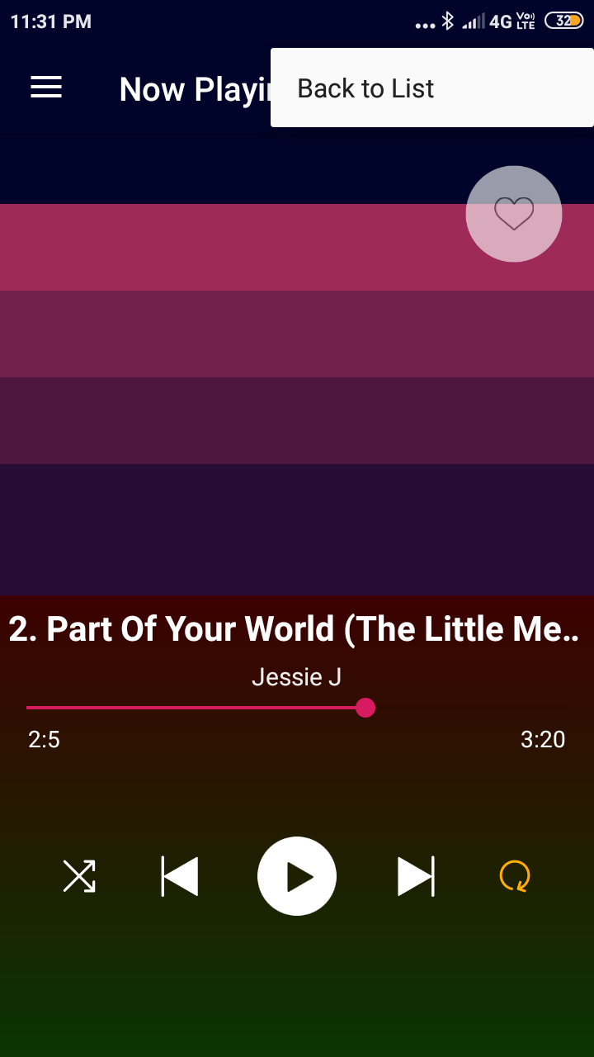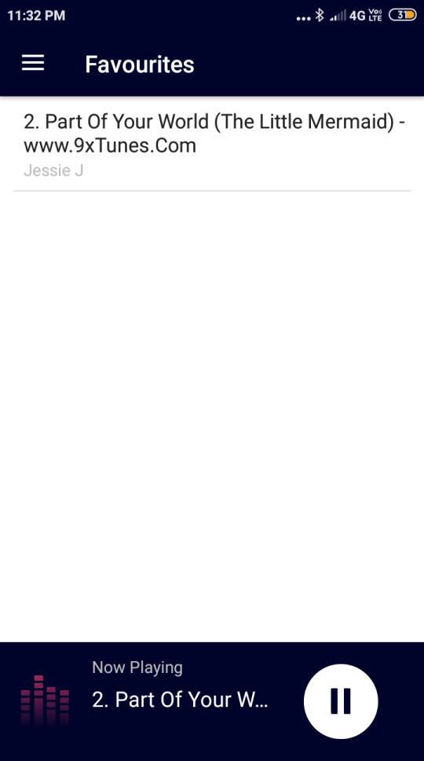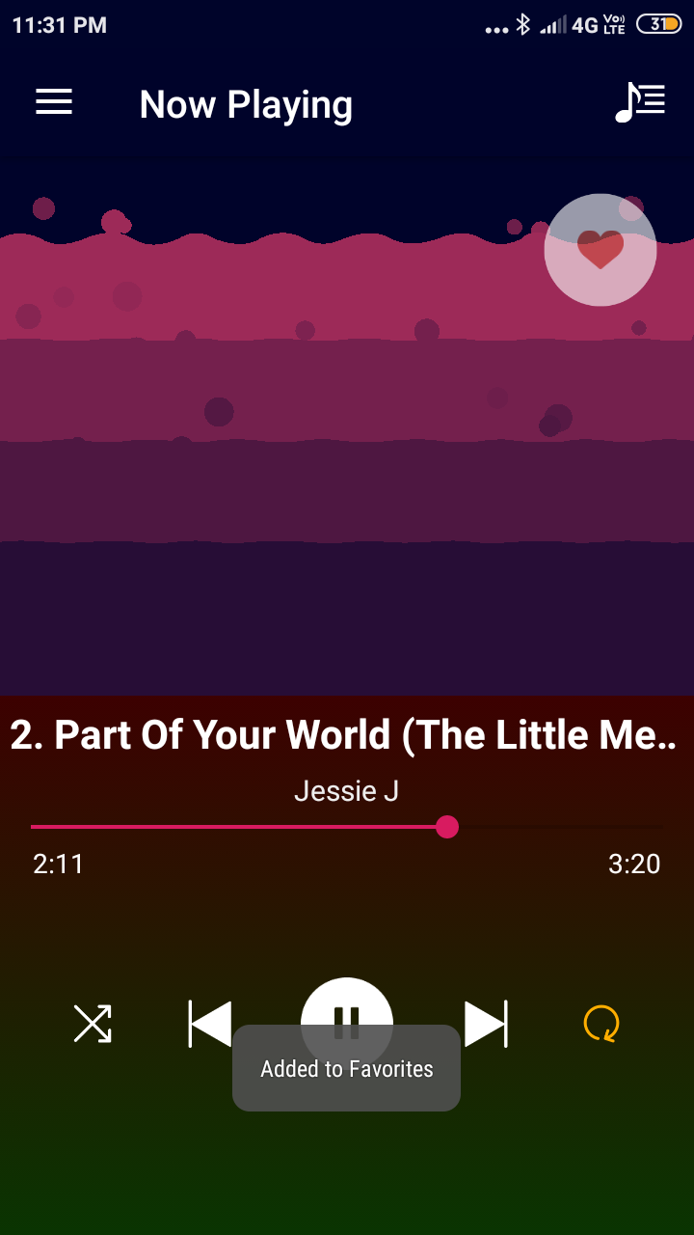

Fig 37 Favourites Screen, Song displayed sucessfully

Fig 36 Added to favourites and will reflect in the database which can be seen in Favourites Screen

Fig 35 Back to list Menu will take to All Songs Screen

Fig 39 Favourites Screen

Fig 38 Another song added to favourites

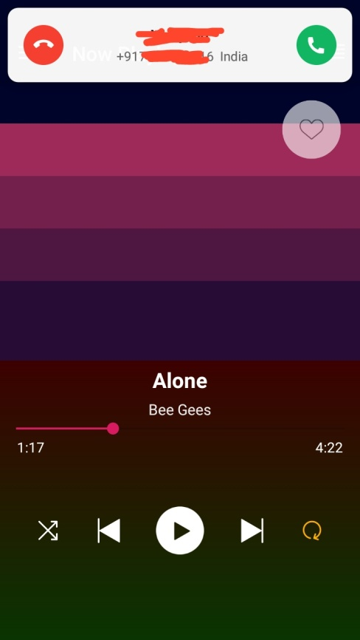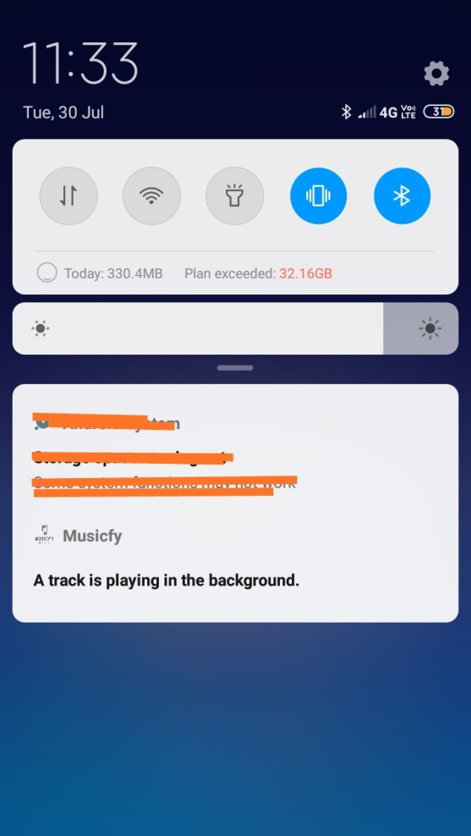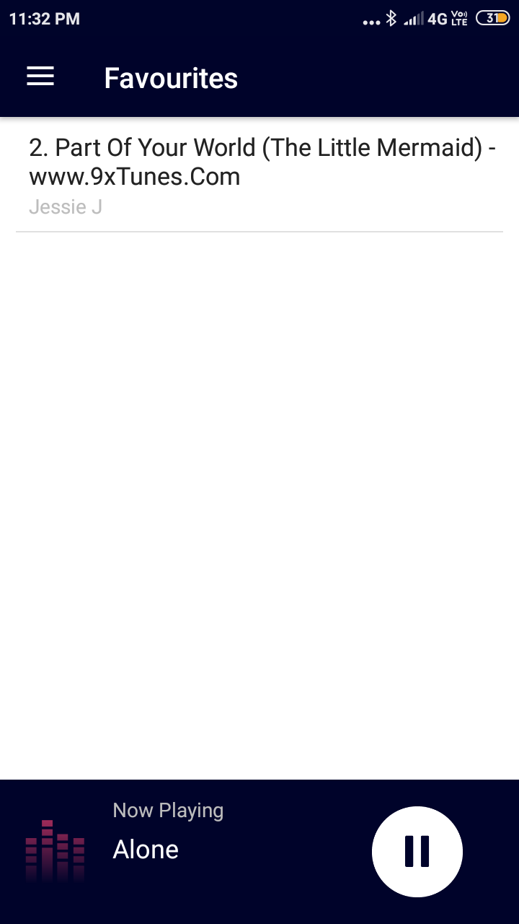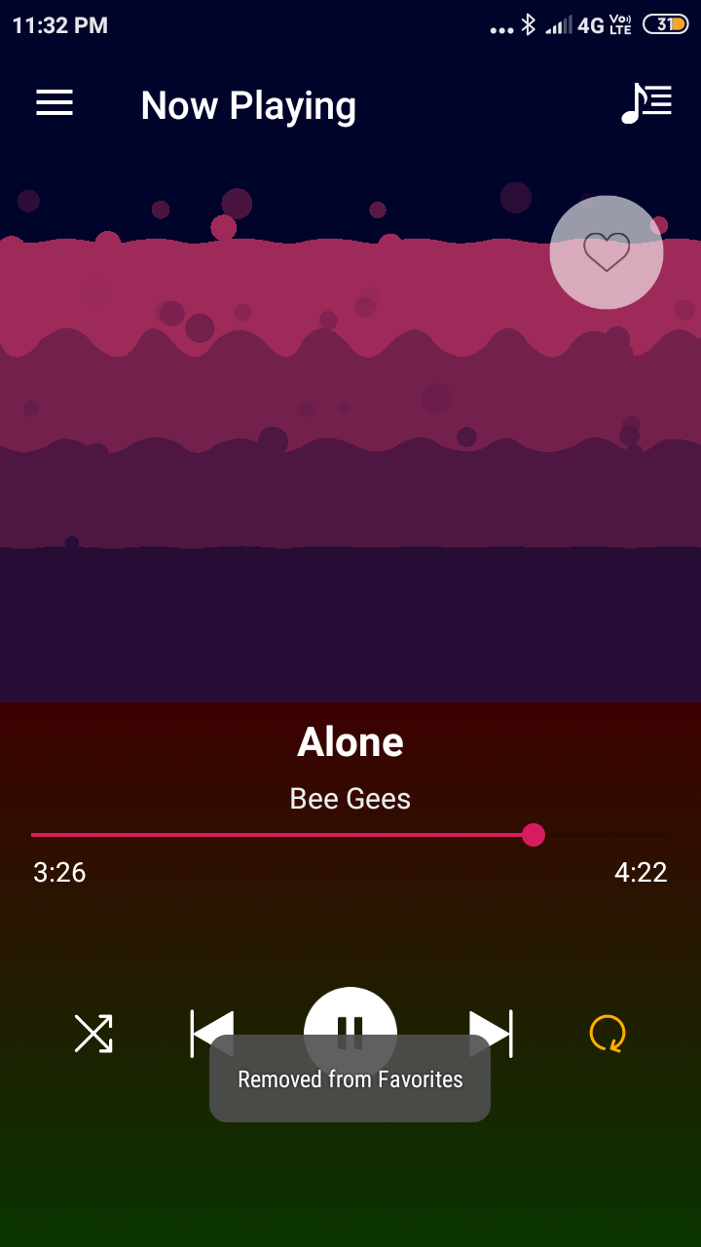

Fig 42 Generated notification if the song is playing

Fig 41 Favourite Screen, successfully removed from database

Fig 40 Removed from favourites list and removed from database

Fig 43 When there is an incoming call or an outgoing call then the song pauses and the notification is disappeared

**Gantt Chart**

|  |  |
| --- | --- |
| **RESPONSIBILITY** | **Time taken** |
| Project coding | 10 days |
| Testing | 2 days |
| Implementing | 3 days |
| Executing | 5 days |
| Final preparations | 3 days |
| **TOTAL** | **24 days** |

**Conclusion**

The project titled Musicfy is an android based application. The aim of the project was to enable our android to play music with a go and with cool visualizer and sone features like shaking the phone to change the song.

The project has been completed successfully which covers the maximum requirement given by Industry. The constraints have been met and overcome with success. The system is designed as like it was decided earlier in the design phase. The project gives a good idea on developing a user-friendly application which satisfies users of all age.

The system is made flexible and versatile. This application has a user-friendly screen that enables the user to use the Musicfy application without any inconvenience. Using the database helps to keep a record of all the favourite songs that the user has opted as a favourite while can be accessed in the favourite screen. Provisions have been made to upgrade the Musicfy application. The application has been tested with live user and has provided a successful result. Hence the application has proved to work efficiently.

Musicfy met its objectives, by being simple to use, will be easy to download from the app store. This software is developed with scalability in mind. Additional modules can be easily added when necessary. However, there is still a lot of scope for future improvement and add on in functionality. Some of the major ones being developing for different mobile operating system like windows, iPhones etc. In future, it can even have a search option for quickly searching for a particular song and can even delete or rename that song or even add artist name for songs whose artist names are unknown. Music player consoles can be controlled directly from the lock screen or from the notification bar.

**BIBLIOGRAPHY**

1. <https://www.google.com/search?q=andy+rubin>
2. <https://stats.areppim.com/stats/stats_mobiosxsnapshot.html>
3. [www.quora.com](http://www.quora.com)
4. [www.stackoverflow.com](http://www.stackoverflow.com)
5. <https://developer.android.com>
6. <https://tutorialspoint.com>
7. Software Engineering - a practitioner's approach by Roger Pressman

**Thank You**