WEEK – 5
TASK-1: MAX SUB ARRAY
class Solution {
public int maxSubArray(int[] nums) {
int currentSum=nums[0];
int maxSum=nums[0];
for(int i=1;i<nums.length;i++){
currentSum=Math.max(nums[i],currentSum + nums[i]);
maxSum=Math.max(maxSum,currentSum);
}
return maxSum;

}
}
OUTPUT:
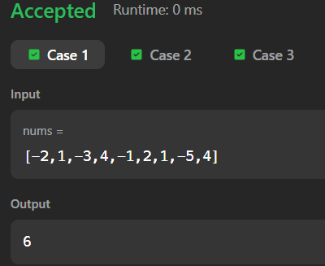
TASK 2:subarraydivison
import java.util.*;
public class Solution {
public static void main(String[] args) {
Scanner sc = new Scanner(System.in);
int n = sc.nextInt();
int[] s = new int[n];

for(int i = 0; i < n; i++) {
s[i] = sc.nextInt();
}
int d = sc.nextInt(); // target sum
int m = sc.nextInt(); // segment length
int count = 0;
int sum = 0;
// first window
for(int i = 0; i < m; i++) {
sum += s[i];
}
if(sum == d) count++;
// slide window
for(int i = m; i < n; i++) {
sum += s[i]; // add next
sum -= s[i - m]; // remove previous
if(sum == d) count++;
}
System.out.println(count);
}
}OUTPUT:
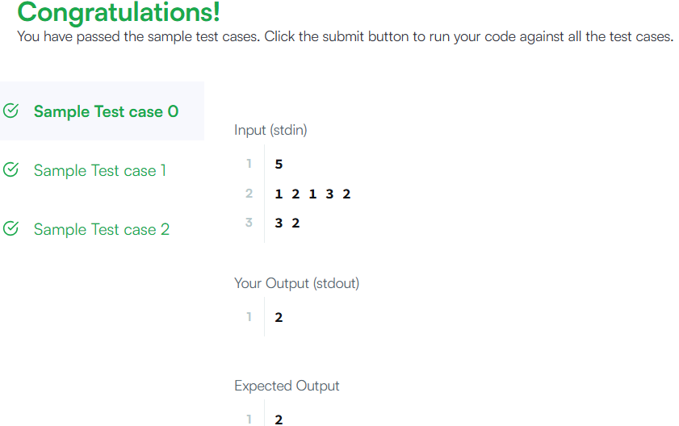
TASK 3:Maximumsubarray
import java.util.*;

public class Solution {
public static void main(String[] args) {
Scanner sc = new Scanner(System.in);

int t = sc.nextInt();

while(t-- > 0) {
int n = sc.nextInt();
int[] arr = new int[n];

for(int i = 0; i < n; i++) {
arr[i] = sc.nextInt();
}

// Kadane's Algorithm
int maxSoFar = arr[0];
int current = arr[0];

for(int i = 1; i < n; i++) {
current = Math.max(arr[i], current + arr[i]);
maxSoFar = Math.max(maxSoFar, current);
}

// Maximum subsequence
int subseqSum = 0;
int maxElement = arr[0];

for(int num : arr) {
if(num > 0) subseqSum += num;
maxElement = Math.max(maxElement, num);
}

if(subseqSum == 0) subseqSum = maxElement;

System.out.println(maxSoFar + " " + subseqSum);
}
}
}OUTPUT:
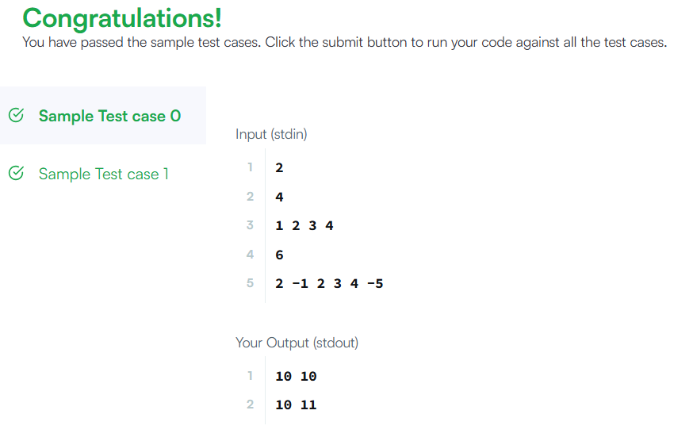

TASK 4: 918. Maximum Sum Circular Subarray
class Solution {
public int maxSubarraySumCircular(int[] nums) {
int total = 0;
int maxSum = nums[0], currentMax = 0;
int minSum = nums[0], currentMin = 0;
for(int num : nums) {
currentMax = Math.max(num, currentMax + num);
maxSum = Math.max(maxSum, currentMax);
currentMin = Math.min(num, currentMin + num);
minSum = Math.min(minSum, currentMin);
total += num;
}
if(maxSum < 0) return maxSum;
return Math.max(maxSum, total - minSum);
}
}
OUTPUT:
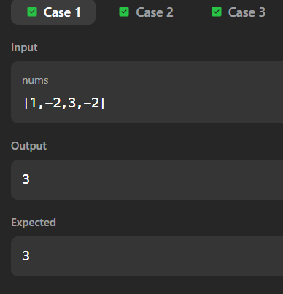

TASK 5: 8. String to Integer (atoi)
class Solution {
public int myAtoi(String s) {
int i = 0, n = s.length();
// 1. Skip spaces
while(i < n && s.charAt(i) == ' ') {
i++;
}
// 2. Handle sign
int sign = 1;
if(i < n && (s.charAt(i) == '+' || s.charAt(i) == '-')) {
if(s.charAt(i) == '-') sign = -1;
i++;
}
// 3. Convert digits
int result = 0;
while(i < n && Character.isDigit(s.charAt(i))) {
int digit = s.charAt(i) - '0';
// 4. Check overflow
if(result > (Integer.MAX_VALUE - digit) / 10) {
return sign == 1 ? Integer.MAX_VALUE : Integer.MIN_VALUE;
}
result = result * 10 + digit;
i++;
}
return result * sign;
}
}
}OUTPUT:
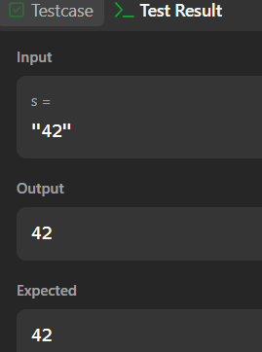

TASK6: Alternating Characters
import java.util.*;
public class Solution {
public static void main(String[] args) {
Scanner sc = new Scanner(System.in);
int t = sc.nextInt();
while(t-- > 0) {
String s = sc.next();
int deletions = 0;
for(int i = 1; i < s.length(); i++) {
if(s.charAt(i) == s.charAt(i - 1)) {
deletions++;
}
}
System.out.println(deletions);
}
}
}
Output:
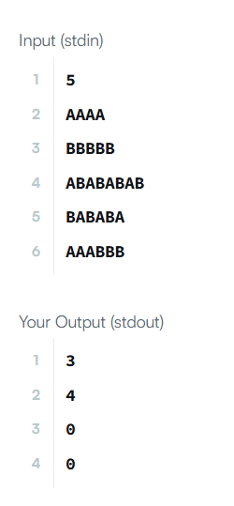
TASK7: 3. Longest Substring Without Repeating Characters
import java.util.*;
class Solution {
public int lengthOfLongestSubstring(String s) {
Set<Character> set = new HashSet<>();
int left = 0, maxLength = 0;
for(int right = 0; right < s.length(); right++) {
while(set.contains(s.charAt(right))) {
set.remove(s.charAt(left));
left++;
}
set.add(s.charAt(right));
maxLength = Math.max(maxLength, right - left + 1);
}
return maxLength;
}
}
Output:
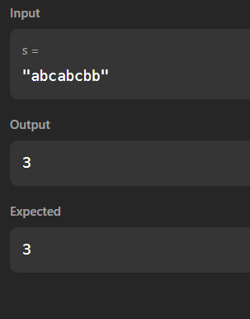
TASK8: 890. Find and Replace Pattern
import java.util.*;
class Solution {
public List<String> findAndReplacePattern(String[] words, String pattern) {
List<String> res = new ArrayList<>();
for (String word : words) {
if (match(word, pattern)) {
res.add(word);
}
}
return res;
}
private boolean match(String w, String p) {
if (w.length() != p.length()) return false;
Map<Character, Character> m1 = new HashMap<>();
Map<Character, Character> m2 = new HashMap<>();
for (int i = 0; i < w.length(); i++) {
char c1 = w.charAt(i);
char c2 = p.charAt(i);
if (m1.containsKey(c1) && m1.get(c1) != c2) return false;
if (m2.containsKey(c2) && m2.get(c2) != c1) return false;
m1.put(c1, c2);
m2.put(c2, c1);
}
return true;
}
}
OUTPUT:
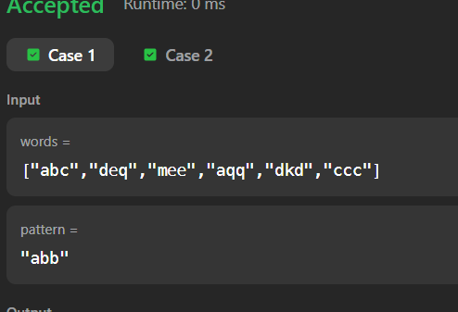

TASK 9: 1408. String Matching in an Array
import java.util.*;
class Solution {
public List<String> stringMatching(String[] words) {
List<String> res = new ArrayList<>();
for (int i = 0; i < words.length; i++) {
for (int j = 0; j < words.length; j++) {
if (i != j && words[j].contains(words[i])) {
res.add(words[i]);
break;
}
}
}
return res;
}
}
Output:
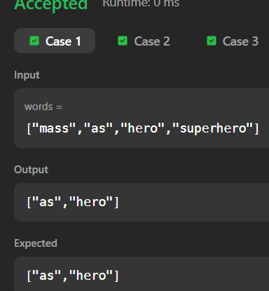

TASK10: Naive pattern search
import java.util.*;
public class Solution {
public static void main(String[] args) {
Scanner sc = new Scanner(System.in);
int m = sc.nextInt();
int n = sc.nextInt();
int r = sc.nextInt();
int[][] matrix = new int[m][n];
for(int i = 0; i < m; i++) {
for(int j = 0; j < n; j++) {
matrix[i][j] = sc.nextInt();
}
}
int layers = Math.min(m, n) / 2;
for(int layer = 0; layer < layers; layer++) {
List<Integer> list = new ArrayList<>();
int top = layer, left = layer;
int bottom = m - layer - 1;
int right = n - layer - 1;
for(int i = left; i <= right; i++) list.add(matrix[top][i]);
for(int i = top + 1; i <= bottom; i++) list.add(matrix[i][right]);
for(int i = right - 1; i >= left; i--) list.add(matrix[bottom][i]);
for(int i = bottom - 1; i > top; i--) list.add(matrix[i][left]);
int len = list.size();
int rot = r % len;
List<Integer> rotated = new ArrayList<>();
rotated.addAll(list.subList(rot, len));
rotated.addAll(list.subList(0, rot));
int idx = 0;
for(int i = left; i <= right; i++) matrix[top][i] = rotated.get(idx++);
for(int i = top + 1; i <= bottom; i++) matrix[i][right] = rotated.get(idx++);
for(int i = right - 1; i >= left; i--) matrix[bottom][i] = rotated.get(idx++);
for(int i = bottom - 1; i > top; i--) matrix[i][left] = rotated.get(idx++);
}
for(int i = 0; i < m; i++) {
for(int j = 0; j < n; j++) {
System.out.print(matrix[i][j] + " ");
}
System.out.println();
}
}
}
Output:
