WEEK – 6
TASK-1: String Similarity
import java.util.*;
class Solution {
public static void main(String[] args) {
Scanner sc = new Scanner(System.in);
int t = sc.nextInt();
while (t-- > 0) {
String s = sc.next();
System.out.println(stringSimilarity(s));
}
}
public static int stringSimilarity(String s) {
int n = s.length();
int[] z = new int[n];
int l = 0, r = 0;
for (int i = 1; i < n; i++) {
if (i <= r) {
z[i] = Math.min(r - i + 1, z[i - l]);
}
while (i + z[i] < n && s.charAt(z[i]) == s.charAt(i + z[i])) {
z[i]++;
}
if (i + z[i] - 1 > r) {
l = i;
r = i + z[i] - 1;
}
}
int sum = n;
for (int val : z) {
sum += val;
}
return sum;
}
}
OUTPUT:
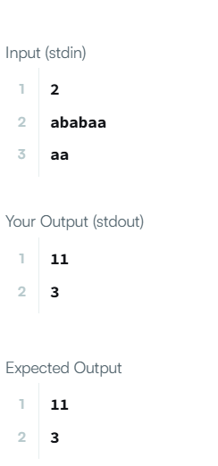
TASK 2: 459. Repeated Substring Pattern
class Solution {
public boolean repeatedSubstringPattern(String s) {
String t = s + s;
return t.substring(1, t.length() - 1).contains(s);
}
}
OUTPUT:
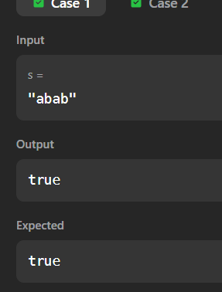

TASK 3: Two Strings
import java.util.*;
class Solution {
public static void main(String[] args) {
Scanner sc = new Scanner(System.in);
int t = sc.nextInt();
while (t-- > 0) {
String s1 = sc.next();
String s2 = sc.next();
System.out.println(twoStrings(s1, s2));
}
}
public static String twoStrings(String s1, String s2) {
Set<Character> set = new HashSet<>();
for (char c : s1.toCharArray()) {
set.add(c);
}
for (char c : s2.toCharArray()) {
if (set.contains(c)) {
return "YES";
}
}
return "NO";
}
}
OUTPUT:
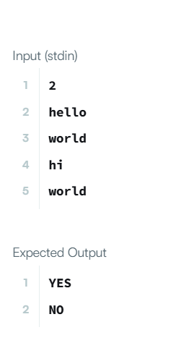
TASK 4: 796. Rotate String
class Solution {
public boolean rotateString(String s, String goal) {
if (s.length() != goal.length()) {
return false;
}
String doubled = s + s;
return doubled.contains(goal);
}
}
OUTPUT:
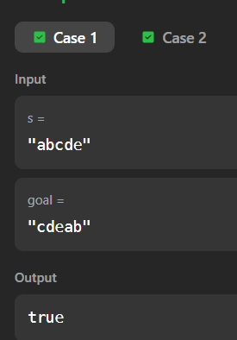

TASK 5: Mars Exploration
import java.util.*;
class Solution {
public static void main(String[] args) {
Scanner sc = new Scanner(System.in);
String s = sc.next();
int count = 0;
for (int i = 0; i < s.length(); i++) {
if (i % 3 == 0 && s.charAt(i) != 'S') {
count++;
}
else if (i % 3 == 1 && s.charAt(i) != 'O') {
count++;
}
else if (i % 3 == 2 && s.charAt(i) != 'S') {
count++;
}
}
System.out.println(count);
}
}OUTPUT:
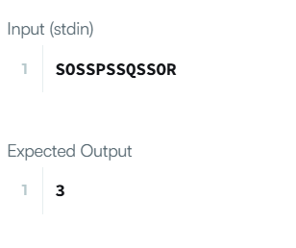
TASK6: 438. Find All Anagrams in a String
import java.util.*;
class Solution {
public List<Integer> findAnagrams(String s, String p) {
List<Integer> res = new ArrayList<>();
if (s.length() < p.length()) return res;
int[] count = new int[26];
for (char c : p.toCharArray()) {
count[c - 'a']++;
}
int left = 0, right = 0, k = p.length();
while (right < s.length()) {
if (count[s.charAt(right) - 'a']-- > 0) {
k--;
}
right++;
if (k == 0) {
res.add(left);
}
if (right - left == p.length()) {
if (count[s.charAt(left) - 'a']++ >= 0) {
k++;
}
left++;
}
}
return res;
}
}

Output:
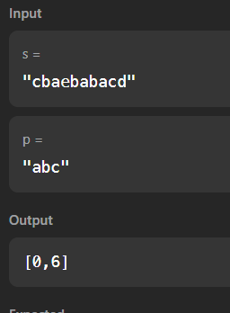
TASK7: Palindrome Index
import java.util.*;
class Solution {
public static void main(String[] args) {
Scanner sc = new Scanner(System.in);
int t = sc.nextInt();
while (t-- > 0) {
String s = sc.next();
System.out.println(palindromeIndex(s));
}
}
public static int palindromeIndex(String s) {
int left = 0, right = s.length() - 1;
while (left < right) {
if (s.charAt(left) != s.charAt(right)) {
if (isPalindrome(s, left + 1, right)) return left;
if (isPalindrome(s, left, right - 1)) return right;
return -1;
}
left++;
right--;
}
return -1;
}
private static boolean isPalindrome(String s, int l, int r) {
while (l < r) {
if (s.charAt(l) != s.charAt(r)) return false;
l++;
r--;
}
return true;
}
}
Output:
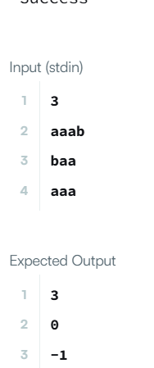
TASK8: 28. Find the Index of the First Occurrence in a String
class Solution{
public int strStr(String haystack,String needle){
int n=haystack.length();
int m=needle.length();
for(int i=0;i<=n-m;i++){
int j=0;
while(j<m && haystack.charAt(i+j)==needle.charAt(j)){
j++;
}
if(j==m){
return i;
}
}
return -1;
}
}
OUTPUT:
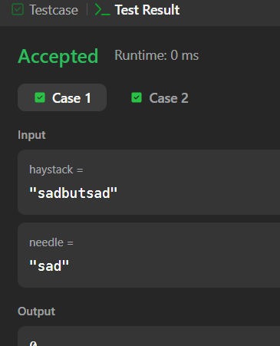

TASK 9: 5. Longest Palindromic Substring
class Solution{
public String longestPalindrome(String s){
if(s==null||s.length()<1)return "";
int start=0,end=0;
for(int i=0;i<s.length();i++){
int len1=expand(s,i,i);
int len2=expand(s,i,i+1);
int len=Math.max(len1,len2);
if(len>end-start){
start=i-(len-1)/2;
end=i+len/2;
}
}
return s.substring(start,end+1);
}
private int expand(String s,int left,int right){
while(left>=0&&right<s.length()&&s.charAt(left)==s.charAt(right)){
left--;
right++;
}
return right-left-1;
}
}Output:
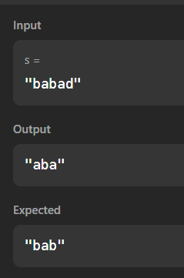

TASK10: Circular Palindromes
class Result{
public static List<Integer> circularPalindromes(String s){
int n=s.length();
String doubled=s+s;
List<Integer> res=new ArrayList<>();
for(int i=0;i<n;i++){
String sub=doubled.substring(i,i+n);
res.add(longestPalindrome(sub));
}
return res;
}
private static int longestPalindrome(String s){
int max=1;
for(int i=0;i<s.length();i++){
max=Math.max(max,expand(s,i,i));
max=Math.max(max,expand(s,i,i+1));
}
return max;
}
private static int expand(String s,int l,int r){
while(l>=0&&r<s.length()&&s.charAt(l)==s.charAt(r)){
l--;
r++;
}
return r-l-1;
}
}Output:
