**SUPPLY AND DEMAND GAP ANALYSIS**

**Aim:**

The aim of this project is to collect and analyse the data in detail of the Pickup point of the Airport and City Request id in Uber Request Data.

**Introduction:**

Uber provides the 2016 data. By using this data find out the demand and supply Analysis gap of the cab.

The main objective of this project is to analyze the data on, Uber Request data. Through the analysis of data, we can find some important insights.

**Problem Statement:**

In this project, we find out how many request id is placed from the pickup point of the Airport and city, How many Drivers are present, How many trips are completed, and how many trips are cancelled also find out how many trips the car is not available for the trips.

**Methodology:**

**Step 1 Data Importing**

In power BI desktop with the help of the get data option import the CSV data which is named as Uber Request data and clicked Transform option.

**Step 2 Data Cleaning**

After Import the data to transform I understand that some of the column contains Null values I have replaced the Null values by 0 with help of replace function then select the close & apply and started working on the data.

**Step 3 Visualization**

In visualization part with the help of power BI desktop software I have used different kinds of charts, graphs, cards and table to display the data in the format which will be easy to understand.

**Analysis:**

* In the first chart, almost 1327 trips are completed for Airport and 1504 trips are completed for City.
* For a total of 1713 trips, there is no Car Available for Airport trips and 937 trips with no car available for city trips.
* A total of 198 trips are cancelled for Airport and 1066 trips are cancelled for city trips.

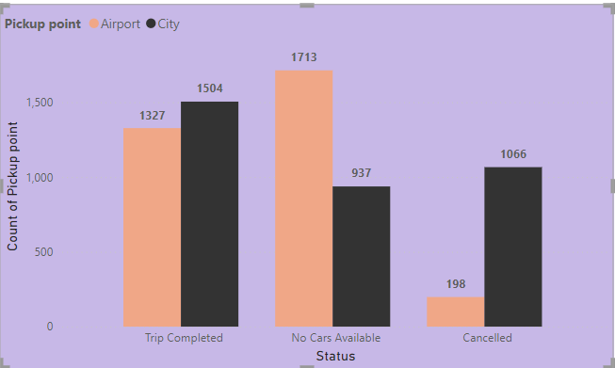

* In the Second chart 15 July 2016, almost 20.47 % of request IDs are placed.

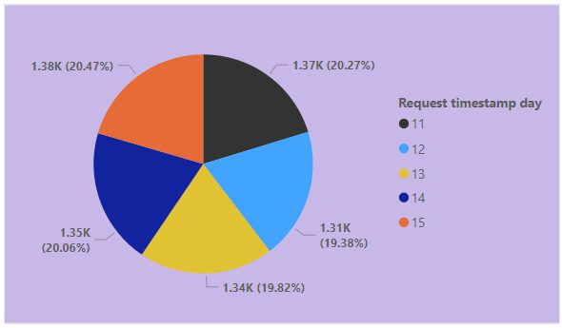

* The Total of 301 Drivers are available in 2016.

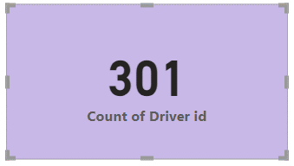

* In the fourth Chart, the Total Request id is placed for airports is 50.99 % and the total request Id are placed for city is 49.01 %.

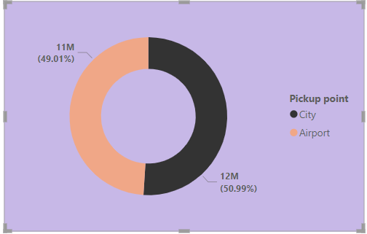

* And in the last chart, 297 Drivers have completed the Airport trip and 299 Drivers are completed the city trip.
* The Total of 145 Drivers cancelled the Airport Trips and 291 Drivers cancelled the city Trips.

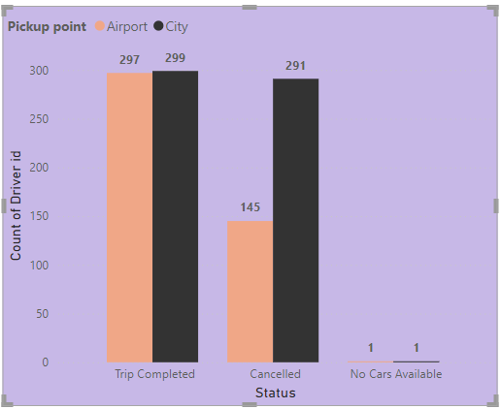

**Insights:**

* In conclusion, we can take a look at the final Dashboard for further Analysis.
* We analyzed the data according to the request ID.

**Recommendations:**

* We can analyze the data of the overall Trips in the City.
* Like this dataset, we can Analyze the Data according to the Different Cities-Area it takes more clarity to how to fill the supply and demand gap
* We can analyze the data with the proper format
* We can collect good datasets for more effective analysis by using charts.

**Conclusion:**

In Conclusion, we can take look at the Dashboard for further Analysis.

* According to analysis, almost 1713 trips are cancelled for Airport trips. In airports, trips need to increase the drivers that help to increase the Business.
* The second points are that almost 1066 trips are cancelled by the customer in the city area and need to improve some features.
* A total of 1327 Drivers successfully completed the Airport trips and 1504 Drivers successfully completed the city trips.

**Kaggle Data set Link**

***https://www.kaggle.com/datasets/hellbuoy/uber-supplydemand-gap***