**COVID – 19 VACCINATIONS TREND ANALYSIS**

**Aim:**

The aim of this project is to analyse the data in details of vaccinated and fully vaccinated people by country wise in 2021-2022.

**Introduction:**

When the start of COVID-19 outbreak, WHO has worked with countries and areas in different region on public health measures to slow or stop the spread of the virus.

The main objective of the project is to analysis Covid – 19 Vaccination data to find some important details.

**Problem Statement:**

* In the project, we need to find out how many people are vaccinated and fully vaccinated at different countries in 2021 and 2022.
* We have analysed the top 5 fully vaccinated countries.
* We have analysed top 5 daily vaccinated details by country.
* We have analysed Fully vaccinated and 1 dose vaccinates.
* We have analysed top 10 one dose vaccinated by country.

**Methodology:**

**Step 1 Data Importing**

In power BI desktop with the help of the get data option import the CSV data which is named as country_vaccinations and clicked Transform option.

**Step 2 Data Cleaning**

After Import the data to transform I understand that some of the column contains Null values I have replaced the Null values by 0 with help of replace function then select the close & apply and started working on the data.

**Step 3 Visualization**

In visualization part with the help of power BI desktop software I have used different kinds of charts, graphs, cards and table to display the data in the format which will be easy to understand.

**Analysis:**

In the analysis part I have analysed the top 5 fully vaccinated country by using line chart and have used the filter option to find the top countries and the result obtained. From the analysis we come to know that India is the top countries in fully vaccinated with 116bn.

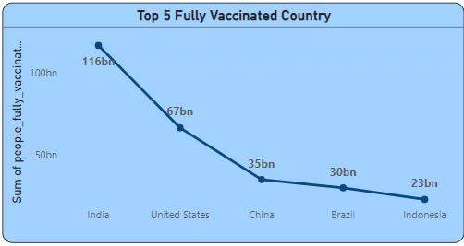

In the second analysis, I have analysed the top 5 daily vaccinated country by using Pie chart and have used filter option to get Top 5 daily vaccinated country. From that analysis we have known that China is top country in daily vaccinated followed by India, U.S, Brazil, Indonesia.

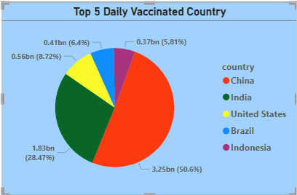

In the third analysis, we have come know that how many people are fully vaccinated and 1 dose vaccinated from whole country.

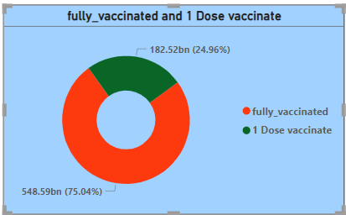

From below card analysis we have came to know about the total country in vaccination process, sum of people fully vaccinated, sum of people vaccinated, sum of total vaccination and slicer also used to know the vaccinate details by year and month wise.

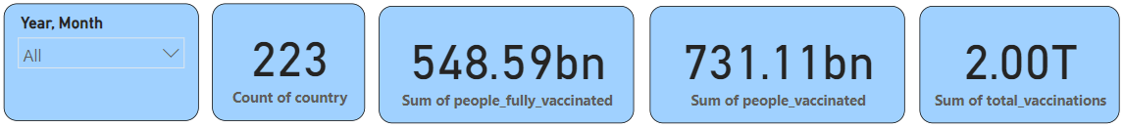

**Insights:**

* Here we analysed the top 5 fully vaccinated countries in which India tops the list which indicates that people in the country were showing lots of interest to get vaccinated.
* Analysed top 5 daily vaccinated country in which China is top.
* And also analysed difference of Fully vaccinated and One dose vaccinated by overall country.
* Analysed top 10 one dose vaccinated by country wise.

**Recommendations:**

* We should collect day to day reports and we should update our records daily to get more accurate details.
* Using that details we can move forward with more vaccination to the right country which needs the most.

**Conclusion:**

In this dataset we came to know that the vaccination process in every country was going ion good pace that indicates we can have control of this disease very soon all over the world.