

INFO 2315: DATA STRUCTURE (S11)

Project 2

Ramandeep Singh  
100394782



December 3, 2022

**Theme**  
 Designing User-centered Menu-driven Java Program for File processing (filtering, sorting, and merging) based on Java data structures (HashMap).

**Functioning**  
- The program reads different files like .txt and .csv files.  
- The program can sort the data of the files.  
- The program can merge the data from different files and combine them in one file.  
- The program can filter data according to the user Output.

**Results**  
1. Reading Data  
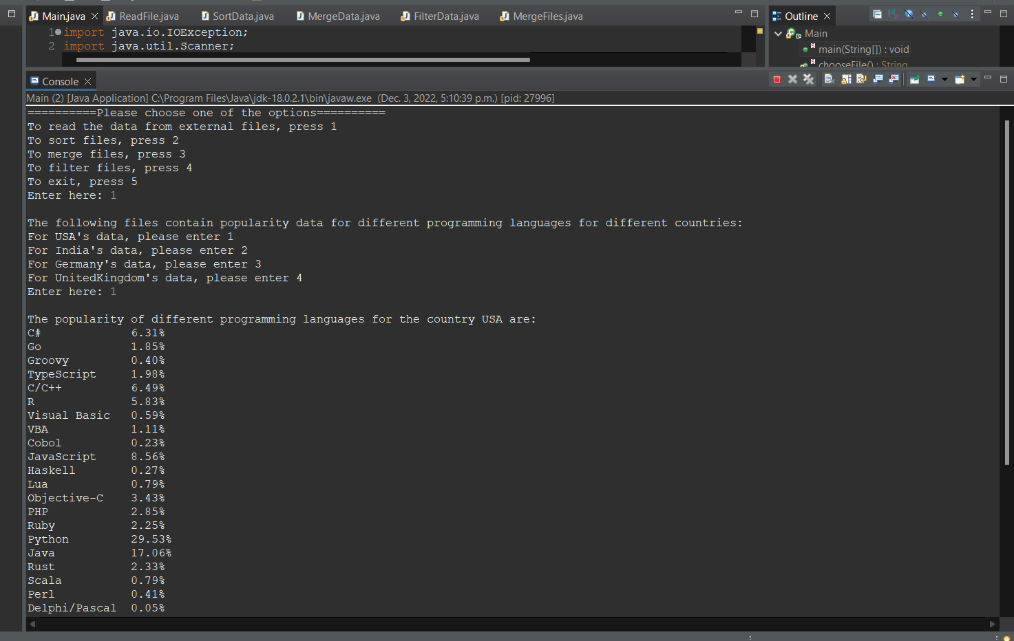

2. Sorting Data

3. Merging Data

4. Filtering Data

5. Exit

**References**<https://statisticstimes.com/tech/top-computer-languages.php>