**--------------------Piping----------------**

Sometimes we can use output of one command as input to another command. This concept is called piping.

By using piping, multiple commands will work together to fulfill our requirement.

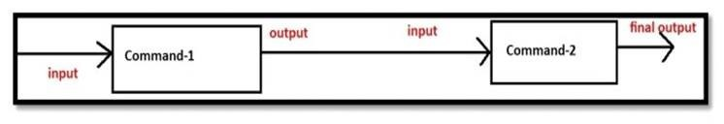

We can implement piping by using vertical bar (|).

$ ls -l /etc | wc

215 1940 11872

First ls got executed and the output of this command will become input to

 wc command.

Eg 2: $ ls -l /etc | more

Eg 3: $ ls -l /etc | wc |wc -l

The output is: 1

Eg 4: $ ls -l /etc | head -5

ex:- given a text file sort it , remove duplicates, give line numbering

**. sort :-**

We can sort data of the file by using sort command.

sort filename

Here sorting is based on alphabetical order

$ cat a.txt

Sunny

Bunny

Chinny

Vinny

Pinny

$ sort a.txt

Bunny

Chinny Pinny

Sunny

Vinny

If we want to sort based on reverse of alphabetical order, then we should use -r option. $ sort -r a.txt

Vinny

Sunny

Pinny

Chinny

Bunny

If the file contains alphanumeric data, then first numbers will be considered and then alphabet symbols.

$ cat a.txt

7

Sunny

8

Bunny

1

If the file contains only numbers, then the sorting is not based on numeric value and it is just based on digits.

$ cat > a.txt

11

2

7

2222222

9

$ sort a.txt

11

2

2222222

7

9

f we want to sort based on numeric value then we have to use -n option.

-n means numeric value

$ sort -n a.txt

2

7

9

11

2222222

Bydefault sort command will display duplicate lines. If we want only unique lines then we

have to use -u option. -u meant for unique lines.

$ cat a.txt

1

1

2

2

Sunny

Sunny

Bunny

$ sort a.txt

1

1 2 2

Bunny

Sunny

Sunny

$ sort -u a.txt

1 2

Bunny

Sunny

**. uniq**

We can use uniq command to display unique content in the file.

But to use uniq command, compulsory the file should be sorted, otherwise it won't work properly

$ cat a.txt

Sunny

sunny

Bunny

Chinny

Sunny

Bunny

Chinny

$ uniq a.txt

Sunny

sunny

Bunny

Chinny

Sunny

Bunny

Chinny

With uniq command we can use multiple options:

-d     To display only duplicate lines

-c     To display number of occurrences of each line

           -i      Ignore case while comparing

-u     To display only unique lines i.e the lines which are not duplicated