**Report on Project**

* **Optimal Number of clusters** were identified through the Elbow method and the knee point was identified by evaluating the clusters which has the stable score for the Distortion score.

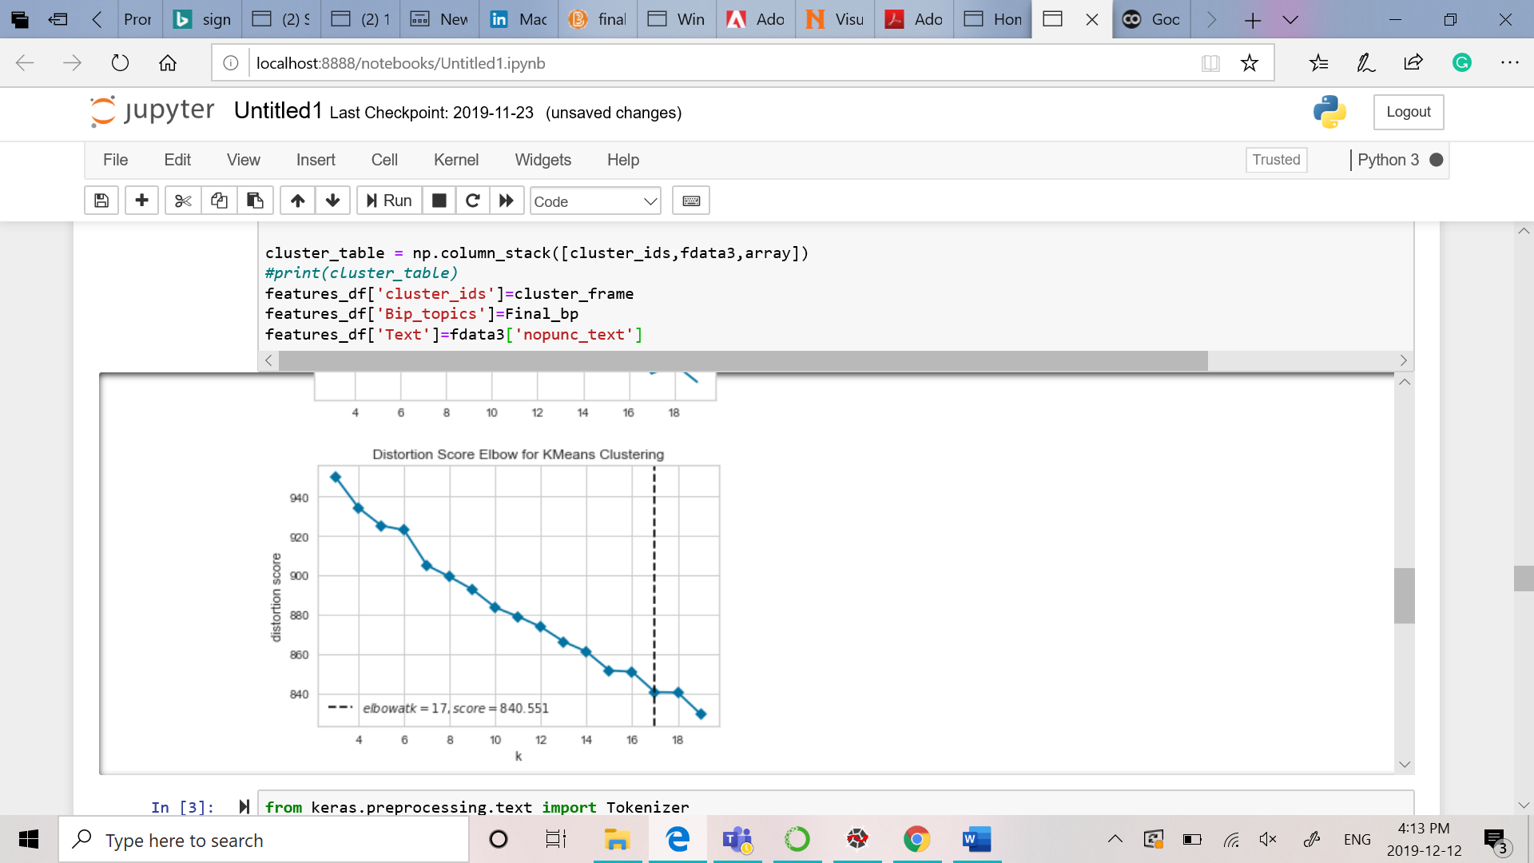

**Cluster Visualization**

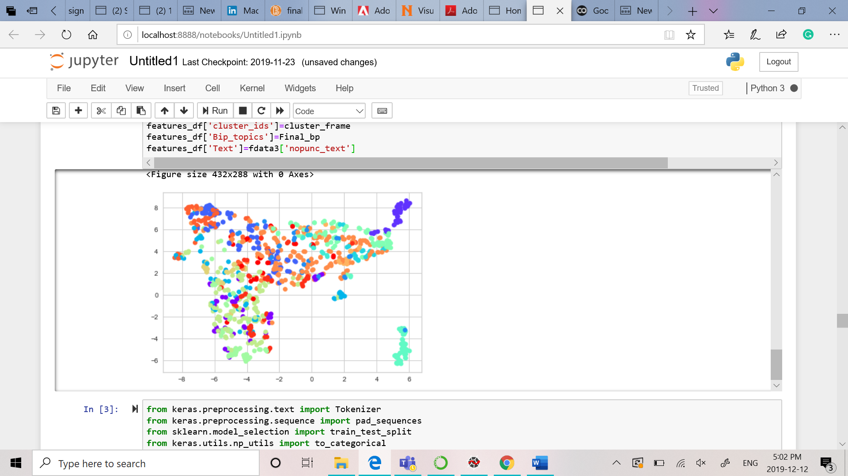

* Write a function to evaluate the quality of your clusters. You may apply any metric set that you like by providing a justification for that

In our project, we have used **the Accuracy metric**. Accuracy is a good measure for evaluating the model for classification. It is a generalizable evaluating metric which is used in other models also. In the next steps for comparing the efficiency of the model with the new features we can learn the how it is performing on the Neural Networks.

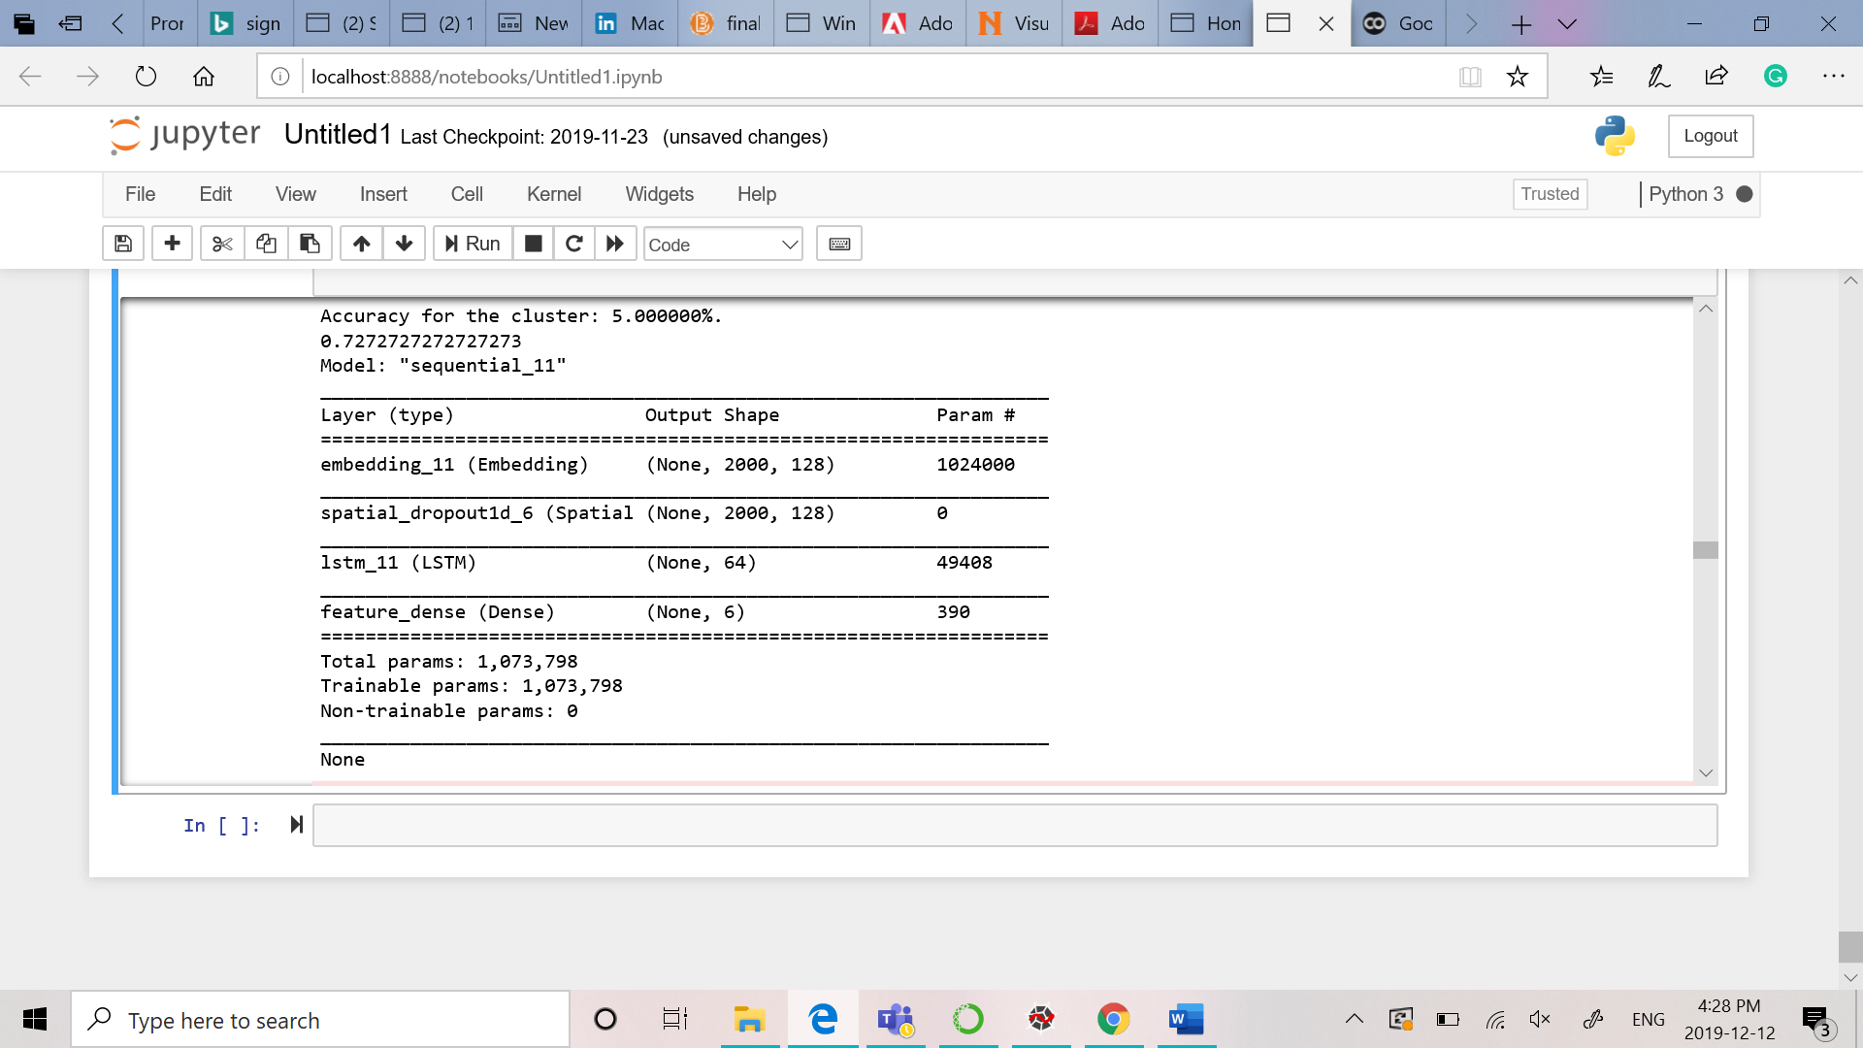

* We have implemented Paper 1. We have implemented the Feature Extraction through **Convolutional Autoencoder**. We observed few results for LDA as well.

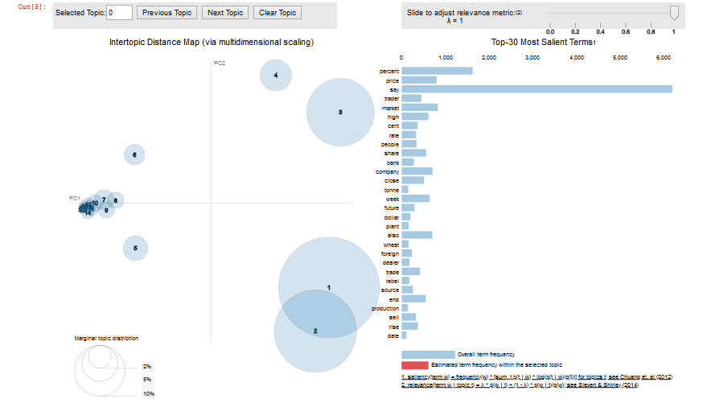

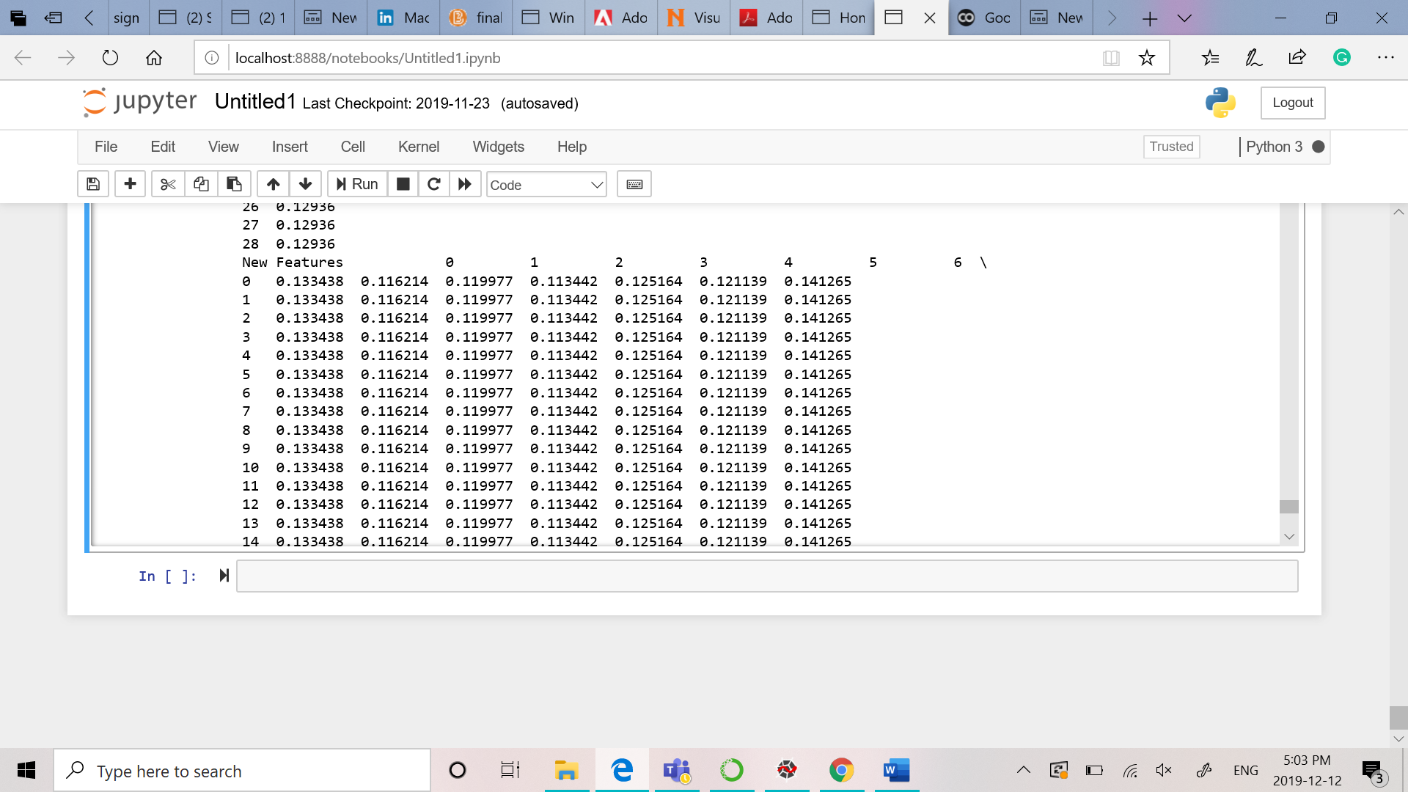

* The differences from the Assignment than the Project are the below following points
  1. The **features extracted** are obtained through the implementation of Neural Networks.
  2. In the Neural Networks, we have observed for the extracted features the validation loss is decreasing as the value of epochs increases.
  3. We have implemented RNN to evaluate the extracted features.
  4. We have used the value **10 for the number of epochs** to increase the accuracy as we observed with the value for 4 the accuracy was less .

