**Tribhuvan University**

**Faculty of Humanities and Social Sciences**



**A PROJECT REPORT**

**on**

**Online Car Rental System**

**(SAWARI SERVICE)**

**Submitted to**

**Faculty of Humanities & Social Sciences**

**Kathmandu Shiksha campus**

***In partial fulfillment of the requirements for the Bachelors in Computer Application***

**Submitted by**

**Raman Shrestha**

**Bikram Bishwokarma**

**Under the Supervision of**

**Yuba raj Devkota**

**Tribhuvan University**

**Faculty of Humanities and Social Sciences**

**Kathmandu Shiksha campus**



**Supervisor’s Recommendation**

I hereby recommend that this project prepared under my supervision by RAMAN SHRESTHA, BIKRAM BISHWOKARMA entitled “**ONLINE CAR RENTAL SYSTEM”** in partial fulfillment of the requirements for the degree of Bachelor in Computer Application is recommended for the final evaluation.

…………………………...

**SIGNATURE**

Mr.YUBA RAJ DEVKOTA

co-ordinator

BCA

Kathmandu Shiksha campus

**Tribhuvan University**

**Faculty of Humanities and Social Sciences**

**Kathmandu Shiksha campus**



**LETTER OF APPROVAL**

This is to certify that this project prepared by RAMAN SHRESTHA and BIKRAM BISHWOKARMA entitled “**ONLINE CAR RENTAL SYSTEM”** in partial fulfillment of the requirements for the degree of Bachelor in Computer Application has been evaluated. In our opinion it is satisfactory in the scope and quality as a project for the required degree.

|  |  |
| --- | --- |
| **SIGNATURE of Supervisor**  Yuba raj Devkota, co-ordinator  BCA  Kathmandu Shiksha Multiple campus | **SIGNATURE of HOD/ Coordinator**    Basanta Baral and Academic Designation  Department name and full address of the college |
| **SIGNATURE of Internal Examiner**  **………………………**  **Internal Examiner** | **SIGNATURE of External Examiner**  **…………………….**  **External Examiner** |

**Tribhuvan University**

**Faculty of Humanities and Social Sciences**

**Kathmandu Shiksha campus**



Ref No:

Date:

## Subject: Approval of Project Proposal

The project entitled “Online car rental system” proposed by Mr. Raman Shrestha and Mr. Bikram Bishwokarma for the partial fulfillment of the requirement for Bachelor in Computer Application (BCA), sixth semester has been approved for further development.

**Proposal Evaluation Committee**

1. **_______________________**
2. **_______________________**
3. **_______________________**
4. **_______________________**

Mr. Satrughan Gupta

Campus Chief

(Kathmandu Shiksha Multiple Campus)

Contents

Subject: Approval of Project Proposal 4

Chapter: 1 Introduction 6

1.1 Introduction 6

1.2 Problem Statement 6

1.3 Objectives 6

1.4 Scope and limitation 6

Chapter: 2 Literature Review 7

2.1 Literature Review 7

Chapter: 3 Methodology 8

3.1 System Analysis 8

3.3System Design 10

Project Schedule 11

CHAPTER 4: IMPLEMENTATION AND EVALUATION 12

Chapter 5 Conclusion 13

APPENDIX 13

References 13

Bibliography 13

# Chapter: 1 Introduction

## 1.1 Introduction

The Car Rental system is being developed for customer so that they can book the vehicles from any part location. This application takes information from the customers through filling their details. A customer being registered in the website has the facility to book a vehicle which he/she requires. The proposed system is completely integrated online system. It automates manual procedure in an effective and efficient way. This automated system facilitates customer and provides to fill up the details according to their requirements. It includes type of vehicle they are trying to hire and location. The purpose of this system is to develop a website for the people who can book their vehicle along with requirements from any part of the world.

## 1.2 Problem Statement

A car rental is a vehicle that can be used temporarily for a fee during a specified period.

Getting a rental car helps people get around despite the fact they do not have access to

Their own personal vehicle or don't own a vehicle at all. The individual who needs a car

Must contact a rental car company and contract out for a vehicle. This system increases0

Customer retention and simplify vehicle and staff management.

## 1.3 Objectives

* To produce a web-based system that allow customer to register and reserve car online and for the company to effectively manage their car rental business.
* To easy customer’s task whenever they need to rent a car.

## 1.4 Scope and limitation

**Scope**

1. Save time
2. Easy to update.
3. Reduce burden of tension.
4. Any (Authorized, Guest) user can use this system.

**Limitation**

1. This system is used for online basis only as we provide.
2. Only admin can update and delete the system.
3. User should login to the system for booking of vehicle.
4. There is administrator account to manage the whole system.

# Chapter: 2 Literature Review

# 2.1 Literature Review

# For this project, we researched and reviewed some of the related websites and applications. Throughout the research, we get to find out that there are very few websites or applications on car rental system. So, the users can’t get the quality information. If some websites are available for users, we found the websites are looking many features regarding the job. Especially, the users are not convinced with the quality facilities given to them.

As our structure relies upon the useful Car Renting System which is an authentic application we inspected the present working circumstance of the renting technique. At present renting organizations are dependent on manual work which consolidates packages of work area similarly as a human resource. To date we find Cab Services incredibly easy to book, pay, or drop as they have formed their structures into helpful applications similarly as locals. So, there is a need to change the arrangement of the Car Renting Service. But, Car rental business, not with- standing everything, uses the central methodology for Renting a vehicle to a customer. The customer thought to go genuinely at center, the owner will similarly be accessible there and the owner will permit the vehicle with his/her own supported driver (which costs more). Our structure work digitally using smart devices, help of application. Customer can book the vehicle by sitting their home, Office or any location area and which makes customer easy.

# Chapter: 3 Methodology

We have used the waterfall methodology while building the application. This project have specific documentation, ample time, fixed requirements, well-understood technology so in order to build this system, water fall methodology is used.

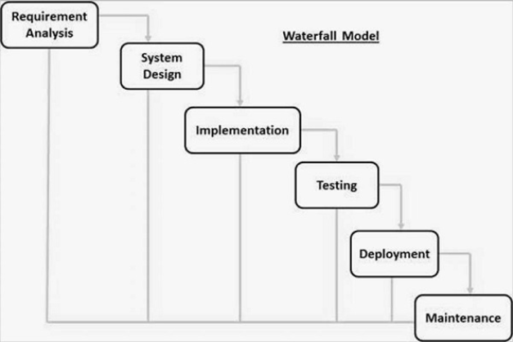

Fig: Waterfall Model

The Waterfall Model was the first Process Model to be introduced. It is also referred to as a linear-sequential life cycle model. It is very simple to understand and use. In a waterfall model, each phase must be completed before the next phase can begin and there is no overlapping in the phases. It is easy to arrange tasks and clearly defined stages.[1]

## 3.1 System Analysis

The system has been designed with two modules in mind. These modules are the customer service and module, the admin module and the user module. These two modules will make up the structure of the system. The admin module will be the part of the system that supposed to provide the authorization to the admins to handle the system or application, also to modify the data and analysis the reports from the customers. The user module will the part of the user that will be the interface to the user where they can register and book the car for a rent. The system be able to interact with outside system to process payment on behalf of the company. The system will keep track of the registered users and bookings.

**3.2Requirements Identification:**

The requirements identification are:-

* **Functional Requirements:**

1. Customer’s registration: The system should allow new users to register online.
2. Online reservation of cars: Customers should be able to use the system to make Booking and online reservation.
3. Automatic update to database once reservation is made or new customer registered.
4. Feedbacks to customers: It should provide means for customers to leave feedback.

* **Non- Functional Requirements:**

1. **Availability:**

This system should always be available for access at 24 hours, 7 days a

week. Also, in the occurrence of any major system malfunctioning, the system should be available in 1 to 2 working days, so that the business process is not severely affected.

1. **Security:**

The subsystem should provide a high level of security and integrity of the data held by the system, only authorized personnel of the company can gain access to the company’s secured page on the system; and only users with valid password and Username can login to view user’s page.

1. **Performance:**

The system should have high performance rate when executing user’s input and should be able to provide feedback or response within a short time span usually 50 seconds for highly complicated task and 20 to 25 seconds for less complicated task.

1. **Error handling:**

Error should be considerably minimized and an appropriate error

Message that guides the user to recover from an error should be provided. Validation of user’s input is highly essential. Also, the standard time taken to recover from an error should be 15 to 20 seconds.

1. **Easy to use:**

Considered the level of knowledge possessed by the users of this system, a simple but quality user interface should be developed to make it easy to understand and required less training.

## 3.3System Design

Use case diagram:

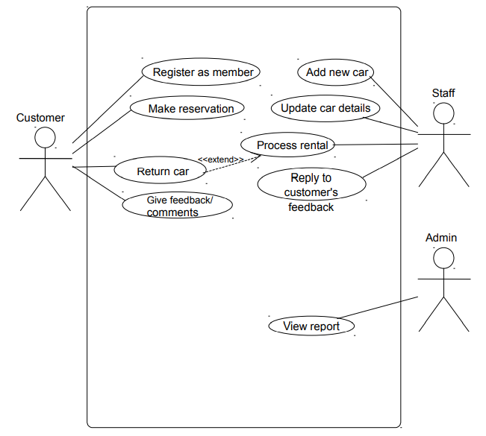

Fig: Use case diagram.

**Data Flow Diagram:**

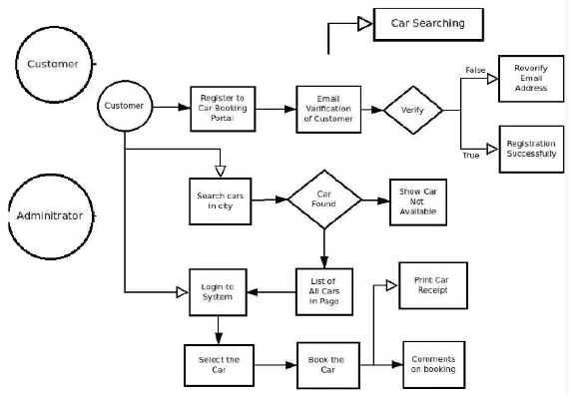

Fig: Data Flow diagram

## Project Schedule

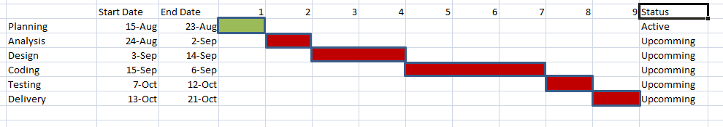

Fig: Gantt Chart

# CHAPTER 4: IMPLEMENTATION AND EVALUATION

**4.1 Tools and Technologies Used**

* Front end:-

we have used the different front-end technologies for the system development and UI design during the project period. The various development technologies used are listed as below**:**

* HTML

HTML is used for describing the structure of the web pages. HTML for providing the structure of the web pages.

* CSS

It is an extremely powerful stylesheet Language which is basically used for describing the presentation of the web pages. It includes the presentation of colors, layouts and fontsetc. It also allows the adaptation of presentation to different type of devices like mobile phones, laptops, tablets, etc.

* JAVASCRIPT

JavaScript is used to make things happen in the user’s browser without sending messages back and forth to the server. It is commonly used as a client-side scripting language.

* BOOTSTRAP

Bootstrap is a free and open-source CSS framework directed at responsive, mobile first front-end web development. It contains CSS and (optionally) JavaScript-based design templates for typography, forms, buttons, navigation, and other interface components.

* Back end

For the development of the system, we have used the back-end technologies during project period as follows:

* MySQL

MySQL is the relational database management system used to manage and store information in tables consisting of columns and rows. Using MySQL database, the data from each and every transaction performed using Home Solution are stored and later can be used for different calculations, preparation of various reports, and analysis purposes.

* PHP

PHP is a server side scripting language designed for the web development. It is an open source general purpose scripting language that is nowadays widely popular among the web developers.

**4.2 Unit Testing**

# Chapter 5 Conclusion

Car rental business has emerged with a new compared to the past expirence where every activity conceming car rental business is limited to a physical location only. Even though the physical location has not been totally eradicated; the nature of functions and how these functions are achieved has been reshaped by the power of internet. Nowadays, customers can reserve cars online, rent car online, and have the car brought to their door step once the customer is a registered member or go to the office to pick the car.

The web based car rental system has offered an advantage to both customers as well as car Rental company to efficiently and effictively manage the business and satisfies customer’s need at the click of a button.

# References

# Bibliography

|  |  |
| --- | --- |
| [1] | a tutorial points, "Simply Easy Learning," 2010. [Online]. Available: https://www.tutorialspoint.com/sdlc/sdlc_waterfall_model.htm#. |
| [2] | MBN, "Market Business News," 2015. [Online]. Available: https://marketbusinessnews.com/financial-glossary/feasibility-study/. |
| [3] | a tutorial points, "Simple Easy Learning," 2008. [Online]. Available: https://www.tutorialspoint.com/system_analysis_and_design/system_analysis_and_design_overview.htm. |
| [4] | N. P, "1000 PROJECTS," 22 AGUST 2017. [Online]. Available: https://1000projects.org/project-report-online-job-portal.html. |

## APPENDIX