(*A Mini Project On*)

**QUIZ GAME**

**A Project Work**

*Submitted in the partial fulfillment for the award of the degree of*

**BACHELOR OF ENGINEERING**

**IN**

**ARTIFICIAL INTELLIGENCE & MACHINE LEARING**

**Submitted By:**

**RAMANUJ ASATI**

**University Roll Number:**

**20BCS6430**

### Under the Supervision of:

### Ms. DEEPANSHU GARG

### 

**DEPARTMENT OF COMPUTER SCIENCE AND ENGINEERING**

**APEX INSTITUE OF TECHNOLOGY**

### CHANDIGARH UNIVERSITY, GHARUAN, MOHALI - 140413,

**PUNJAB**

**JULY, 2021**

**DECLARATION**

I, **‘Ramanuj’**, student of **‘Bachelor of Engineering in Computer Science and Engineering’**, **session 2020-2021**, Department of Computer Science and Engineering, Apex Institute of Technology, Chandigarh University, Punjab, hereby declare that the work presented in this Project Work entitled ‘**Quiz Game’** is the outcome of our own bona fide work and is correct to the best of our knowledge and this work has been undertaken taking care of Engineering Ethics. It contains no material previously published or written by another person nor material which has been accepted for the award of any other degree or diploma of the university or other institute of higher learning, except where due acknowledgment has been made in the text.

**Ramanuj Asati**

**UID: 20BCS6430**

**Date: 28 July, 2021**

**Place: Chandigarh University**

**II**

**ACKNOWLEDGEMENT**

Though perseverance and enthusiasm combined with effort in the right direction can bring forth the thing called success. But the realization of the harsh reality that the path towards success is full of my temptations, impediments and pitfalls often proves to be disheartening in such situation, it is the able guidance of knowledgeable person that steers one through difficulties and help him achieve success.

I am highly obliged to express our deep sense of gratitude and grateful thanks to my erudite guide **Ms. Deepanshu Garg** for her valuable guidance and support which led to the successful and timely completion of my seminar report.

Last but not the least; I deeply appreciate the cheerful encouragement of all staff members of my department and my friends.

Thanks.

**III**

**ABSTRACT**

The sole intention behind the consideration of this Project is to generate and manage a simple database for question.

This project is developed considering “QUIZ” information keeping context of the customer in mind.

Here, data is stored in a binary file by “QUESTION” and this database is basically used as MASTER file. Reports are designed on the basis of customer’s stay and payments made by the customer.

**IV**

**TABLE OF CONTENTS**

* **TITLE PAGE**  **I**
* **DECLARATION**  **II**
* **ACKNOWLEDGEMENT** **III**
* **ABSTRACT**  **IV**

1. **INTRODUCTION**

**1.1 PROBLEM DEFINITION**  **1**

**1.2 PROJECT OVERVIEW**  **2**

1. **SPECIFICATION / REQUIREMENTS**

**2.1 HARDWARE**  **2**

**2.2 SOFTWARE**  **2**

1. **DATA FLOW DIAGRAM**

**3.1 FLOW CHART**  **3**

1. **TECHNOLOGY UDED**

**4.1 FRONT END**  **4**

**4.2 BACK END**  **4**

1. **RESULTS**

**5.1 PROJECT OUTPUTS**  **5 - 10**

1. **CONCLUSION 10**
2. **REFERENCES 11**
3. **INTRODUCTION**
   1. **PROBLEM DEFINITION :**

Quiz Game is a program developed to conduct a quiz. Quiz Contest system is accessed by entering the full name and UID.

Quiz game will start with three options. “PLAY”, “ADD QUESTIONS” and “EXIT”. If we select “PLAY” then we can play quiz. If we select “ADD QUESTIONS” then we can add questions in our database file and if we select “EXIT” then we can quit the game.

Quiz is started by displaying one question with four, two or three options each based on computer, science and mathematics. If the answer is correct score is incremented by five and no negative marks for wrong answers.

After completion of the quiz we will see the score board on the screen in which the score of the person will be with name and UID.

**1**

* 1. **PROJECT OVERVIEW :**

This 'QUIZ GAME' Project is designed for a question in which you can generate and manage a simple database for questions. The question number is automatically generated by the software and is stored in a binary file by the name 'QUESTION'. This data base is basically used as a MASTER file to be used as a look-up table for information like Quiz Option, Sub menu, either Computer / Mathematics / Science and the Return. In this software you can ask for any Menu on the basis of the Menu Question will be asked to the user. If the user is correct the he get 5 points on every question. If he is incorrect then he lost the game and back to main menu.

1. **SPECIFICATION / REQUIREMENTS**
   1. **HARDWARE :**

* 1.7 GHz Pentium IV
* 64 MB RAM
* Hard drive for storing questions
  1. **SOFTWARE :**
* Operating System
* Any Compiler (MINGW, TORBUC)
* Any IDE for run code (VS CODE, DEV C++)

**2**

1. **DATA FLOW DIAGRAM**
   1. **FLOW CHART :**

**QUIZ**

**GAME**

**PLAY ADD EXIT**

**QUESTIONS**

**COMPUTERS**

**SCIENCE**

**MATH**

**D. B. M. S.**

**MAIN** **MENU**

**3**

1. **TECHNOLOGY UDED**
   1. **FRONT END :**
   * **C++**

C++ is an object oriented programming language. It is a superset of c language. C++ adds a number of object oriented features such as object inheritance, function overloading, operator overloading to C. C++ is a versatile language for handling very large programs.

* + **Uses of C++**

C++ can be used to build a variety of system such as editor, compiler, database, communication system.

C++ is easily maintainable and expandable.

* 1. **BACK END :**
* Any file for storing database.

Many real life problems handle large volumes of data so we need to use some devices such as floppy disk or hard disk to store a data. The data is stored in these devices using a concept of files. A file is a collection of data stored in a particular area on a disk. Programs can be designed to perform read and write operations on these files.

**4**

1. **RESULTS**
   1. **PROJECT OUTPUTS :**

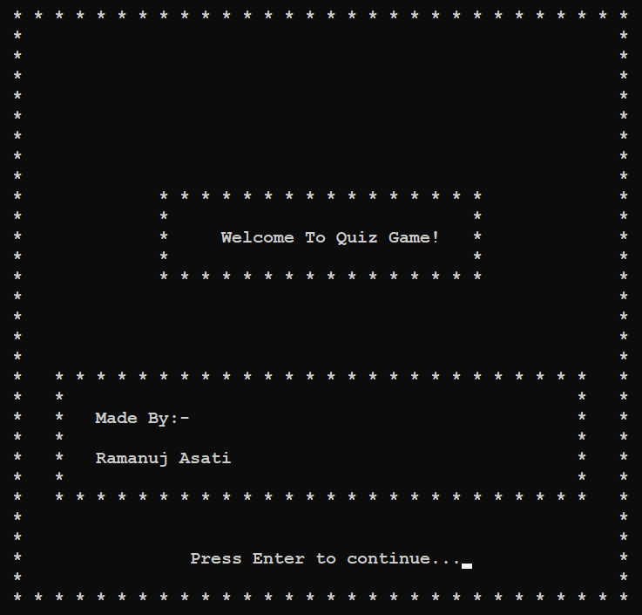

**WELCOME SCREEN**

**5**

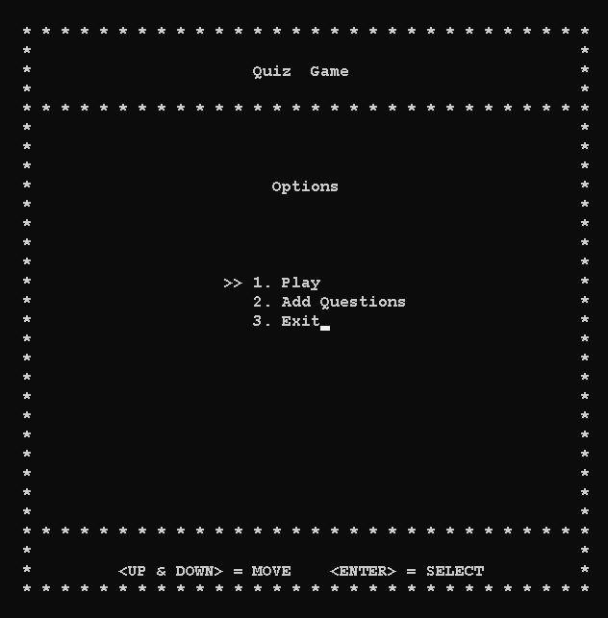

**MAIN MENU**

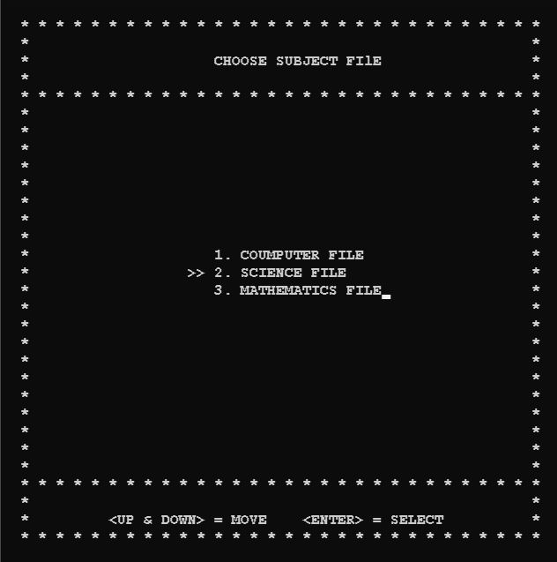

**FILE MENU**

**6**

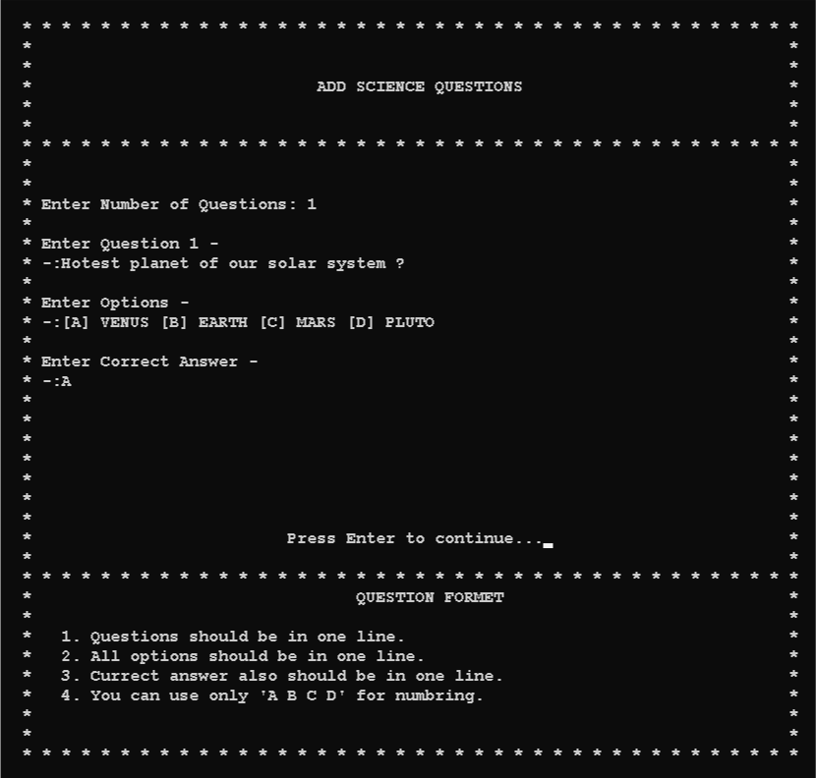

**ADD QUESTIONS**

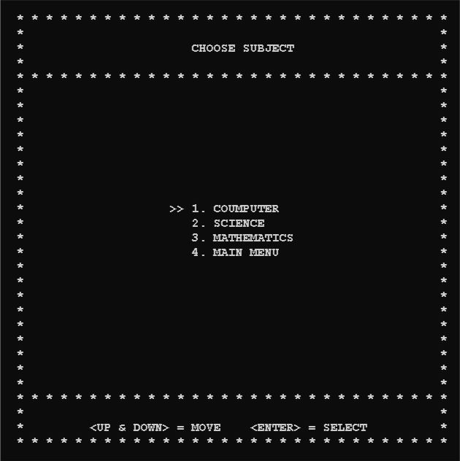

**SUBJECT MENU**

**7**

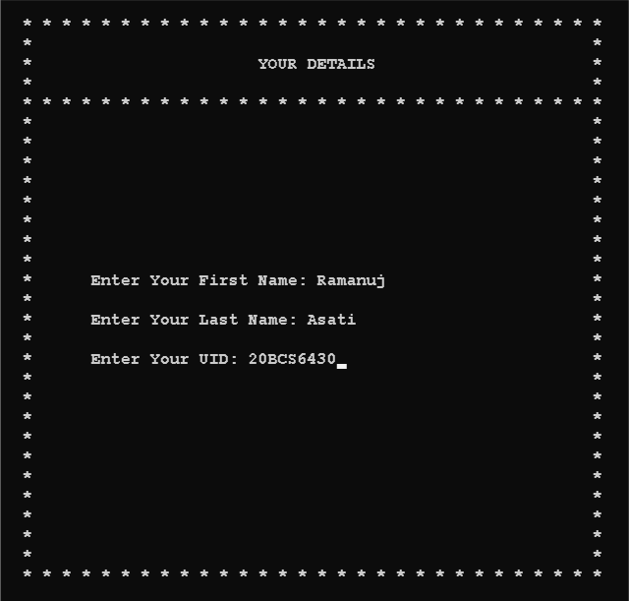

**DETAILS**

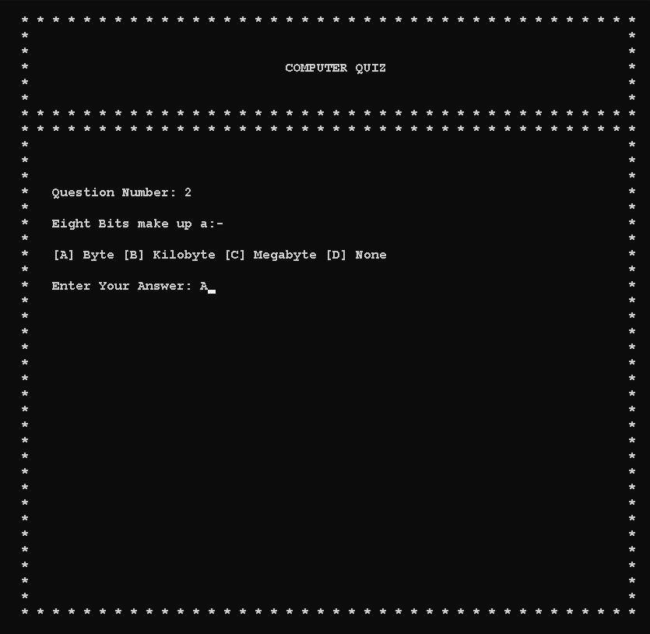

**QUESTION & OPTIONS**

**8**

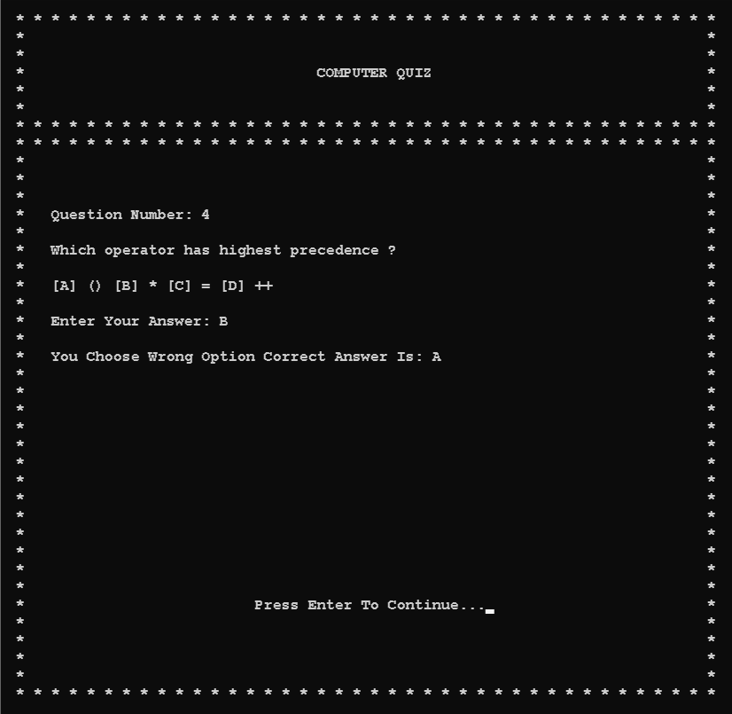

**WRONG ANSWER**

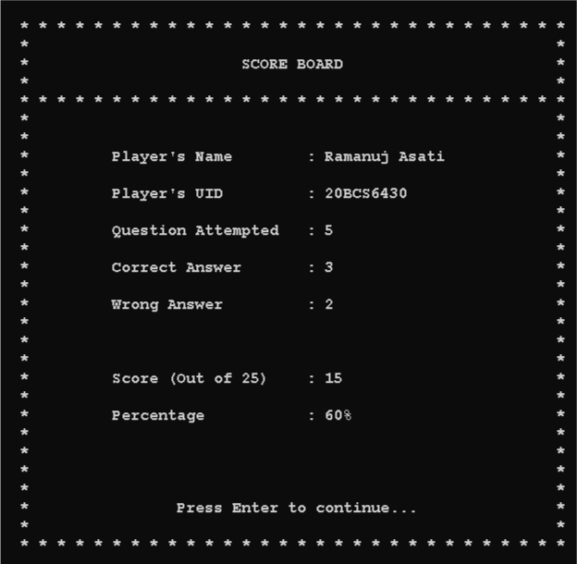

**SCORE BOARD**

**9**

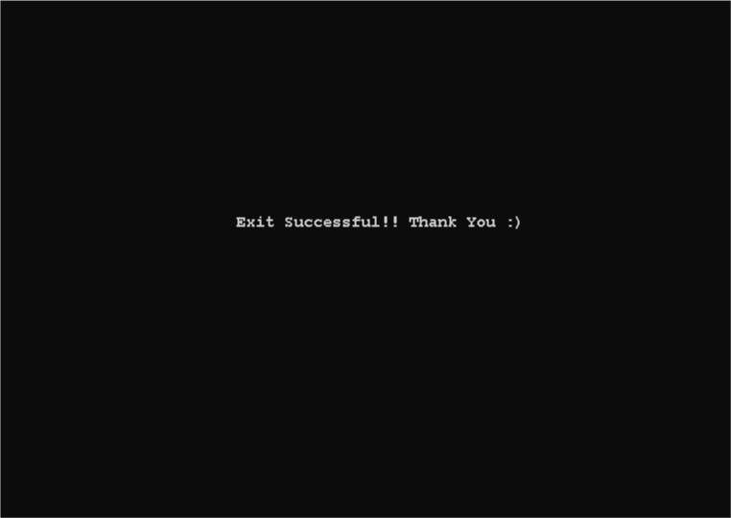

**EXIT**

1. **CONCLUSION**

The Quiz Game is capable to handle number of Question record having all their information stored in the backend file.

**10**

1. **REFERENCES**

**[1] Google:**

* [***https://www.google.com/***](https://www.google.com/)

**[2] You tube:**

* [***https://www.youtube.com/***](https://www.youtube.com/)

**[3] Git hub:**

* [***https://github.com/wilfredarin/Cpp-Quiz-Game***](https://github.com/wilfredarin/Cpp-Quiz-Game)

**[4] Stack overflow:**

* [***https://stackoverflow.com/***](https://stackoverflow.com/)

**[5] Geeks for geeks:**

* [***https://www.geeksforgeeks.org/***](https://www.geeksforgeeks.org/)

**11**