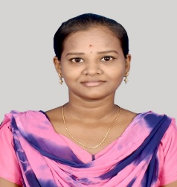

Profile Summary

Successfully completed the GenC training program as a MEAN stack developer. I have a strong knowledge on overall workflow and Full Stack Web Application Process. I also have a training experience of 4 months.

**Technical Skill**

|  |  |
| --- | --- |
| **Hardware / Platforms** | Windows |
| **Technology** | MERN STACK |
| **Programming Languages** | Java Script |
| **Databases** | Mongo DB |
| **Scripting Languages** | Java Script  **Certification** |

Successfully completed the training program. CDB-DX-Channels-CDB22DX011 27/06/2022

**Project Experience**

|  |  |
| --- | --- |
| **Hardware / Platforms** | XXX |
| **Technology** | XXX |
| **Programming Languages** | XXX |
| **Databases** | XXX |
| **Scripting Languages** | XXX |

**Project Experience**

|  |  |
| --- | --- |
|  |  |
| **Client** | Express CBE Job Portal |
| **Operating System** | Windows |
| **Tools** | MS Visual Studio |
| **Duration** | 2 weeks |
| **Technical Skill Involved** | JavaScript, MongoDB, ReactJS, Express, HTML & CSS |
| **Project Overview/Background/Context –**  Main objective is to create list of users and display created users in the form of table and which is sortable. | |
| **Roles & Responsibilities – Front end design and backend** | |
|  |  |

**Education**

|  |  |  |
| --- | --- | --- |
| **Degree** | **College/University** | **Year of Passing** |
| B.E ( Electrical and Electronics Engineering) | Muthayammal Engineering College | 2020 |

**Contact**

**Contact no: 9342543970**

**Cognizant id:** [**rama.priyar@cognizant.com**](mailto:rama.priyar@cognizant.com)

**Personal id: ramapriya1924@gmail.com**

