**1. Mocking and Stubbing**

**Code:**

**DataServiceTest.java**

import org.junit.Test;

import static org.junit.Assert.*;

import static org.mockito.Mockito.*;

import org.mockito.Mockito;

interface ExternalApi {

String getData();

}

class DataService {

private ExternalApi externalApi;

public DataService(ExternalApi externalApi) {

this.externalApi = externalApi;

}

public String fetchExternalData() {

return externalApi.getData();

}

}

public class DataServiceTest {

@Test

public void testFetchExternalData() {

ExternalApi mockApi = Mockito.mock(ExternalApi.class);

when(mockApi.getData()).thenReturn("Mock Response");

DataService dataService = new DataService(mockApi);

String actualResponse = dataService.fetchExternalData();

assertEquals("Mock Response", actualResponse);

}

}

**Output:**

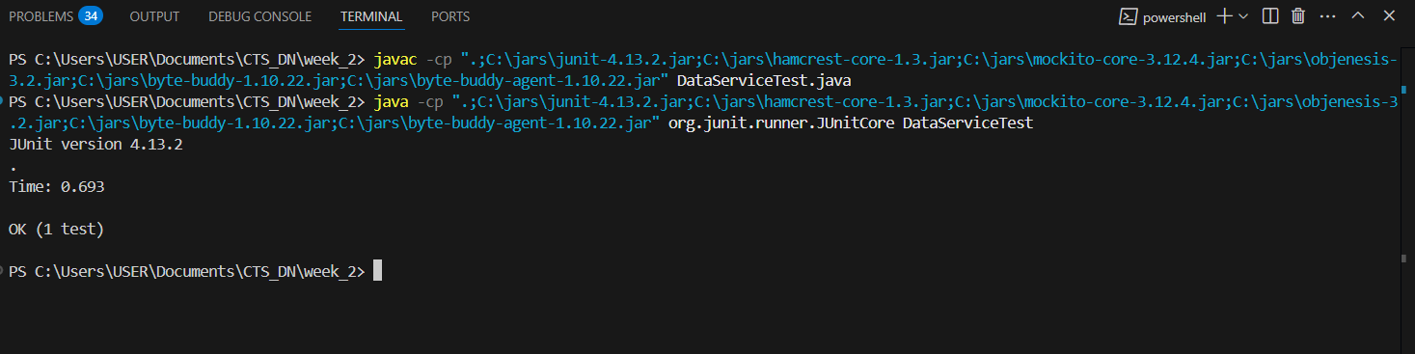

**2. Verifying Interactions**

**Code:**

**ApiInteractionTest.java**

import org.junit.Test;

import static org.mockito.Mockito.*;

import org.mockito.Mockito;

interface ExternalApi {

void getData();

}

class ApiService {

private ExternalApi externalApi;

public ApiService(ExternalApi externalApi) {

this.externalApi = externalApi;

}

public void fetchData() {

externalApi.getData();

}

}

public class ApiInteractionTest {

@Test

public void testMethodInteraction() {

ExternalApi mockApi = Mockito.mock(ExternalApi.class);

ApiService service = new ApiService(mockApi);

service.fetchData();

verify(mockApi).getData();

}

}

**Output:**

