**1. Configuring a Basic Spring Application**

**ProjectName: LibraryManagement**

**ProjectStructure:**

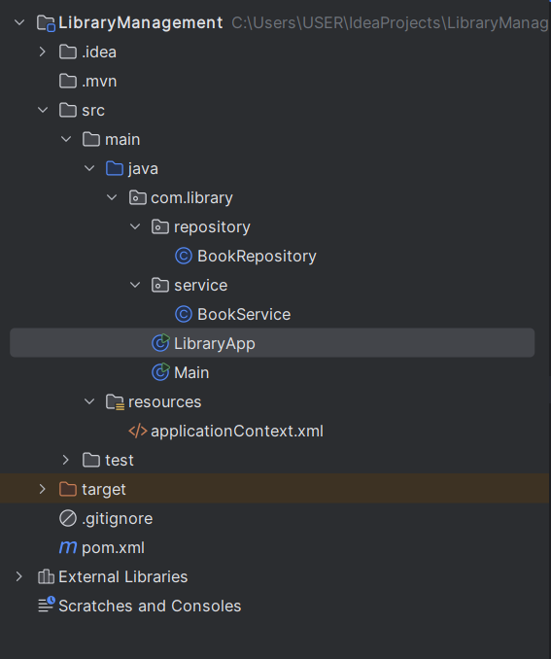

**Code:**

**pom.xml**

<dependencies>

<dependency>

<groupId>org.springframework</groupId>

<artifactId>spring-context</artifactId>

<version>5.3.36</version>

</dependency>

</dependencies>

**BookRepository.java**

package com.library.repository;  
  
public class BookRepository {  
  
 public String findBookById(int bookId) {  
 if (bookId == 1) {  
 return "The Alchemist";  
 } else {  
 return "Unknown Book";  
 }  
 }  
}

**BookService.java**

package com.library.service;  
  
import com.library.repository.BookRepository;  
public class BookService {  
  
 private BookRepository bookRepository;  
  
 public void setBookRepository(BookRepository bookRepository) {  
 this.bookRepository = bookRepository;  
 }  
  
 public void displayBook(int bookId) {  
 String bookName = bookRepository.findBookById(bookId);  
 System.out.println("Book Found: " + bookName);  
 }  
}

**LibraryApp.java**

package com.library;  
  
import com.library.service.BookService;  
import org.springframework.context.ApplicationContext;  
import org.springframework.context.support.ClassPathXmlApplicationContext;  
  
public class LibraryApp {  
 public static void main(String[] args) {  
 ApplicationContext context = new ClassPathXmlApplicationContext("applicationContext.xml");  
  
 BookService service = (BookService) context.getBean("bookService");  
 service.displayBook(1);  
 }  
}

**applicationContext.xml**

<?xml version="1.0" encoding="UTF-8"?>  
<beans xmlns="http://www.springframework.org/schema/beans"  
 xmlns:xsi="http://www.w3.org/2001/XMLSchema-instance"  
 xsi:schemaLocation="  
 http://www.springframework.org/schema/beans  
 http://www.springframework.org/schema/beans/spring-beans.xsd">  
  
 <bean id="bookRepository" class="com.library.repository.BookRepository"/>

<bean id="bookService" class="com.library.service.BookService">  
 <property name="bookRepository" ref="bookRepository"/>  
 </bean>  
  
</beans>

**Output:**

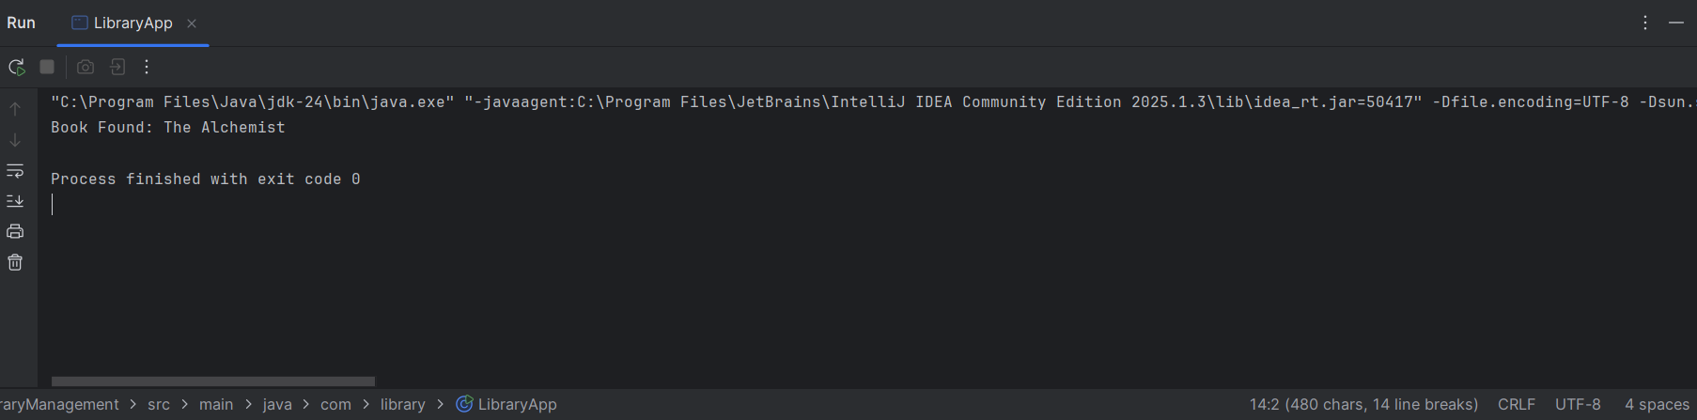

**2. Implementing Dependency Injection**

**ProjectName: LibraryManagement**

**Code:**

**pom.xml**

<!-- pom.xml -->

<dependencies>

<dependency>

<groupId>org.springframework</groupId>

<artifactId>spring-context</artifactId>

<version>5.3.36</version>

</dependency>

</dependencies>

**BookRepository.java**

package com.library.repository;

public class BookRepository {

public String findBookById(int bookId) {

if (bookId == 1) {

return "The Alchemist";

} else {

return "Unknown Book";

}

}

}

**BookService.java**

package com.library.service;

import com.library.repository.BookRepository;

public class BookService {

private BookRepository bookRepository;

public void setBookRepository(BookRepository bookRepository) {

this.bookRepository = bookRepository;

}

public void displayBook(int bookId) {

String bookName = bookRepository.findBookById(bookId);

System.out.println("Book Found: " + bookName);

}

}

**LibraryApp.java**

package com.library;

import com.library.service.BookService;

import org.springframework.context.ApplicationContext;

import org.springframework.context.support.ClassPathXmlApplicationContext;

public class LibraryApp {

public static void main(String[] args) {

ApplicationContext context = new ClassPathXmlApplicationContext("applicationContext.xml");

BookService service = (BookService) context.getBean("bookService");

service.displayBook(1);

}

}

**applicationContext.xml**

<?xml version="1.0" encoding="UTF-8"?>

<beans xmlns="http://www.springframework.org/schema/beans"

xmlns:xsi="http://www.w3.org/2001/XMLSchema-instance"

xsi:schemaLocation="

http://www.springframework.org/schema/beans

http://www.springframework.org/schema/beans/spring-beans.xsd"

<bean id="bookRepository" class="com.library.repository.BookRepository"/>

<bean id="bookService" class="com.library.service.BookService">

<property name="bookRepository" ref="bookRepository"/>

</bean>

</beans>

**Output:**

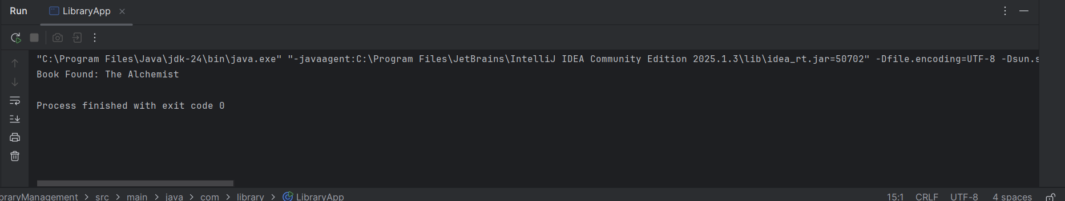

**3. Creating and Configuring a Maven Project**

**ProjectName: LibraryManagement**

**Code:**

**pom.xml**

<project xmlns="http://maven.apache.org/POM/4.0.0"

xmlns:xsi="http://www.w3.org/2001/XMLSchema-instance"

xsi:schemaLocation="http://maven.apache.org/POM/4.0.0

http://maven.apache.org/xsd/maven-4.0.0.xsd">

<modelVersion>4.0.0</modelVersion>

<groupId>com.library</groupId>

<artifactId>LibraryManagement</artifactId>

<version>1.0-SNAPSHOT</version>

<properties>

<maven.compiler.source>1.8</maven.compiler.source>

<maven.compiler.target>1.8</maven.compiler.target>

</properties>

<dependencies>

<dependency>

<groupId>org.springframework</groupId>

<artifactId>spring-context</artifactId>

<version>5.3.36</version>

</dependency>

<dependency>

<groupId>org.springframework</groupId>

<artifactId>spring-aop</artifactId>

<version>5.3.36</version>

</dependency>

<dependency>

<groupId>org.springframework</groupId>

<artifactId>spring-webmvc</artifactId>

<version>5.3.36</version>

</dependency>

</dependencies>

<build>

<plugins>

<plugin>

<groupId>org.apache.maven.plugins</groupId>

<artifactId>maven-compiler-plugin</artifactId>

<version>3.11.0</version>

<configuration>

<source>1.8</source>

<target>1.8</target>

</configuration>

</plugin>

</plugins>

</build>

</project>

**Output:**

