**1. Spring Data JPA - Quick Example**

**ProjectName:orm-learn**

**Code:**

**application.properties**

logging.level.org.springframework=info

logging.level.com.cognizant=debug

logging.level.org.hibernate.SQL=trace

logging.level.org.hibernate.type.descriptor.sql=trace

logging.pattern.console=%d{dd-MM-yy} %d{HH:mm:ss.SSS} %-20.20thread %5p %-25.25logger{25} %25M %4L %m%n

spring.datasource.driver-class-name=com.mysql.cj.jdbc.Driver

spring.datasource.url=jdbc:mysql://localhost:3306/ormlearn

spring.datasource.username=root

spring.datasource.password=Abhi123

spring.jpa.hibernate.ddl-auto=validate

spring.jpa.properties.hibernate.dialect=org.hibernate.dialect.MySQL5Dialect

**Country.java**

package com.cognizant.ormlearn.model;

import javax.persistence.Column;

import javax.persistence.Entity;

import javax.persistence.Id;

import javax.persistence.Table;

@Entity

@Table(name = "country")

public class Country {

@Id

@Column(name = "code")

private String code;

@Column(name = "name")

private String name;

public String getCode() {

return code;

}

public void setCode(String code) {

this.code = code;

}

public String getName() {

return name;

}

public void setName(String name) {

this.name = name;

}

@Override

public String toString() {

return "Country{" +

"code='" + code + '\'' +

", name='" + name + '\'' +

'}';

}

}

**CountryRepository.java**

package com.cognizant.ormlearn.repository;

import com.cognizant.ormlearn.model.Country;

import org.springframework.data.jpa.repository.JpaRepository;

import org.springframework.stereotype.Repository;

@Repository

public interface CountryRepository extends JpaRepository<Country, String> {

}

**CountryService.java**

package com.cognizant.ormlearn.service;

import com.cognizant.ormlearn.model.Country;

import com.cognizant.ormlearn.repository.CountryRepository;

import org.springframework.beans.factory.annotation.Autowired;

import org.springframework.stereotype.Service;

import javax.transaction.Transactional;

import java.util.List;

@Service

public class CountryService {

@Autowired

private CountryRepository countryRepository;

@Transactional

public List<Country> getAllCountries() {

return countryRepository.findAll();

}

}

**OrmLearnApplication.java**

package com.cognizant.ormlearn;

import com.cognizant.ormlearn.model.Country;

import com.cognizant.ormlearn.service.CountryService;

import org.slf4j.Logger;

import org.slf4j.LoggerFactory;

import org.springframework.boot.SpringApplication;

import org.springframework.boot.autoconfigure.SpringBootApplication;

import org.springframework.context.ApplicationContext;

import java.util.List;

@SpringBootApplication

public class OrmLearnApplication {

private static final Logger LOGGER = LoggerFactory.getLogger(OrmLearnApplication.class);

private static CountryService countryService;

public static void main(String[] args) {

ApplicationContext context = SpringApplication.run(OrmLearnApplication.class, args);

LOGGER.info("Inside main");

countryService = context.getBean(CountryService.class);

testGetAllCountries();

}

private static void testGetAllCountries() {

LOGGER.info("Start");

List<Country> countries = countryService.getAllCountries();

LOGGER.debug("countries={}", countries);

LOGGER.info("End");

}

}

**MySQL Table & Data**

CREATE TABLE country (

code VARCHAR(2) PRIMARY KEY,

name VARCHAR(50)

);

INSERT INTO country VALUES ('IN', 'India');

INSERT INTO country VALUES ('US', 'United States of America');

**Output:** 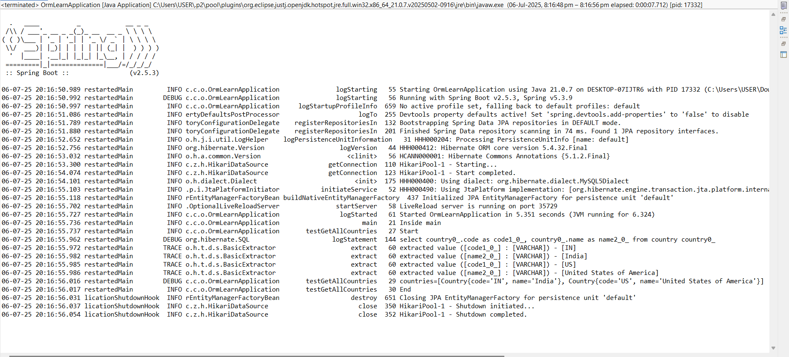

**2. Difference between JPA, Hibernate and Spring Data JPA**

**ProjectName:employee-demo**

**Code:**

**application.properties**

spring.datasource.url=jdbc:mysql://localhost:3306/employeedb

spring.datasource.username=root

spring.datasource.password=Abhi123

spring.jpa.hibernate.ddl-auto=update

spring.jpa.show-sql=true

spring.jpa.properties.hibernate.dialect=org.hibernate.dialect.MySQLDialect

**pom.xml**

<?xml version="1.0" encoding="UTF-8"?>

<project xmlns="http://maven.apache.org/POM/4.0.0" xmlns:xsi="http://www.w3.org/2001/XMLSchema-instance"

xsi:schemaLocation="http://maven.apache.org/POM/4.0.0 https://maven.apache.org/xsd/maven-4.0.0.xsd">

<modelVersion>4.0.0</modelVersion>

<parent>

<groupId>org.springframework.boot</groupId>

<artifactId>spring-boot-starter-parent</artifactId>

<version>3.5.3</version>

<relativePath/> <!-- lookup parent from repository -->

</parent>

<groupId>com.cognizant</groupId>

<artifactId>employee-demo</artifactId>

<version>0.0.1-SNAPSHOT</version>

<name>employee-demo</name>

<description>Spring Data JPA Employee Demo</description>

<url/>

<licenses>

<license/>

</licenses>

<developers>

<developer/>

</developers>

<scm>

<connection/>

<developerConnection/>

<tag/>

<url/>

</scm>

<properties>

<java.version>17</java.version>

</properties>

<dependencies>

<dependency>

<groupId>org.springframework.boot</groupId>

<artifactId>spring-boot-starter-data-jpa</artifactId>

</dependency>

<dependency>

<groupId>org.springframework.boot</groupId>

<artifactId>spring-boot-devtools</artifactId>

<scope>runtime</scope>

<optional>true</optional>

</dependency>

<dependency>

<groupId>com.mysql</groupId>

<artifactId>mysql-connector-j</artifactId>

<scope>runtime</scope>

</dependency>

<dependency>

<groupId>org.springframework.boot</groupId>

<artifactId>spring-boot-starter-test</artifactId>

<scope>test</scope>

</dependency>

</dependencies>

<build>

<plugins>

<plugin>

<groupId>org.springframework.boot</groupId>

<artifactId>spring-boot-maven-plugin</artifactId>

</plugin>

</plugins>

</build>

</project>

**Employee.java**

package com.cognizant.employeedemo.model;

import jakarta.persistence.*;

@Entity

@Table(name = "employee")

public class Employee {

@Id

@GeneratedValue(strategy = GenerationType.IDENTITY)

private int id;

private String name;

private String department;

public int getId() {

return id;

}

public void setId(int id) {

this.id = id;

}

public String getName() {

return name;

}

public void setName(String name) {

this.name = name;

}

public String getDepartment() {

return department;

}

public void setDepartment(String department) {

this.department = department;

}

@Override

public String toString() {

return "Employee{id=" + id + ", name='" + name + "', department='" + department + "'}";

}

}

**EmployeeRepository.java**

package com.cognizant.employeedemo.repository;

import com.cognizant.employeedemo.model.Employee;

import org.springframework.data.jpa.repository.JpaRepository;

import org.springframework.stereotype.Repository;

@Repository

public interface EmployeeRepository extends JpaRepository<Employee, Integer> {

}

**EmployeeDemoApplication.java**

package com.cognizant.employeedemo;

import com.cognizant.employeedemo.model.Employee;

import com.cognizant.employeedemo.service.EmployeeService;

import org.springframework.boot.SpringApplication;

import org.springframework.boot.autoconfigure.SpringBootApplication;

import org.springframework.context.ApplicationContext;

import java.util.List;

@SpringBootApplication

public class EmployeeDemoApplication {

public static void main(String[] args) {

ApplicationContext context = SpringApplication.run(EmployeeDemoApplication.class, args);

EmployeeService service = context.getBean(EmployeeService.class);

Employee emp = new Employee();

emp.setName("Abhigna");

emp.setDepartment("IT");

service.addEmployee(emp);

List<Employee> list = service.getAllEmployees();

list.forEach(System.out::println);

}

}

**Output:**

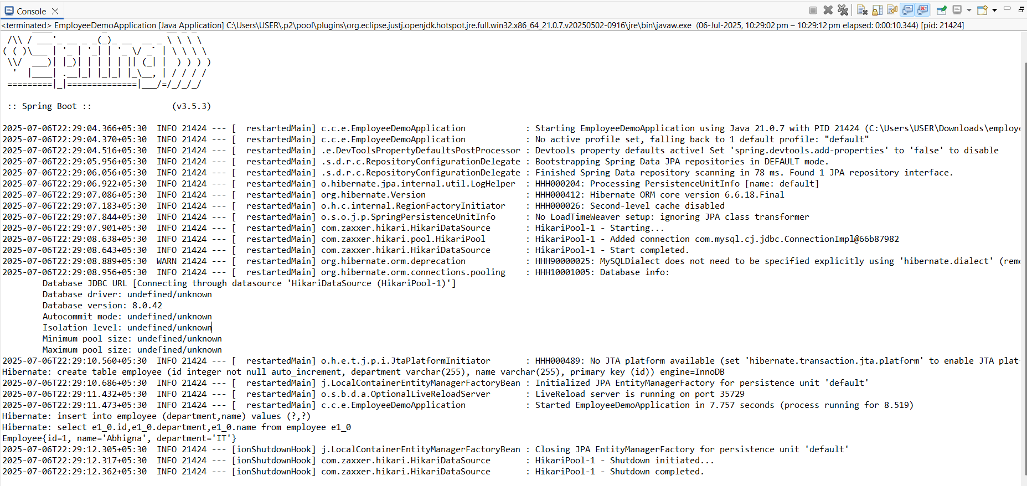

**Conclusion:**

* JPA (Java Persistence API) is a specification provided by Java to standardize the way Java applications interact with databases. It defines a set of rules and interfaces but does not provide any implementation.
* Hibernate is a popular implementation of JPA, offering additional features like caching and lazy loading, and it helps in managing database operations using ORM.
* Spring Data JPA, on the other hand, is a framework built on top of JPA and Hibernate. It reduces boilerplate code by providing ready-to-use interfaces like JpaRepository, and allows developers to perform database operations with minimal custom code.
* In short, JPA is the standard, Hibernate is an implementation, and Spring Data JPA is an abstraction that simplifies development.