**Creating Microservices for account and loan**

**Account Microservices**

**Project Name: Account**

**Project Structure:**

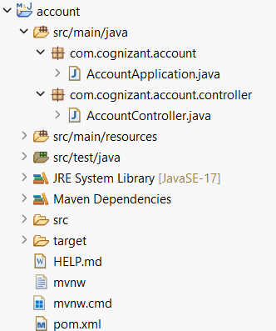

**Code:**

**AccountController.java**

package com.cognizant.account.controller;

import org.springframework.web.bind.annotation.GetMapping;

import org.springframework.web.bind.annotation.PathVariable;

import org.springframework.web.bind.annotation.RestController;

import java.util.HashMap;

import java.util.Map;

@RestController

public class AccountController {

@GetMapping("/accounts/{number}")

public Map<String, Object> getAccountDetails(@PathVariable("number") String accountNumber) {

Map<String, Object> accountDetails = new HashMap<>();

accountDetails.put("number", accountNumber);

accountDetails.put("type", "savings");

accountDetails.put("balance", 234343);

return accountDetails;

}

}

**AccountApplication.java**

package com.cognizant.account;

import org.springframework.boot.SpringApplication;

import org.springframework.boot.autoconfigure.SpringBootApplication;

@SpringBootApplication

public class AccountApplication {

public static void main(String[] args) {

SpringApplication.run(AccountApplication.class, args);

}

}

**Output:**

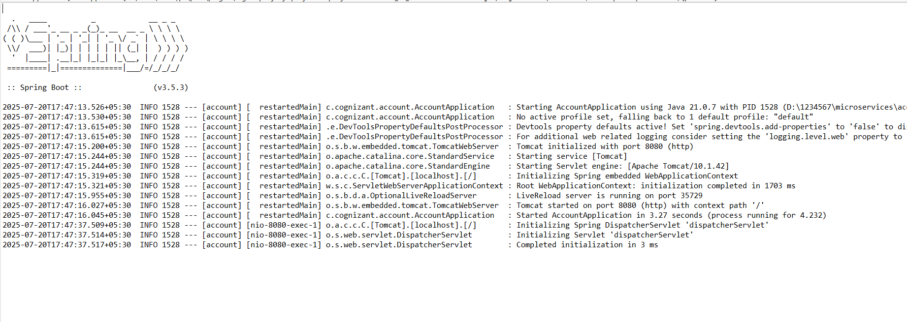

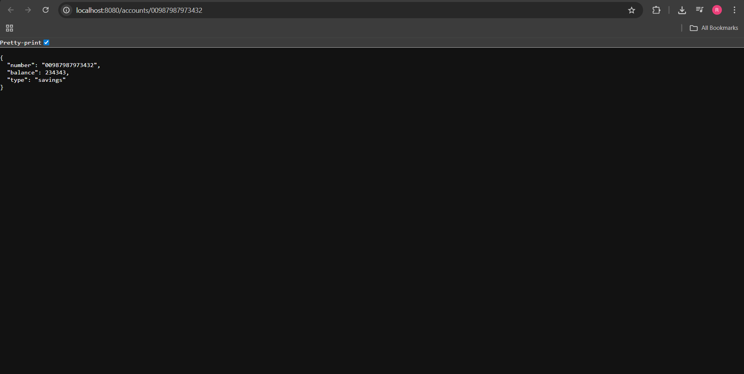

**Loan Microservices**

**Project Name: Loan**

**Project Structure:**

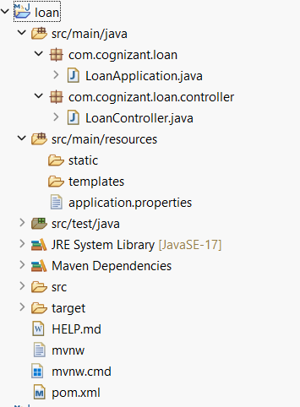

**Code:**

**application.properties**

spring.application.name=loan

server.port=8081

**LoanController.java**

package com.cognizant.loan.controller;

import org.springframework.web.bind.annotation.GetMapping;

import org.springframework.web.bind.annotation.PathVariable;

import org.springframework.web.bind.annotation.RestController;

import java.util.LinkedHashMap;

import java.util.Map;

@RestController

public class LoanController {

@GetMapping("/loans/{number}")

public Map<String, Object> getLoanDetails(@PathVariable("number") String loanNumber) {

Map<String, Object> loanDetails = new LinkedHashMap<>();

loanDetails.put("number", loanNumber);

loanDetails.put("type", "car");

loanDetails.put("loan", 400000);

loanDetails.put("emi", 3258);

loanDetails.put("tenure", 18);

return loanDetails;

}

}

**LoanApplication.java**

package com.cognizant.loan;

import org.springframework.boot.SpringApplication;

import org.springframework.boot.autoconfigure.SpringBootApplication;

@SpringBootApplication

public class LoanApplication {

public static void main(String[] args) {

SpringApplication.run(LoanApplication.class, args);

}

}

**Output:**

