**What is DevOps?**[**1**](https://www.ap2v.com/interview-questions/top-21-devops-interview-questions-and-answers#collapse_1)

Using DevOps practices and tools, an organization can improve its ability to develop applications and services in close alignment with its business goals.

**Why DevOps is Important?**[**1**](https://www.ap2v.com/interview-questions/top-21-devops-interview-questions-and-answers#collapse_1)

DevOps is more about a collection of processes that work together to support software development. DevOps' popularity is that it helps enterprises to build and enhance products at a faster pace.

#### [3|What are the principles of DevOps?](https://www.ap2v.com/interview-questions/top-21-devops-interview-questions-and-answers#collapse_3)

The key aspects of DevOps are

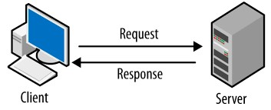

* Continuous deployment
* Infrastructure as Code
* Automation of services
* Monitoring
* Security

#### [4|How does HTTP work?](https://www.ap2v.com/interview-questions/top-21-devops-interview-questions-and-answers#collapse_4)

The Hypertext Transfer Protocol works as a client-server protocol. It allows interaction with web resources by transmitting hypertext messages between client and servers.

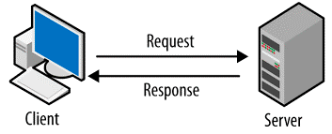

#### [5|What are the core operations of DevOps?](https://www.ap2v.com/interview-questions/top-21-devops-interview-questions-and-answers#collapse_5)

The core operations of DevOps include:   
•    Development  
•    Version control  
•    Testing  
•    Integration  
•    Deployment  
•    Delivery  
•    Configuration  
•    Monitoring  
•    Feedback

#### [6|How is DevOps a unique software development methodology?](https://www.ap2v.com/interview-questions/top-21-devops-interview-questions-and-answers#collapse_6)

DevOps allows the development and operations team to work together for continuous development, testing, integration, deployment, and monitoring of the software throughout the lifecycle.

#### [7|What are the most popular DevOps tool?](https://www.ap2v.com/interview-questions/top-21-devops-interview-questions-and-answers#collapse_7)

•    Selenium  
•    Ansible  
•    Docker  
•    Puppet  
•    Chef  
•    Git  
•    Jenkins

#### [8|What is the commonly used scripting language by a DevOps engineer?](https://www.ap2v.com/interview-questions/top-21-devops-interview-questions-and-answers#collapse_8)

Python is the most preferred scripting language as it is simple.

#### [9|What are the different phases of DevOps lifecycle?](https://www.ap2v.com/interview-questions/top-21-devops-interview-questions-and-answers#collapse_9)

•    Plan    
•    Code    
•    Build    
•    Test    
•    Integrate   
•    Deploy    
•    Operate    
•    Monitor

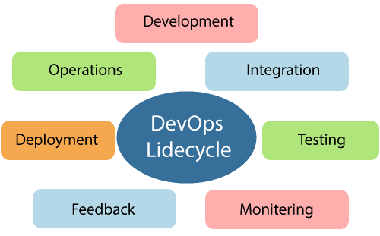

#### [10|What are the benefits of DevOps for business and technical work?](https://www.ap2v.com/interview-questions/top-21-devops-interview-questions-and-answers#collapse_10)

#### Business benefits

•    Faster delivery   
•    Stable operating environments  
•    More time to add product value

#### Technical benefits

•    Continuous software delivery  
•    Easy to fix problems  
•    Bug resolutions takes less time

#### [11|What is the role of AWS in DevOps?](https://www.ap2v.com/interview-questions/top-21-devops-interview-questions-and-answers#collapse_11)

AWS has the following role in DevOps

•    A ready-to-use, flexible service that does not require any installation.  
•    AWS services allow you to scale from a single instance to thousands.  
•    Automation - AWS automates tasks and processes for you, so you can focus on innovation.  
•    AWS Identity and Access Management (IAM) allows you to set permissions for users.  
•    AWS has a large ecosystem of partners that extend and integrate AWS services.

#### [12|What role does configuration management play in DevOps?](https://www.ap2v.com/interview-questions/top-21-devops-interview-questions-and-answers#collapse_12)

•    It is possible to manage and change multiple systems.  
•    Standardizing resource configurations helps to manage IT configurations.  
•    It allows the administration and management of multiple servers and ensures the integrity of the entire network.

#### [13|What is the need for DevOps and Cloud computing?](https://www.ap2v.com/interview-questions/top-21-devops-interview-questions-and-answers#collapse_13)

DevOps practice considers development and operations as one single entity. Agile development along with Cloud Computing makes it advantageous in scaling practices and creating strategies to bring about changes in business adaptability.

#### [14|What is CodePipeline in AWS DevOps?](https://www.ap2v.com/interview-questions/top-21-devops-interview-questions-and-answers#collapse_14)

AWS CodePipeline provides continuous integration and continuous delivery services. It has provision of infrastructure updates.  
The CodePipeline ensures reliable delivery of new software updates and features in a timely manner.

#### [15|What is CodeBuild in AWS DevOps?](https://www.ap2v.com/interview-questions/top-21-devops-interview-questions-and-answers#collapse_15)

CodeBuild in AWS DevOps is a fully managed in-house build service that helps in the compilation of source code, testing, and the production of software packages that are ready to deploy. There is no need for management, allocation, or provision to scale the build servers as it is takes place automatically.

#### [16|What is CodeDeploy in AWS DevOps?](https://www.ap2v.com/interview-questions/top-21-devops-interview-questions-and-answers#collapse_16)

CodeDeploy automates the process of deploying code to any instances, be it local servers or Amazon’s EC2 instances. It helps to handle all of the complexity that is involved in updating the applications for release. Its main advantage is it helps users rapidly release new builds and model features and avoid any sort of downtime during this process of deployment

#### [17|What is the purpose of configuration management in DevOps?](https://www.ap2v.com/interview-questions/top-21-devops-interview-questions-and-answers#collapse_17)

Configuration management automates repetitive and time-consuming tasks and makes a company more agile by enhancing its flexibility. By streamlining design, documentation, control, and implementation of changes during various phases of a project, it improves the quality and consistency of the product/service.

#### [18|What are the cloud platforms used for DevOps implementation?](https://www.ap2v.com/interview-questions/top-21-devops-interview-questions-and-answers#collapse_18)

Cloud Platforms used for DevOps implementation include:

•    Google Cloud  
•    Amazon Web services  
•    Microsoft Azure

#### [19|What are the standard approaches for a project that need to implement DevOps?](https://www.ap2v.com/interview-questions/top-21-devops-interview-questions-and-answers#collapse_19)

The following standard approaches are required for implementation of DevOps in a project:  
Stage 1  
Assessment of the existing process and implementation to identify areas that need improvement. It helps the team to create a road map for them implementation.  
Stage 2  
Create a proof of concept. After acceptance and approval of this, team can start on the actual implementation and roll out of the project plan.  
Stage 3  
The project can now be implement DevOps by following the step-by-step process of version control/integration/testing/deployment/delivery and monitoring.

#### [20|What is the role of continuous monitoring in maintaining the entire architecture of the system?](https://www.ap2v.com/interview-questions/top-21-devops-interview-questions-and-answers#collapse_20)

As part of DevOps, continuous monitoring involves detecting, identifying, and reporting any damages to the entire infrastructure of the system.

•    The server must have all services, applications, and resources running properly.  
•    Identifies whether applications are working correctly by monitoring server status.  
•    Provides continuous audits, transaction inspections, and controlled monitoring.

#### [21|What are the three important KPIs of DevOps?](https://www.ap2v.com/interview-questions/top-21-devops-interview-questions-and-answers#collapse_21)

The three important KPIs of DevOps:

•    Meantime to failure recovery – The average time for recovering from a failure.  
•    Deployment frequency - The frequency in which the deployment occurs.   
•    Percentage of failed deployments - The number of deployments that fail.