**Problem:**

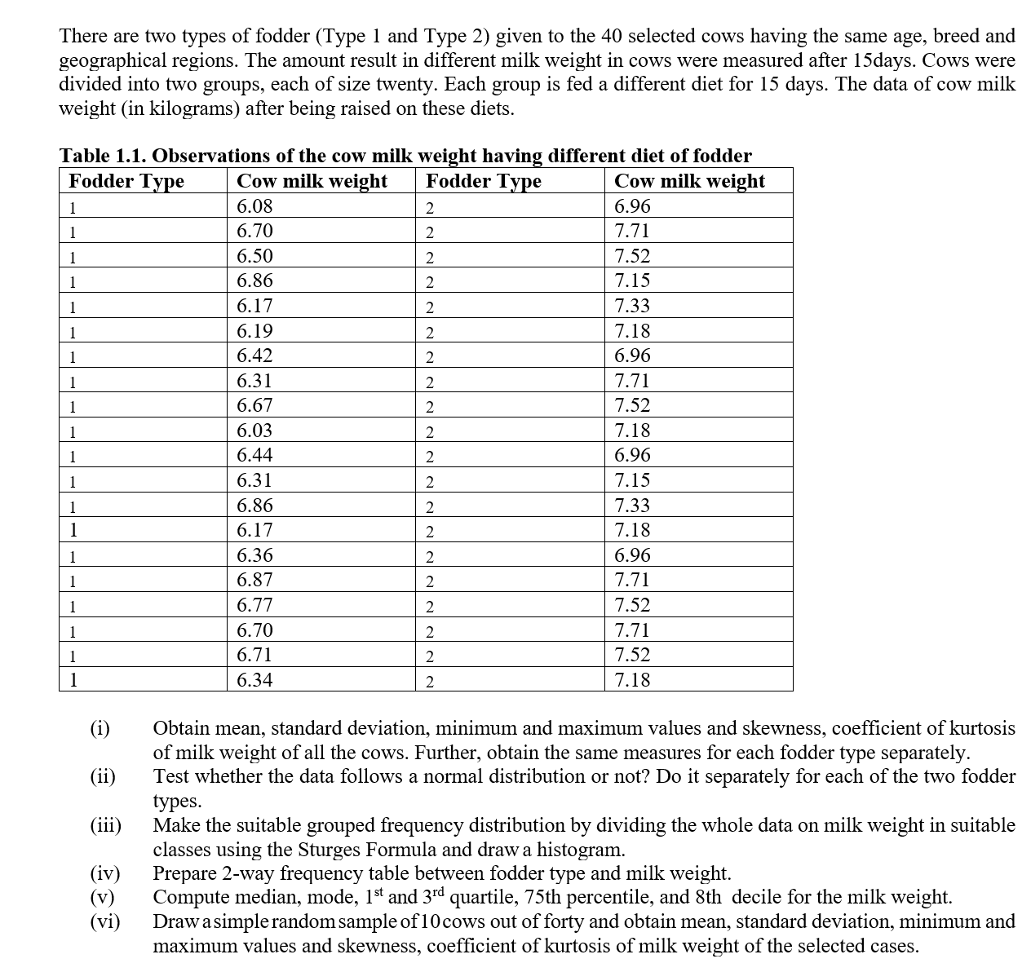

**Output :**

|  |  |  |  |  |  |  |  |  |  |
| --- | --- | --- | --- | --- | --- | --- | --- | --- | --- |
| **Descriptive Statistics** | | | | | | | | | |
|  | N | Minimum | Maximum | Mean | Std. Deviation | Skewness | | Kurtosis | |
| Statistic | Statistic | Statistic | Statistic | Statistic | Statistic | Std. Error | Statistic | Std. Error |
| Cow_Milk_Weight | 40 | 6.03 | 7.71 | 6.8975 | .50832 | .007 | .374 | -1.087 | .733 |
| Valid N (listwise) | 40 |  |  |  |  |  |  |  |  |

**(i)**

|  |  |  |  |  |  |  |  |
| --- | --- | --- | --- | --- | --- | --- | --- |
| **Case Processing Summary** | | | | | | | |
|  | Fodder_Type | Cases | | | | | |
|  | Valid | | Missing | | Total | |
|  | N | Percent | N | Percent | N | Percent |
| Cow_Milk_Weight | 1.00 | 20 | 100.0% | 0 | 0.0% | 20 | 100.0% |
| 2.00 | 20 | 100.0% | 0 | 0.0% | 20 | 100.0% |

|  |  |  |  |  |  |
| --- | --- | --- | --- | --- | --- |
| **Descriptives** | | | | | |
|  | Fodder_Type | | | Statistic | Std. Error |
| Cow_Milk_Weight | 1.00 | Mean | | 6.4730 | .06169 |
| 95% Confidence Interval for Mean | Lower Bound | 6.3439 |  |
| Upper Bound | 6.6021 |  |
| 5% Trimmed Mean | | 6.4756 |  |
| Median | | 6.4300 |  |
| Variance | | .076 |  |
| Std. Deviation | | .27587 |  |
| Minimum | | 6.03 |  |
| Maximum | | 6.87 |  |
| Range | | .84 |  |
| Interquartile Range | | .49 |  |
| Skewness | | .029 | .512 |
| Kurtosis | | -1.357 | .992 |
| 2.00 | Mean | | 7.3220 | .06120 |
| 95% Confidence Interval for Mean | Lower Bound | 7.1939 |  |
| Upper Bound | 7.4501 |  |
| 5% Trimmed Mean | | 7.3206 |  |
| Median | | 7.2550 |  |
| Variance | | .075 |  |
| Std. Deviation | | .27368 |  |
| Minimum | | 6.96 |  |
| Maximum | | 7.71 |  |
| Range | | .75 |  |
| Interquartile Range | | .37 |  |
| Skewness | | .152 | .512 |
| Kurtosis | | -1.365 | .992 |

**(ii)**

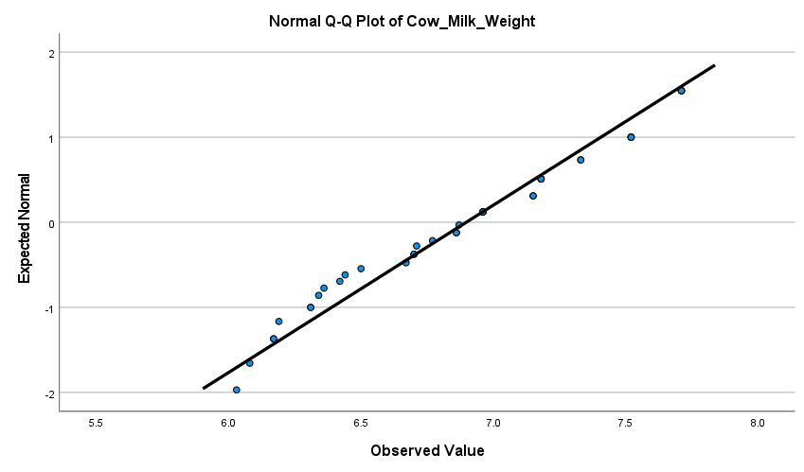

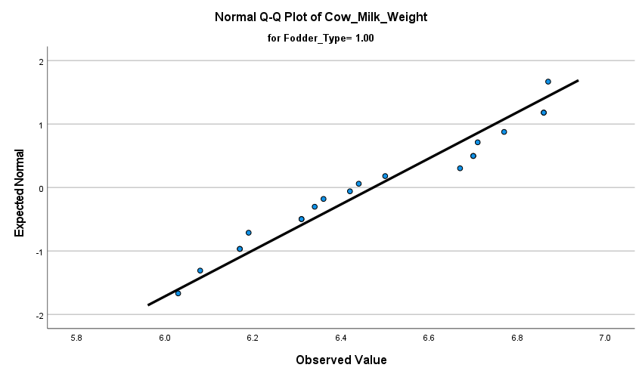

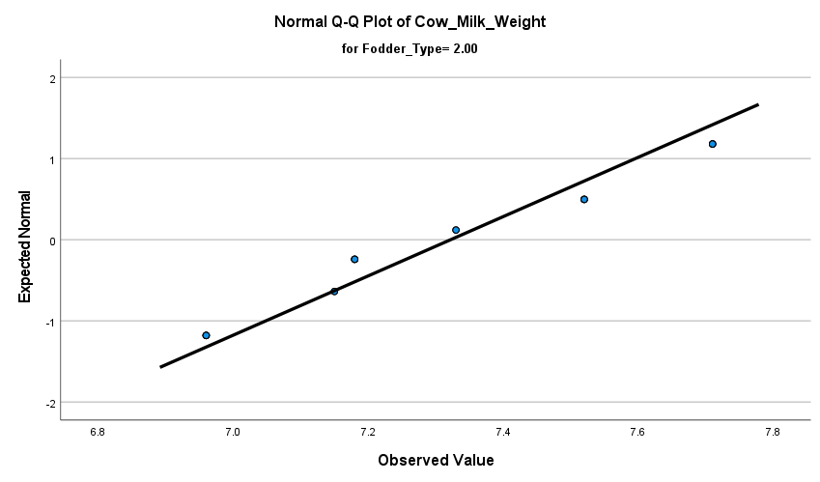

**(iii)**

|  |  |  |  |  |  |
| --- | --- | --- | --- | --- | --- |
| **Cow_Milk_Weight (Binned)** | | | | | |
|  | | Frequency | Percent | Valid Percent | Cumulative Percent |
| Valid | <= 6.03 | 1 | 2.5 | 2.5 | 2.5 |
| 6.04 - 6.31 | 6 | 15.0 | 15.0 | 17.5 |
| 6.32 - 6.59 | 5 | 12.5 | 12.5 | 30.0 |
| 6.60 - 6.87 | 8 | 20.0 | 20.0 | 50.0 |
| 6.88 - 7.15 | 6 | 15.0 | 15.0 | 65.0 |
| 7.16 - 7.43 | 6 | 15.0 | 15.0 | 80.0 |
| 7.44+ | 8 | 20.0 | 20.0 | 100.0 |
| Total | 40 | 100.0 | 100.0 |  |

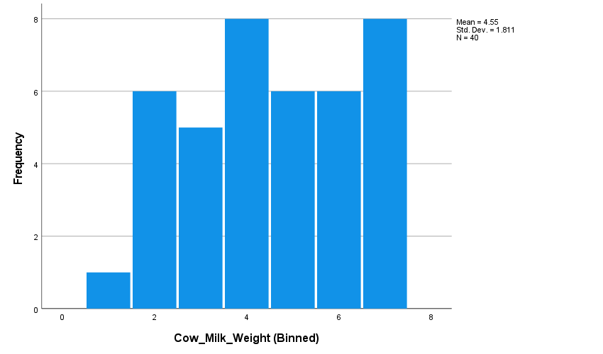

**(iv)**

|  |  |  |  |  |  |  |  |  |  |
| --- | --- | --- | --- | --- | --- | --- | --- | --- | --- |
| **Fodder_Type * Cow_Milk_Weight (Binned) Crosstabulation** | | | | | | | | | |
| Count | | | | | | | | | |
|  | | Cow_Milk_Weight (Binned) | | | | | | | Total |
| <= 6.03 | 6.04 - 6.31 | 6.32 - 6.59 | 6.60 - 6.87 | 6.88 - 7.15 | 7.16 - 7.43 | 7.44+ |
| Fodder_Type | 1.00 | 1 | 6 | 5 | 8 | 0 | 0 | 0 | 20 |
| 2.00 | 0 | 0 | 0 | 0 | 6 | 6 | 8 | 20 |
| Total | | 1 | 6 | 5 | 8 | 6 | 6 | 8 | 40 |

**(v)**

|  |  |  |
| --- | --- | --- |
|  | | |
| Cow_Milk_Weight | | |
| N | Valid | 40 |
| Missing | 0 |
| Median | | 6.9150 |
| Mode | | 6.96a |
| Percentiles | 25 | 6.4250 |
| 50 | 6.9150 |
| 75 | 7.2925 |
| 80 | 7.4820 |
| a. Multiple modes exist. The smallest value is shown | | |

**(vi)**

|  |  |  |  |  |  |  |  |  |  |  |
| --- | --- | --- | --- | --- | --- | --- | --- | --- | --- | --- |
| **Descriptive Statistics** | | | | | | | | | | |
|  | N | Minimum | Maximum | Mean | Std. Deviation | Skewness | | Kurtosis | |
| Statistic | Statistic | Statistic | Statistic | Statistic | Statistic | Std. Error | Statistic | Std. Error |
| Cow_Milk_Weight | 10 | 6.03 | 7.52 | 6.5670 | .49777 | .858 | .687 | -.301 | 1.334 |
| Valid N (listwise) | 10 |  |  |  |  |  |  |  |  |