**Name : Ramashish kumar**

**Group : A**

**Roll No. : 24056765001**

❷

**(ii)**

**Table : 1.1 : Compute Total and Average Marks Individually**

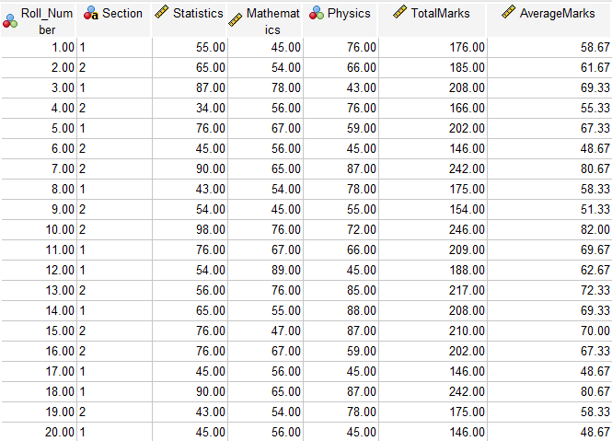

**Table : 1.2 : Whole Group:**

|  |  |  |  |  |  |
| --- | --- | --- | --- | --- | --- |
| Descriptive Statistics | | | | | |
|  | N | Minimum | Maximum | Mean | Std. Deviation |
| TotalMarks | 20 | 146.00 | 246.00 | 192.1500 | 31.81571 |
| AverageMarks | 20 | 48.67 | 82.00 | 64.0500 | 10.60524 |
| Valid N (listwise) | 20 |  |  |  |  |

**Table : 1.3 : Section-wise:**

**Section 1 :**

|  |  |  |  |  |  |
| --- | --- | --- | --- | --- | --- |
| Descriptive Statisticsa | | | | | |
|  | N | Minimum | Maximum | Mean | Std. Deviation |
| TotalMarks | 10 | 146.00 | 242.00 | 190.0000 | 30.09983 |
| AverageMarks | 10 | 48.67 | 80.67 | 63.3333 | 10.03328 |
| Valid N (listwise) | 10 |  |  |  |  |
| a. Section = 1 | | | | | |

**Section 2 :**

|  |  |  |  |  |  |
| --- | --- | --- | --- | --- | --- |
| Descriptive Statisticsa | | | | | |
|  | N | Minimum | Maximum | Mean | Std. Deviation |
| TotalMarks | 10 | 146.00 | 246.00 | 194.3000 | 34.93820 |
| AverageMarks | 10 | 48.67 | 82.00 | 64.7667 | 11.64607 |
| Valid N (listwise) | 10 |  |  |  |  |
| a. Section = 2 | | | | | |

**(iii) Table : 2.1 : Rank the students according to their average marks.**

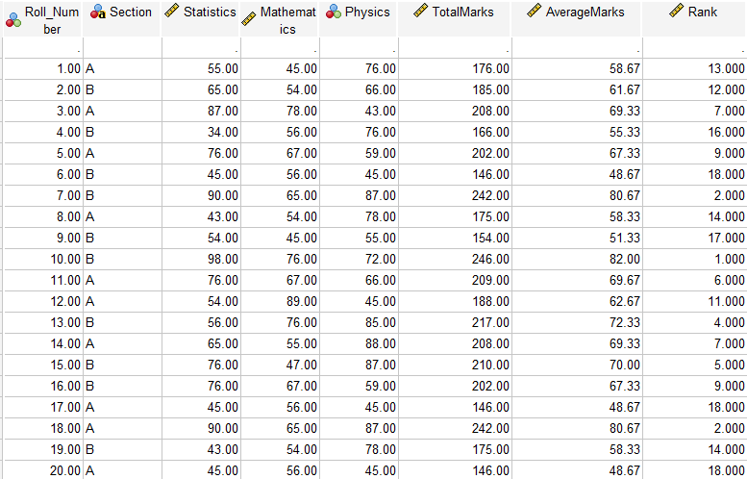

**(iv)** 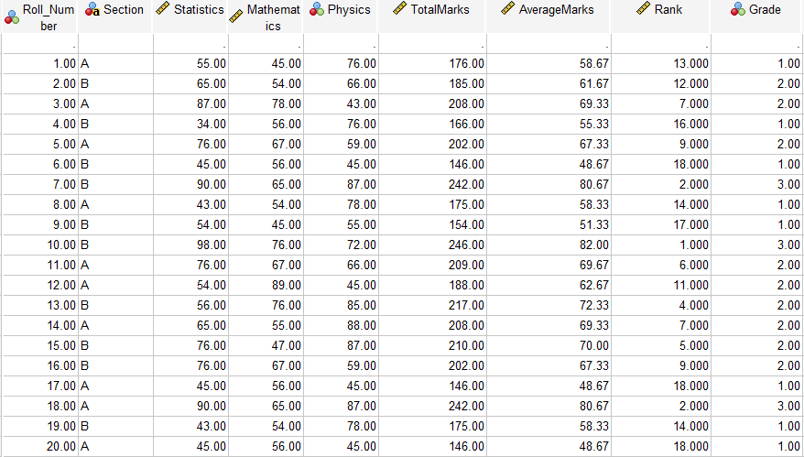

**(v)**

|  |  |  |  |  |  |  |
| --- | --- | --- | --- | --- | --- | --- |
| **Section * Grade Crosstabulation** | | | | | | |
|  | | | **Grade** | | | **Total** |
| **low(<=60)** | **Medium(61-80)** | **High(81-100)** |
| **Section** | **1** | **Count** | **4** | **5** | **1** | **10** |
| **% within Section** | **40.0%** | **50.0%** | **10.0%** | **100.0%** |
| **% within Grade** | **50.0%** | **55.6%** | **33.3%** | **50.0%** |
| **% of Total** | **20.0%** | **25.0%** | **5.0%** | **50.0%** |
| **2** | **Count** | **4** | **4** | **2** | **10** |
| **% within Section** | **40.0%** | **40.0%** | **20.0%** | **100.0%** |
| **% within Grade** | **50.0%** | **44.4%** | **66.7%** | **50.0%** |
| **% of Total** | **20.0%** | **20.0%** | **10.0%** | **50.0%** |
| **Total** | | **Count** | **8** | **9** | **3** | **20** |
| **% within Section** | **40.0%** | **45.0%** | **15.0%** | **100.0%** |
| **% within Grade** | **100.0%** | **100.0%** | **100.0%** | **100.0%** |
| **% of Total** | **40.0%** | **45.0%** | **15.0%** | **100.0%** |