**Problem :**

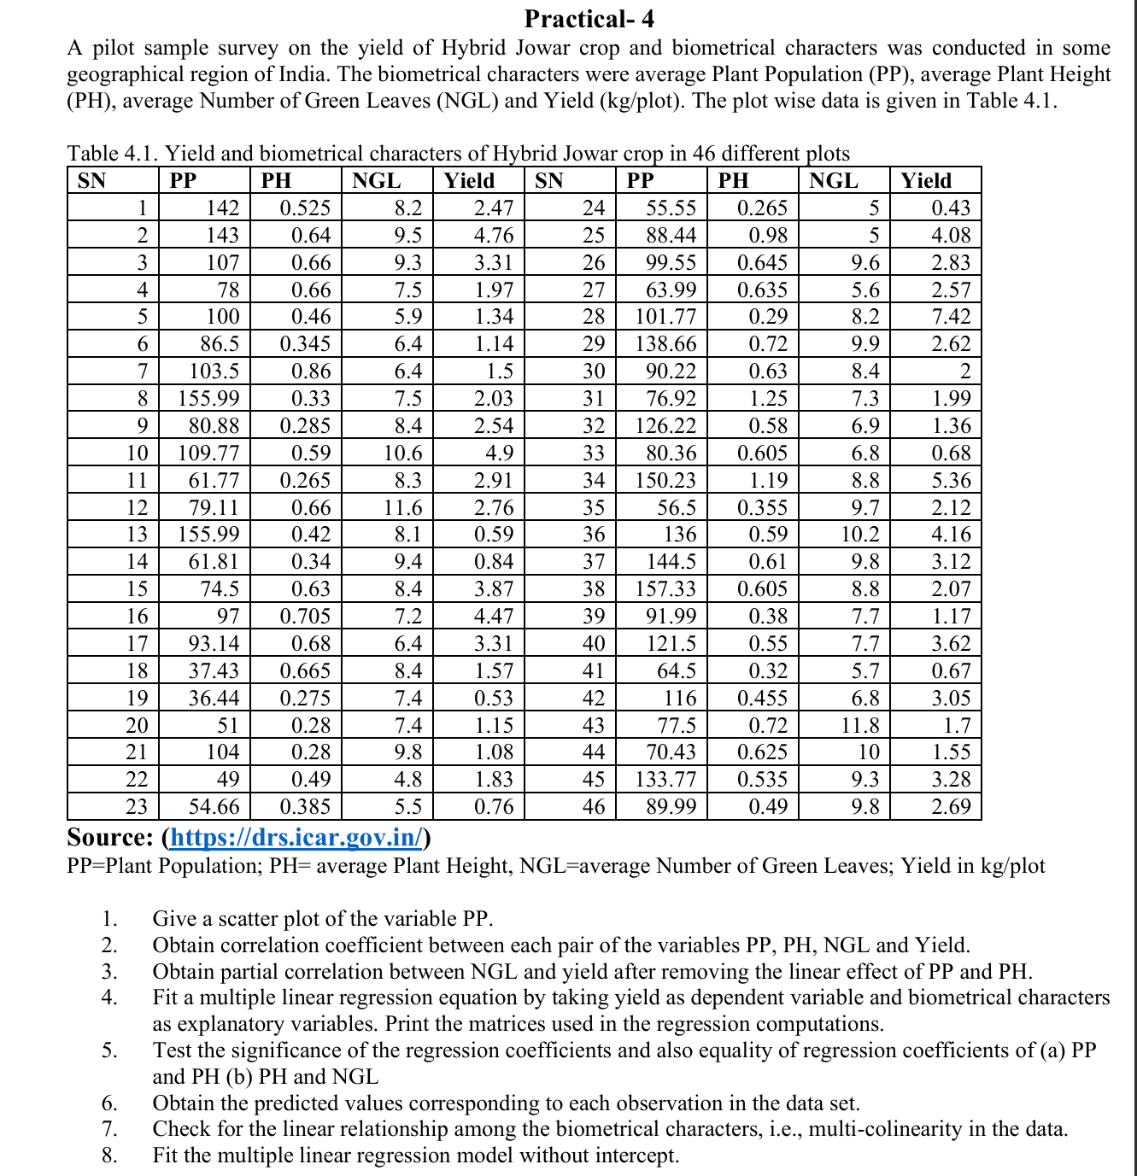

**Output:**

**1.**

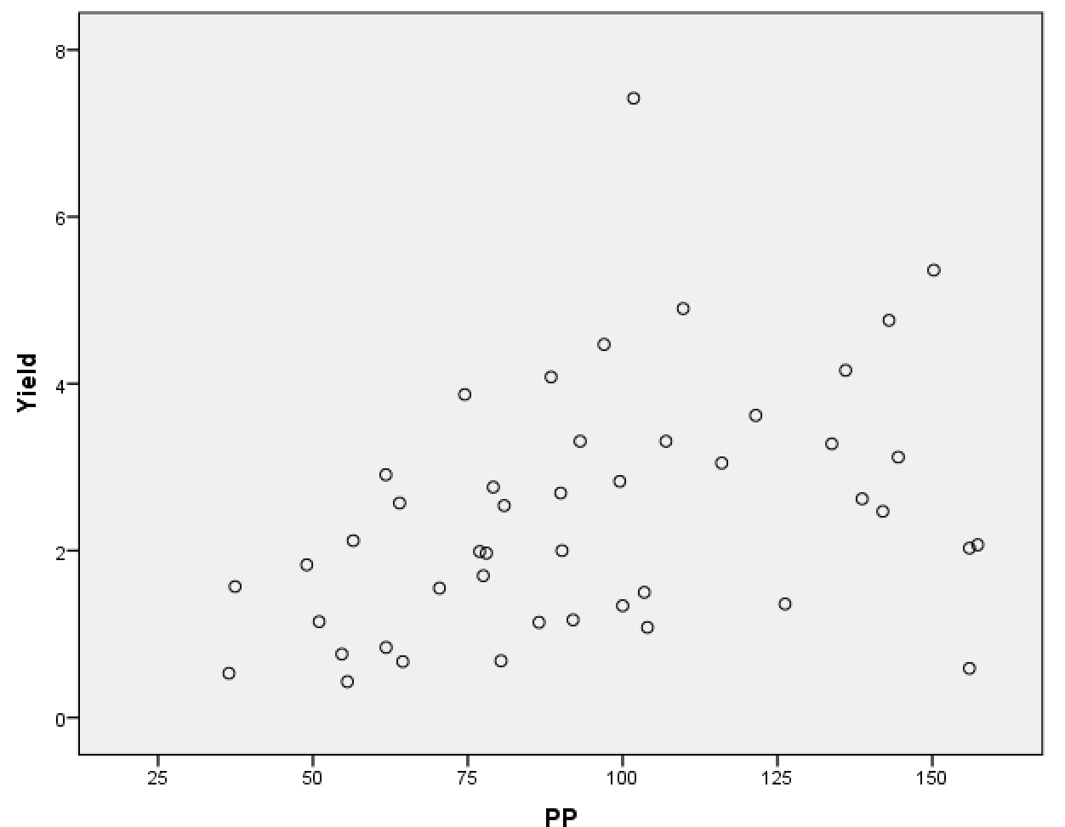

**Figure 4.1: Scatterplot of PP vs Yield**

**2.**

**Table 4.1 : Correlations between PP,PH,NGL,Yield**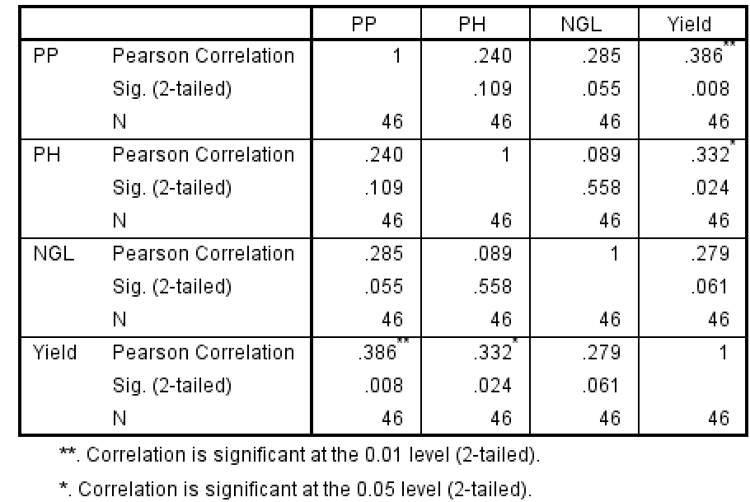

**3.**

**Table 4.2 : Partial correlation between the NGL and Yield**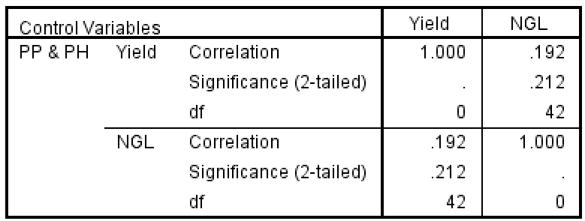

**4.**

**Table 4.3 : Multiple Linear Regression & it’s coefficientsa**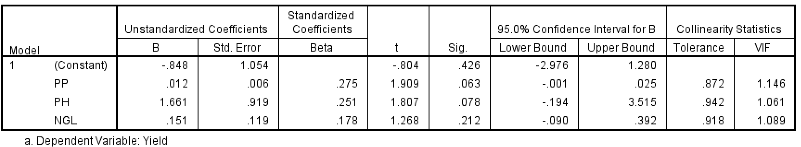

**Table 4.4 : Covariance and Correlation Matricesa**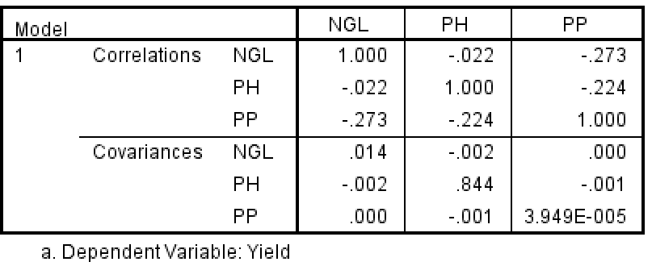

**ANOVAa**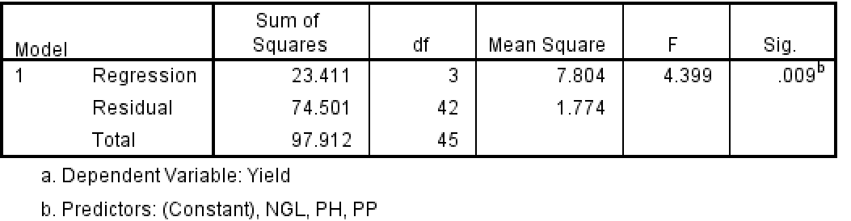

**Table 4.5 : Predicted values and Residuals**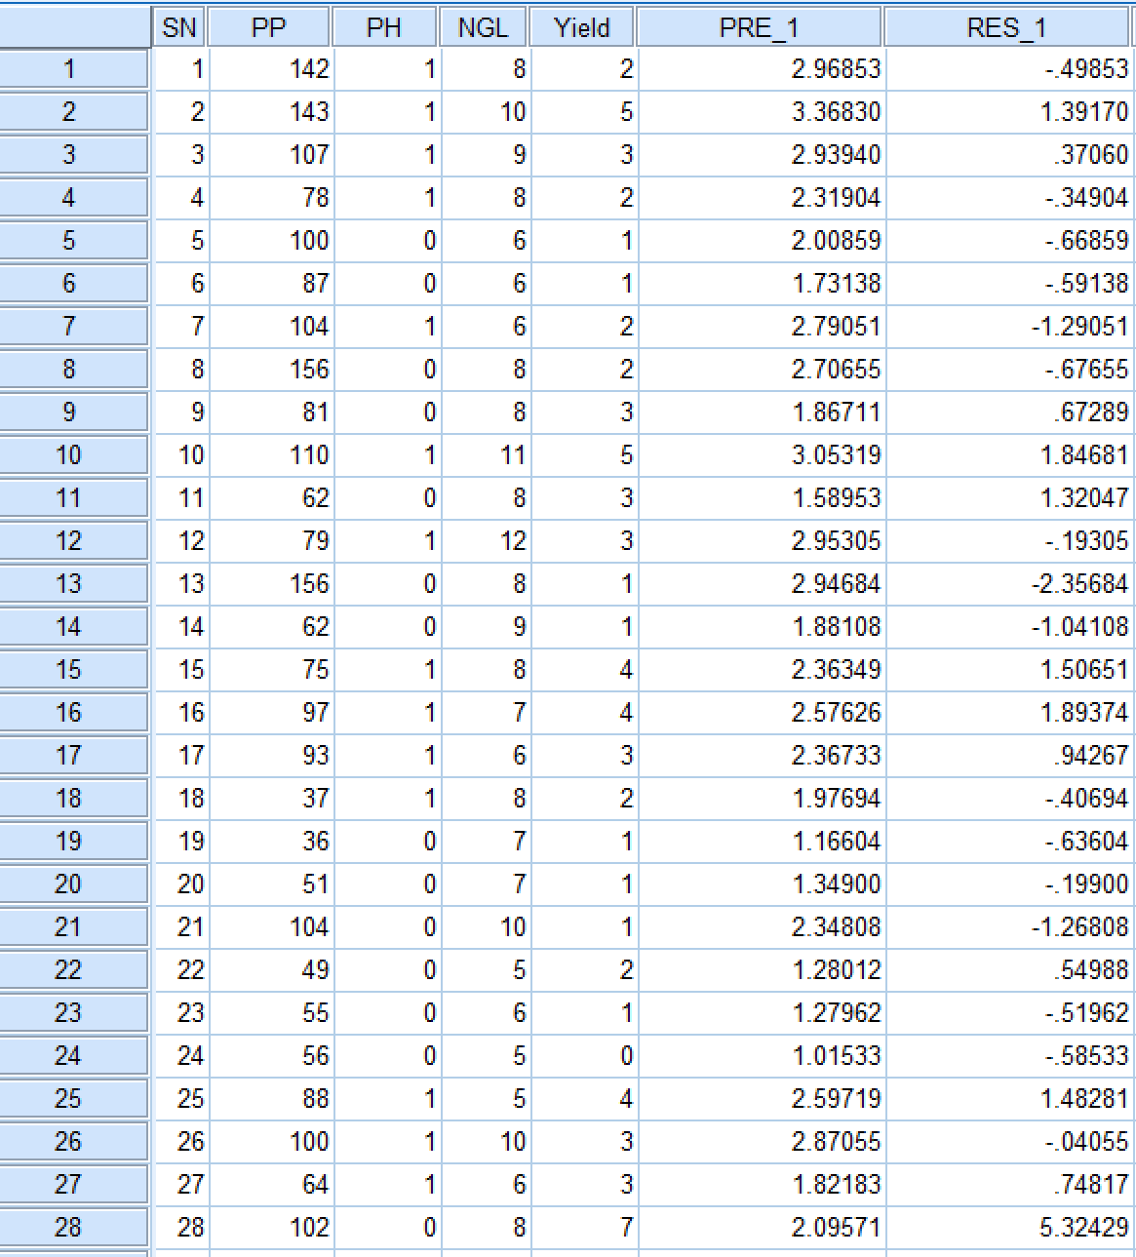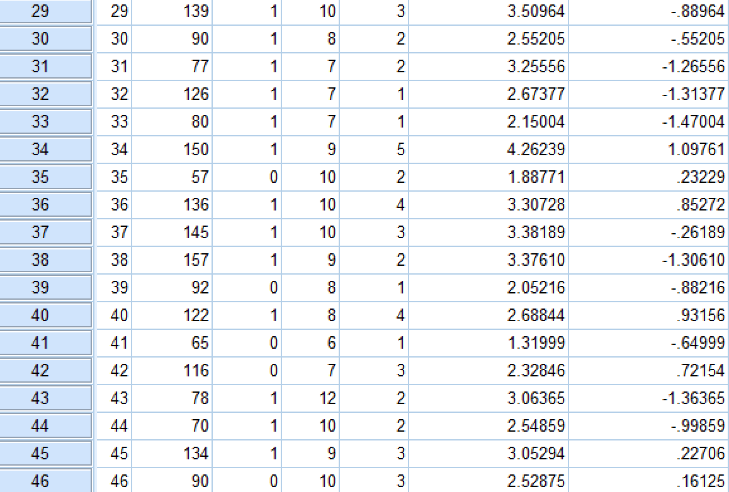

**Table 4.6 : Linear Regression without Intercept terma,b**

