pv, pvc and mount the volume to our pod using nfs
Document prepared by B.R.Tulasi
Step 1 : Create NFS server
Go to volumes create EBS volume
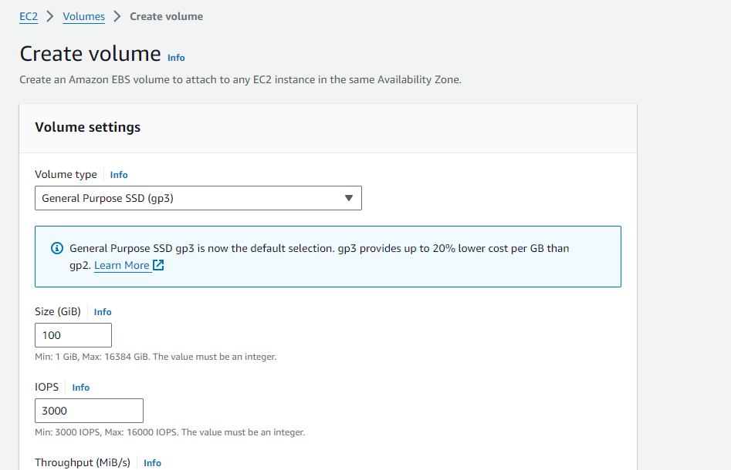
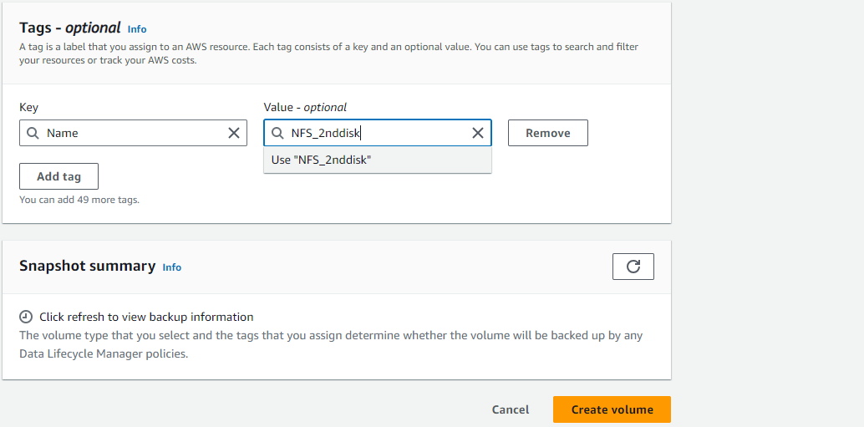

Step 2 : Attach EBS volume into your nfs instance
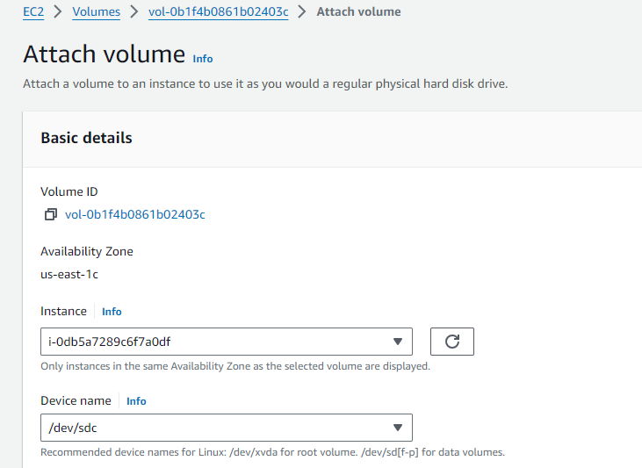
Step 3 :
Got to terminal nfs
Install nfs
yum install nfs-utils for linux server
Lsblk
Run this command
mkfs.ext4 /dev/xvdb
“mkfs.ext4 /dev/xvdb” is used in Linux to create an ext4 filesystem on a specified block device
Step 4 :
Create directory and mount it.
mkdir /app
mount /dev/xvdb /app
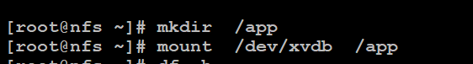
Step 5 :
And give the permission to your directory .
chown -R root:root /app
chmod 777 /app
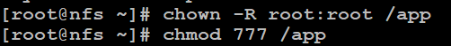
df –h display information about disk space usage on mounted filesystems in a human-readable format
Step 6 :
vi /etc/exports
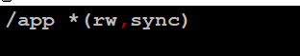
/app *(rw,sync)
Step 7 :
exportfs -a
exportfs
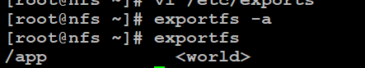
start the nfs-utils and check the status
systemctl start nfs-utils
systemctl status nfs-utils
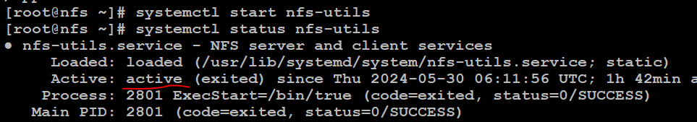

Step 8:
install nfs in workernodes
sudo apt install nfs-kernel-server
open nfs port on all workernodes
nfs port 2049

Step 9:
Create pv and pvc and deployment files in K8 Master
Create a PersistentVolume
vi pv.yaml
apiVersion: v1
kind: PersistentVolume
metadata:
name: nfsvol
spec:
capacity:
storage: 10Gi
volumeMode: Filesystem
accessModes:
- ReadWriteMany
persistentVolumeReclaimPolicy: Recycle
storageClassName: manual
mountOptions:
- hard
- nfsvers=4.1
nfs:
path: /app
server: 54.84.8.248
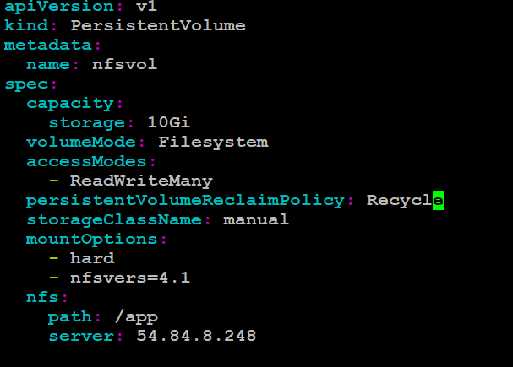
kubectl apply -f pv.yaml
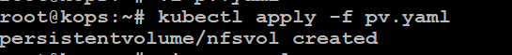
kubectl get pv

Step 10 :
Create a PersistentVolumeClaim

vi pvc.yaml
apiVersion: v1
kind: PersistentVolumeClaim
metadata:
name: nfsvol
spec:
storageClassName: manual
accessModes:
- ReadWriteMany
resources:
requests:
storage: 5Gi
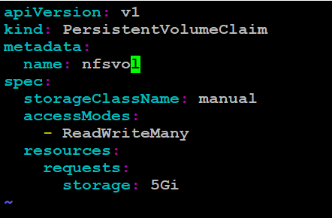
kubectl apply -f pvc.yaml
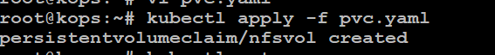
﻿ kubectl get pvc
Step 11 :
Create deployment
vi deployment.yaml
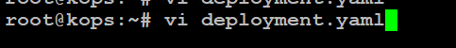
apiVersion: apps/v1
kind: Deployment
metadata:
name: nginx-deployment
spec:
replicas: 3
selector:
matchLabels:
app: nginx
template:
metadata:
labels:
app: nginx
spec:
containers:
- name: nginx
image: nginx
ports:
- containerPort: 80
volumeMounts:
- mountPath: /var/www/html
name: nfsvol
volumes:
- name: nfsvol
persistentVolumeClaim:
claimName: nfsvol
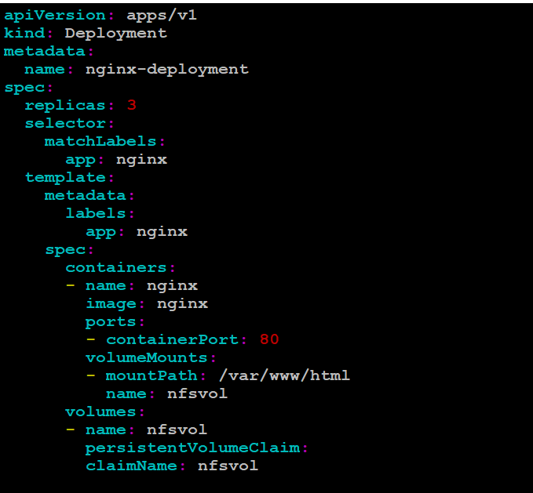
kubectl apply -f deployment.yaml

kubectl get pods
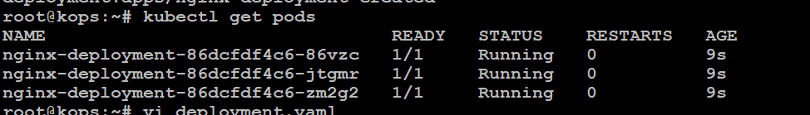
kubectl get -o wide pods
