EKS
Step 1: Create IAM role
Select eks
Select cluster policy
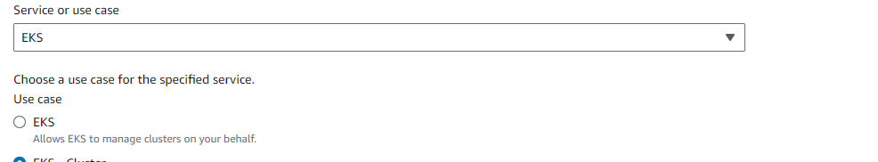
Give the role name
Create
Step 2: Go to Elastic Kubernetes Service (Amazon EKS)
add cluster and create the cluster
Attach role and Attach security group id
Create cluster
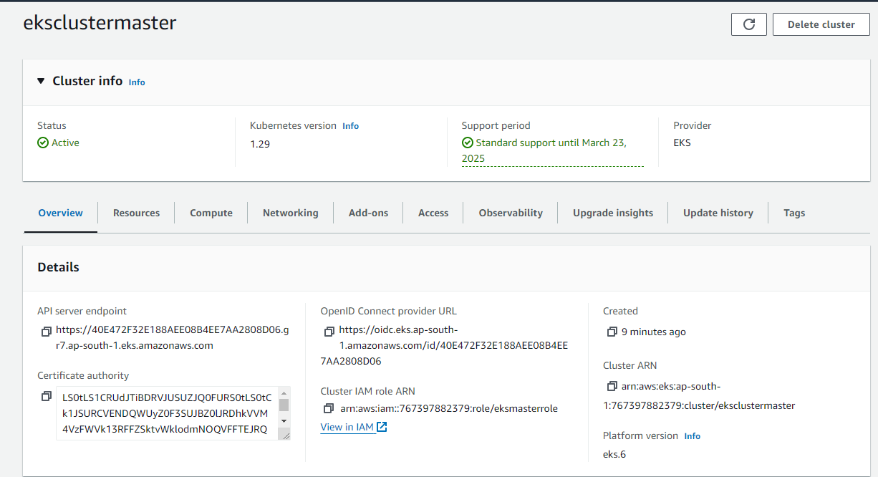
Step 3: Go to compute
Add node groups
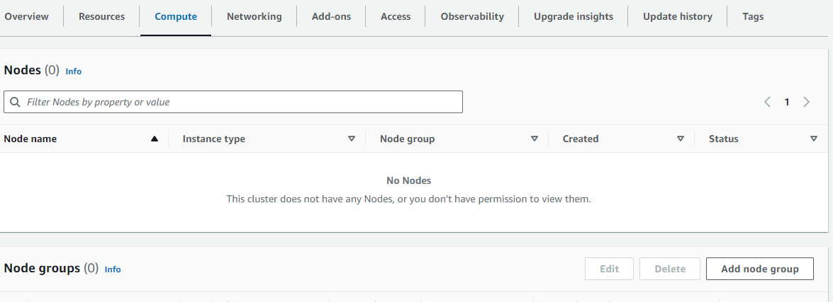
Step 4: Before creating the node groups
Create IAM role and the below permissions
Cni policy
Workernode policy
Amazon ec2 container registry
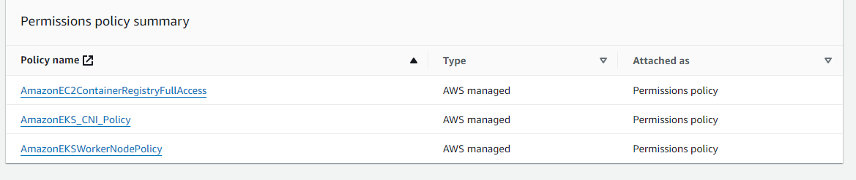
Step 5: Node group created
