Kops
Step 1: Create ec2 name with kops_master
Step 2: Create IAM user and role and add permissions
- AmazonEC2FullAccess
- AmazonRoute53FullAccess
- AmazonS3FullAccess
- IAMFullAccess
- AmazonVPCFullAccess
- AmazonSQSFullAccess
- AmazonEventBridgeFullAccess
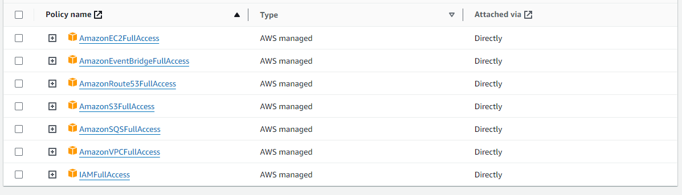
Step 3: Go to ec2 security modify IAM role and attach your role
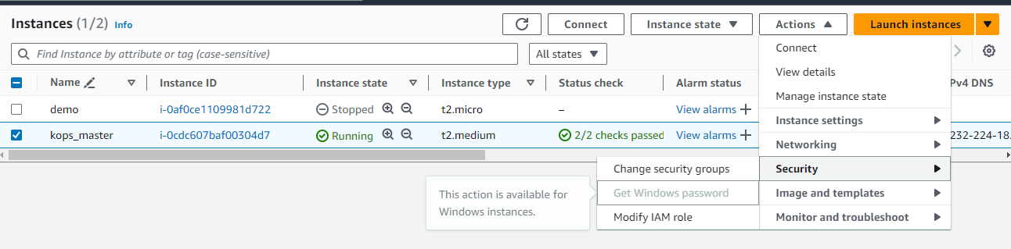
Go to Terminal
Step 4:
Set the hostname
sudo hostnamectl set-hostname kops
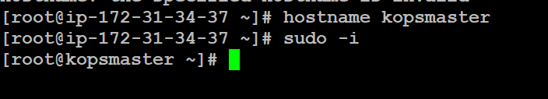

Kops ubuntu
Cli installation
curl "https://awscli.amazonaws.com/awscli-exe-linux-x86_64.zip" -o "awscliv2.zip"
sudo apt install unzip
sudo unzip awscliv2.zip
sudo ./aws/install
aws --version

Step 5: aws configure
Enter the access key id, secret access key, and region and output format.
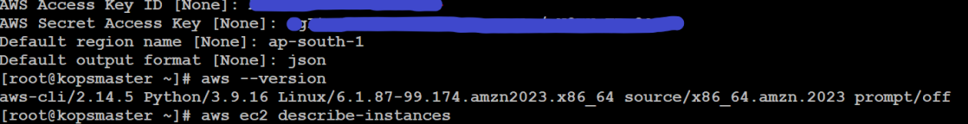

Select cops server note down the vpc details and availability zone
Step 6:
Go to route 53
Create private network we are access only in aws
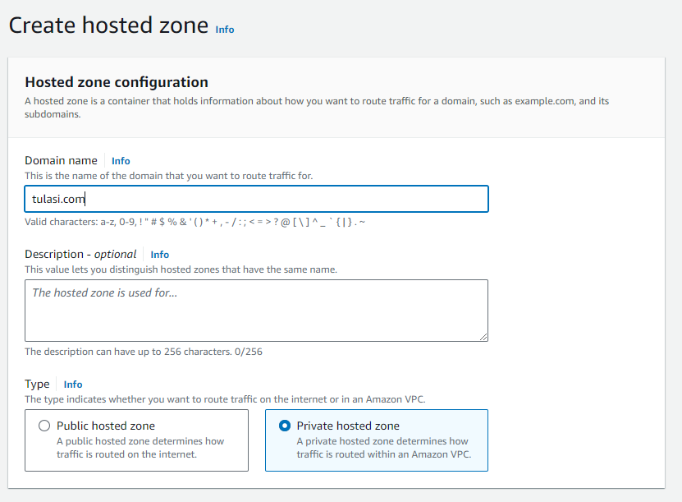
- Create hosted zone
- Enter the name and select private hosted zone
- Select region and vpc
- Create hosted zone
- Installing kops
Step 7:
curl -LO https://github.com/kubernetes/kops/releases/download/$(curl -LO https://github.com/kubernetes/kops/releases/download/v1.28.4/kops-linux-amd64)

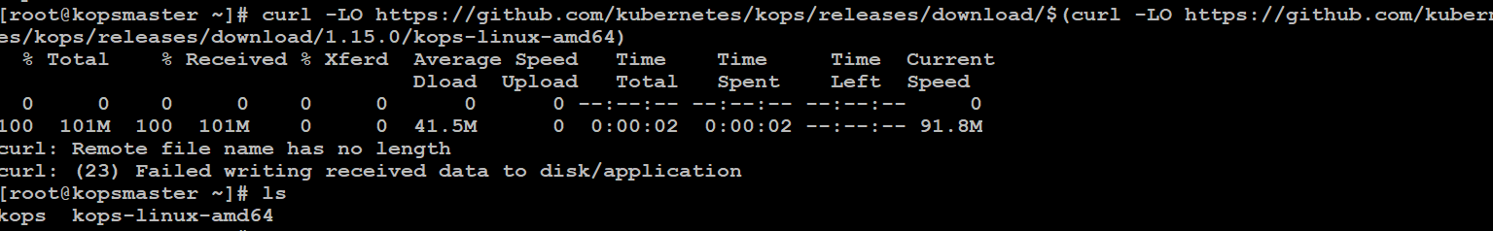
Step 7:
chmod +x kops-linux-amd64
sudo mv kops-linux-amd64 /usr/local/sbin/kops
Step 8:Create s3 bucket
aws s3 mb s3://clusters.demo.tulasi.com
Step 9: export KOPS_STATE_STORE=s3://clusters.demo.tulasi.com
Step 10: We have to add above entry in /etc/profile (at the end of the file)
vi /etc/profile in this export KOPS_STATE_STORE=s3://clusters.demo.tulasi.aws.com
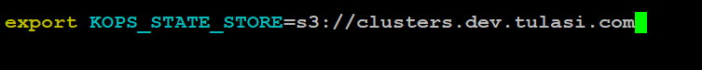
Step 11:
curl -LO https://storage.googleapis.com/kubernetes-release/release/$(curl -s https://storage.googleapis.com/kubernetes-release/release/stable.txt)/bin/linux/amd64/kubectl
chmod +x ./kubectl
sudo mv ./kubectl /usr/local/sbin/kubectl
Step 12:
ssh-keygen
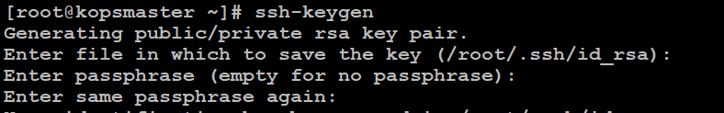
Step 13: yum install docker

Step 14: Creating the cluster
kops create cluster --zones=us-east-1c clusters.demo.tulasi.com --dns-zone=tulasi.com --dns private
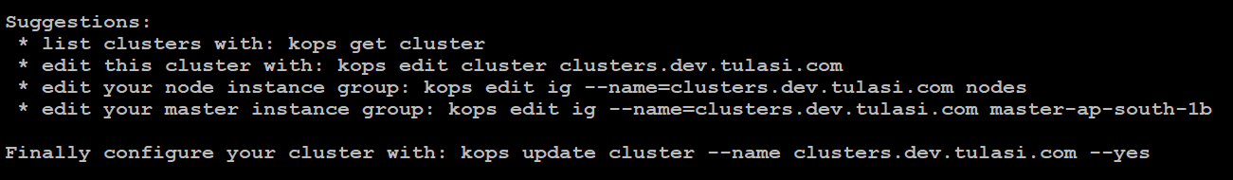
------------------------------------------------------------------------------------------------------------------------------------
Suggestions:
* list clusters with: kops get cluster
* edit this cluster with: kops edit cluster clusters.demo.tulasi.com
* edit your node instance group: kops edit ig --name=clusters.demo.tulasi.com nodes-us-east-1c
* edit your control-plane instance group: kops edit ig --name=clusters.demo.tulasi.com control-plane-us-east-1c

Finally configure your cluster with: kops update cluster --name clusters.demo.tulasi.com --yes --admin--------------------------------------------------------------------------------------------------------------------------------------
Step 14: update the cluster
kops update cluster --name clusters.demo.tulasi.com --yes
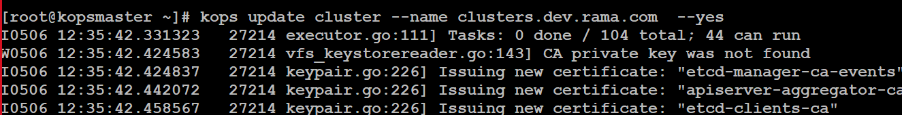
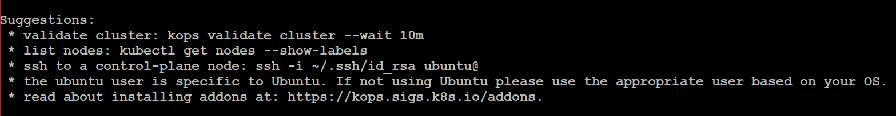
--------------------------------------------------------------------------------------------------------------------------------------
Suggestions:
* validate cluster: kops validate cluster --wait 10m
* list nodes: kubectl get nodes --show-labels
* ssh to a control-plane node: ssh -i ~/.ssh/id_rsa ubuntu@
* the ubuntu user is specific to Ubuntu. If not using Ubuntu please use the appropriate user based on your OS.
* read about installing addons at: https://kops.sigs.k8s.io/addons.
--------------------------------------------------------------------------------------------------------------------------------------
Automatically nodes will created into ec2 instance.
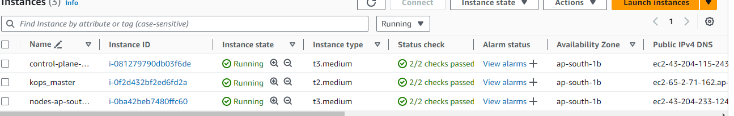

kops validate cluster
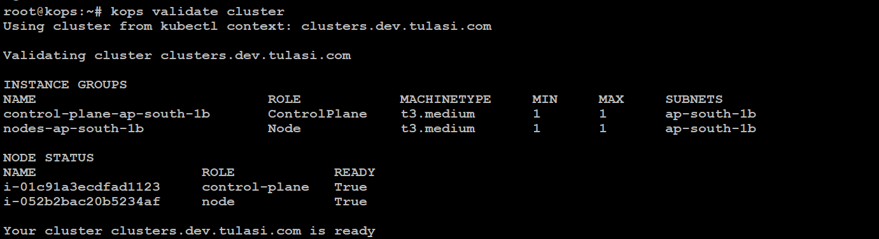
kubectl get nodes
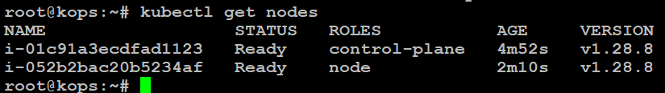

Deleting the cluster run this command
kops delete cluster --name clusters.demo.tulasi.com –yes
Deleting the s3 bucket
aws s3 rb s3://clusters.demo.tulasi.com

